ZOO102 :( Principles of Animal Life I)

Contents:
Sr. # | Name of Experiment | Page. #
1 | Qualitative and Quantitative Tests for Carbohydrates
2 | Qualitative and Quantitative Tests for Proteins
3 | Qualitative and Quantitative Tests for Lipids
4 | Study of the prepared slides of epithelial tissue (squamous, cuboidal, and columnar)
5 | Study of the prepared slides of connective tissue
6 | Study of the prepared slides of Nervous tissue
7 | Study of the prepared slides of muscle tissue (skeletal, smooth and cardiac)
8 | Plasmolysis in blood. Preparation of blood smears
9 | De-plasmolysis in blood. Preparation of blood smears
10 | Protein digestion by pepsin.
11 | Ecological notes one animal (Chimpanzees) of a model habitat (Forest).
12 | Ecological notes one animal (Kangaroos) of a model habitat (Island).
13 | Ecological notes one animal (Polar Bear) of a model habitat (Polar Region).
14 | Ecological notes one animal (Hawk Eagle) of a model habitat (Mountains).
15 | Field observation and report writing on animals in their ecosystem (A terrestrial ecosystem study).
16 | Field observation and report writing on animals in their ecosystem (an aquatic ecosystem study).
Practical # 1
Qualitative and quantitative Tests for Carbohydrates
Apparatus Required:
Test tubes, test tube holder, dropper, beaker, spirit lamp
Theory:
“Carbohydrates are polyhydroxy aldehydes or ketones, or substances that yield such compounds on hydrolysis”. Many of the carbohydrates have the empirical formula (CH2O) n. Some carbohydrates also contain phosphorus, nitrogen or sulfur.
Carbohydrates are classified into four major groups:
- Monosaccharides
- Disaccharides
- Oligosaccharides
- Polysaccharides
Monosaccharides:
Monosaccharides (simple sugars) are those which cannot be hydrolyzed further into simpler forms. The backbones of monosaccharides are unbranched carbon chains in which all the carbon atoms are connected by single bonds. For example, glucose, fructose.
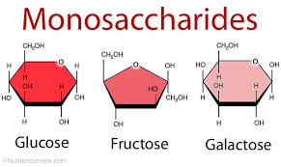
Figure 1: Monosaccharaides
Disaccharides:
Disaccharides are those sugars which yield two molecules of the same or different monosaccharides on hydrolysis. For example, maltose, lactose.
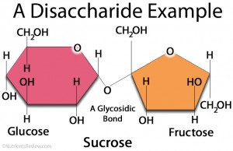
Figure 2: Disaccharides

Oligosaccharides:
Oligosaccharides are small chains of monosaccharide units (3-10) linked by distinctive linkages called glyosidic linkage.
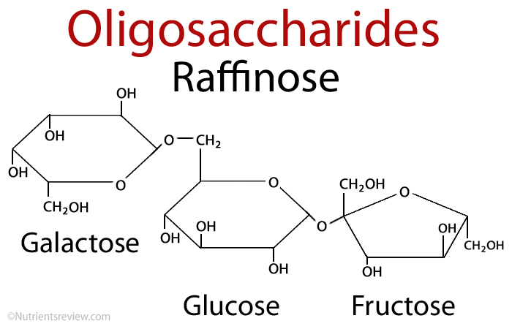
Figure 3: Oligosaccharides
Polysaccharides:
Polysaccharides (Glycans) are those which yield more than 10 molecules of monosaccharides on hydrolysis. Some have hundreds or thousands of units. For example, cellulose, glycogen.
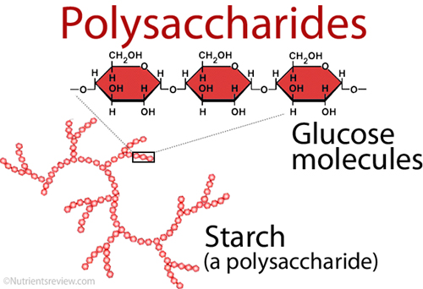
Figure 4: Polysaccharides
A). Molisch’s Test
It is a sensitive group test that is used regularly for the detection for all carbohydrates present either in free or combined form. Monosaccharides react rapidly whereas disaccharides and polysaccharides react slowly.
Principle: This test makes use of concentrated H2SO4 to catalyze the dehydration of sugars to form hydroxymethyl furfural (from hexoses) or furfural (from pentoses). The furfurals then condense with α-naphthol to give a violet or purple colored product.
Reagents Required:
Conc. sulfuric acid
Molisch’s Reagent: 5% α-naphthol solution in 95% ethanol
Carbohydrates (glucose, maltose)
Procedure:
- Add 1-2 ml of unknown solution in a test tube.
- Add 2-3 drops of Molisch’s reagent ad mix well.
- Hold the test tube in an inclined position and add carefully 1-2 ml of Conc. Sulfuric acid down the side of the tube to make a layer of it at the bottom of the tube.
- Formation of purple product/ring at the border of two layers indicates a positive test.

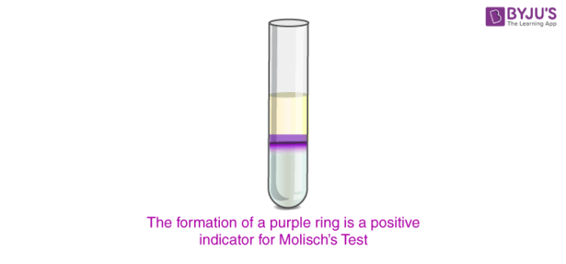
Figure 5: Molisch’s Test result
B). Benedict’s test
Benedict’s test is used for the detection of reducing sugars (sugars having free reactive carbonyl group).
Principle:
This test utilizes a mixture of sodium citrate, copper (II) sulfate and sodium carbonate in a slightly basic solution. Reducing sugars reduce the copper (II) ions to copper (I) oxide (Red ppt).
R-CHO + 2Cu2+ +5OH- R-CO2-+Cu2O (red ppt) + 3H2O
R-CHO =Reducing carbohydrates
R-CO2- = Carbohydrate ion

Reagents Required:
Benedict’s reagent: Dissolve Sodium Citrate (173 g) and anhydrous Sodium Carbonate (100 g) in about 700 ml of distilled water by gently heating the contents. Dissolve Copper Sulfate (17.3 g) in about 100 mL of distilled water in a separate beaker. Transfer this solution gradually into the Carbonate-Citrate mixture with constant stirring and raise the volume to 1 L with distilled water.
Carbohydrates (glucose, starch/sucrose)
Procedure:
1. Add 1 ml of sample in a test tube.
2. Then add 2 ml of Benedict’s reagent.
3. Heat the solution in a boiling water bath for 3 minutes.
4. Formation of red precipitate indicates positive test.
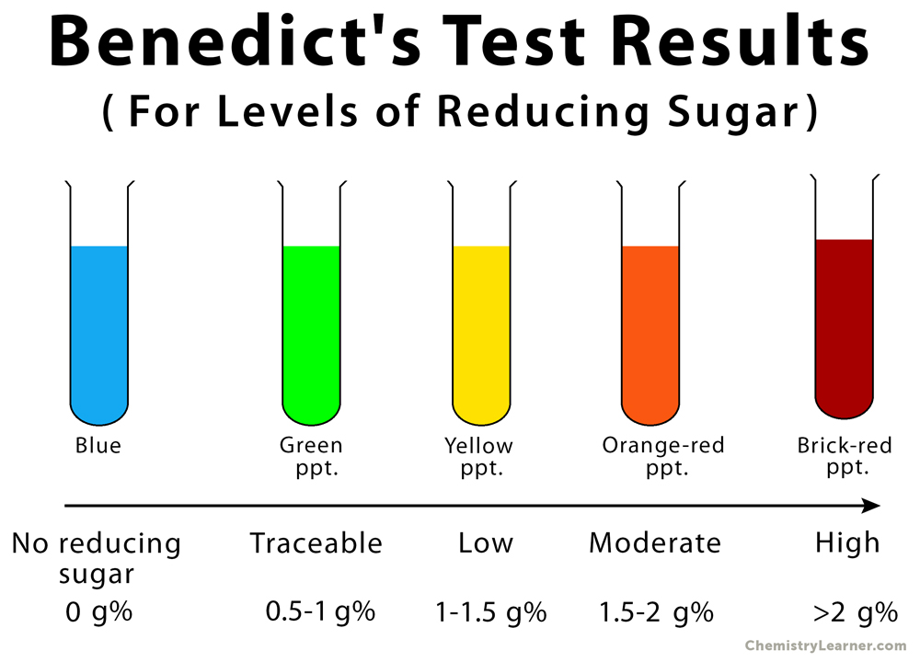
Figure 6: Benedict’s test result
C). Iodine Test
This test is used to differentiate polysaccharides from monosaccharides and disaccharides.
Principle:
Different carbohydrates e.g. starch form colored adsorption complexes with iodine due to the adsorption of iodine on the polysaccharide chains. The intensity of the color is dependent on the length of the unbranched or linear chain accessible for the complex formation. Iodine forms complex with starch to give deep blue-black color. Glycogen (highly branched polysaccharide) gives red color with iodine.
Reagents Required:
- Iodine solution: Dissolve Iodine (1.0 g) and potassium iodide (2.0 g) in 300 ml of distilled water.
- Starch solution (1%)
Procedure:
1. Add 2 ml of sample in a test tube.
2. Add 1-2 drops of iodine solution.
3. Formation of blue-black color indicates the presence of starch.

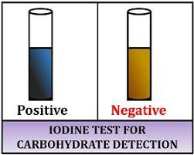
Figure 7: Iodine Test result

Practical # 2
Qualitative and Quantitative Tests for Proteins
Apparatus
Test tubes, test tube holder, dropper, beaker, spirit lamp
Theory
Amino acids have an amino group and a carboxyl group bonded to the same carbon atom (α carbon) and a side chain that varies for different amino acids.
“Proteins are polymers of amino acids, with each amino acid residue joined to its neighbor by a specific type of covalent bond termed the peptide bond.”

A). Ninhydrin Test
It is general test used for the detection of proteins, peptides and amino acids.
Principle:
Ninhydrin reacts with α-amino acids (-NH2) to give a purple colored complex. Proteins also have a free amino group on α-carbon that can react with ninhydrin to give a blue purple product.
Amino acids such as Proline which has a secondary amino group react with ninhydrin to form a yellow reaction product.
Reagents Required:
1. Ninhydrin solution: Add 0.2 g of ninhydrin in 50 ml of acetone and raise the volume to 100 ml with acetone.
2. Amino acid solution (Lysine/alanine/proline etc...)
Procedure:
1. Add 1 ml of amino acid solution in a test tube.
2. Add 5 drops of 0.2% ninhydrin solution.
3. Place the test tubes in boiling water for 5 min.
4. Allow it to cool and observe the purple color formed.
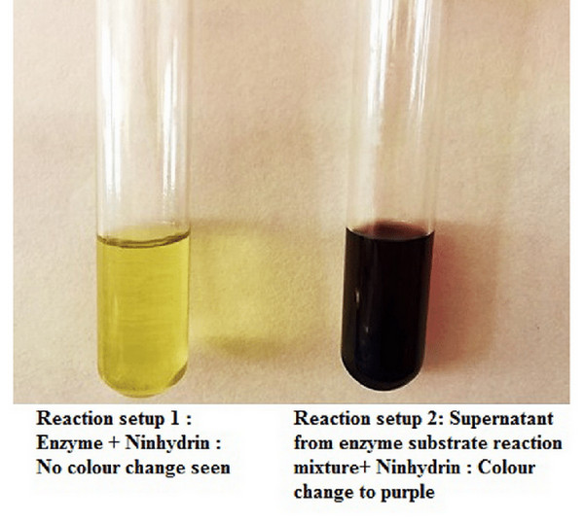
Figure 8: Ninhydrin Test result
B). Biuret Test.
This test is used for the detection of proteins containing at least two peptide bonds.
Principle:
The reaction incorporates the violet complex formation of the proteins with Cu2+ ions in an intensely alkaline solution.
Biuret Complex:
Reagents Required:
1. 10% sodium hydroxide solution
2. 1% copper sulfate solution
3. Protein solution (casein, gelatin, albumin)
Procedure:
1. Add 1 ml of protein solution in a test tube.
2. Add 1 ml of 10% sodium hydroxide solution and 2-3 drops of 1% copper sulfate solution.
3. Mix well and observe the formation of violet color.
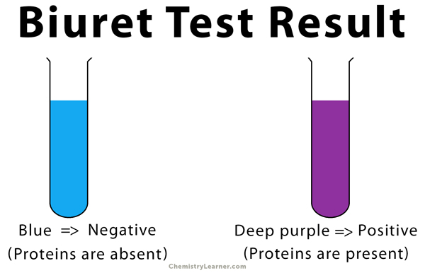
Figure 9: Biuret Test result

C). Xanthoproteic Test.
It is a general test used for the detection of tyrosine, tryptophan and proteins containing these two amino acids.
Principle:
Some amino acids have aromatic groups that are derivatives of benzene. The amino acids tryptophan and tyrosine contain activated benzene rings that readily undergo nitration and form yellow product. The intensity of yellow color increases when the reaction is carried out in basic solution. Phenylalanine also carries a benzene ring but the ring is not activated and hence does not undergo nitration readily.
Tyrosine or Tryptophan + conc. HNO3 Yellow product
Heat
Reagents Required:
i. Conc. Nitric acid
ii. 40% sodium hydroxide solution
iii. Amino acid solution (Tyrosine/Tryptophan)
Procedure:
i. Add 2 ml of amino acid solution in a test tube.
ii. Add equal volume of conc. HNO3.
iii. Heat over the flame for two minutes and observe the color. Positive test is indicated by the formation of yellow color.
iv. Cool the test tube thoroughly under the tap water and add sufficient 40% NaOH solution to make the solution alkaline.
v. Observe the color (orange) of the nitro derivative of aromatic nucleus.

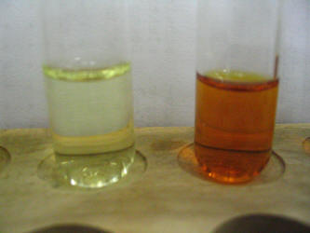
Figure 10: Xanthoproteic Test result

Practical # 3
Qualitative and Quantitative Tests for Lipids
Apparatus:
Test tubes, dropper, filter paper, spirit lamp
Materials required:
Oil/Ghee, Chloroform/alcohol, 20% alcoholic KOH
Theory
The lipids are a heterogeneous group of compounds that contain hydrocarbons and include fats, oils, steroids, waxes, their derivatives and precursors. They are insoluble in water but are soluble in nonpolar solvents such as ether and chloroform.
A). Spot Test
i. Take a piece of filter paper.
ii. Add a drop of sample on it.
iii. A greasy spot penetrating the paper indicates lipids. The spot is also translucent in nature.
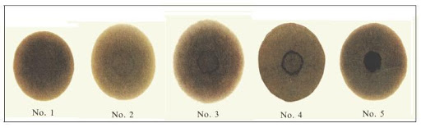
Figure 1: Spot Test result

B). Solubility Test
i. Take a small amount of sample in two test tubes.
ii. To one test tube, add 5 ml of water and add 5 ml of chloroform in the second test tube.
iii. Shake well.
iv. Miscibility of sample in chloroform and immiscibility of sample in water indicates lipids.

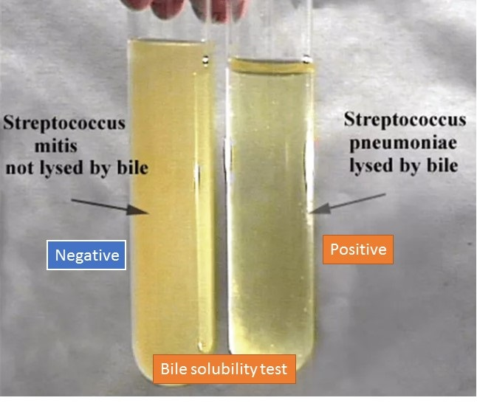
Figure 2: Solubility Test result

C). Saponification Test
Principle:
Saponification is the process that produces soap from fats. In this process, oil or fat is hydrolyzed with alkali that results in the formation of glycerol and salt of fatty acids (soap).
Procedure:
i. Take sample and alcoholic potassium hydroxide in 1:3 ratio.
ii. Boil for 10-20 minutes.
iii. After heating, a semi solid layer develops (soap).
iv. Separate the upper semi solid layer.
v. Add little water to upper separated layer and shake well. Formation of bubbles indicates soap formation.
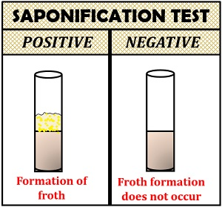
Figure 3: Saponification Test result
Practical # 4
Study of the prepared slides of epithelial tissue (squamous, cuboidal, and columnar)
Definition:
Epithelial tissues line the outer surfaces of organs and blood vessels throughout the body, as well as the inner surfaces of cavities in many internal organs. An example is the epidermis, the outermost layer of the skin. There are three principal shapes of epithelial cell: squamous, columnar, and cuboidal.
Functions:
Epithelial tissue serves two main functions in the body.
- It provides linings for external and internal surfaces that face harsh environments. The outer layer of the skin is epithelial tissue, as are the innermost layers of the digestive tract, the respiratory tract, and blood vessels.
- It forms glands that secrete materials onto epithelial surfaces or into the blood. Sweat glands, salivary glands, mammary glands, adrenal glands, and pituitary glands are examples of glands made of epithelial tissue.
Epithelial tissue is often classified according to numbers of layers of cells present, and by the shape of the cells.
Materials required:
Prepared slides, light microscope, tissue papers to clean slides and microscope lens
Procedure:
Focus all the available prepared slides of cells to examine different organelles present in them and record your observation in practical notebook.

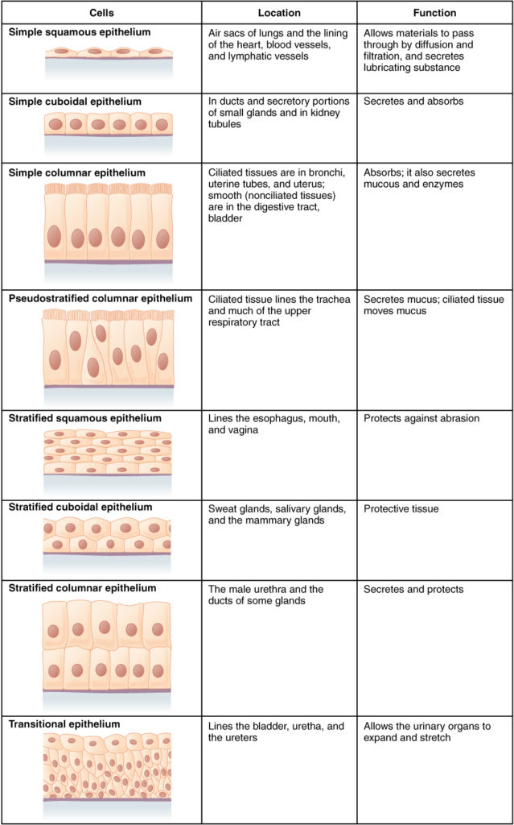
Simple squamous epithelium (frog skin)
This slide shows a thin section of frog skin. The outermost portion of this skin is composed of a single layer of irregularly-shaped, flat (squamous) cells, which gives the tissue its name. Note: You are viewing this tissue section from the top! This slide shows a thin section of frog skin. The outermost portion of this skin is composed of a single layer of irregularly-shaped, flat (squamous) cells, which gives the tissue its name.

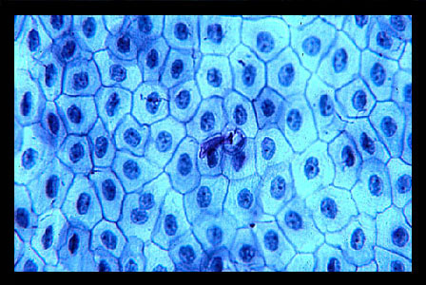
Figure 1: Simple squamous epithelium (frog skin)

Simple cuboidal epithelium (cross section of the kidney)
The red and blue arrows point to simple cuboidal epithelial tissue.
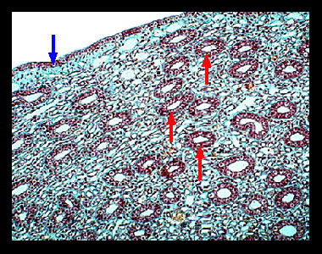
Figure 2: Simple cuboidal epithelium (cross section of the kidney)
This is a slide of a thin section taken from the mammalian kidney showing the many tubular ducts that make up much of this organ. The walls of these ducts (pointed to by the red arrows) are comprised of simple cuboidal epithelial cells, which are usually six-sided in shape but may appear square from a side view. Note also the thin wall of simple cuboidal epithelium (pointed to by the blue arrow) that forms the top edge of this section.

Simple columnar epithelium (cross section of the small intestine)
- Smooth muscle (long. layer)
- Smooth muscle (circ. layer)
- Simple columnar epithelium
- Goblet cell
- Lumen of the intestine
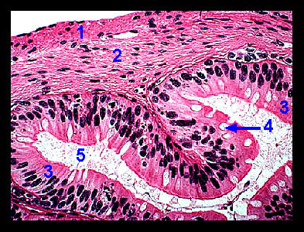
Figure 3: Simple columnar epithelium (cross section of the small intestine)
This slide is a cross section from the small intestine. Projecting into the intestinal lumen (space) are numerous finger-like projections called villi, which function to slow the passage of food and increase the surface area for the absorption of nutrients. The lining of these villi is a tissue layer called the mucosa, which is made up of simple columnar epithelial cells. Interspersed among these columnar cells are goblet cells that secrete mucus into the lumen of the intestine. During routine histological preparation, the mucus is lost, leaving a clear or lightly stained cytoplasm. Beneath a thin, outer covering of the intestine called the serosa is a thick layer of smooth muscle cells called the muscularis externa? The muscularis externa is divided into an outer longitudinal muscle layer with cells that run along the axis of the intestine and an inner, circular muscle layer whose fibers encircle the organ. Peristaltic contraction of these two muscle layers keeps food moving through the digestive tract.

Practical # 5
Study of the prepared slides of connective tissue
Definition of connective tissue
Connective tissue is one of the four basic types of animal tissue, along with epithelial tissue, muscle tissue, and nervous tissue. It develops from the mesoderm. Connective tissue is found in between other tissues everywhere in the body, including the nervous system. In the central nervous system, the three outer membranes (the meninges) that envelop the brain and spinal cord are composed of connective tissue. All connective tissue consists of three main components: fibers (elastic and collagenous fibers), ground substance and cells. Not all authorities include blood or lymph as connective tissue because they lack the fiber component. All are immersed in the body water. The cells of connective tissue include fibroblasts, adipocytes, macrophages, mast cells and leucocytes.
Materials required:
Prepared slides, light microscope, tissue papers to clean slides and microscope lens
Procedure:
Focus all the available prepared slides of cells to examine different organelles present in them and record your observation in practical notebook.
Types of Connective tissue:
Connective tissue is divided into four main categories:
- Connective proper
- Cartilage
- Bone
- Blood
Connective tissue proper has two subclasses, loose and dense.
Loose connective tissue
Loose connective tissue is divided into
1) Areolar
2) Adipose
3) Reticular
Areolar Connective Tissue
These tissues are widely distributed and serve as a universal packing material between other tissues. The functions of areolar connective tissue include the support and binding of other tissues.
It also helps in defending against infection. When a body region is inflamed, the areolar tissue in the area soaks up the excess fluid as a sponge and the affected area swells and becomes puffy, a condition called edema.
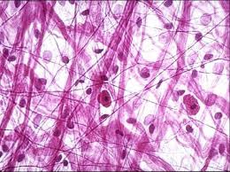
Figure 1: Areolar Connective Tissue

Adipose Tissue or Body Fat
This is loose connective tissue composed of adipocytes. It is technically composed of roughly only 80% fat. Its main role is to store energy in the form of lipids, although it also cushions and insulates the body.
The two types of adipose tissue are white adipose tissue (WAT) and brown adipose tissue (BAT). Adipose tissue is found in specific locations, referred to as adipose depots.
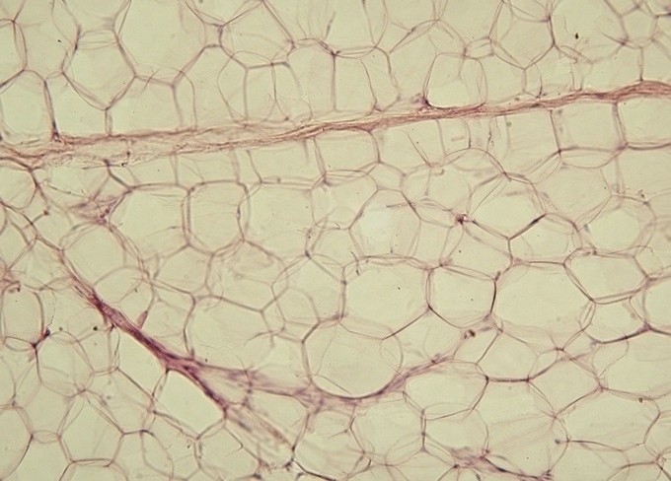
Figure 2: Adipose tissue: Yellow adipose tissue in paraffin section with lipids washed out.
Reticular Connective Tissue
This tissue resembles areolar connective tissue, but the only fibers in its matrix are the reticular fibers, which form a delicate network. The reticular tissue is limited to certain sites in the body, such as internal frameworks that can support lymph nodes, spleen, and bone marrow.
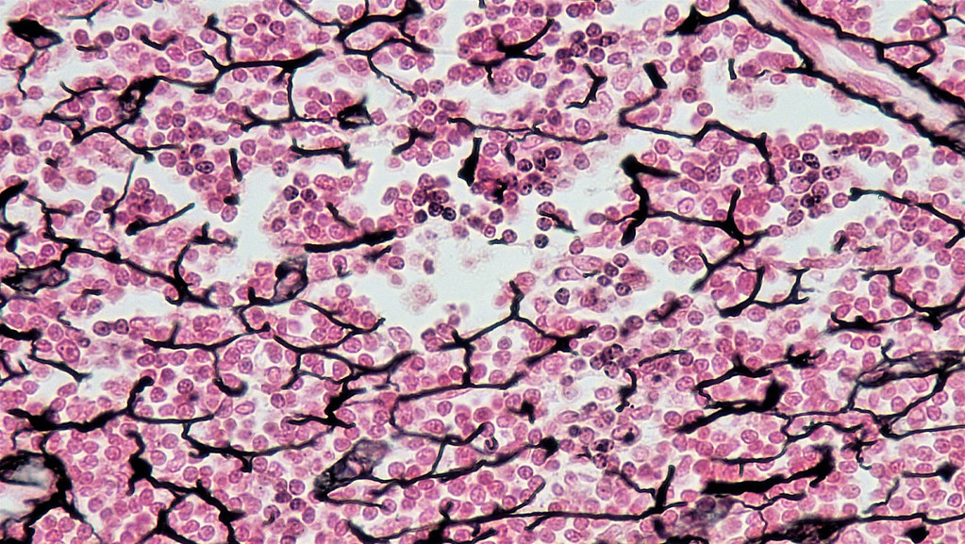
Figure 3: Reticular Connective Tissue
Dense connective tissue
Dense connective tissue is divided into
1) Dense regular
2) Dense irregular
3) Elastic
Dense Regular Connective Tissue
This consists of closely packed bundles of collagen fibers running in the same direction. These collagen fibers are slightly wavy and can stretch a little bit.
With the tensile strength of collagen, this tissue forms tendons, aponeurosis and ligaments. This tissue forms the fascia, which is a fibrous membrane that wraps around the muscles, blood vessels, and nerves.
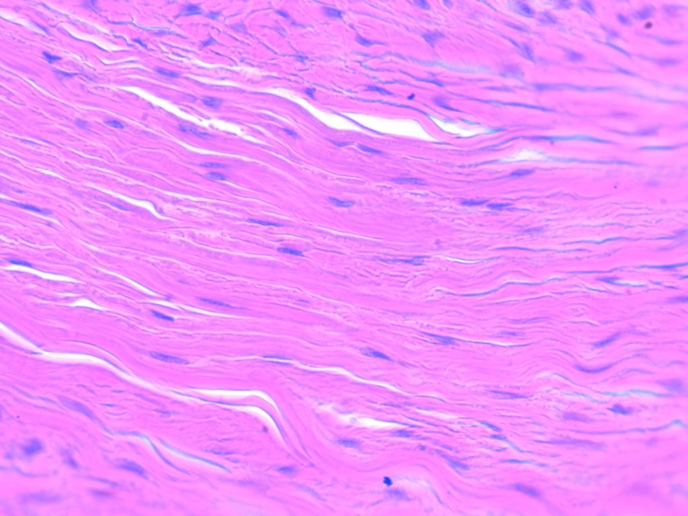
Figure 4: Dense Regular Connective Tissue
Dense Irregular Tissue
This has the same structural elements as dense regular tissue, but the bundles of collagen fibers are much thicker and arranged irregularly. This tissue is found in areas where tension is exerted from many different directions. It is part of the skin dermis area and in the joint capsules of the limbs.
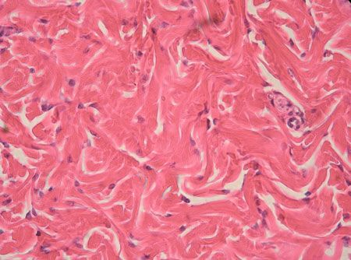
Figure 5: Dense Irregular Tissue
Elastic Connective Tissue
The main fibers that form this tissue are elastic in nature. These fibers allow the tissues to recoil after stretching. This is especially seen in the arterial blood vessels and walls of the bronchial tubes.
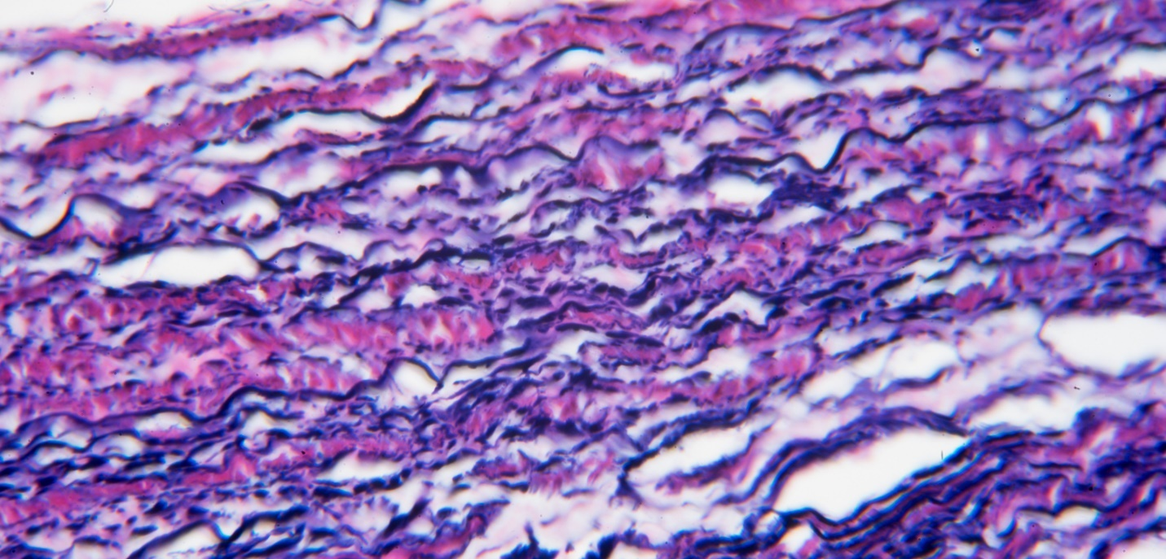
Figure 6: Elastic Connective Tissue
Cartilage
This is a flexible connective tissue found in many areas in the bodies of humans and other animals, including the joints between bones, the rib cage, the ear, the nose, the elbow, the knee, the ankle, the bronchial tubes, and the intervertebral discs.
Cartilage is composed of specialized cells called chondroblasts and, unlike other connective tissues; cartilage does not contain blood vessels.
Cartilage is classified in three types:
1) Elastic cartilage
2) Hyaline cartilage
3) Fibrocartilage, which differ in the relative amounts of these three main components.
Elastic Cartilage
This is similar to hyaline cartilage but is more elastic in nature. Its function is to maintain the shape of the structure while allowing flexibility. It is found in the external ear (known as an auricle) and in the epiglottis.
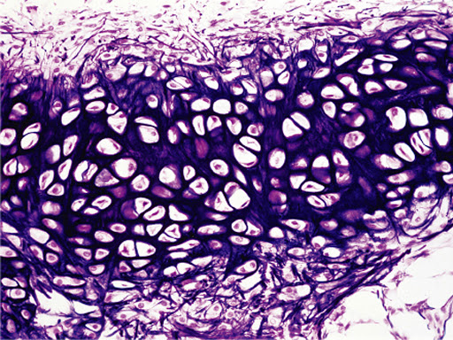
Figure 7: Elastic Cartilage
Hyaline Cartilage
This is the most abundant of all cartilage in the body. Its matrix appears transparent or glassy when viewed under a microscope. It provides strong support while providing pads for shock absorption. It is a major part of the embryonic skeleton, the costal cartilages of the ribs, and the cartilage of the nose, trachea, and larynx.
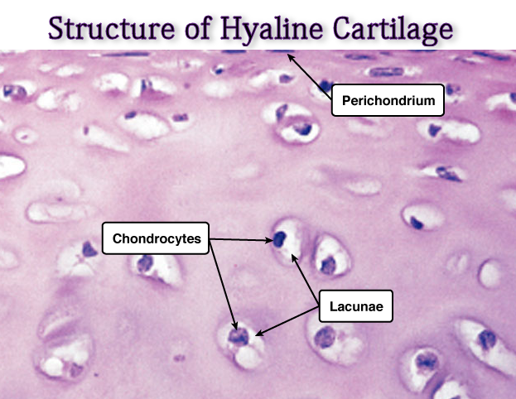
Figure 8: Hyaline Cartilage
Fibrocartilage
This is a blend of hyaline cartilage and dense regular connective tissue. Because it is compressible and resists tension well, fibrocartilage is found where strong support and the ability to withstand heavy pressure are required. It is found in the intervertebral discs of the bony vertebrae and knee meniscus.
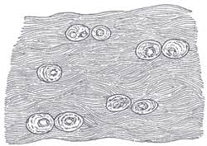
Figure 9: Fibrocartilage
Bone
Bone tissue is also called the osseous tissue. The osseous tissue is relatively hard and lightweight in nature. It is mostly formed of calcium phosphate in the chemical arrangement termed calcium hydroxyapatite, which gives bones their rigidity. It has relatively high compressive strength, but poor tensile strength, and very low shear stress strength.
The hard-outer layer of bones is composed of compact bone tissue, so-called due to its minimal gaps and spaces. Its porosity is 5–30%. This tissue gives bones their smooth, white, and solid appearance, and accounts for 80% of the total bone mass of an adult skeleton.
Filling the interior of the bone is the trabecular bone tissue (an open cell porous network also called cancellous or spongy bone), which is composed of a network of rod and plate-like elements that make the overall organ lighter and allow room for blood vessels and marrow.
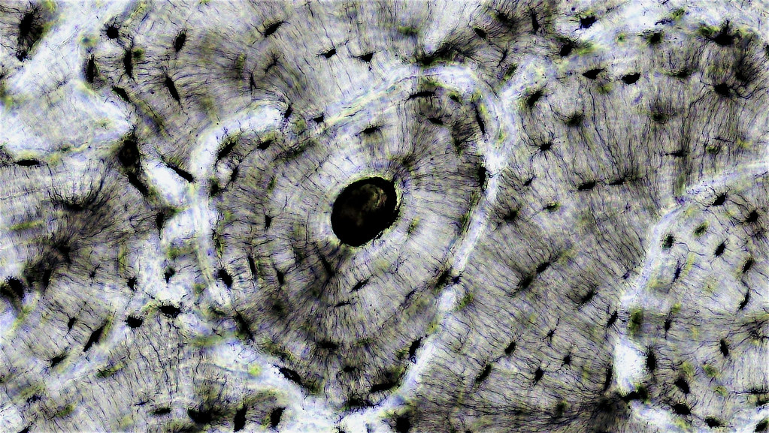
Figure 10: Bone tissue
Blood
This is considered a specialized form of connective tissue. Blood is a bodily fluid in animals that delivers necessary substances, such as nutrients and oxygen, to the cells and transports metabolic waste products away from those same cells.
It is an atypical connective tissue since it does not bind, connect, or network with any body cells. It is made up of blood cells and is surrounded by nonliving fluid called plasma.
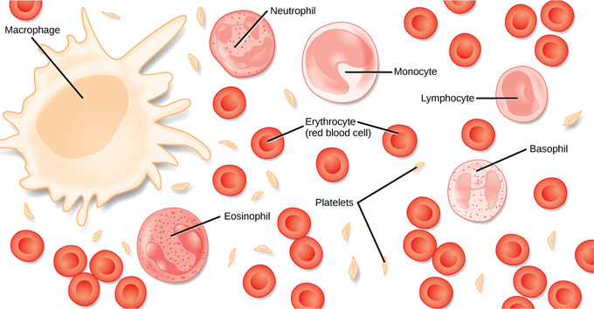
Figure 11: Blood

Practical # 6
Nervous tissue
Nervous tissue, also called neural tissue, is the main tissue component of the nervous system. The nervous system regulates and controls bodily functions and activity and consists of two parts: the central nervous system (CNS) comprising the brain and spinal cord, and the peripheral nervous system (PNS) is comprising the branching peripheral nerves. It is composed of neurons, also known as nerve cells, which receive and transmit impulses, and neuroglia, also known as glial cells or glia, which assist the propagation of the nerve impulse as well as provide nutrients to the neurons.
Functions of the nervous system are sensory input integration, control of muscles and glands, homeostasis, and mental activity.
Materials required:
Prepared slides, microscope
Procedure:
Student will be made to focus the available prepared slides in microscope.
Types of Nervous tissue
Nervous tissue is composed of two types of cells, neurons and glial cells. Neurons are responsible for the computation and communication that the nervous system provides. They are electrically active and release chemical signals to communicate between each other and with target cells. Glial cells, or glia or neuroglia, are much smaller than neurons and play a supporting role for nervous tissue. Glial cells maintain the extracellular environment around neurons, improve signal conduction in neurons and protect them from pathogens. Ongoing research also suggests that glial cell number matches neuron number and that they even can send signals themselves.
Neuron Anatomy
Neurons are nucleated cells with specialized structural properties. Some neurons have a single long extension (axon) that reaches great distances, others are very small, star shaped cells without obvious axons Figure 1.
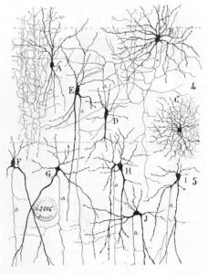
Figure 1– The variety of neuron shapes found in the brain: Note, letters B and C show star shaped neurons without axons. Compare with F, G that shows distinct neurons.
Types of Neurons
There are trillions of neurons in the nervous system and cell shape can vary widely. Three common shapes of neurons are shown in Figure 2.
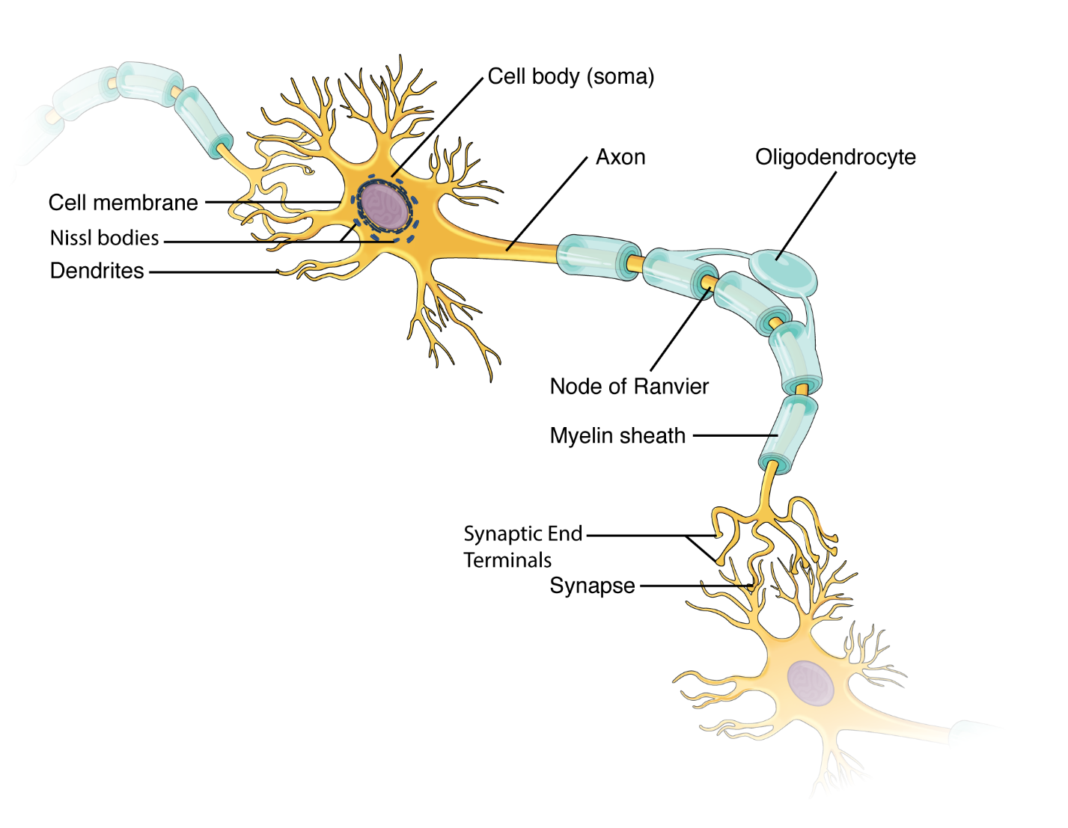
Figure 2– Parts of a Multipolar Neuron: The major parts of the neuron are labeled on a multipolar neuron from the CNS.
- Multipolar neurons have multiple processes emerging from their cell bodies (hence their name, multipolar). They have dendrites attached to their cell bodies and often, one long axon. Motor neurons are multipolar neurons, as are most of the CNS.
- Bipolar cells have two processes, which extend from each end of the cell body, opposite to each other. One is the axon and one the dendrite. Bipolar cells are not very common. They are found mainly in the olfactory epithelium (where smell stimuli are sensed), and as part of the retina in the eye.
- Unipolar cells have one long axon emerging from the cell body, but the cell body is located at neither end of that axon. At one end of the axon are dendrites, and at the other end, the axon forms synaptic connections with a target cell. Unipolar cells are exclusively sensory neurons and have their dendrites in the periphery where they detect stimuli.
Glial Cells
There are six types of glial cells. Four of them are found in the CNS and two are found in the PNS.
Glial Cells of the CNS
One cell providing support to neurons of the CNS is the astrocyte, so named because it appears to be star-shaped under the microscope (astro- = “star”). Astrocytes have many processes extending from their main cell body (not axons or dendrites like neurons, just cell extensions). Those processes extend to interact with neurons, blood vessels, or the connective tissue covering the CNS (Figure. 3). Generally, they are supporting cells for the neurons in the central nervous system. Some ways in which they support neurons in the central nervous system are by maintaining the concentration of chemicals in the extracellular space, removing excess signaling molecules, reacting to tissue damage, and contributing to the blood-brain barrier (BBB). The blood-brain barrier is a physiological barrier that keeps many substances that circulate in the blood from getting into the central nervous system, restricting what can cross from circulating blood into the CNS.
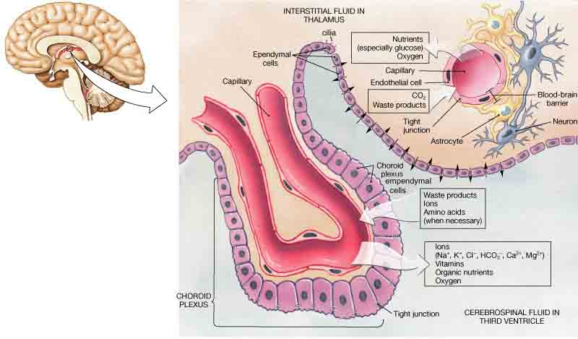
Figure 3– Glial Cells of the CNS: The CNS has astrocytes, oligodendrocytes, microglia, and ependymal cells that support the neurons of the CNS in several ways.
Practical # 7
Muscle tissue (Skeletal, Smooth and Cardiac)
Materials required:
Prepared slides, microscope
Procedure:
Student will be made to focus the available prepared slides in microscope.
Muscle Tissue Definition
Muscle tissue is a specialized tissue found in animals which functions by contracting, thereby applying forces to different parts of the body. Muscle tissue consists of fibers of muscle cells connected together in sheets and fibers. Together these sheets and fibers and known as muscles, and control the movements of an organisms as well as many other contractile functions. There are three different types of muscle found in animals, depending on their use. While these muscles differ slightly, they function in a similar way.
Function of Muscle Tissue
Muscle tissue functions as a single unit, and is often connected to the same nerve bundles. A nerve impulse traveling from the brain or another outside signal tells the muscle to contract. The nerve impulse is transferred almost instantaneously to all the nerve cells in the muscle tissue, and the entire muscle contracts.
At the cellular level, each muscle cell has a complex of proteins containing actin and myosin. These proteins slide past one another when the signal to contract is received. The filaments are connected to the ends of the cells, and as they slide past one another, the cell contracts in length. A single cell can contract up to 70% in length, which shortens the entire muscle when contraction happens. Muscle tissue can be used to move bones, compress chambers, or squeeze various organs. These different types of muscle tissue are discussed below.
Types of Muscle Tissue
Skeletal Muscle Tissue
Skeletal muscle tissue is a type of striated muscle, meaning clear bands can be seen in it under a microscope. This can be seen in image (a) below. These tiny light and dark bands are sarcomeres, highly organized bundles of actin, myosin, and associated proteins. These organized bundles allow striated muscle to contract quickly and release quickly. Muscle tissue is attached to the bones through tendons, which are highly elastic portions of connective tissue. Many muscles may seem to control a single appendage, but in reality, each one only controls one small aspect of movement. Skeletal muscle tissue can be controlled voluntarily, by the somatic nervous system. The other types of muscle are controlled mainly by the involuntary or autonomous nervous system.
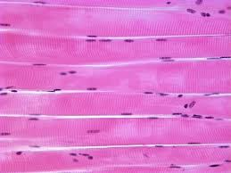
Figure 5: Skeletal Muscle Tissue
Cardiac Muscle Tissue
While the striations in skeletal muscle tissue are even and parallel, complex and branching striations are seen in cardiac muscle tissue. Cardiac muscle can be seen in image (c) below. While the striations are hard to see in this image, the branching nature of the cells is easy to pick out. The branching is caused by the connection of cardiac muscle cells to one another. The cells are connected via intercalated discs. These junctures help cardiac muscle to contract as one and provide a rapid and coordinated contraction to move blood.
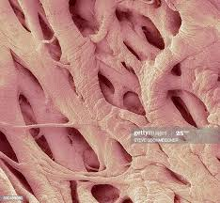
Figure 4: Cardiac Muscle Tissue
Smooth Muscle Tissue
Unlike cardiac and skeletal muscle tissue, smooth muscle tissue has no striations. The fibers of myosin and actin in smooth muscle fiber are not nearly as organized as in the other types of muscle tissue. In smooth muscle, the contractions are not quick and rapid but rather smooth and continuous. Smooth muscle is found surrounding many organs, blood vessels, and other vessels used for transporting fluids. The smooth muscle can contract to apply a force on organ. This can be used to move blood or food throughout their respective systems.
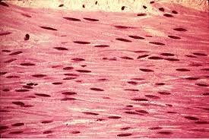
Figure 5: Smooth Muscle Tissue
Practical # 8
Plasmolysis in blood by preparation of blood smears
What is Plasmolysis?
Plasmolysis is defined as the process of contraction or shrinkage of the protoplasm of a plant cell and is caused due to the loss of water in the cell. Plasmolysis is an example of the results of osmosis and rarely occurs in nature.
The word Plasmolysis was generally derived from a Latin and Greek word plasma – The mould and lusis meaning loosening.
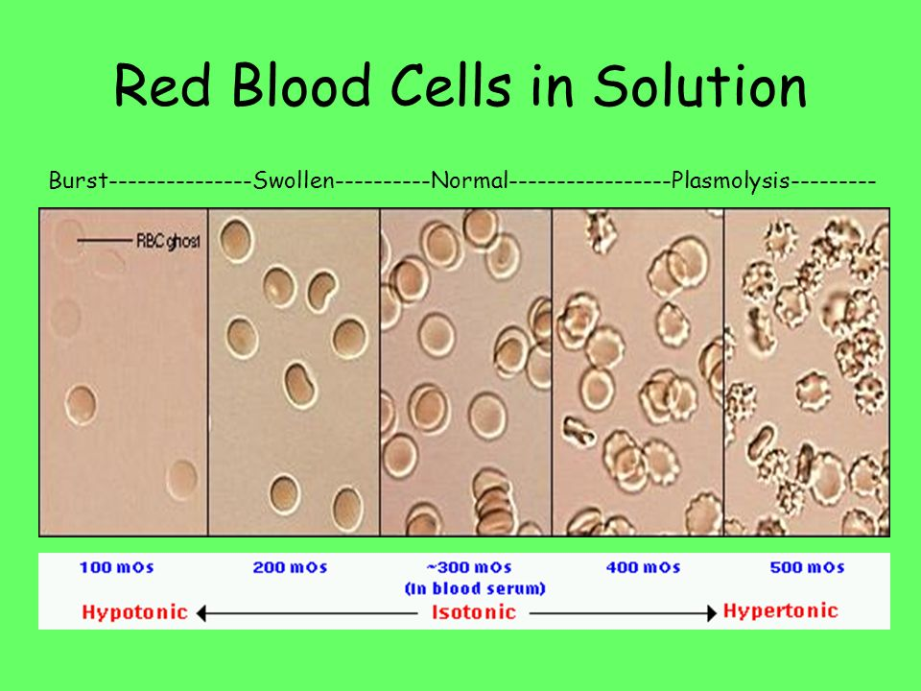
Figure 1: Plasmolysis
Preparation of Blood Smear:
1. Label pre-cleaned slides (preferably frosted-end) with patient’s name (or other identifier), date and time of collection.
2. Wear gloves.
3. Clean slides with 70 to 90% alcohol and allow drying. Do not touch the surface of the slide where the blood smear will be made.
4. Select the finger to puncture, usually the middle or ring finger. In infants, puncture the heel.
5. Clean the area to be punctured with 70% alcohol; allow drying.
6. Puncture the ball of the finger, or in infants puncture the heel.
7. Wipe away the first drop of blood with clean gauze.
8. Touch the next drop of blood with a clean slide. Repeat with several slides (at least two thick and two thin smears should be made). If blood does not well up, gently squeeze the finger.
Making thick and thin blood smears
1. Whenever possible, use separate slides for thick and thin smears.
2. Bring a clean spreader slide, held at a 45° angle, toward the drop of blood on the specimen slide.
3. Wait until the blood spreads along the entire width of the spreader slide.
4. While holding the spreader slide at the same angle, push it forward rapidly and smoothly.
5. Thick film: Using the corner of a clean slide spread the drop of blood in a circle the size of a dime (diameter 1-2 cm). Do not make the smear too thick or it will fall off the slide. (You should be able to read newsprint through it.)
6. Wait until the thin and thick films are completely dry before staining. Fix the thin film with methanol (100% or absolute) and let it dry completely before staining. The thick film should not be fixed.
7. If both thin and thick films need to be made on the same slide, fix only the thin film with methanol. The thick film should not be fixed.
Stages of Plasmolysis
The complete process of Plasmolysis take place in three different stages:
- Incipient plasmolysis: It is the initial stage of the plasmolysis, during which, water starts flowing out of the cell; initially, the cell shrinks in volume and cell wall become detectable.
- Evident plasmolysis: It is the next stage of the plasmolysis, during which, the cell wall has reached its limit of contraction and cytoplasm gets detached from the cell wall attaining the spherical shape.
- Final plasmolysis: It is the third and the final stage of the plasmolysis, during which the cytoplasm will be completely free from the cell wall and remains in the center of the cell.
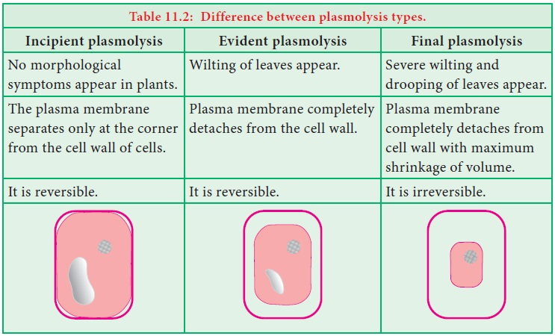
Types of Plasmolysis
There are two different types of plasmolysis and this classification is mainly based on the final structure of the cytoplasm.
- Concave Plasmolysis
During the concave plasmolysis, both the cell membrane and protoplasm shrink away and begins to detach from the cell wall, which is caused due to the loss of water. Concave plasmolysis is a reversible process and it can be revised by placing the cell in a hypotonic solution, which helps calls to regain the water back into the cell.
- Convex plasmolysis
During the convex plasmolysis, both the cell membrane and protoplasm lose so much water that they completely get detach from the cell wall. Later, the cell wall collapses and results in the destruction of the cell. Similar to concave plasmolysis, convex plasmolysis cannot be reversed, and this happens when a plant wilts and dies from lack of water. This type of plasmolysis is more complicated compared to convex plasmolysis.
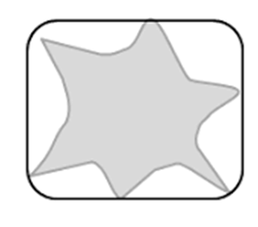
Figure 2: Plasmolysis

Practical # 9
Deplasmolysis in blood by preparation of blood smears
When the plasmolyzed cell is placed in a hypotonic solution, (the solution in which solute concentration is less than the cell sap), the water travels into the cell, due to the higher concentration of water outside the cell. Then the cell swells and becomes turgid. This is known as deplasmolysis.
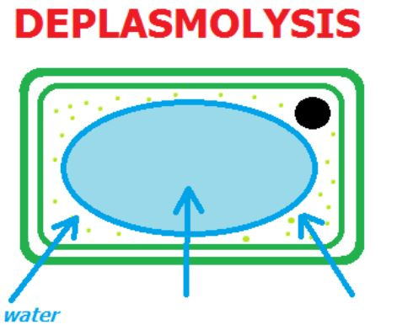
Figure 1: Deplasmolysis
Preparation of Blood Smear:
1. Label pre-cleaned slides (preferably frosted-end) with patient’s name (or other identifier), date and time of collection.
2. Wear gloves.
3. Clean slides with 70 to 90% alcohol and allow to dry. Do not touch the surface of the slide where the blood smear will be made.
4. Select the finger to puncture, usually the middle or ring finger. In infants, puncture the heel.
5. Clean the area to be punctured with 70% alcohol; allow drying.
6. Puncture the ball of the finger, or in infants puncture the heel.
7. Wipe away the first drop of blood with clean gauze.
8. Touch the next drop of blood with a clean slide. Repeat with several slides (at least two thick and two thin smears should be made). If blood does not well up, gently squeeze the finger.
Making thick and thin blood smears
1. Whenever possible, use separate slides for thick and thin smears.
2. Bring a clean spreader slide, held at a 45° angle, toward the drop of blood on the specimen slide.
3. Wait until the blood spreads along the entire width of the spreader slide.
4. While holding the spreader slide at the same angle, push it forward rapidly and smoothly.
5. Thick film: Using the corner of a clean slide spread the drop of blood in a circle the size of a dime (diameter 1-2 cm). Do not make the smear too thick or it will fall off the slide. (You should be able to read newsprint through it.)
6. Wait until the thin and thick films are completely dry before staining. Fix the thin film with methanol (100% or absolute) and let it dry completely before staining. The thick film should not be fixed.
7. If both thin and thick films need to be made on the same slide, fix only the thin film with methanol. The thick film should not be fixed.
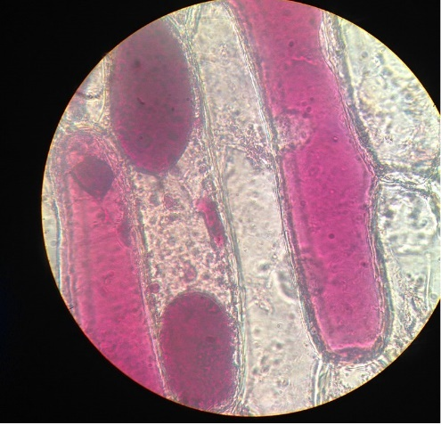
Figure 2: Microscopic view of deplasmolysis in blood

Practical # 10
Protein digestion by Pepsin
Pepsin
Pepsin is the powerful enzyme in gastric juice that digests proteins such as those in meat, eggs, seeds, or dairy products. Pepsin is the mature active form of the zymogen (inactive protein) pepsinogen. Pepsin is a stomach enzyme that serves to digest proteins found in ingested food. Gastric chief cells secrete pepsin as an inactive zymogen called pepsinogen. Parietal cells within the stomach lining secrete hydrochloric acid that lowers the pH of the stomach. A low pH (1.5 to 2) activates pepsin.
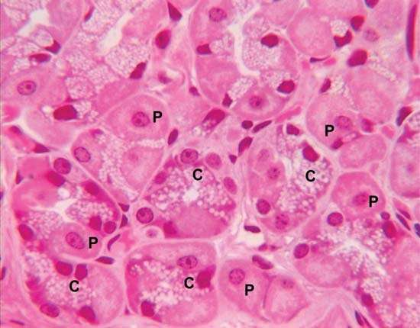
Figure: 1 Chief cells in the stomach (Chief cells (C) in the stomach synthesize and secrete pepsinogen, which mixes with hydrochloric acid secreted by parietal cells (P). The reaction of pepsinogen with hydrochloric acid produces pepsin.)
Protein Digestion
It's good to keep in mind that protein digestion is not as simple as eating an egg and magically getting amino acids. A large protein molecule breaks down via a few intermediate steps, in the stomach and in the small intestine, before it becomes the tiny amino acids. So, let's take a look at how proteins are broken down by your digestive system.
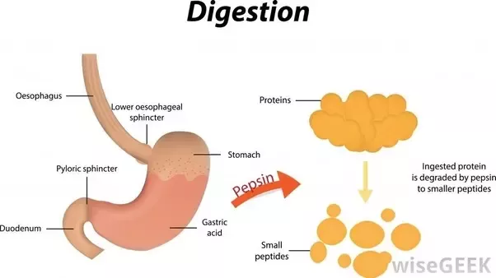
Figure 2: Protein Digestion by pepsin
Protein digestion begins in the stomach with the action of an enzyme that we previously learned about called pepsin. Pepsin is the active protein-digesting enzyme of the stomach. When pepsin acts on the protein molecule, it breaks the bonds that hold the protein molecule together, called peptide bonds. So, you can think of pepsin as the enzyme that breaks peptide bonds. When these bonds are broken, you get chains of amino acids linked together called polypeptides. Since we know that the prefix 'poly' means 'many,' we can easily recall that a polypeptide is many amino acid units joined together. These polypeptides then move into your small intestine, where digestion will be completed by additional enzymes.
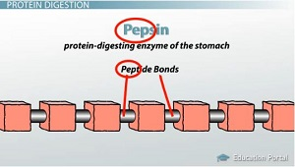
Figure: 3 Pepsin is an enzyme in the stomach that breaks down the peptide bonds in protein.
Materials
- Egg whites, fresh Metric ruler
- Hydrochloric acid solution, 0.1 M, 8 mL Paper towels
- Pepsin solution, 1%, 10 mL Pipets, Beral-type, thin-stem
- Toluene, several drops Scalpel
- Beaker, 400-mL, or pot for water bath Scissors
- Forceps Test tubes, 13 × 100 mm, 4
- Hot plate Water bath
- Markers
Preparation
1. Separate the egg whites from the yolks prior to the laboratory work. One egg is required for every 3–4 lab teams.
2. Prepare the hydrochloric acid and pepsin solutions.

Safety Precautions
This activity requires the use of hazardous components and/or has the potential for hazardous reactions. Use care in working with hot surfaces and substances. Hydrochloric acid can damage the eyes, skin, and clothing. If spilled, rinse thoroughly with excess water. Toluene is poisonous and flammable and should be dispensed by the instructor. Wear chemical splash goggles, chemical-resistant gloves, and a chemical-resistant apron. Please review current Safety Data Sheets for additional safety, handling, and disposal information.

Procedure
- Secure two Beral-type pipets. Carefully draw egg white into the pipets, one at a time, until each pipet stem is filled with liquid egg white. Use scissors to cut off the end of each pipet while the stem is still submerged in the egg white (Figure Use paper towels to prevent liquid egg white from getting on the table tops, etc.
- Immerse one of the pipets into a boiling water bath until the egg white is cooked, i.e., it hardens and turns white.
- Repeat this procedure for the other pipet. Be careful with the boiling water and allow the pipet to cool before handling the stem.
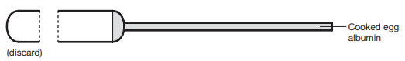
Figure 4: Beral pipet with cooked egg albumin
- Use a sharp scalpel or razor blade to cut each filled pipet stem into two 3-cm pieces. The egg white should be flush at both ends of the cut stem.
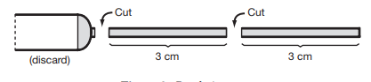
Figure 5: Beral pipet cut
- Place each of your egg white stems into four separate test tubes.
- Pour 5 mL of water into the first test tube and label it “W.” Pour 5 mL of a 1% pepsin solution into the second test tube and label it “P.” Pour 5 mL of a 0.1 M hydrochloric acid solution into the third test tube and label it “A.” Pour equal amounts of pepsin solution and hydrochloric acid solution into the fourth test tube to equal 5 mL total volume and label it
- “PA”. Be sure the solutions completely cover the stems containing the egg white.
- Every ten minutes for the rest of this lab period, use a forceps to remove the stems, one at a time, from each test tube and observe them. Place each stem on a separate paper towel and be sure to return the stem to the proper test tube after your observations are complete. Rinse the forceps between each tube. In some of the stems, you may notice that the egg white is no longer flush with the ends of the tubing. With the metric ruler, measure the clear area between one end of the stem and the solid egg white. This distance is a measure of how much of the egg white protein has been digested. (When digested, protein becomes a clear liquid that flows out of the tube). For each reading, measure the same end of the stems. Record your measurements in Data Table 1 on the Protein Digestion Worksheet.
- Allow digestion to continue overnight. Store the test tubes in a water bath or warm place as directed by your instructor.
- Bacteria are likely to start to grow on the egg white; therefore, something must be added to retard bacterial growth during the rest of the experiment. Your instructor will add a drop of toluene to each of your test tubes. Caution: Toluene is flammable and poisonous. Handle safely.
- After 24 hours, remove each stem carefully and measure the amount of digestion in each. Record your results in Data Table
- After 48 hours, record another set of measurements.
- Plot your measurements of amount of digestion versus time on graph paper. Label each treatment separately (W, P, A, and PA). Answer the questions on the Protein Digestion Worksheet.
Protein Digestion Worksheet
Data Table
Tube | Distance Between Egg White and End of Stem (mm)
Tube | 0 min. _ | ___ min. | ___ min. | ___ min. | ___ min. | 24 hours | 48 hours
W (Water)
P (Pepsin)
A (Acid)
PA (Pepsin/Acid

Practical # 11
Ecological notes one animal (Chimpanzees) of a model habitat (Forest).
COMMON NAME: Chimpanzees
SCIENTIFIC NAME: Pan troglodytes
TYPE: Mammals
DIET: Omnivore
GROUP NAME: Community
AVERAGE LIFE SPAN IN THE WILD: 45 years
SIZE: Four to 5.5 feet
WEIGHT: 70 to 130 pounds
What is the chimpanzee?
Chimpanzees are great apes found across central and West Africa. Along with bonobos, they are our closest living relatives, sharing 98.7 percent of our genetic blueprint. Humans and chimps are also thought to share a common ancestor who lived some seven to 13 million years ago.
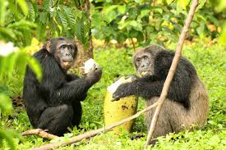
Figure 1: chimpanzee
Behavior
Chimpanzees are highly social. They live in communities of several dozen animals, led by an alpha male and his coalition of male allies. Research has shown that male and female chimps have individual personalities, with females being more trusting and timid. Grooming is an important part of their social life, helping chimpanzees bond as they remove ticks and dirt from one another’s bodies.
Although they normally walk on all fours (knuckle-walking), chimpanzees can stand and walk upright. Chimpanzees have long arms, hands, and fingers, which help them, climb trees and swing from branch to branch.
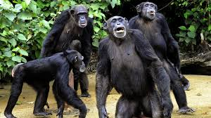
Figure 2: Behavior
Tool use
This intelligent animal is one of the few species we know to use tools—which primatologist Jane Goodall famously observed in 1960. Her groundbreaking discovery led archeologist Louis Leakey to declare, “Now we must redefine ‘tool,’ redefine ‘man,’ or accept chimpanzees as humans.”
As Goodall observed, chimpanzees shape and use sticks to retrieve insects from their nests or dig grubs out of logs. They use stones to smash open tasty nuts and employ leaves as sponges to soak up drinking water. And chimpanzees can even be taught to use some basic human sign language.
Habitat and diet
Chimpanzees have the widest range of any great ape. Though many populations live in tropical rainforests, they can also be found in woodlands and grasslands spanning from central to western Africa. They usually sleep in trees—typically the sturdy Ugandan ironwood tree, which offers the most firm and stable place to sleep—and build themselves nests of leaves.
Chimps also do most of their eating in trees. Though they generally prefer fruits and plants, they have a varied diet that also includes insects, eggs, nuts, and hundreds of other things. They relish meat, and have been known to kill and eat monkeys, small antelope, and even tortoises, which they slam against trees to break open their shells.
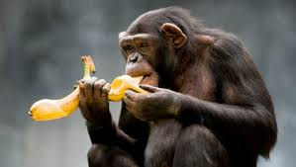
Figure 3: Chimpanzee eating banana
Reproduction
Female chimpanzees can give birth at any time of year, typically to a single infant that clings to its mother's fur and later rides on her back until the time of weaning between ages three and five. Females reach reproductive age at 13, while males are not considered adults until they are 15.
Threats to survival
The International Union for the Conservation of Nature has declared the chimpanzee an endangered species—and the booming human population is primarily to blame. As humans move into more and more of the chimp’s geographic range, they clear away the ape’s forest habitat to make way for agriculture. Logging, mining, oil extraction, and new road and highway projects threaten to further degrade and fragment the chimp’s habitat.
In western Uganda, habitat loss has fueled conflict between humans and our closest relatives. Deforestation not only makes it harder for chimps to find a place to live, but it also strains their wild food supply. In desperation, many resort to foraging from the homes of humans nearby. Though they mostly steal fruit and other food within reach, the apes occasionally snatch and kill small children. Humans kill chimps in retaliation and to protect their families from future attacks.
Bushmeat hunters target chimps because they provide more meat than smaller mammals, sometimes collecting their offspring as pets for themselves or to sell into the illegal pet trade. And chimpanzees are susceptible to infectious diseases, too. Since the 1980s, the Ebola virus has killed them in significant numbers.
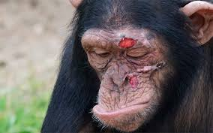
Figure 4: Chimpanzee after defending territory
Conservation
Chimpanzees are protected by national and international laws, including the U.S. Endangered Species Act. Some of their habitat is protected as sanctuaries or reserves, too. Conservation organizations are working to expand these protected areas, while also pushing for an end to the illegal killing and taking of the animals.
Key to securing the future of the chimpanzee, though, is improving its relationship with humans. Many organizations work with communities to build awareness about the threats chimpanzees face, develop action plans to preserve their habitats, and help community members develop alternative livelihoods that do not jeopardize the animal’s habitat.
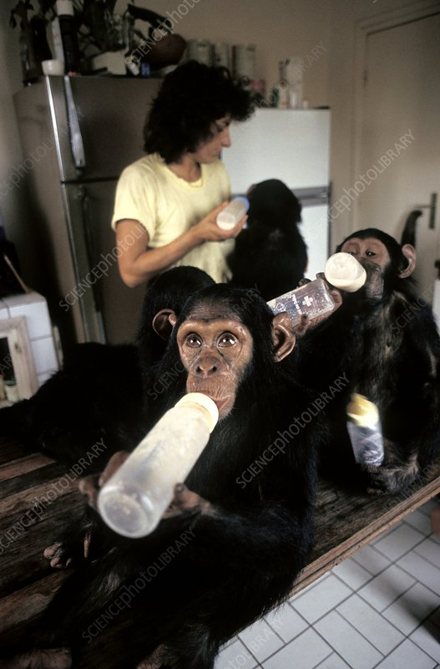
Figure 5: Chimpanzee Conservation center
Practical # 12
Ecological notes one animal (Kangaroos) of a model habitat (Island).
Scientific Name: Macropus
Common Names: Kangaroo, Roo
Order: Diprotodontia
Basic Animal Group: Mammals
Distinguishing Characteristics: Large hind legs long feet, large tail and pouch (females)
Size: 3 - 7 feet in height
Weight: 50 - 200 pounds
Life Span: 8 - 23 years
Diet: Herbivore
Habitat: Forests, plains, savannas, and woodlands in Australia and Tasmania
Population: Approximately 40 - 50 million
Conservation Status: Least concern
Fun Fact: Like camels, kangaroos may go for periods of time without drinking water.
Kangaroo, any of six large species of Australian marsupials noted for hopping and bouncing on their hind legs. The term kangaroo, most specifically used, refers to the eastern gray kangaroo, the western gray kangaroo, and the red kangaroo, as well as to the antilopine kangaroo and two species of wallaroo (see below). Less specifically, kangaroo refers to all 14 species in the genus Macropus, some of which are called wallabies. In its broadest usage, kangaroo refers to any member of the family Macropodidae, which comprises about 65 species, including tree kangaroos and the quokka; rat kangaroos are classified into “sister” familes, Potoroidae and Hypsiprymnodontidae. The Macropodidae are found in Australia (including Tasmania and other offshore islands, such as Kangaroo Island), New Guinea, and the islands east to the Bismarck Archipelago. Several species have been introduced into New Zealand.
Common features
With the exception of tree kangaroos (genus Dendrolagus), all members of the kangaroo family (Macropodidae) rely on long, powerful hind legs and feet for hopping and leaping, their predominant forms of locomotion. Their long tails, thickened at the base, are used for balancing. This feature is most obvious in the large kangaroos, which use the tail as a third leg when standing still. Each long, narrow hind foot has four toes, the large fourth toe bearing most of the animal’s weight. The second and third toes are united and merely vestigial, a condition known as syndactyly. The short forelimbs, having five unequal digits, are used almost like human arms, but all digits of the “hand” are sharp-clawed, and the thumb is not opposable. The head is relatively small; the ears are (in most macropodids) large and rounded; and the mouth is small, with prominent lips. The pelage is generally soft and woolly; in many species it is grizzled, and stripes may be present on the head, back, or upper limbs. All macropodids are herbivorous and have a chambered stomach that is functionally similar to those of such ruminants as cattle and sheep. Ecologically, they occupy the niche filled elsewhere by grazing and browsing animals (larger species tend to be grazers, smaller ones browsers). Several smaller species have become extinct or are gravely endangered, probably because of predation by introduced foxes. The wedge-tailed eagle (Aquila audax) is one of the macropodids’ few natural predators.
Habitat and Distribution
Kangaroos live in Australia, Tasmania, and surrounding islands in a variety of habitats such as forests, woodlands, plains, and savannas. Depending on the species, kangaroos occupy different niches in the ecosystem.
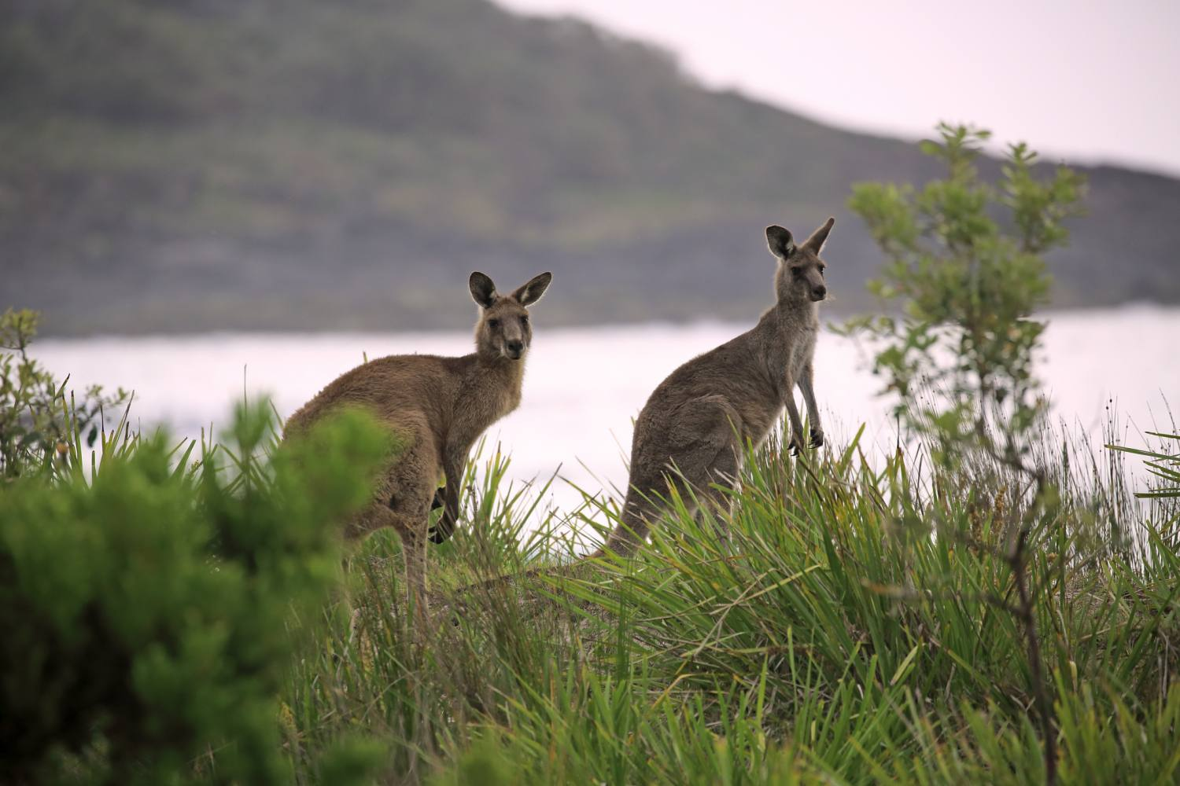
Figure 1: Habitat of Kangroo
Reproduction and development
In all species, the marsupium (or pouch) is well developed, opens forward, and contains four teats. The young kangaroo (“joey”) is born at a very immature stage, when it is only about 2 cm (1 inch) long and weighs less than a gram (0.04 ounce). Immediately after birth, it uses its already clawed and well-developed forelimbs to crawl up the mother’s body and enter the pouch. The joey attaches its mouth to teeth, which then enlarges and holds the young animal in place. After continuous attachment for several weeks, the joey becomes more active and gradually spends more and more time outside the pouch, which it leaves completely at 7 to 10 months of age.
Female macropodids of many species enter into heat within a few days after giving birth, mating and conception thus occurring while the previous offspring is still in the pouch. After only one week’s development, the microscopic embryo enters a dormant state, called diapause that lasts until the first joey begins to leave the pouch or until conditions are otherwise favorable. The development of the second embryo then resumes and proceeds to birth after a gestation period of about 30 days. Therefore, the teats are for a while feeding young of very different developmental stages, during which time different teats produce two different compositions of milk. This is thought to be an adaptation for recovering population numbers quickly after a drought, when breeding ceases and the diapause state is prolonged. In the gray kangaroos, which live in wooded country with a more predictable environment, this system does not exist; there is no diapause, and the pouch is occupied by one young at a time.
Dentition
The larger species of kangaroos have complex, high-crowned teeth. The four permanent molars on each side of both jaws erupt in sequence from front to back and move forward in the jaw, eventually being pushed out at the front. Thus, an old kangaroo may have only the last two molars in place, the first two (and the premolar) were having long since been shed. The molars possess cross-cutting ridges, so that tough grass is sheared between opposing teeth. The molars of smaller macropodids are much simpler. The large kangaroos continue growing throughout life, especially the males (most markedly in the red kangaroo), whereas the smaller macropodids do not.
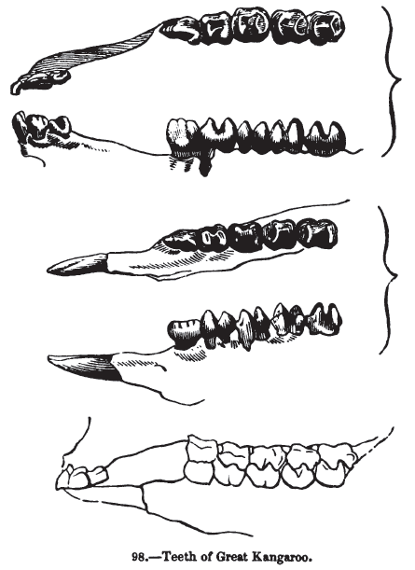
Figure 2: Teeth of Great Kangaroo
Behavior
Kangaroos have an irregular activity rhythm; generally, they are active at night and during periods of low light, but it is quite possible to find them out in the open in bright sunlight. During hot weather, kangaroos lick their forearms, which promote heat loss by evaporation. Kangaroos travel and feed in groups (“mobs”) whose composition shifts, but they are not truly social, since the individual members move at liberty. One member can send the mob into a wild rout—individuals bounding off in all directions—by thumping its tail on the ground in a signal of alarm. In any mob, the largest male (“old man,” or “boomer”) dominates during the mating season. Males fight for access to females by biting, kicking, and boxing. These methods are also used by kangaroos to defend themselves against predators. With their agile arms, they can spar vigorously. They can also use the forepaws to grip an enemy while rocking back on their tails and then swiftly dropping their huge clawed hind feet. This tactic has been known to disembowel dogs and humans. When chased by hunters with dogs, kangaroos often make for water, where they have been known to turn and press down on the dog with their forepaws in an attempt to drown it.
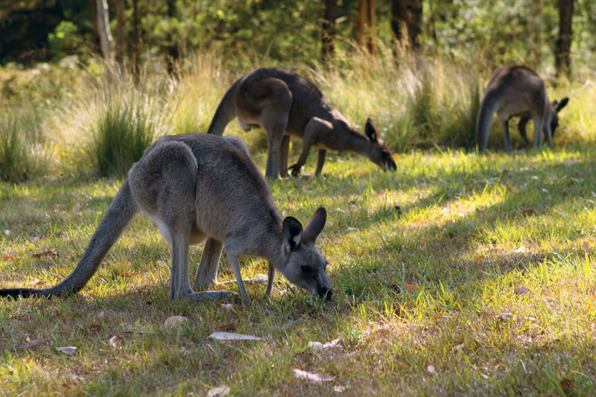
Figure 3: Forester or eastern gray kangaroo (Macropus giganteus)
Overall, however, kangaroos have benefited from human presence. Aboriginal hunters regularly burned large areas of forest and grassland, opening up the country for large grazers at the expense of smaller browsers. European pastoralists then cleared further tracts of dense vegetation and provided permanent sources of water in arid and seasonal habitats. By the late 20th century, the number of kangaroos in Australia had increased to the point that a major industry came to be based on them. The three most abundant species, the eastern gray, western gray, and red kangaroos, together number in the tens of millions. Every year millions of these three species, and thousands of medium-size species such as whiptail wallabies (M. parryi), are harvested. Their skins are made into rugs and clothing, and their meat, formerly used as pet food, is now increasingly sold for human consumption. The kangaroo’s status as a national symbol makes harvests politically controversial. Kangaroos are also killed because they compete for forage with livestock. Other threats are feral dogs introduced to the Australian mainland.
Descriptions of Selected Species
The eastern gray kangaroo (Macropus giganteus) is found mostly in the open forests of eastern Australia and Tasmania. It is replaced by the western gray kangaroo (M. fuliginosus) along the southern coast into the southwest of Western Australia. The ranges of the two species overlap in western New South Wales and western Victoria. Both species, but especially the eastern, prefer lightly forested country, at least for refuge, but they go out into the open plains for grazing. Western grays are stockier and more brownish; there are different subspecies in the southwest, on Kangaroo Island, and on the Nullarbor Plain. Each of these may in fact be distinct species. Eastern grays may grow up to 2.1 meters (6.9 feet) in length, and some males can weigh as much as 90 kg (about 200 pounds). In contrast, western grays are shorter, with an average length of 1.6 meters (5.25 feet), and some males can weigh up to 54 kg (about 120 pounds).
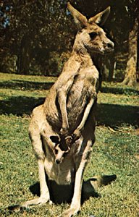
Figure 4: Western gray kangaroo (Macropus fuliginosus)
Gray kangaroos can clear more than 9 meters (30 feet) at a bound—13.5 meters has been recorded—and can attain a speed of 55 km/hr. (kilometers per hour; 34 mph [miles per hour]). Research has revealed a remarkable advantage to bipedal hopping. Although at low speeds kangaroos expend more energy than do quadrupeds of the same size, the red kangaroo (M. Rufus) actually uses less energy at 10.1 km/hr. than at 6.5 and less still at higher speeds. This seems to be related to the storage of elastic strain energy in its tendons and muscles. In addition, the heavy tail swings downward as the legs are moving backward, which helps to counteract the natural pitching motion of the head and upper body—another energy-saving device.
The red kangaroo is found throughout Australia’s interior grasslands and is the largest and most powerful macropodid. An old male may attain a head and body length of 1.5 meters (5 feet), have a tail 1 meter (3.3 feet) long, and stand 2 meters (6.6 feet) tall. Males can weigh 90 kg (200 pounds), but females are much smaller. Usually males are red and females are blue-gray, but there are generally a few red females and gray males in most populations. In regions such as western New South Wales, where red kangaroos and both species of grays can be found in the same general area, the red kangaroo is easily distinguished by its longer arms, convex face, whitish under parts, prominent black and white whisker marks on the muzzle, and bald patch on the nose (rhinarium). Gray kangaroos are more uniformly colored, and the nose is haired.
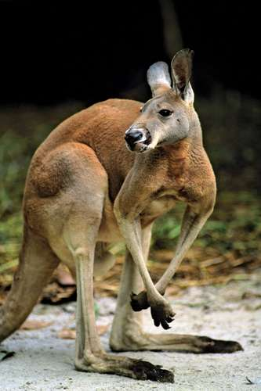
Figure 5: Red kangaroo (Macropus rufus) the home range of this species spans much of Australia's interior, and it is the largest member of the family Macropodidae.
The antilopine kangaroo (M. antilopinus), sometimes called the antilopine wallaroo, replaces the red kangaroo in the plains of the tropical north, from Cape York Peninsula in the east to the Kimberleys in the west. It is smaller than the red kangaroo and more wallaroo-like in general appearance, although it is more slenderly built. Males can grow to be 1.8 meters (5.9 feet) long and can weigh as much as 70 kg (154 pounds), whereas females are smaller, often weighing less than 30 kg (66 pounds). The antilopine kangaroo is an extremely fast hopper. The wallaroo, or euro (M. Robustus), is a smaller, stockier animal quite closely related to the red kangaroo and like it in that the sexes are colored differently (black in the male, reddish in the female), though this is not universal. The rhinarium is larger than in the red kangaroo. This wallaroo lives in hilly country throughout mainland Australia except in the far north, where it is replaced by the smaller Woodward’s, or black, wallaroo (M. bernardus).

Practical # 13
Ecological notes one animal (Polar Bear) of a model habitat (Polar Region).
COMMON NAME: Polar Bear
SCIENTIFIC NAME: Ursus maritimus
TYPE: Mammals
DIET: Carnivore
AVERAGE LIFE SPAN IN THE WILD: 25 to 30 years
SIZE: Head and body: 7.25 to 8 feet; tail: 3 to 5 inches
WEIGHT: 900 to 1,600 pounds
Distribution
Polar bears are found throughout the circumpolar Arctic. Polar bears, or their tracks, have been reported almost as far north as the pole; however, scientists believe few bears frequent areas north of 88° north latitude on the ice over the continental shelf. The northern Arctic Ocean has little food for them. The polar bears' southern range is limited by the amount of sea ice that forms in the winter. Polar bears prefer to travel on sea ice and must have ice from which to hunt seals. In the south, polar bears are annual visitors to southern Labrador, Newfoundland, and Norway. They can reach the Gulf of St. Lawrence and Bering Sea during years with heavy pack ice. The most southerly dwelling polar bears live year-round in James Bay, Canada. The majority of polar bears are found near land masses around the edge of the polar basin, where the continental shelf makes conditions ideal for hunting.
Scientists believe there are 15 relatively discrete polar bear subpopulations (four others are recognized for management purposes). A subpopulation is a group of polar bears that interbreed with a range independent of but overlapping that of other polar bears. For example, two subpopulations live in the James/Hudson Bay area, one in western Hudson Bay, and the other in northwestern Ontario and James Bay.
Habitat
Polar bears inhabit arctic sea ice, water, islands, and continental coastlines. Polar bears prefer sea ice habitat with leads and polynyas, next to continental coastlines or islands. Leads are water channels or cracks through ice which may remain open (ice free) for only a few minutes to several months, depending upon weather conditions and water currents. Polar bears hunt seals in the leads, using sea ice as a platform. Polynyas are areas of water, surrounded by ice, that remain open throughout the year due to winds, upwellings, and tidal currents. Polynyas are important breathing and feeding areas for wintering or migrating marine mammals and birds. Some polar bears follow the southern edge of the ice pack year-round, making extensive migrations as the ice recedes and advances. Some polar bears spend part of the year on land. They have been found as far inland as 402 km (250 mi.). Polar bears in warmer climates may become stranded on land. In summer, sea ice melts along the coastlines, and pack ice (floating sea ice, or floes, not connected to land) moves so far north, that polar bears can't reach it, even though they are excellent swimmers. Most pregnant females spend the autumn and winter on land in maternity dens. Air temperatures in the Arctic average -34°C (-29°F) in winter and 0°C (32°F) in summer. The coldest area in winter is northeastern Siberia, where the temperature has been recorded as low as -69°C (-92°F). The warmest areas in summer are inland regions of Siberia, Alaska, and Canada where temperatures can reach as high as 32°C (90°F). The ocean temperatures in the Arctic are about -1.5°C (29°F) in summer. In winter the ocean temperatures can drop to -2°C (28°F), at which point seawater begins to freeze.
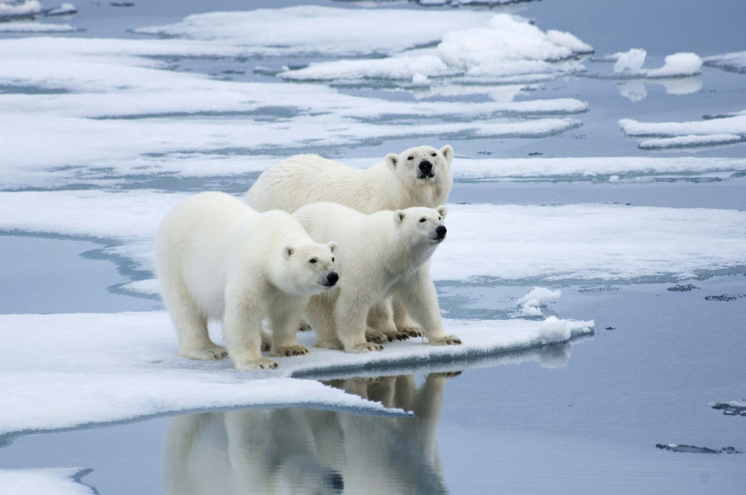
Figure 1: Polar-bears-ice-floe-Norway
Arctic Adaptations
Polar bears live in one of the planet's coldest environments and depend on a thick coat of insulated fur, which covers a warming layer of fat. Fur even grows on the bottom of their paws, which protects against cold surfaces and provides a good grip on ice. The bear's stark white coat provides camouflage in surrounding snow and ice. But under their fur, polar bears have black skin—the better to soak in the sun's warming rays.
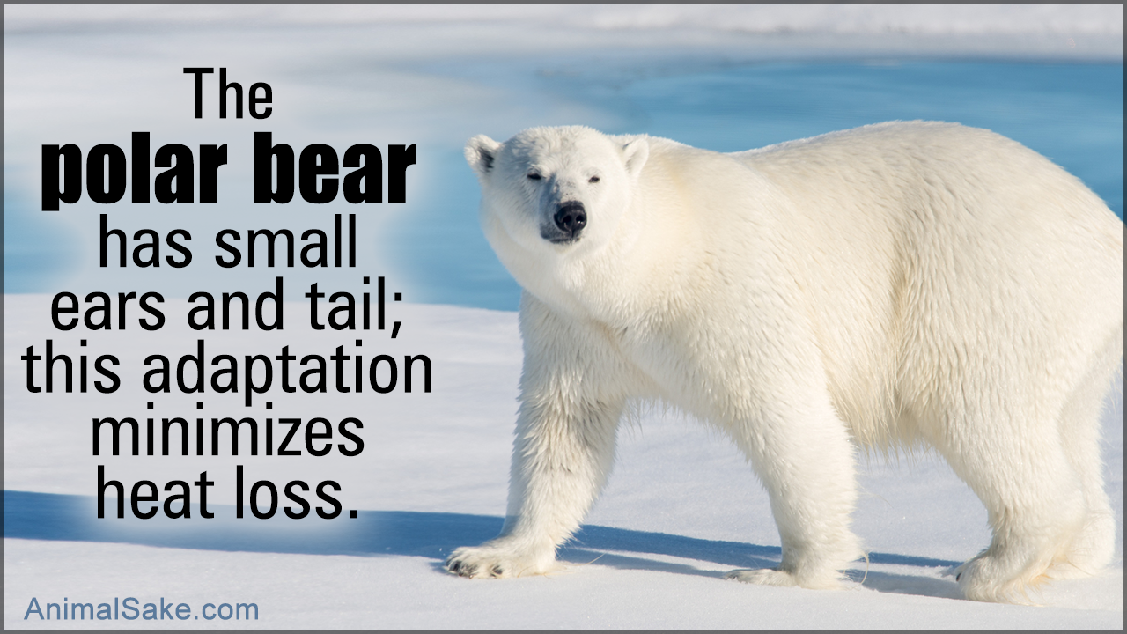
Figure 2: Polar Bear Arctic Adaptations
Breeding and Behavior
Females den by digging into deep snow drifts, which provide protection and insulation from the Arctic elements. They give birth in winter, usually to twins. Young cubs live with their mothers for some 28 months to learn the survival skills of the far north. Females aggressively protect their young, but receive no help from their solitary male mates. In fact, male polar bears may even kill young of their species.
Polar bears are attractive and appealing, but they are powerful predators that do not typically fear humans, which can make them dangerous. Near human settlements, they often acquire a taste for garbage, bringing bears and humans into perilous proximity.
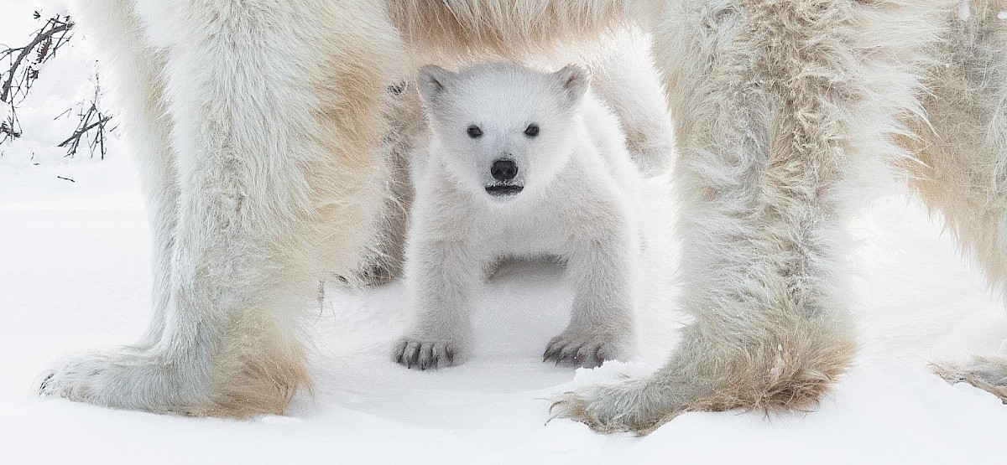
Figure 3: Breeding and Behavior of Polar Bear
Foraging and Eating
Polar bears travel throughout the year within loose, individual home ranges. Home range size varies among individuals depending upon access to food, mates, and dens. Home ranges tend to be larger than for other mammal species because sea ice habitat changes from season to season and year to year. A small home range may be 50,000 to 60,000 sq. km (19,305-23,166 sq. mi.). Small home ranges can be found near Canadian Arctic islands. A large home range may be in excess of 350,000 sq. km (135,135 sq. mi.). Large home ranges can be found in the Bering or Chukchi seas.
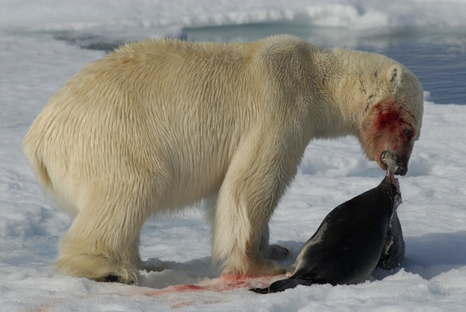
Figure 4: Diet of polar Bear
Polar bears don't mark their home ranges. Polar bears undergo seasonal migrations, following the movements of the ice pack. Some bears prefer to remain at the edge of the ice pack year-round, making extensive migrations as the ice advances and recedes. On the southern shores of Hudson Bay, some bears move onto land for summer and disperse over ice for the winter. Polar bears are capable of traveling 30 km (19 mi.) or more per day for several days. One polar bear was tracked traveling 80 km (50 mi.) in 24 hours. Another polar bear traveled 1,119 km (695 mi.) in one year.
Population
The world polar bear population is estimated at 20,000 to 25,000 individuals. The ratio of males to females is approximately one to one. 1972 estimates of polar bears ranged from 5,000 to 20,000 bears. The current, worldwide population of polar bears may or may not have increased from this estimate. More recently, some polar bear populations are declining due to loss of vital sea ice habitat.
Practical # 14
Ecological notes one animal (Hawk Eagle) of a model habitat (Mountains).
Kingdom: Animalia
Phylum: Chordata
Class: Aves
Order: Accipitriformes
Family: Accipitridae
Genus: Nisaetus
Species: Nisaetus nipalensis
The mountain hawk-eagle (Nisaetus nipalensis) or Hodgson's hawk-eagle is a large bird of prey native to Asia. The latter name is in reference to the naturalist, Brian Houghton Hodgson, who described the species after collecting one himself in the Himalayas. A less widely recognized common English name is the feather-toed eagle. Like all eagles, it is in the family Accipitridae. Its feathered tarsus marks this species as a member of the subfamily Aquilinae. It is a confirmed breeding species in the northern part of the Indian subcontinent, from India, Nepal (hence the epithet nipalensis) through Bangladesh to Thailand, Taiwan and Japan, although its distribution could be wider still as breeding species. Like other Asian hawk-eagles, this species was earlier treated under the genera of Spizaetus but genetic studies have shown this group to be paraphyletic, resulting in the Old World members being placed in Nisaetus (Hodgson, 1836) and separated from the New World species. As is typical of hawk-eagles, the mountain hawk-eagle is a forest dwelling opportunistic predator that readily varies its prey selection between birds, mammals and reptiles along with other vertebrates. Although classified currently as a least-concern species due its persistence over a rather wide distribution, this species is often quite rare and scarce and seems to be decreasing, especially in response to large-scale habitat degradation and deforestation.
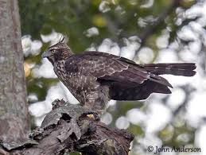
Figure 1: Hawk Eagle
Distribution and habitat
Both the northern and southern limits of this widely found raptor are surprisingly poorly known to this day, with historic records suggesting that the species may take up residence hundreds of kilometers north of its accepted range and year-around reports of this species from areas formerly considered only to be visited by wintering migrant or vagrant hawk-eagles. The mountain hawk-eagle is distributed through the Himalayas, extending from northeastern Pakistan through north India in at least the states of central Jammu and Kashmir, Himachal Pradesh and Uttarakhand, continuing into Nepal, Bhutan to northern Assam thence southward into the north and east Burmese highlands, west and peninsular Thailand, also the northern parts of Laos and probably Vietnam. Their range continues eastward into southeastern China where they may be found in Yunnan, Guangxi and Guangdong Province northward in the east to the lower reaches of the Yangtze in Anhui and Zhejiang. Their range also extends to Hainan, an offshore island of China. Mountain hawk-eagles are additionally found in the island nations of Taiwan and Japan, with the highest concentration known on northern islands such Hokkaido but they may be found on nearly all the islands of Japan. The mountain hawk-eagle has been recorded under the status of "rare breeder" in areas much farther north than is conventionally accepted as part of their range, such as far eastern Mongolia and the landlocked, extreme southern part of the Russian Far East such as in Primorsky Krai. To this date, the IUCN has not updated the range maps for mountain hawk-eagles to reflect the species’ presence in these areas, although their status as continual breeders here may still need confirmation. Through much of their range, mountain hawk-eagles are typically sedentary but both adults and young hawk-eagles sometimes also disperse in descent from higher grounds in winter and it may be characterized as a partial migrant. There are several recorded cases of the species wandering in north India down into Indo-Gangetic plains. In Bhutan, fragmentary information suggests short-distance altitudinal movements are not infrequent. Relatively low volumes of migrant mountain hawk-eagles were detected in Nepal, however. With a fair amount of consistency, the hawk-eagles found in the northern part of Southeast Asia range into more lowland areas of Burma, eastern Thailand and peninsular Malaysia, they are also similar movements to lowlands in Japan with some Japanese ones moving to the Korean peninsula. In some of the areas above such as Thailand and Malaysia (mainly far northern part of country), year-around reports of mountain hawk-eagles may suggest small, isolated pockets of residency and/or breeding occurring. Mountain hawk-eagles have been recorded as a vagrant in Hong Kong and Cambodia. Broader vagrancy has been reported in the case of a mountain hawk-eagle that turned up in the island of Borneo.
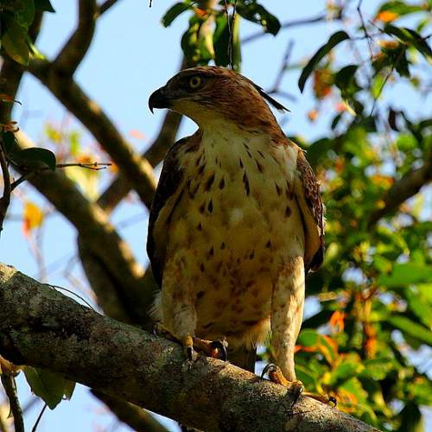
Figure 2: Indian-birds-mountain-hawk-eagle-nisaetus-nipalensis
The mountain hawk-eagle tends to reside in dense hill and montane forests at any point up to the tree line. They are mainly found in various wooded foothills. Typically, primary evergreen or mixed forests are preferred, with the presence of nearby streams a plus. However, in some areas the species can range into second growth. In non-breeding times, mountain hawk-eagles may sometimes wander through wooded plains and briefly near fairly developed villages and even cities. In Japan, they reportedly entirely avoid woods near urban areas. Elevations the species has been known to live at in the Himalayas are mostly 600 to 2800 m above sea-level. However, they've been recorded at elevations of up to 4000 m in northern Yunnan. In Japan, they usually reside somewhat lower than in their mainland haunts, typical at between 250 and 1500 m. Mostly only during winter, the species has been recorded (albeit seldomly) down to 200 m or even lower as vagrant.
Behavior and ecology
Mountain hawk-eagles are well adapted to living in forests. As is the case for all Nisaetus species, their physical form and flight style is typical of forest-dwelling raptors in general and is often found to be roughly comparable to the features of true hawks or Accipiters in particular larger species such as the occasionally sympatric Northern goshawk (Accipiter gentilis). Like most other forest raptors, mountain hawk-eagles (and Nisaetus species in general) have a long tail, short broad wings and relatively long but powerful legs, all of which impart greater maneuverability and quicker strike times in denser wooded hunting grounds than other raptorial body plans. The common name hawk-eagle is apparently in reference to their similar adaptations to true hawks. Contrary to the suggestion that, based on their physiology, especially their longer wings and tarsus but shorter talon and bill length, when physically compared to the Legge's hawk-eagle implies that the mountain hawk-eagle is morphologically adapted to hunting birds more so than mammals, dietary studies indicate that the mountain hawk-eagle is not necessarily a specialized bird predator but rather a generalist and opportunist like many predators. In fact the small handful of dietary studies of the species show that the mountain hawk-eagle somewhat prefer small mammals as prey but readily takes both birds and reptiles given the opportunity. Typically, the mountain hawk-eagle tends to still-hunt from a concealed perch in foliage, stooping down to take prey. Most prey is taken on the ground. Mountain hawk-eagles have also been observed catching passerines on the wing by giving chase from an ambush or when the prey is flushed by flying low at the canopy level. They will also readily take arboreal mammals and birds from a perch or roost if they're able to fly upon them in an ambush. While most of their prey is relatively small, well within typical prey size range for most raptorial birds, mountain hawk-eagles can take remarkably large prey. Therefore, Brown & Amadon (1986) consider the species as markedly "rapacious and powerful".
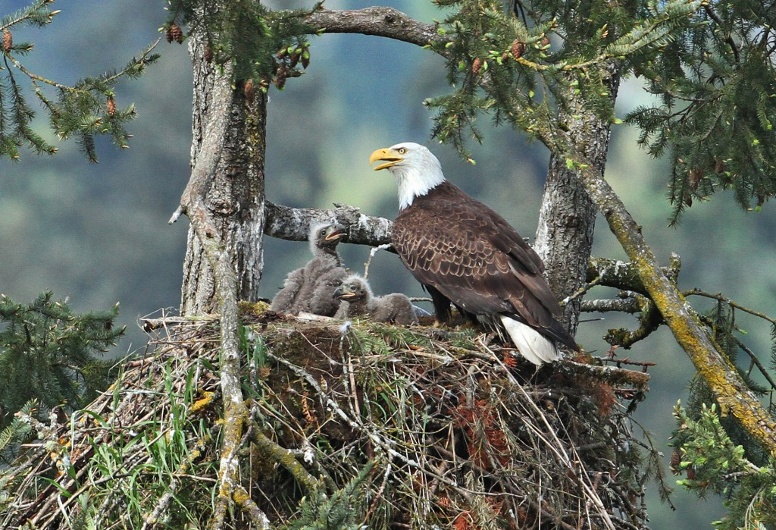
Figure 3: Habitat of Hawk Eagle
One study that reviewed 118 prey items in several nests from southern Taiwan revealed a surprising preferred prey type for mountain hawk-eagles, giant flying squirrels. The Indian giant flying squirrel (Petaurista philippensis) and the red and white giant flying squirrel (Petaurista alborufus), both weighing about 1.65 kg on average, accounted for 47.4% of the food items in Taiwan. How they capture these elusive and nocturnal rodents is not clear, but perhaps the flying squirrels’ relatively huge size makes them more conspicuous from the hawk-eagle's lofty perch. A rather smaller true squirrel, the approximately 277 g Pallas's squirrel (Callosciurus erythraeus), made up a further 19.5% of the mean diet here. In total, 78.3% of prey taken in the southern Taiwan study was mammalian. However, the fourth most often taken prey species here was the 1.1 to 1.6 kg Swinhoe's pheasant (Lophura swinhoii), constituting on average 6.7% of the prey. A study in the Hyōgo Prefecture of Japan reviewed 142 prey items of a single breeding pair. Quantitatively, most prey deliveries by this pair were rather (almost surprisingly) small in body size, whether this is typical of Japanese hawk-eagles is not clear given the lack of comprehensive study. About 17.5% of the nest prey deliveries were unidentified small birds, of an estimated mass of 17.5 g (mostly brought by the male), while 7.7% of prey deliveries were unidentified medium-sized birds, of an estimated mass of 175 g. These were followed by the merely 20 g Japanese shrew mole (Urotrichus talpoides) which constituted 7% of prey deliveries (again largely by male) . The most often delivered prey (18.2% of her 44 deliveries) by the female once she resumed hunting were larger class Elaphe snakes, in excess of 100 cm length and 325 g. Overall, the estimated size of nest prey deliveries here ranged from a 5 g Japanese grass lizard (Takydromus tachydromoides) to several Japanese hares (Lepus brachyurus) weighing an estimated mean of 1.9 kg, the latter presumably constituting a majority of the prey biomass. In another study, the mean size of Japanese hares caught was apparently estimated as somewhat larger at about 2.5 kg. In Jim Corbett National Park, India, prey reportedly consisted largely of smallish or medium-sized birds (albeit probably larger than those in the above Japanese study) such as mynas, doves, parakeets, nightjars, owls and village poultry. In the Russian Far East, apparently the most important prey types were reported as Manchurian hares (Lepus mandshuricus), a close cousin and of the same size as the Japanese hare, and hazel grouse (Tetrastes bonasia), while most of the remainder of the diet consisted of a mixture of smallish mammals like (moles, hedgehogs and flying squirrels) and largish forest birds (woodpeckers, pheasants and owls). Quantitatively rare prey items that have been recorded have including amphibians and, recorded only once, fish.

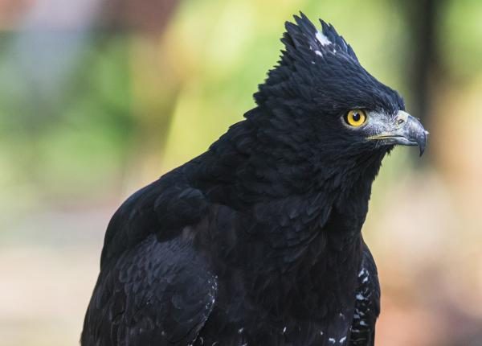
Figure 5: Black hawk eagle
While most of the prey mentioned above is of relatively modest size, the mountain hawk-eagle is not infrequently reported to attack prey of quite large sizes, including prey equal to their own size or larger. Mountain hawk-eagles have been reported to attack young ungulates but often relatively very young and small ones, probably close to a neonatal state. In Taiwan, they took the young of Formosan serow (Capricornis swinhoei) that were estimated to weigh on average less than 2 kg. Of similar size, in Japan, they took young piglets of the wild boar (Sus scrofa), averaging about 1.75 kg. Reportedly, newborn sika deer (Cervus nippon), weighing at least 4.5 kg, have been preyed upon in Japan as well. Scavenging of sika deer killed by human hunters has also been reported. Larger avian prey has been taken by mountain hawk-eagles, including adult Indian peafowl (Pavo cristatus) weighing up to an estimated 4 kg. In Echizen-Kaga Kaigan Quasi-National Park, Japan, mountain hawk-eagles have been recorded attacking exclusively relatively large water birds on several occasions namely: the 1.12 kg mallard (Anas platyrhynchos), the 1.45 kg grey heron (Ardea cinerea), the 2.53 kg greater white-fronted goose (Anser albifrons) and the 2.77 kg bean goose (Anser fabalis).
Carnivorans taken by mountain hawk-eagles can also be relatively large as well as potentially dangerous. An estimated 1.8 kg kit of a Japanese badger (Meles anakuma) was preyed upon by a female. Meanwhile, four adult Chinese ferret-badgers (Melogale moschata), weighing on average about 1.3 kg, were taken in Taiwan, while a Japanese marten (Martes melampus) of the same estimated weight was taken there by a female hawk-eagle. Sable (Martes zibellina) is also likely at threat from these birds. More impressive carnivoran prey dispatched by this species included an adult yellow-throated marten (Martes flavigula) weighing an estimated 2.75 kg, an adult red panda (Ailurus fulgens) weighing an estimated 4.5 kg and reportedly adult raccoon dogs (Nyctereutes procyonoides), which weigh an average of 6.5 kg, not to mention (in a similar size range) an occasional domestic cat (Felis silvestris catus) taken by this species. Of a similarly impressive nature in size and defensive temperament are primates, of which the mountain hawk-eagle is an occasional predator. However, a rather large portion of primate prey, such as monkeys, are taken as infants or juveniles, and most but not adults killed by them are perhaps are likely to be previously injured or sickly. Taking even infant monkeys can be provide some risk for hunting hawk-eagles due to the protective nature of mothers as well as the overall monkey troops. For example, Formosan rock macaques (Macaca cyclopis) recorded to be taken in Taiwan were infants, weighing only an estimated 500 to 700 g. An Assam macaque (Macaca assamensis) juvenile taken by a mountain hawk-eagle weighed an estimated 2 kg. Cases of possible predation have also involved rhesus macaques (Macaca mulatta) in the Indian subcontinent. The mountain hawk-eagle is also considered a potential or confirmed threat to some larger primates (though largely or entirely younger, more vulnerable members of their troops) including: the François' langur (Trachypithecus francoisi), the black snub-nosed monkey (Rhinopithecus bieti), the lar gibbon (Hylobates lar) and the eastern hoolock gibbon (Hoolock leuconedys). However, the most impressive primate kill was an adult Japanese macaque (Macaca fuscata), estimated to weigh somewhere between 8.3 and 10 kg, that was taken alive and subsequently dismantled by a large (presumed female) mountain hawk-eagle.
Interspecies predatory relationships
The mountain hawk-eagle overlaps in distribution with several other eagles, including about three species of Aquila and three species of Haliaeetus that are broadly similar in size to them as well as one slightly (in Japan) to notably (mainland) larger Aquila, the golden eagle (Aquila chrysaetos), and two much larger Haliaeetus species. However, the mountain hawk-eagle is the largest eagle in its range to live mostly within the confines of forest habitats, thus habitat differences against other larger eagles would normally provide ample partitioning and lessen competition. Some writers have claimed in life history and dietary habits that the mountain hawk-eagle warrants comparison to the top African forest eagle, crowned eagle (Stephanoaetus coronatus). While the mountain hawk-eagle and crowned eagle do show similarities in their territorial display and primary hunting techniques, beyond being larger with proportionately larger feet and talons, the latter is significantly more prone to taking primates and to taking extremely large prey (both relative to itself and compared to other eagles). In some of its range, the mountain hawk-eagle overlaps and shares forests with three other Nisaetus species and, often, with various species of Accipiter, the latter of which lead a comparable lifestyle but are far smaller and more agile. However, usually these other forest raptors can co-exist with the larger raptor by focusing on more generalized and usually smaller prey, largely birds but also reptiles and amphibians, than the mammals seemingly preferred by the mountain hawk-eagle. Larger owls sometimes also occur in the mountain hawk-eagles range and are a potential source of competition (excluding the fish owls, which are more restricted by diet) despite the temporal partitioning implied in their nocturnal habits. Although the Eurasian eagle-owl (Bubo bubo) usually prefers more open and rockier environments, the little-known spot-bellied eagle owl (Bubo nipalensis) has a very similar central distribution and habitat preferences as the mountain hawk-eagle, and despite being slightly smaller, it goes after exceptionally large prey with perhaps even more aplomb.
In Japan, mountain hawk-eagles are regarded as the fourth largest eagle after the Steller's sea eagle (Haliaeetus pelagicus), the white-tailed eagle (Haliaeetus albicilla) and the golden eagle. Despite the golden eagle race in Japan (A. c. japonica) being much smaller than other races and the larger size of Japanese mountain hawk-eagles, the golden eagle here still has a slight size advantage (about 7% larger) and much larger wings which gives them an advantage at fighting and hunting in open air but less maneuverability. While the golden is more a bird of open and rocky environments, the two species prey selection overlaps here (probably more so than mainland populations of the two species), with both taking Japanese hares supplemented by pheasants whenever possible, and this can cause a level of direct competition despite their different preferred habitats. In at least one case, a golden eagle attacked and may have preyed upon a mountain hawk-eagle. On the other hand, a mountain hawk-eagle may have preyed on the young of the black eagle (Ictinaetus malaiensis) in Taiwan. The mountain hawk-eagle is an occasional predator of a wide diversity of owls. Owl prey known to have been taken has included Asian barred owlet (Glaucidium cuculoides), jungle owlet (Glaucidium radiatum), brown boobook (Ninox scutulata), barn owl (Tyto alba), Ural owl (Strix uralensis) and, once reportedly, even an Eurasian eagle-owl, a species of similar size and power to the hawk-eagle itself.
Breeding
The mountain hawk-eagle maintains their home range with a rather spectacular aerial display. Display activities tend to peak within the time period prior to breeding. Their aerial display includes conspicuous and often noisy high circling, both single and mutual, and undulating sky dance of steep dives and climbs with bubbling call uttered at each peak. Like many raptors, the display is likely largely to proclaim ownership to conspecifics but also probably has some function in reinforcing existing pair bonds. The breeding season falls between February and June in the Himalayas while in Japan, it falls from April to July. The laying dates largely correspond to early spring or colder dry season in most of their range. The pair builds a large stick nest that can be up to 1.8 m across and 90 to 120 cm deep (after repeated uses). Pairs may have as many as 2 to 3 nests but usually have just one. The male in the pair is said to bring most of the nest materials while female is said to primarily construct the nest. As in many accipitrids, active nests are more often than not lined with greenery, usually either green leaves or conifer sprigs. Nests are usually located at 12 to 30 m above the ground in a large forest tree, though also sometimes more isolated trees such as Deodar cedars (Cedrus deodara), which were popular in the Himalayas region. In the Indian subcontinent, sal trees (Shorea robusta) and red cedar (Toona ciliata) are favored at slightly lower elevation forests whereas deodar cedars, pines, holly, saj (Terminalia elliptica) and moru oak (Quercus floribunda) are often favored at higher elevations. Many nests are often near a steep-edged ravine, or alternately near a natural tree line, freshwater wetland or other environment that provides ample view of the surrounding area. Clutch size is usually 1 or 2 but up to 3 eggs in a clutch have been reported in Japan. It is claimed that one egg is considered the norm in most of the range, as is invariably the case in the related changeable hawk-eagle. The egg is pale clay-colored or reddish in color with varied freckling of darker red or pure white, and often with blotches and spots of red at the large end. A sample of egg sizes in the nominate subspecies showed a range of 65 to 72.7 mm in height, with an average of 69.9 mm while the range in diameter was 51.2 to 57.4 mm, with an average of 53.8 mm. One egg from N. n. orientalis measured 69 x 56 mm. It has been claimed that only the female will incubate and will be fed by the male. Hatching dates seem to peak around mid-March in the Indian subcontinent. At one nest, an immature male was recorded as the mate of an adult female. In another case, when the female in a pair died during nesting, the following year the male paired with another female and used a nest 200 m from the original nest.
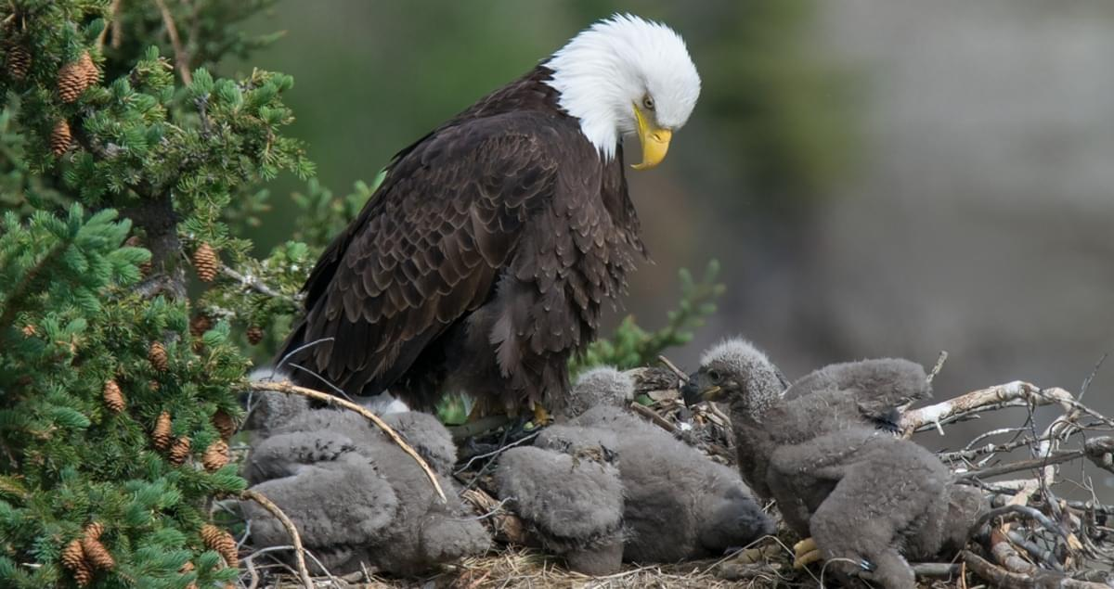
Figure 6: Breeding of Hawk Eagle
As is typical of accipitrids, the female takes by far the primary role in brooding and protecting the young, while the male makes prey deliveries into the nest or the nearby nest vicinity. Reportedly, the female is very aggressive if nest is disturbed but male is less so or not at all. The aggressiveness of the female may rival that of the often co-occurring spot-bellied eagle-owl and even outrival the defensive attacks on human by the more powerful African crowned eagle. Cousins such as the Legge's and changeable hawk-eagle do not typically display any aggression or, if so, are very mild in protective behavior towards humans while nesting. Apparently, wood-cutters in particular often attract the ire of the female mountain hawk-eagle. Unlike attacks on humans by crowned eagles and northern goshawks, the attack of mountain hawk-eagle is unlikely to be deterred either by traveling in parties or counterattack. Even when struck with branches, machetes or fist and hit with buckshot by humans, apparently the female will still not cease her attack unless killed or grievously injured. In one case, a local woman in the Kumaon division of northern India fell victim to a "particularly savage" attack by a female mountain hawk-eagle and subsequently died from the injuries sustained. Cases have been observed in north India where rhesus macaques, northern plains gray langurs (Semnopithecus entellus) and yellow-throated martens, all known nest predators, have been driven off by the female hawk-eagle, in the case of the marten while repeatedly raking the back as it ran off. The males may make up to two prey deliveries each day but in the area of nests around disturbed village-side forest in India seemed to have problems procuring a sufficient amount of prey. Caches of food may be kept during incubation and the early nestling stage but generally cease thereafter. After about three weeks, the young are more active and may engage in wing stretching and flapping. At this point, the female takes to a perch about 50 to 100 m away but continues to watchfully protect the young. The young may soon also be able to feed themselves but are often apparently fed by the mother well after this. Reportedly family remains together for some time after young fly and the young eagle is fed until they can fly more strongly. In Japan, an eaglet that hatched in April flew by the end of June. In India, the minimum amount of time from hatching to leaving the nest was claimed as 53 days. The breeding cycle lasts for at least 80 days.
Practical # 15
Field observation and report writing on animals in their ecosystem (A terrestrial ecosystem study)
Ecology Field Trip
Observation and Scientific Study of a Selected Ecosystem
Student Name:
This field trip will give you the chance to explore different habitats such as grassland, wood- land and freshwater systems. You will have the opportunity to sample the types of animals available in these habitats by using various apparatus to collect species and then identify them using a simple key.
You will look at both the abiotic factors, such as temperature, light intensity and soil pH, as well as biotic factors, such as species interactions (competition, predation) within the habitats.
By the end of this field trip you should be able to:
- Identify a variety of habitats within the ecosystem
- Identify 5 animals using simple keys
- Use various apparatus required for collection of species
- Conduct a quantitative study of animals and know the difference between quantitative and qualitative surveys
- Understand the difference between abiotic and biotic factors that influence an ecosystem
- Identify adaptations of different species and understand its purpose
- Construct food webs and a pyramid of numbers based on field study

Site Description

Site Map/Sketch

Activity 1: Animal Collection and Identification
There are different methods of collecting specimens depending on the type of habitat you are sampling. Use a variety of sampling methods and record your findings.
Apparatus that you will use:
- Garden gloves
- Aspirator
- Collecting Jars
- Forceps
- Insect net
- Killing Jars
Choose 3 pieces of equipment and fill out the boxes below:
Collection Apparatus Used:

Name: | Diagram
How was it used | Diagram
Type of organism collected | Diagram

Name: | Diagram
How was it used | Diagram
Type of organism collected | Diagram

Name: | Diagram
How was it used | Diagram
Type of organism collected | Diagram

You will use a biological key to identify the species caught. Identify the organism and note any adaptations it has to help it survive in its particular habitat.
Remember to return all organisms to where you found them when you are done!
Organism | Adaptation | Sketch

Why are structural, competitive or behavioral adaptations by organisms necessary?

Capture-Recapture Method
This method involves collecting a number of animals of the same species. The species are then marked in some way that will not endanger them or inhibit their behavior, for example marking snail shells with white paint will make them more visible to birds and so they will be easier prey! After marking the animals they should be released as close as possible to the capture site. After a set period of time (preferably days) a second animal collection is carried out in the same habitat. The number of marked individuals caught on the second visit should be noted. The following formula gives an approximation of the total population of that animal in that habitat.
Example:

- Animals caught and marked on 1st visit = 20
- Animals caught on 2nd visit = 15
- Marked animals caught on second visit = 5

Activity 2: Animal Study
Part 1 – Random Sampling: Using a quadrat
(i) Percent Frequency
In this exercise you will investigate the percent frequency of a animal. This is a qualitative survey, meaning it tells you if a animal species is present or absent. This method gives you an idea of the variety of species in a habitat.
For this exercise you must identify and record a minimum of 5 animals and record and adaptations present.
A small object will be thrown at random behind the students back and then a quadrat will be placed on top of the pen. If a species is present it is noted by a tick, if it is absent it is marked by an x. This is repeated 10 times. The number of quadrats a species shows up in is multiplied by the total number of quadrats thrown to get the percent frequency. For example if 10 quadrats are thrown and Rabbits are found in 7 quadrats then the total percent frequency of daisies in that habitat is 70%. An example of what your table should look like is given below: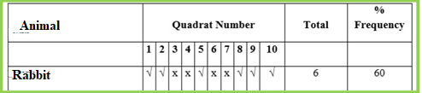
Carry out the above exercise and record your data in the table below:
Animal | Quadrants Numbers |  |  |  |  |  |  |  |  |  | Total | %Frequency
 | 1 | 2 | 3 | 4 | 5 | 6 | 7 | 8 | 9 | 10

(ii) Percent cover
In this exercise you will investigate the percent cover of a animal. For this activity you will use a quadrat with a grid. The grid has horizontal and vertical lines, where these lines cross each other (in other words where they intersect) is a “hit point”. If a species is found under a hit point it is recorded as a “hit”. If the quadrat is 5x5 it has 25 squares and so the maximum number of hits a species may have in one quadrat is 25. Throw the quadrat 10 times and record your results in the table.
Next you must calculate the percentage cover of each species. If rabbit was hit 196 times over the 10 quadrats you would calculate as follows:
1. Total number of hits = 196
2. Total number of possible hits = 25x10 = 250
3. Divide total hits by possible hits = 196/250 = 0.784
4. Multiply by 100 to get percentage cover = 0.784 x 100 = 78.4%
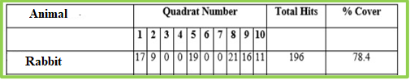
Carry out the above exercise and record your data in the table below:
Animal |  |  |  |  |  |  |  |  |  |  | Total Hits | %cover
 | 1 | 2 | 3 | 4 | 5 | 6 | 7 | 8 | 9 | 10
Part 2 – Non-Random Sampling: Using a line transect
For this activity you will use a rope marked at every meter. This will allow you to see the change in vegetation over a length of space within a habitat. There are 10 sampling points on the line transect with a grid quadrat at each meter mark.
At each meter mark you will measure the following abiotic factors; light intensity = light meter, humidity = hygrometer, air temperature = thermometer, soil temperature = soil thermometer, soil pH = soil pH probe.
You will also record which plant species are present and give an estimate of what percent- age of the quadrat they take up.
You will work in pairs. Each pair will work at each meter mark and collate the results when you return to your class.
Abiotic Factor | Equipment used | Result  (include units)
Light Intensity
Humidity
Air Temperature
Soil Temperature
Soil pH
Transect Line and Meter Mark: ______________
Animal Species Found
Activity 3: Food Webs, Chains and Pyramid of Numbers
Part 1 - Food Chains
Using the species identified earlier and habitats investigated, identify the role of different organisms in the pathways of energy flow.
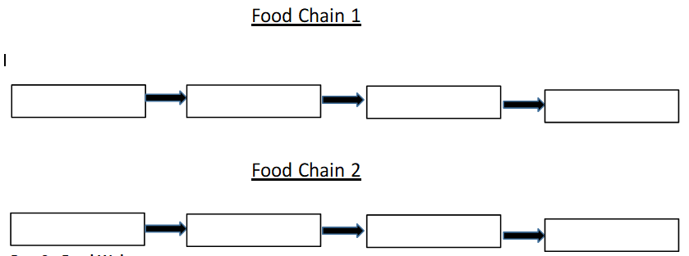
Part 2 - Food Webs
Each animal you have seen today is part of a food chain. All food chains within an ecosystem are connected because many organisms eat the same things or are eaten by the same things.
List all of the animals that you have discussed today and make a food web by drawing arrows and linking them all together.
Decomposers
__________________________________________________________________________________________________________________________________________________________________________________________________________________________________________
Primary Producers
__________________________________________________________________________________________________________________________________________________________________________________________________________________________________________
Herbivores
__________________________________________________________________________________________________________________________________________________________________________________________________________________________________________
Omnivores
__________________________________________________________________________________________________________________________________________________________________________________________________________________________________________
Carnivores
__________________________________________________________________________________________________________________________________________________________________________________________________________________________________________
Food Web

Pyramid of Numbers
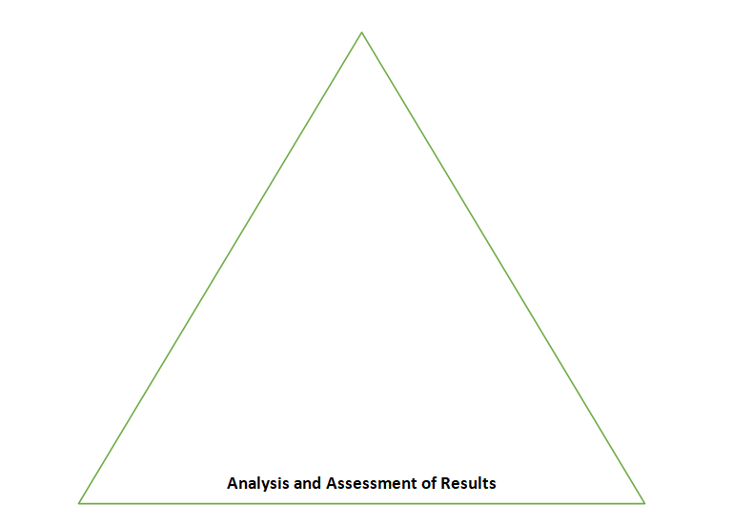
Possible sources of Error during the Field Trip
Relevance of reports in everyday life e.g. Environmental Impact Assessment
Links to other areas of syllabus
Practical # 16
Field observation and report writing on animals in their ecosystem (An aquatic ecosystem study)
Ecology Field Trip
Observation and Scientific Study of a Selected Ecosystem
Student Name:
This field trip will give you the chance to explore different habitats such as grassland, wood- land and freshwater systems. You will have the opportunity to sample the types of animals available in these habitats by using various apparatus to collect species and then identify them using a simple key.
You will look at both the abiotic factors, such as temperature, light intensity and soil pH, as well as biotic factors, such as species interactions (competition, predation) within the habitats.
By the end of this field trip you should be able to:
- Identify a variety of habitats within the ecosystem
- Identify 5 animals using simple keys
- Use various apparatus required for collection of species
- Conduct a quantitative study of animals and know the difference between quantitative and qualitative surveys
- Understand the difference between abiotic and biotic factors that influence an ecosystem
- Identify adaptations of different species and understand its purpose
- Construct food webs and a pyramid of numbers based on field study

Site Description

Site Map/Sketch

Activity 1: Animal Collection and Identification
There are different methods of collecting specimens depending on the type of habitat you are sampling. Use a variety of sampling methods and record your findings.

Apparatus that you will use:
- Dipnets
- Sorting pans (e.g., plastic dishpans)
- Plastic buckets
- Aquaria
- Dechlorinated water
- Aeration system (air pumps, air tubing, airstones)
- Siphon (to clean aquaria)
- Fish food (e.g., goldfish flake food)
- Fishing pole and earthworms, or seine (required only if fish are desired or needed to produce chemical cue)

Choose 3 pieces of equipment and fill out the boxes below:
Collection Apparatus Used:

______________________________________________________________________________

Name: | Diagram
How was it used | Diagram
Type of organism collected | Diagram

Name: | Diagram
How was it used | Diagram
Type of organism collected | Diagram

Name: | Diagram
How was it used | Diagram
Type of organism collected | Diagram

You will use a biological key to identify the species caught. Identify the organism and note any adaptations it has to help it survive in its particular habitat.
Remember to return all organisms to where you found them when you are done!
Organism | Adaptation | Sketch

Why are structural, competitive or behavioral adaptations by organisms necessary?

Capture-Recapture Method
This method involves collecting a number of animals of the same species. The species are then marked in some way that will not endanger them or inhibit their behavior, for example marking snail shells with white paint will make them more visible to birds and so they will be easier prey! After marking the animals they should be released as close as possible to the capture site. After a set period of time (preferably days) a second animal collection is carried out in the same habitat. The number of marked individuals caught on the second visit should be noted. The following formula gives an approximation of the total population of that animal in that habitat.
Example:

- Animals caught and marked on 1st visit = 20
- Animals caught on 2nd visit = 15
- Marked animals caught on second visit = 5

Activity 2: Animal Study
Part 1 – Random Sampling: Using a quadrat
(i) Percent Frequency
In this exercise you will investigate the percent frequency of an animal. This is a qualitative survey, meaning it tells you if an animal species is present or absent. This method gives you an idea of the variety of species in a habitat.
For this exercise you must identify and record a minimum of 5 animals and record and adaptations present.
A small object will be thrown at random behind the students back and then a quadrat will be placed on top of the pen. If a species is present it is noted by a tick, if it is absent it is marked by an x. This is repeated 10 times. The number of quadrats a species shows up in is multiplied by the total number of quadrats thrown to get the percent frequency. For example if 10 quadrats are thrown and Snails are found in 7 quadrats then the total percent frequency of daisies in that habitat is 70%. An example of what your table should look like is given below:
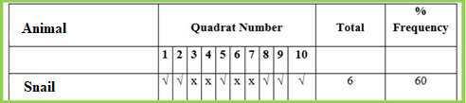
Carry out the above exercise and record your data in the table below:
Animal | Quadrants Numbers |  |  |  |  |  |  |  |  |  | Total | %Frequency
 | 1 | 2 | 3 | 4 | 5 | 6 | 7 | 8 | 9 | 10

(ii) Percent cover
In this exercise you will investigate the percent cover of an animal. For this activity you will use a quadrat with a grid. The grid has horizontal and vertical lines, where these lines cross each other (in other words where they intersect) is a “hit point”. If a species is found under a hit point it is recorded as a “hit”. If the quadrat is 5x5 it has 25 squares and so the maximum number of hits a species may have in one quadrat is 25. Throw the quadrat 10 times and record your results in the table.
Next you must calculate the percentage cover of each species. If Snail was hit 196 times over the 10 quadrats you would calculate as follows:
1. Total number of hits = 196
2. Total number of possible hits = 25x10 = 250
3. Divide total hits by possible hits = 196/250 = 0.784
4. Multiply by 100 to get percentage cover = 0.784 x 100 = 78.4%
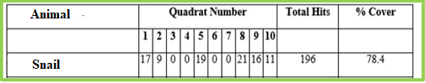
Carry out the above exercise and record your data in the table below:
Animal |  |  |  |  |  |  |  |  |  |  | Total Hits | %cover
 | 1 | 2 | 3 | 4 | 5 | 6 | 7 | 8 | 9 | 10
Part 2 – Non-Random Sampling: Using a line transect
For this activity you will use a rope marked at every meter. This will allow you to see the change in vegetation over a length of space within a habitat. There are 10 sampling points on the line transect with a grid quadrat at each meter mark.
At each meter mark you will measure the following abiotic factors; light intensity = light meter, humidity = hygrometer, air temperature = thermometer, soil temperature = soil thermometer, soil pH = soil pH probe.
You will also record which plant species are present and give an estimate of what percent- age of the quadrat they take up.
You will work in pairs. Each pair will work at each meter mark and collate the results when you return to your class.
Abiotic Factor | Equipment used | Result  (include units)
Light Intensity
Humidity
Air Temperature
Soil Temperature
Soil pH
Transect Line and Meter Mark: ______________
Animal Species Found
Activity 3: Food Webs, Chains and Pyramid of Numbers
Part 1 - Food Chains
Using the species identified earlier and habitats investigated, identify the role of different organisms in the pathways of energy flow.
Part 2 - Food Webs
Each animal you have seen today is part of a food chain. All food chains within an ecosystem are connected because many organisms eat the same things or are eaten by the same things.
List all of the animals that you have discussed today and make a food web by drawing arrows and linking them all together.
Decomposers
__________________________________________________________________________________________________________________________________________________________________________________________________________________________________________
Primary Producers
__________________________________________________________________________________________________________________________________________________________________________________________________________________________________________
Herbivores
__________________________________________________________________________________________________________________________________________________________________________________________________________________________________________
Omnivores
__________________________________________________________________________________________________________________________________________________________________________________________________________________________________________
Carnivores
__________________________________________________________________________________________________________________________________________________________________________________________________________________________________________
Food Web

Pyramid of Numbers
Possible sources of Error during the Field Trip
Relevance of reports in everyday life e.g. Environmental Impact Assessment
Links to other areas of syllabus

