ZOO – 301
Animal Form and Function - I

LABORATORY MANUAL

DEPARTMENT OF BIOLOGY
Virtual University of Pakistan

Practical Contents

Sr # | Practical list
1. | Study of Insect chitin & Study of Fish Scales
2. | Study of Amphibian Skin and Study of Reptilian Scales
3. | Study of Feathers
4. | Study of a Mammalian skin
5. | Study and notes of Skeleton of Labeo (Labeo rohita)
6. | Study and notes of Skeleton of Frog (Hoplobatrachus tigerinus)
7. | Study and notes of Skeleton of Varanus (Varanus bengalensis)
8. | Study and notes of Skeleton of Fowl (Gallus gallus domesticus)
9. | Study and notes of Skeleton of Rabbit (Oryctolagus cuniculus)
10. | Dissection of Earthworm or leech
11. | Dissection of Cockroach and Freshwater Mussel
12. | Dissection of Channa or Catla catla or Labeo or any other local fish
13. | Dissection of Frog or Pigeon
14. | Study of heart in dissection of representative fish/mammals
15. | Study of principal Arteries in dissection of representative fish/mammals
16. | Study of principal Veins in dissection of representative fish/mammals

Note: Exercises of notes on the adaptations of skeletons to their function must be done

Practical # 1
Study of Insect Cuticle & Study of Fish Scales

- Procuticle of chitin is present
- Epicuticle of waxy layer is present

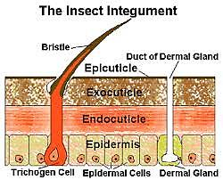
Fig 1: Insect cuticle
Study of Fish Scales

Fish has following type of Scales:
- Placoid Scale: These scales have a basal plate. A spine is raised from this plate. It is present in sharks.
- Ganoid Scales: It is diamond shaped scales. It has a ganoine layer.
- Cycloid Scales: Concentric growth lines are present in these sales.
- Ctenoid Scales: In these scales teeth like ctenia spines present.

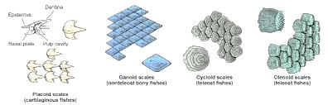
Fig 2: Fish scales

Practical # 2.0
Study of Amphibian skin & Study of Reptilian Scales

The outer layer of Epidermis is present and mucous and serous glands also present.

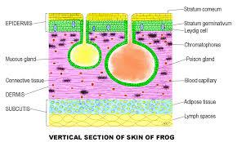
Fig 3: vertical section of a Frog skin

Study of Reptilian Scales
The origin of scales is dermal and osteoderm is present.
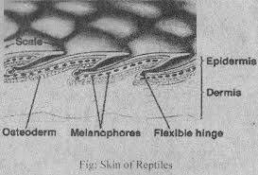
Fig 4: Reptilian scale

Practical # 3
Study of Birds Feathers
The main shaft is present with barbs

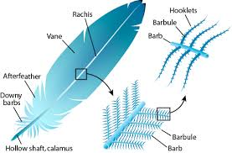
Fig 5: Birds feather
Practical # 4
Study of Mammalian skin
Sweat glands are present and hairs with hair follicles.

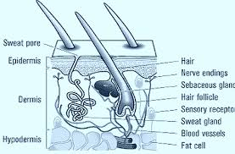
Fig 6: Structure of a mammalian skin

Practical # 5

Study of the Skeleton of Labeo rohita
Skull structure
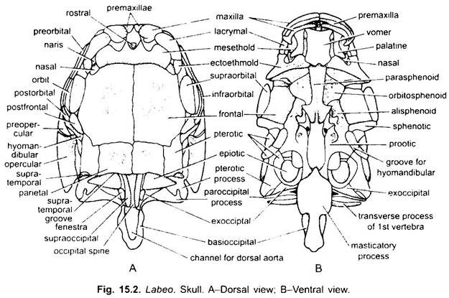
Fig 7: Labeo skull (A) dorsal view (B) ventral view

Explanation of Fish skull
- Occipital region: It is composed of bones: Basi-occipital, Ex-occipital and supra occipital.
- It is a posterior part of the skull.
- Auditory or Otic region: It consisits of bones: Pro-otic, Epi-otic, Sphenotic and Pterotic.
- Temporal Region: It consists of Parietal, Alisphenoids, Parashenoids and Frontal bones.
- Orbital Regions: It is composed of Supra-orbital, Post-frontal, Pre-orbital, Infra-orbital and Post orbital.
- Ethmoidal or Nasal Region: It is composed of Nasal, Ecto-ethmoid, Larymals, Mesethmoid, vomer and Rostral bones.
Special Adaptive Features of Fish skull
- Occipital process is reduced and it shows lack of neck.
- Orbital and temporal bones are flat.
- Maxilla and Pre-maxilla is ventrally placed and it result in increased entry of water through mouth.
- Nasal bone is closed at the Posterior end which reduces the entry of water in to nasal cavity.
- The skull bone of the fish is flat and this reduces the friction.
Mandibular Arch

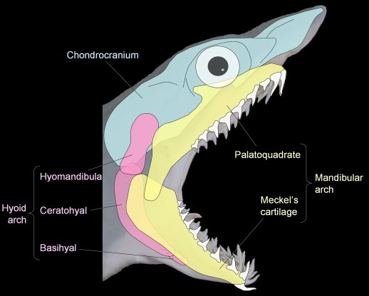
Fig 8: outer view of the right jaws and hyoid arch

Adaptive Features of hyoid arch and Jaw
- Jaw bones are supported by dentary bone.
- Trinagular bone is quadrate which limits the movement of lower jaw.
- In Labeo the jaw bone is reduced.

Dorsal Fin

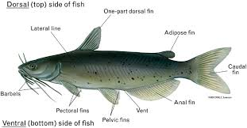
Fig 9: Dorsal fin with vertebra

- Fin rays form a flat surface. It balances the body in water.
- Fin rays are present in one row and it reduces the friction.
Vertebral Column
    - No. vertebra in Labeo is 37. It provides support to longer body.
    - Prezygapophyses and post-zygapophyses is less developed in trunk vertebra. It reduces flexibility in the trunk.
Anal Fin
- It consists of 8 fin rays which keeps the lower balance of the fish
- Locomotion is provided by the fins to caudal fin.
Caudal Fin
    - Fin rays are supported by epurals and hypurals.
    - Caudal fin lateral movement is supported by radial which gives the forward thrust to the fish.
    - Caudal fin is divided into two lobes: epichordal and hypochordal lobes.
Pelvic girdle and Pelvic fin
- Pelvic girdle is composed of two pelvic bones. Pelvic fin is composed of nine fin rays and three radials.
- Fin rays give support to pelvic fin.
- Articulation of fin is performed by using radials.

Practical # 6
Study of the Skeleton of Frog

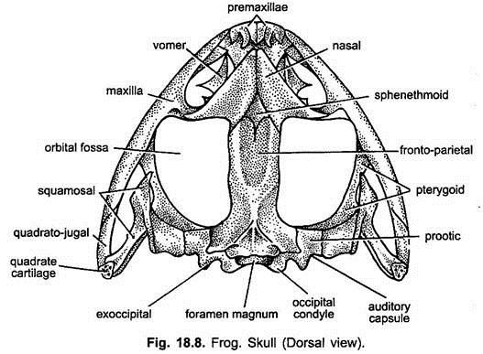
Fig 10: Frog skull dorsal view
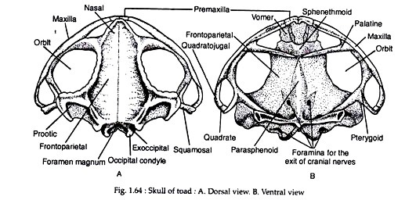
Fig 11: (A) dorsal view of the frog skull (b) ventral view
The skull of frog consists of six parts: cranium, auditory capsule, olfactory capsule, upper and lower jaw and hyoid apparatus.
- Cranium: It has orbit bone, fronto-parietal bone, Sphenethmoid, Exoccipital, occipital condoyle and Parasphenoid. It encloses the brain.
- Auditory capsules: It encloses the auditory organ. It is cartilaginous.
- Olfactory capsule: it is present at the anterior end of the skull. Its roof is formed by the nasal bone. Its floor is formed by a pair of vomers. Vomer has 6-8 vomerine teeth.
- Upper jaw: The outer bones consist of premaxilla, maxilla, quadrato-jugal. The inner bones consist of palatine, ptergyoid, squamosal and quadrate cartilage.
- Lower Jaw: It is composed of two cartilaginous rods called Mackel’s Cartilage. The anterior end of the cartilages fuse to form a small bone called Mentomeckelian. The rest of cartilage is covered by two bones called dentary and angulo-splenial.
- Hyoid Apparatus: it supports tongue and larynx. Its main body lies in the floor of buccal cavity.

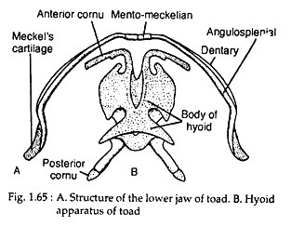
Fig 12: lower jaw of Frog and hyoid bones
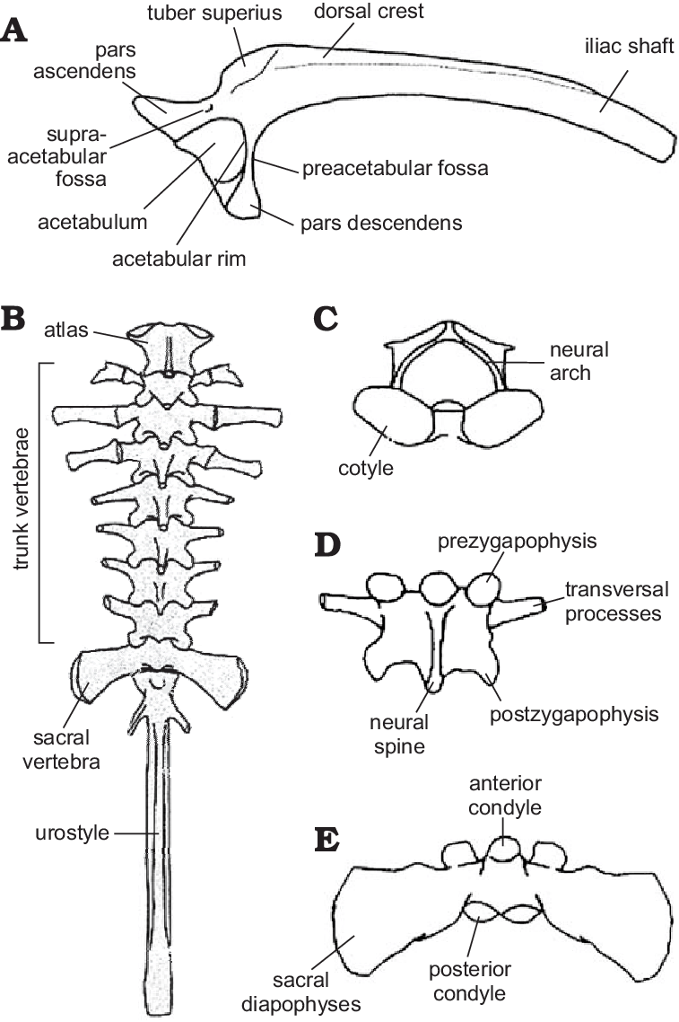

Fig 13: vertebral column of frog
It consists of nine vertebrae. 1st 8th and 9th vertebra has specific structures but vertebrae 2-7 have similar typical structures.

Adaptive features of vertebral column of Frog
- The first vertebrae Atlas is modified to attach with the skull.
- Neck vertebrae is absent in frog. Axis is also absent so frog cannot rotate its head.
- Last bone is urostyle and it represents reduced tail vertebrae in frog.

Pectoral Girdle and Forelimb
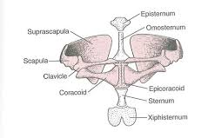
Fig 14: Pectoral girdle ventral view
Special features of Pelvic girdle of frog
- It has broad scapula and supra-scapula. It is adapted to swim in water.
- Coracoids are short. It shows lesser role of forelimbs in jumping movement on land.
- During jump the clavicle acts as shock absorber.

Special Features of Forelimb of Frog
- For support on land humerus is long.
- Radio-ulna is much short and it takes part in jumping movement.
- First digit is reduced and it is adaptation for jumping on land.

Special features of Pelvic Girdle and Hind limb
- Ileum is used to produce to high jumps.
- Ischium is much reduced which is indication of reduced walking movement.
- Femur is short and it shows reduced walking in frog.
- Tibio-fibula is longer and takes part in jumps.
- Phalanges is longer for jumping.

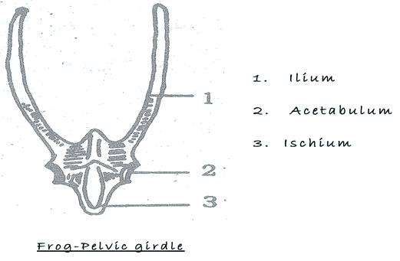
Fig 15: Fog Pelvic girdle

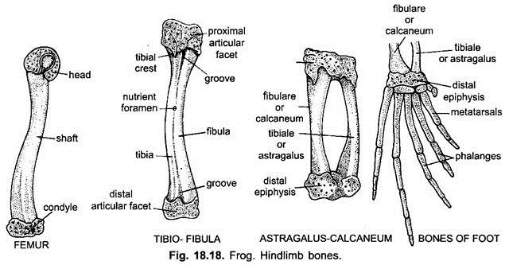
Fig 16: Hind limb structure of Frog

Practical # 7
Study of skeleton of a Varanus

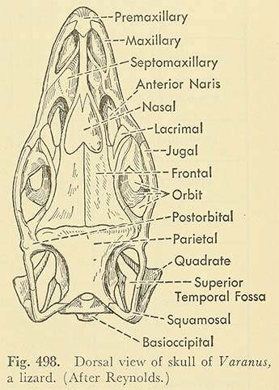
Fig 17: Dorsal view of varanus skull
It has following bones
- Cranium: it is composed of occipital region, parietal region and frontal region.
- Occipital region is composed of basioccipital, paired exoccipital and supra occipital bones.
- Parietal region is composed of frontal bone, basisphenoid and pro-otics.
- Frontal region is composed of frontal bone, parasphenoid and orbito-sphenoids.
- Olfactory capsule: It is composed of nasals and vomer bones.
- Auditory capsule: It is composed of pro-otic and opistho-otic bones.
- Suspensorium: it is composed of para-occipital process of exoccipital, squamosal and quadrate.
- It is composed of pre-frontal and lachrymal bones.
- Maxillo-palatine apparatus: palatine, pterygoid, quadrate, premaxilla and maxilla.
- Special features of Varanus skull

- It is flat and conical and has adaptation for burrowing life. Its skull is ossified.
- Maxilla and vomer is longer and it has adaptation for insectivorous habit.
- Its skull is diapsid with two temporal fossae which makes the skull strong.
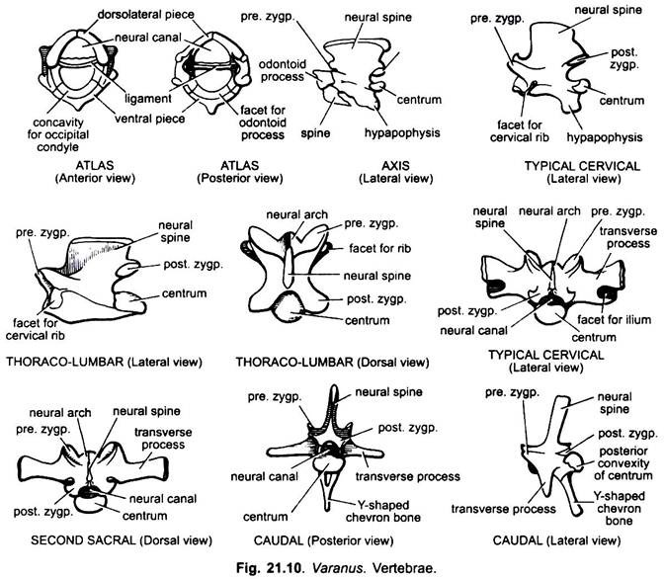

Fig: VertebFig 18: verteral column of Varanus
Vertebral column of Varanus is composed of four regions:
- Cervical vertebrae: It has seven vertebrae. Atlas is first and second is axis.
- Thoracic vertebrae: It is twenty in number.
- Sacral vertebrae: It is two in numbers.
- Caudal vertebrae: it is indefinite in number.

Special features of Varanus Vertebral column
- Varanus can rotate its neck as axis vertebra is present.
- Vertebrae of Varanus is procoelous which makes it flexible.

Pelvic girdle and hind limb
It is composed of following bones: Ileum, pubis, epipubis, prepubis, Ischium, hypoischium. Hind limb is composed femur, tibia fibula, tarsals, metatarsals, phalanges and claws.

Special features of Pelvic girdle of Varanus
- Pubis of both sides is united by epipubis. It strengths the pelvic girdle.
- Ligament is present between epipubis and hypo-ischium. It increases flexibility in the pelvic girdle for burrowing habit.
- Ilium is elongate which increases the walking strength of Varanus.

Special features of Hind limb of Varanus

- Femur is reduced in length and is adapted for burrowing habit.
- Tibia and fibula are not fused which helps in swift walking.
- Metatarsals are reduced in size which reduces the size of palm.

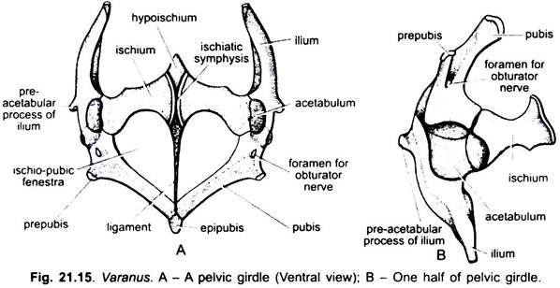

Fig 19: Pelvic girdle of varanus
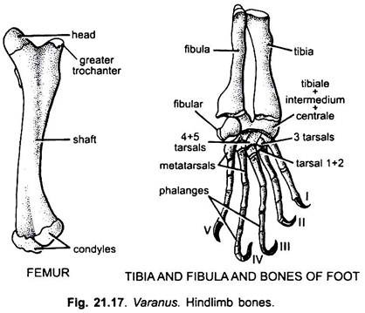
Fig 20: Hind limb of varanus

Practical # 8
Study of skeleton of Fowl (Gallus)
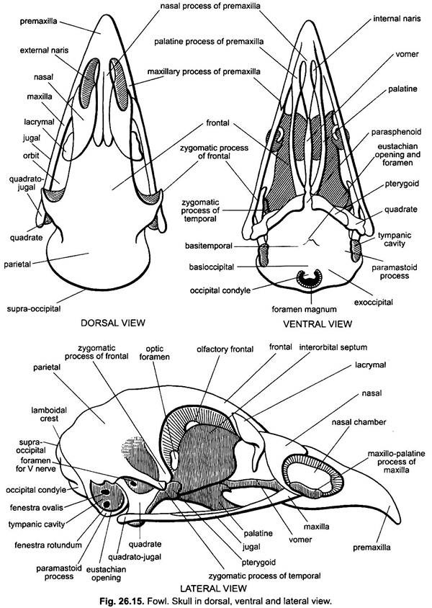
Fig 21: Skull of Fowl ventral and dorsal view
Special features of skull of Fowl
- Skull of Fowl is point at the anterior end and it sis adapted for flight.
- To reduce the weight the skull bones are fused.
- Premaxilla and maxilla is without teeth and it form beak.
Vertebral column of Fowl
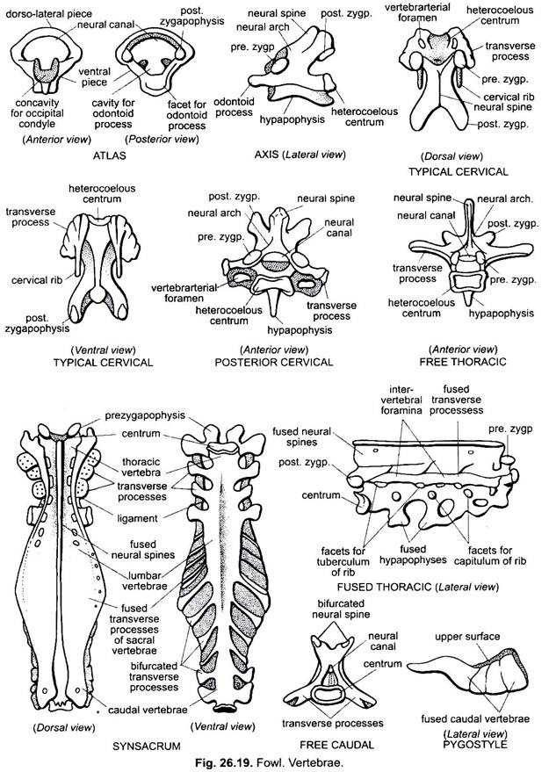
Fig 22: vertebrae of Fowl: (a.) atlas (posterior view), (b.) cervical (lateral view), (c.) axis (lateral view)
Special features of Vertebral column of Fowl
- It has long neck composed of 16 vertebrae. The second vertebra is axis which is used for the rotation of neck.
- It is heterocoelous (saddle like) that increases the flexibility in the vertebral column.
- The last thoracic, all lumber, all sacral and first seven caudal vertebrae fused to form synsacrum. It helps in the flight.
Fig 23: Synsacrum

Pectoral Girdle and Forelimb of Fowl
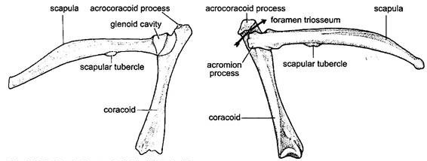

Fig 24: Pectoral Girdle

Features of Pectoral Girdle of Fowl
- Scapula with acromion process is sword like which act as a fulcrum during flapping of wings.
- Clavicle is long which gives support to the pectoral girdle in flapping of wings.
- Foramen triossum is present. The tendon of the pectoral muscle passes through it.

Features of the Forelimb of Fowl
- Humerus is strong which lifts wings.
- Radius is thin and ulna is broad and support the wings.
- For attachment of the feathers the carpels and metacarpals is reduced.

Pelvic Girdle and Hind limb of Fowl
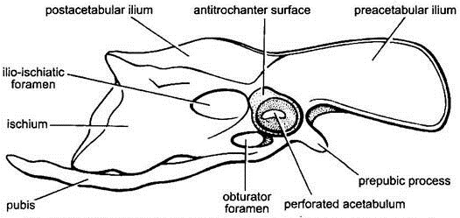

Fig 25: Pelvic Girdle of fowl
Features of the Pelvic Girdle
- Ileum is firmly united with synsacrum that keeps the body in the vertical position.
- Antitrochanter process is present which limits the movement of the femur.

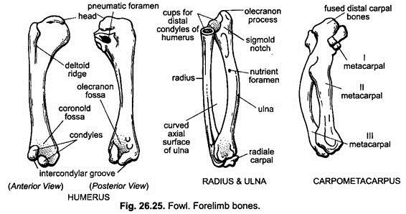
Fig 26: Hindlimb of fowl
Features of the Hind limb
- Femur is long and stout that supports the body.
- Fibula and Tibo-tarsus is fused which increase the strength of hind limb for walking.
Practical # 9
Study of the skeleton of the Rabbit
Skull of Rabbit
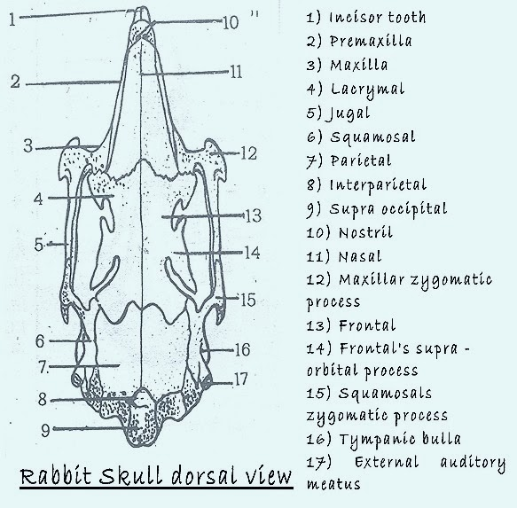
Fig 27: rabbit skull dorsal view
Skull of the rabbit is composed of premaxilla, maxilla, zygomatic bone, nasal bone, lachrymal bone, frontal, jugal, parietal bone and occipital bones.

Features of the skull of Rabbit
- The skull of rabbit is conical for burrowing habit.
- For herbivory habit the Premaxilla and nasal bones form snout like structure.
- Canine is absent and a space diastema is present on premaxilla.

Vetebral column of Rabbit
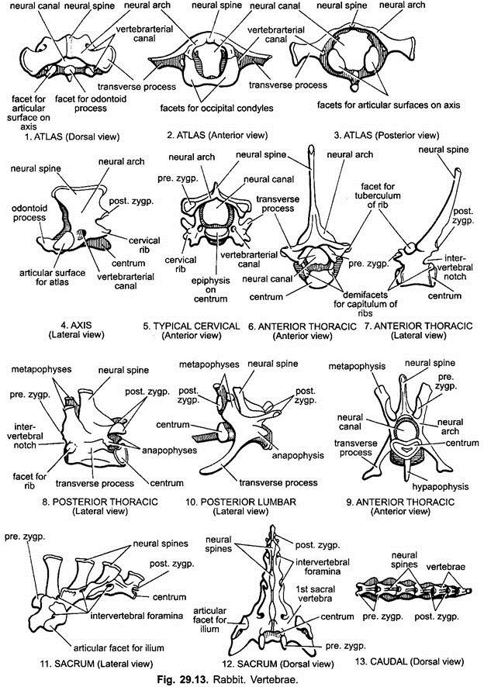
Fig 28: Atlas (dorsal view), Axis (side view), Typical cervical vertebra

Fig 29: sacrum of rabbit. Lateral view

Rabbit has 7 cervical vertebrae, 12 thoracic vertebrae, 7 lumbar vertebrae, 2 sacral vertebrae, 15 caudal vertebrae.

Features of the Vertebral column of the Rabbit
- Cervical vertebrae have axis vertebra for neck rotation.
- 15 caudal vertebrae support the tail.
Ribs and Sternum
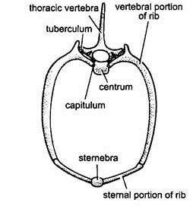
Fig 30: Thoracic vertebra with its Ribs of rabbit
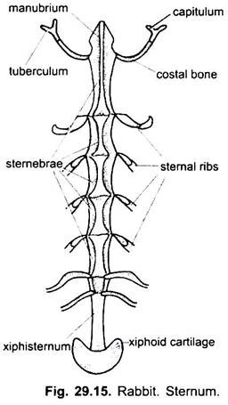
Fig 31: Sternum of rabbit

Features of the ribs of Rabbit
- There are 12 ribs. These are slender. It gives support to chest cavity.
- Last three or four pairs are floating. It gives support to chest cavity during swift walking.

Pectoral Girdle and Forelimb
- The pectoral girdle of rabbit is broad and long which gives support to forelimbs.
- The scapula and supra scapula is broad.
- Clavicle is slender and rod shaped. It attaches the pectoral girdle with sternum.
- Humerus is reduced in length and it is adaptation for forelimb walking.
- Radius and ulna is reduced. It gives support to forelimb for walking.
- Carpels and phalanges are longer for digitigrade mode of walking.

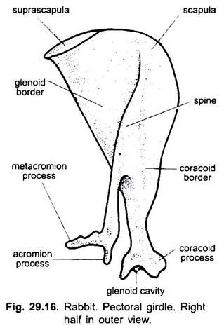
Fig 32: Pectoral girdle of rabbit, (outer view right half)

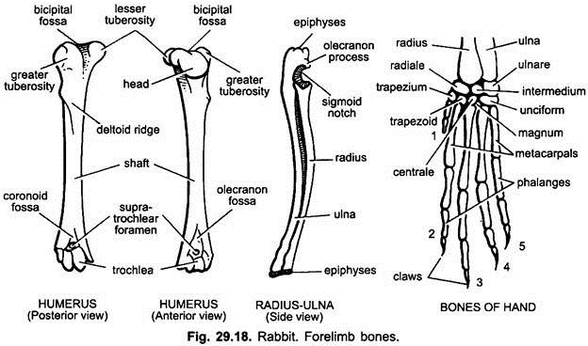
Fig 33. humerus of rabbit, radius and ulna and forelimb

Pelvic Girdle and Hind limb of Rabbit
Features of Pelvic Girdle
- Ileum is much longer. It articulates with sternum.
- Pubis bones of both sides are fused at pubic symphysis which makes the pelvic girdle stronger.

Features of Hind limb
- Femur is much longer that remains vertical in position during walking.
- Tibio-Fibula is also longer which keeps the body above the ground.
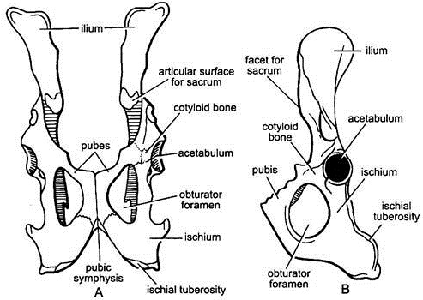
Fig 34: Pelvic girdle A-Ventral view, B- left half

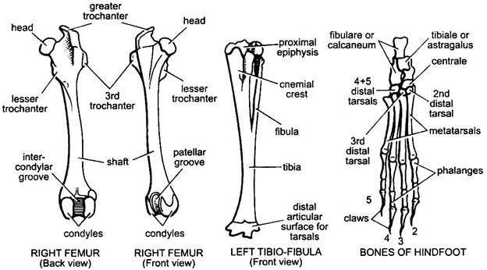

Fig 35: Rabbit hindlimb bone

Practical # 10
Dissection of Earthworm
Dissection Method
- The dissection dish is taken and preserved or killed earthworm is placed in it. The dorsal side is placed on upper side and pins are inserted into head and tail. The body of the earthworm is stretched across length.
- The skin is cut dorsally with the help of blade from anterior to posterior side. The loose skin of the earthworm is fixed with the help of pins.

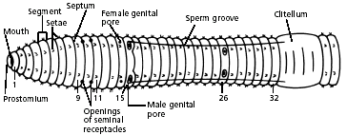
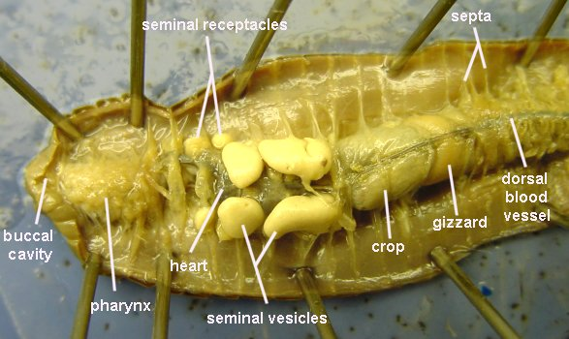
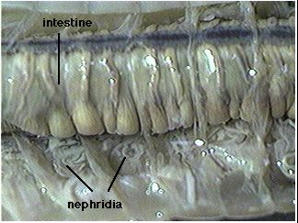
Fig 36: (a) earthworm, (b) digestive system, (c) nephridia
Digestive system: It is composed of pharynx, oesophagus, gizzard, stomach, intestine, intestinal glands. The intestine has also typhlosoles. Pharynx can protrude out of mouth. It is used to suck organic matter and soil. The process of digestion starts in stomach and absorption takes place in intestine.
Excretory System: It is composed of nephridia and a pair of nephridia is present in each segment. The nephridia is composed of ciliated funnel, coiled tube, outer loop, inner loop and nephridiopore.
Nervous System: It is composed of a pair of cerebral ganglia, pharyngeal connective, subpharyngeal ganglion, segmental ganglia and ventral nerve cord.
Reproductive System: The male reproductive system of Earthworm is composed of testis, testis sac, seminal vesicle, vasa efferentia, prostate gland and spermatic duct. Female reproductive system is composed of ovary and oviduct.

Practical # 11
Dissection of Cockroach & Freshwater Mussel
Method of Dissection
- It is dissected from dorsal side. The wings are cut and animal is fixed on board with pins.
- The terga is removed one by one. The abdominal cavity contains mass of white matter and it is removed with cotton.
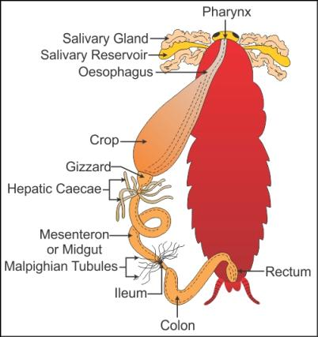
Fig 37: digestive system of cockroach
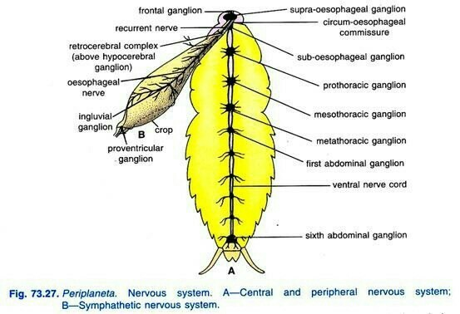
Fig 38: nervous system of cockroach

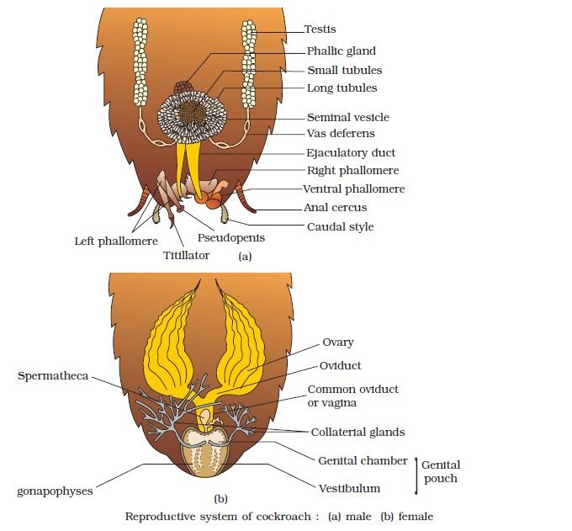
Fig 39: male and female reproductive system of cockroach

Male reproductive system: It is composed of testis, phallic, utriulus majors, vas deferens, utriuli breviores, ejaculatory duct, male genital pore, genital pouch and gonapophyses pore.
Female reproductive system: It is composed of terminal filament, germarium, ovary, oviduct, collaterial gland, genital chamber, genital pouch and gonapophyses.

Dissection of Fresh water Mussel (Unio)
Method of Dissection
- A Fresh water mussel is taken and its small teeth like structure present at the ventral edge of the closed shell is scraped with razor. The blade of razor is inserted into anterior and posterior side of closed shells. The adductor mussels are cut and shell is opened.
- The mantle is removed and different digestive organs are studied.

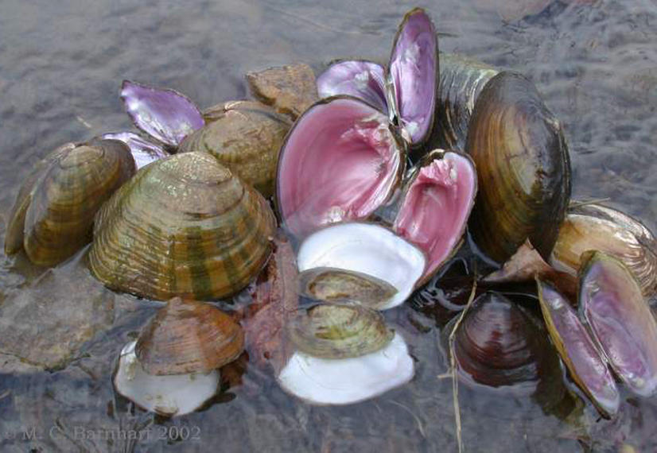
Fig 40: Fresh water mussel

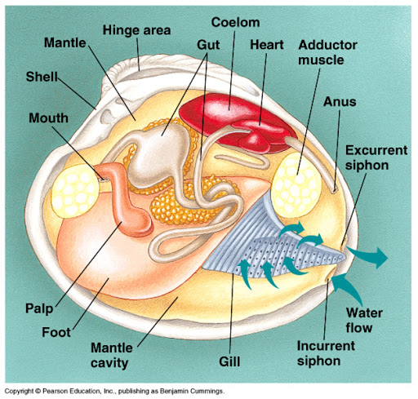
Fig 41: digestive system of Fresh water mussel

Digestive system: It is composed of alimentary canal and digestive glands.
Alimentary canal: It is composed of following parts:
- Mouth: It is transverse slit like opening. Labial palps are present on each side of mouth. These palps enclosethe ciliated oral groove. Jaws and radula is absent.
- Oesophagus: It is narrow tube like and inner wall is ciliated.
- Stomach: It is a sac like structure and it is surrounded by a pair of large digestive glands or liver.
- Intestine: It arises from the posterior end of the stomach. It runs ventrally into stomach.
- Rectum: It is the terminal part of the intestine. It opens outside by means of anus.

Digestive glands: It is also called digestive diverticulum or liver. It opens into the dorsal portion of stomach. It secretes digestive enzymes into stomach.
Nervous System: It is composed of central nervous system (three ganglia), their connectives and small nerves.
- Cerebro pleural ganglia: It is present at the base of labial palps. It is yellowish in color equal to the size of pin head. The ganglion is formed by the fusion of cerebral and pleural ganglia.
- Pedal ganglia: It lies in foot and two pedal ganglia unite to form bilobed mass.
- Visceral ganglia: The two visceral ganglia is present near posterior adductor muscle. It is fused into flattened X shaped mass. Each visceral ganglia gives rise nerve, dorsal pallial nerve, posterior pallial nerve and renal nerves.

Practical # 12
Dissection of Labeo rohita
Method of Dissection
The fish is washed with water and a mid- ventral cut is given at abdomen. The skin is cut up to anus. Then a transverse cut is given to from pelvic fin up to the base of pectoral fin. Then it is fixed on the board with the help of pins or nails. The different systems of fish are observed.

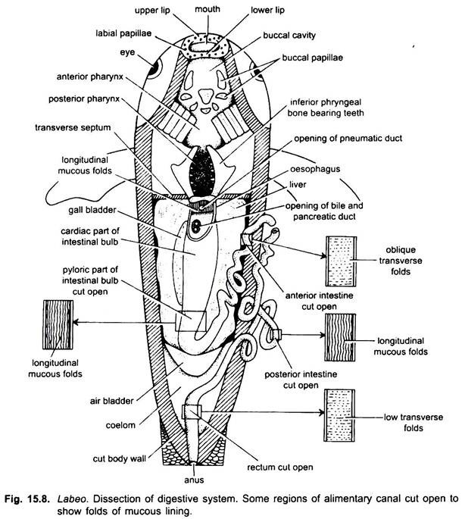
Fig 42: dissection of Labeo

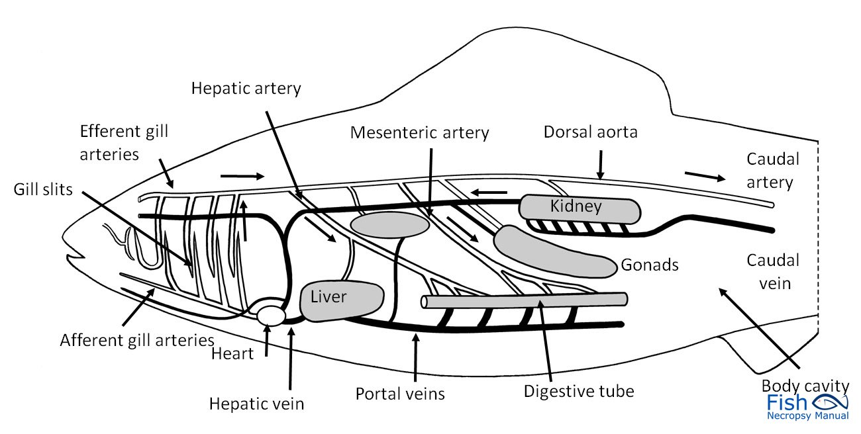
Fig 43: venous system
Cranial nerves of Labeo
- Olfactory: sensory, smell
- Optic: sensory, vision
- Oculomotor: motor, eyelids, eyes, adjustment to light
- Trochlea: motor, conditions of eye muscles
- Trigeminal: (a) eyes, tear glands, scalp, forehead, upper eyelid

Practical # 13

Dissection of Frog

Method of Dissection
- A chloroformed or pithed frog is placed on board. Its ventral side is kept upward.
- The limbs of frog is fixed with nails. Then the skin of frog is lifted with the help of forceps. A cut is made in the skin in abdominal region. The skin is cut from abdomen to lower jaw.
- The anterior abdominal vein that passes through the midline should not be cut. The body wall is raised and two lateral cuts are made in it. The body wall is cut from these two lateral sides. The lower side of the mid section (with abdominal vein) is tied with a thread. Now it is cut and bleeding do not take place from abdominal vein.
- The sternum is cut at anterior side. The digestive system is present in the abdominal cavity.

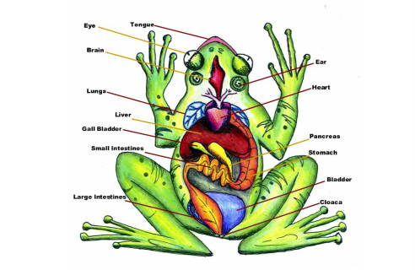
Fig 44: digestive system

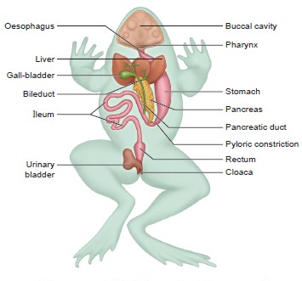
Fig 45: respiratory system of frog

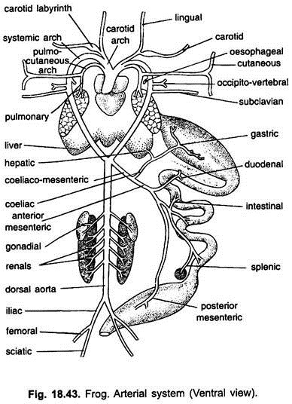

Fig 46: arterial system of frog

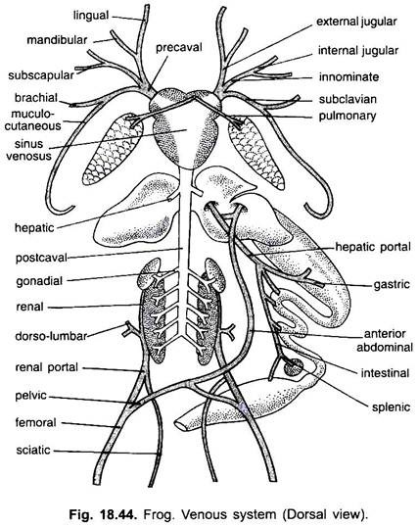
Fig 47: venous system of frog dorsal view

Practical #14 & 15 & 16
Study of heart, principal arteries and principal veins in a representative vertebrate. (dissection of representative fish/mammals)

Hemolymph
It is a circulating fluid in animals with an open circulatory system. Most arthropods, ascidians and many molluscs have hemolymph.

Function of Vertebrate blood
It transports oxygen, carbon dioxide and nutrients. It defends against harmful microrganisms, cells and viruses.

Agranulocytes
These are without granules in the cytoplasm. Eosinophils, basophils and neutrophils are its three different types.

Platelets
These are fragmented disk-shaped cells which initiate blood clotting. These move to the injury site and form clump in the damaged area and start the process of blood coagulation.

Artery and vein
The blood vessels which carry blood away from the heart to the organs and tissues is called artery. The blood vessels which brings blood to the heart from the organs and tissues is called vein.

Disclaimer:
The practical material has been taken from different literature resources due to copyrights and it is not for sale.

