Animals Form and Function II
(ZOO302)

Contents:

Sr. # | Name of Experiment | Page. #
1 | Study of excretory system in an invertebrate and a vertebrate representative. | 3
2 | Study of Excretory System of Birds and reptiles (Model) | 14
3 | Comparative Anatomy of Excretory System of Fish, Frog and Rabbit | 20
4 | Study of Excretory System of Grasshopper (Model) | 24
5 | Excretory System of Frog (Dissection) | 26
6 | Study of digestive system in invertebrate and a vertebrate representative. | 28
7 | Study of digestive system in Reptiles (Model) | 34
8 | Study of digestive system in Fish (Dissection) | 37
9 | Study of digestive system in Honey Bee (Model) | 41
10 | Study of digestive system in Cockroach (Dissection) | 43
11 | Study of digestive system in Earthworm (Dissection) | 47
12 | Study of male and female reproductive system in invertebrates (Model) | 53
13 | Study of male and female reproductive system in vertebrates (Model) | 58
14 | Study of male reproductive system of Chicken (Dissection) | 61
15 | Study of female reproductive system of Chicken (Dissection) | 63
16 | Study of male and female reproductive system of Reptiles | 65

Practical 1

Study of excretory system in invertebrate and vertebrate representative (Model)

Invertebrate Excretory system

Invertebrate excretory systems

In their detoxication mechanisms, so far as they have been investigated, the invertebrates in general conform to the principles applying to all animals, namely, that aquatic forms get rid of ammonia by diffusion through the surface of the body; terrestrial forms convert ammonia to uric acid. This implies that in aquatic forms the excretory organ is principally of importance for the composition of their body fluids. Normally, the body fluids of marine invertebrates have the same concentration as seawater; they usually differ, however, in the proportions of ions, with relatively more potassium and less magnesium than seawater. Furthermore, their urine normally has the same concentration as seawater, but correspondingly it contains less potassium and more magnesium. In freshwater invertebrates the urine is commonly, though not invariably, more dilute than the body fluids. By producing dilute urine a freshwater invertebrate conserves the salt content of its body while eliminating the water that enters its body by osmosis through its water-permeable surface.

Some invertebrates, notably echinoderms, cnidarians, and sponges, have no organs to which an excretory function can be confidently ascribed. Since all of these animals are aquatic, it is reasonable to suppose that they excrete nitrogen (as ammonia) by simple diffusion. Their body fluids (where present) are closely similar to seawater in composition, and it may be presumed that regulation operates only at the cellular level.

The excretory organs of other invertebrates are of diverse evolutionary origin. This is not to say, however, that each invertebrate phylum has evolved its own particular type of excretory organ; rather, there appear to be five main types of invertebrate excretory organ: contractile vacuole, nephridium, renal gland, coxal gland, and malpighian tubule.

The contractile vacuoles of protozoans

Some protozoan animals possess an organelle having the form of an internal sac, or vacuole, which enlarges by the accumulation of a clear fluid and then discharges its contents to the exterior. The cycle of filling and emptying may be repeated as frequently as every half minute. The chief role of the contractile vacuole appears to be in osmotic regulation, not in nitrogen excretion.

Contractile vacuoles occur more frequently and are more active in freshwater species than in closely related marine species. In fresh water, the concentration of dissolved substances in the cell is greater than in the external medium, and the cell takes in water by osmosis. If the contractile vacuole is put out of action, the cell increases in volume. If the concentration of salts in the medium increases—which would have the effect of decreasing the rate of osmosis—the rate of output by the contractile vacuole diminishes. The fluid eliminated by the vacuole is more dilute than the cytoplasm.

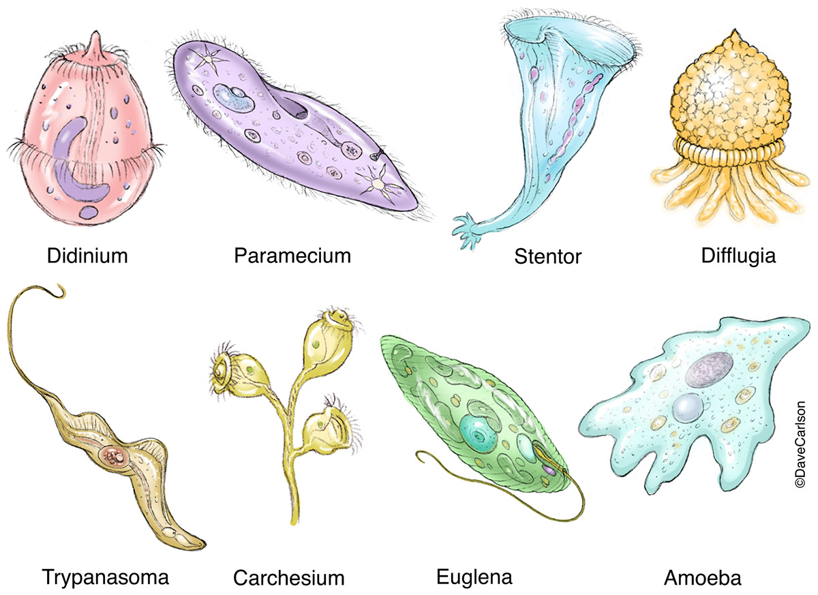

Figure 1. Different types of protozoans and their Contractile vacuoles

The nephridia of annelids, nemertines, flatworms, and rotifers

The word nephridium applies in its strict sense only to the excretory organs of annelids, but it may usefully be extended to include the excretory organs of other phyla having similar characteristics. Annelids are segmented animals that typically contain a pair of nephridia on each segment. Each nephridium has the form of a very fine tubule, often of considerable length; one end usually opens into the body cavity and the other to the exterior. In some annelids, however, the tubule does not open into the body cavity but ends internally in a cluster of cells of a special type known as solenocytes, or flame cells. The possession of solenocytes by some annelids is one of the characteristics that allies them with other non-segmented phyla that have no true body cavity. They also have a system of tubules opening at the surface and ending internally in flame cells embedded among the other cells of the body. In most cases, there is no regular arrangement of the various parts of the system. Animals belonging to all of these phyla are primarily aquatic, and, in the few cases known, the main excretory product is ammonia. How much of it leaves the body by the nephridia and how much through the body surface is not known.

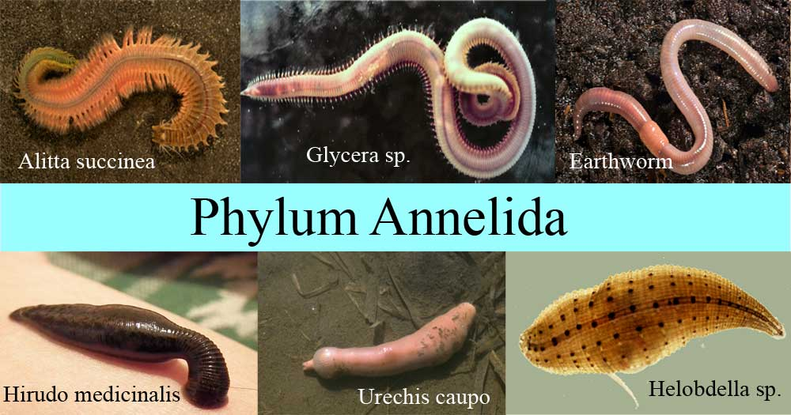

Figure 2. Organisms of phylum Annelida

Few physiological studies have been made on nephridia other than those of the earthworm. Although the earthworm is considered a terrestrial animal, its relationships with its environment are characteristically those of a freshwater animal. The nephridium of the earthworm is longer and more complex than that of marine annelids, four regions being distinguishable. Body fluid enters the nephridium via an internal opening called the nephridiostome. As the fluid passes along the tubule, probably driven by cilia, its composition is modified. In the two lower regions of the tubule the fluid becomes progressively more dilute, presumably as a result of the reabsorption of salts. Finally, a very dilute urine passes into the bladder (an enlarged portion of the tubule) and then to the exterior through the external opening, or nephridiopore. The rate of urine flow for an earthworm may be as much as 60 percent of its body weight in a period of 24 hours.

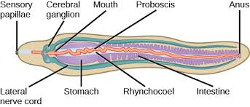

Figure 3. Nephridia of annelids, nemertines, flatworms, and rotifers

The renal glands of mollusks

The anatomical form of the renal gland varies from one class of mollusks to another, but a common plan is clearly evident. The renal gland is a relatively wide tube opening from a sac (the pericardium) surrounding the heart, at one end, and to the mantle cavity (effectively to the exterior) at the other. There is a single pair of renal glands; in some forms one member of the pair may be reduced or absent. Clams have the simplest arrangement; the region nearest to the pericardium has glandular walls and gives way to a nonglandular, wider tube that extends to the urinary opening.

The vast majority of mollusks is aquatic and excretes nitrogen in the form of ammonia. In octopuses, however, nitrogen is excreted as ammonium chloride, which is quite strongly concentrated in the urine. Terrestrial snails and slugs excrete uric acid but may also excrete ammonia when living in moist surroundings.

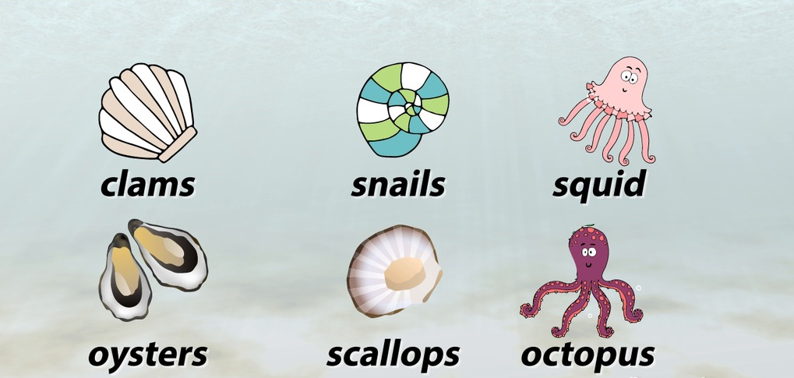

Figure 4. Different organism belong to Mollusks

In all mollusks so far investigated the primary process in urine production appears to be filtration of the blood. This may take place through the wall of the heart into the pericardium, or from blood vessels that supply the glandular part of the renal gland. The composition of the primary urine may be altered by reabsorption or secretion, or both. In freshwater mollusks salts are reabsorbed in the glandular tube and in the wide tubule, and the final urine is more dilute than the blood. The rate of urine flow is high, up to 45 percent of the body weight per day in the freshwater mussel. In marine mollusks the urine has the same concentration as the blood, but (in the few cases examined) its ionic composition is different.

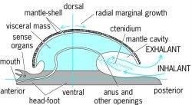

Figure 5. Renal glands of mollusks

The coxal glands of aquatic arthropods

Coxal glands are tubular organs, each opening on the basal region (coxa) of a limb. Since arthropods are segmented animals, it is reasonable to suppose that the ancestral arthropod had a pair of such glands in every segment of the body. In modern crustaceans there is, as a rule, only a single pair of glands, and in higher crustaceans these open at the bases of the antennae. Each antennal gland is a compact organ formed of a single tubule folded upon it. When unraveled the tubule is seen to comprise three or four easily recognizable regions. The tubule arises internally as a small sac, the coelomic sac, which opens into a wider region, the labyrinth, having complex infoldings of its walls. The labyrinth opens either directly into the bladder, as in marine lobsters and crabs, or into a narrow part of the tubule, the canal, which in turn opens into the bladder, as in freshwater crayfishes.

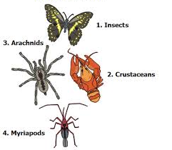

Figure 6. Organism from Phylum Arthropods

The coelomic sac, well supplied with blood vessels, gives evidence that the primary process in urine production is filtration of the blood through the wall of the coelomic sac in a manner analogous to filtration in the glomerulus and Bowman’s capsule of the vertebrate kidney (see below). In lobsters and marine crabs the urine in all parts of the organ has the same ion concentration as the blood. In freshwater crayfishes the urine has the same concentration as far as the end of the labyrinth; from that point on reabsorption takes place in the canal and the urine leaves the body as a very dilute solution. The addition of the canal to the system demonstrates one way crustaceans have adapted to life in fresh water. But this is not the only way in which the regulatory problem is solved in freshwater crustaceans. In freshwater crabs, for example, there is a great decrease in the water permeability of the surface (principally the gills) so that water enters by osmosis quite slowly. In contrast to the rate of urine flow in a freshwater crayfish (about 5 percent of the body weight per day), that of the freshwater crab is 100 times less (about 0.05 percent). In the crab the urine has the same concentration as the blood, but because the flow is so small the salt loss via the urine is negligible. A few semi terrestrial crabs are known to produce urine more concentrated than the blood.

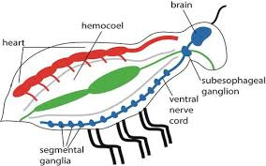

Figure 7. Coxal glands of aquatic arthropods

In all crustaceans for which analyses are available the concentrations of ions in blood and urine differ. At a urine flow of 5 percent of the body weight per day the activities of the antennal glands are certainly capable of effecting changes in the composition of the blood. These activities are somehow coordinated with salt uptake by the cells of the body surface so as to subserve homeostasis. The role of the antennal glands in nitrogenous excretion seems to be unimportant.

The malpighian tubules of insects

Although some terrestrial arthropods (e.g., land crabs, ticks) retain the coxal glands of their aquatic ancestors, others, the insects, have evolved an entirely different type of excretory system. The malpighian tubules, which vary in number from two in some species to more than 100 in others, end blindly in the body cavity (which is a blood space) and open not directly to the exterior but to the alimentary canal at the junction between midgut and hindgut. The primary urine issuing from the malpighian tubules has to pass through the rectum before it leaves the insect’s body, and in the rectum its composition is markedly changed. The insect excretory system therefore comprises the malpighian tubules and the rectum acting together.

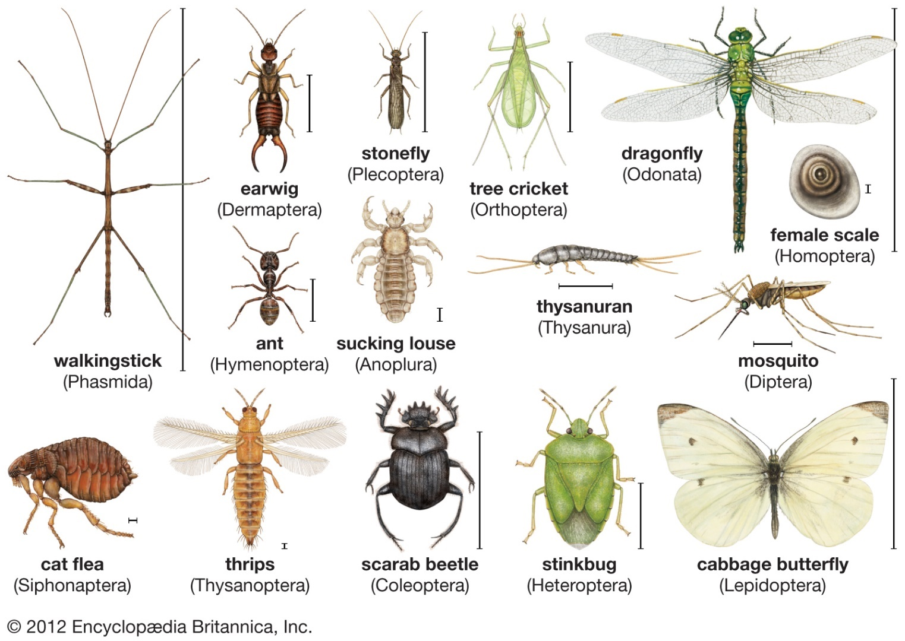

Figure 8. Different types of insects

The malpighian tubules are bathed in the insect’s blood, but since they are not rigid it is impossible for any hydrostatic pressure to be developed across their walls, such as could bring about filtration. The primary urine is formed by a process of secretion in the following way: Potassium ions are actively transported from the blood into the cavity of the tubule and are necessarily followed by negatively charged ions so as to maintain electroneutrality. In turn, water follows the ions, probably by osmosis, and various other substances—sugars, amino acids, and urate ions—also enter the primary urine by diffusion from the blood.

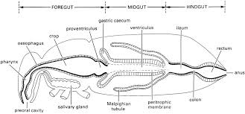

Figure 9. Malpighian tubules of insects

The primary urine, together with soluble products of digestion and insoluble indigestible matter from the midgut, then passes to the rectum. There (or in some insects at an earlier stage) the urine is acidified and the soluble urate is thereby converted to insoluble uric acid, which comes out of solution. Water is then reabsorbed together with the soluble products of digestion and other useful substances, including the bulk of the ions that entered the primary urine. In insects that live in dry surroundings the rectum have remarkable powers of reabsorption, its contents finally being voided as hard, dry pellets containing solid uric acid.

The activity of the excretory system in insects is under hormonal control. This has been most clearly demonstrated in the case of Rhodnius, a bloodsucking bug. Immediately after the ingestion of a blood meal there is a rapid flow of urine whereby most of the water taken in with the blood meal is eliminated. The distension of the body after ingestion is the stimulus that causes certain cells in the central nervous system to release a hormone that acts upon the malpighian tubules to promote a brisk flow of primary urine.

Vertebrate Excretory system

Human Excretory System

You have already learned about excretion. But did you know that in humans, the skin is also an excretory organ? That’s right; sweat is actually the waste of our body. Let us study all about the human excretory system.

Parts of the Human Excretory System

Every living organism generates waste in its body and has a mechanism to expel it. In humans, the excretory system takes care of waste generation and elimination. It comprises of the following structures:
- Kidneys
- Ureters
- Urinary bladder
- Urethra
- Human Excretory System

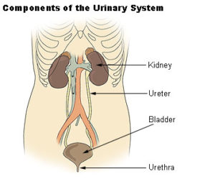

Figure 10. Parts of the Human Excretory System

Kidneys

Kidneys are the main organ of the human excretory system. Also, every individual has a pair of kidneys. They are located one on each side of the spine at the level of the liver. Kidneys are divided into three regions. Namely, the renal cortex which is the outer layer. Next, the renal medulla which is the inner layer and lastly, the renal pelvis which carries the urine from the kidney to the ureter.

Structure of a Nephron

The nephron is the functional unit of a kidney. In fact, each kidney consists of millions of nephrons. They all function together to filter blood and expel waste products. It consists of the following parts:

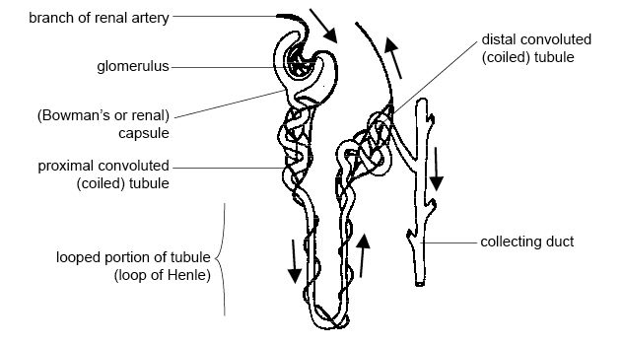

Figure 11. Structure of a Nephron

Bowman’s capsule

It is the first part of the nephron. It is a cup-shaped structure and receives the blood vessels. Glomerular filtration occurs here. The blood cells and proteins remain in the blood.

Proximal Convoluted Tubule

The Bowman’s capsule extends downwards to form the proximal tubule. Water and reusable materials from the blood are now reabsorbed back into it.

The loop of Henle

The proximal tubule leads to the formation of a u-shaped loop called the Loop of Henle. It has three parts: the descending limb, the u-shaped bend, and the ascending limb. It is in this area in which urine becomes concentrated as water is reabsorbed. The descending limb is permeable to water whereas the ascending limb is impermeable to it.

Distal Convoluted Tubule

The Loop of Henle leads into the distal convoluted tubule. It is where the kidney hormones cause their effect.

Collecting Duct

The Distal Convoluted Tubule of each nephron leads to the collecting ducts. The collecting ducts together form the renal pelvis. Through renal pelvis, the urine passes into the ureter and then into the bladder.

Ureters

There is one ureter that comes out of each kidney as an extension of the renal pelvis. It is a thin muscular tube that carries urine from the kidneys to the bladder.

Urinary Bladder

The bladder is a sac-like structure. And a smooth muscle layer lines it. It stores the urine until micturition. Furthermore, Micturition is the act of expelling urine from the body. The bladder receives urine from the ureters, one from each kidney. In addition, the level of placement of the bladder in the body differs in men and women.

Urethra

The urethra is a tube that arises from the urinary bladder. Its function is to expel the urine outside by micturition. In addition, it is shorter in females and longer in males. Furthermore, in males, it functions as a common path for sperms and urine. Also, sphincter guards the opening of the urethra.

Other Excretory Organs

Apart from the above-mentioned organs, there are other organs that perform excretion. They are:

Skin

The skin is the largest organ in the body. Its primary function is to protect the different organs of the body. In addition, the skin excretes sweat. In particular, the skin eliminates compounds like NaCl, some amount of urea etc.

Lungs

Lungs are the primary respiratory organs. They help take in oxygen and expel carbon dioxide. But, in this process, they also eliminate some amount of water in the form of vapour.

Liver

This organ has an important function in excreting waste from the body. It is the first line of defence when it comes to hormones, fats, alcohol, and drugs. In fact, most drugs undergo first-pass metabolism in this organ. The kidneys also eliminate a few drugs. Furthermore, the liver eliminates excess fats and cholesterol. This is essential to maintain the health of the body.

Functions of the Excretory System

The excretory system performs many functions such as:
- Eliminating waste products such as urea, uric acid ammonia, and other chemical products via urine.
- Maintaining the osmotic level of blood and plasma
- Maintaining the electrolyte balance in the body
- And it also helps in the metabolism of those drugs that do not get metabolized in the liver.

Practical 2

Study of Excretory System of Birds and reptiles

Study of Excretory System of Birds

In birds the excretory system is the way those organisms perform the function of discharging wastes, particularly nitrogen produces, maintain electrolyte balance, and maintain water balance. The excretory system consists of two kidneys, each with a ureter that carries urine produced by kidneys to the cloaca where it leaves the body. The cloaca is the external opening that services all systems that excrete something.

Birds are part of a limited group, including insects, reptiles, birds, and some dogs that excrete uric acid. Uric acid is nontoxic and non-soluble so it can be expelled in a paste with minimal water loss, especially for birds with a limited water source. However, the production of uric acid is one of the most energy consuming processes for the body to produce and requires more than urea synthesis. There is also no urinary bladder so that is why most birds excrete a paste like substance that is a combination of their feces and uric acid. Another advantage to uric acid is that it can accumulate in eggs without damaging the embryos of the birds.

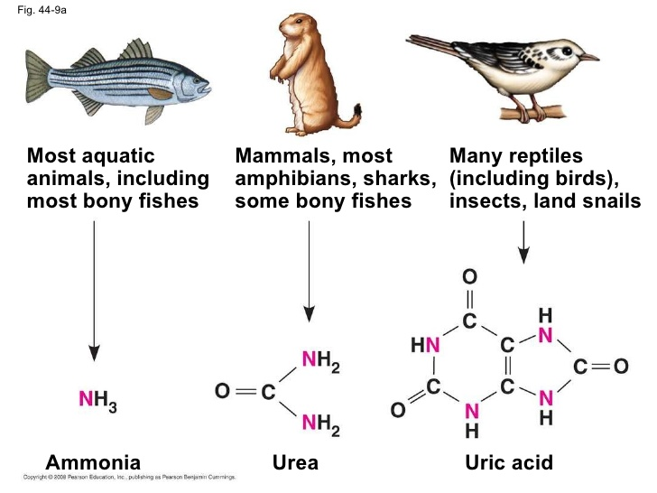

Figure 12. Comparison of excretory eystem of Birds, Mammals and Aquatic animals

This diagram is the different waste products organisms have based on environment, lifestyle, and evolution. Birds are a part of the group including reptiles and insects that excrete uric acid.

The Kidney

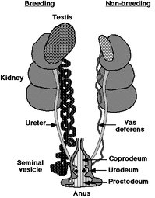

Figure 13. Structure of kidney

These are the kidneys of a male bird, because of the testis shown. Here one can see the three lobes and the different organs associated with the kidneys for excretion.

The kidneys are the body’s main organ that performs the processes of removing waste and maintaining homeostasis. The kidneys in bird are considerable larger than those of humans. They have three lobes, the cranial (top), middle, and caudal (bottom), however they lack a defined cortex, medulla, and renal pelvis. Within the kidney it is divided into different lobules. Each lobule has an outer area and medullary cone. The nephrons are located in the lobules and empty into the collecting ducts that surround the lobule.

Birds are several types of nephrons. The first is a reptile like nephron that has a small glomerulus and no loops which is found entirely in the cortex. The second type in a mammalian type that as convoluted tubules with the cortex and its loop descending into the medulla, all of which is capable of concentration urine. While the mammalian type nephron always has a high filtration on, the reptile one has a low filtration that ducts down during heavy salt loads. The combination of this strategy conserves water and maximizes urine concentration during osmotic challenges.

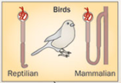

These are the different types of nephrons a bird has in their kidney's to create an excellent water retention system.

Study of Excretory System of reptiles

Excretory Systems

Excretion is performed mainly by two small kidneys. In crocodilians, snakes, lizards, and tuatara, uric acid is the main nitrogen-containing waste product. Turtles, like mammals, mainly excrete urea. Unlike the kidneys of mammals and birds, reptile kidneys are unable to produce liquid urine that is more concentrated than their body fluids. This is because they lack a specialized structure present in the nephrons of birds and mammals called the Loop of Henle. Because of this, many reptiles use the colon to aid in the reabsorption of water. Some are also able to take up water stored in the bladder. Excess salts are also excreted by salt glands found in the nasal passages and tongues of some reptiles. Marine iguanas, shown in Figure below, excrete excess salt through their nasal glands, and crocodiles excrete salt through their lingual (tongue) salt glands.

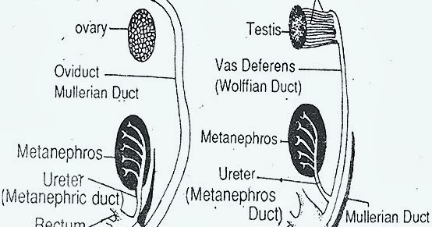

Figure 14. Excretory System of reptiles

Comparison of Birds and Reptiles
EXCRETORY SYSTEM -GARDEN LIZARD | EXCRETORY SYSTEM -PIGEON
1. Paired kidneys are dark red and irregular in shape. These are flattened organs. | 1. Kidneys are dark red and some what rectangular and flattened organs.
2. Kidneys are located in the posterior region of the abdominal cavity and attached to the dorsal wall by a fold of peritoneum. | 2. Kidneys are situated in the anterior part of the abdomen.
3. Right and left kidneys are opposite to each other. | 3. Same as in calotes
4. They are attached to the dorsal muscles. | 4. They are fitted in the hollows of the pelvic girdle.
5. They are very near to the median line kidneys are Metanephros type. | 5. They are a little away from the median line. Kidneys are Meta nephros type.
6. Each kidney has two lobes Anterior lobe is broad and posterior lobe is broad Hilus is absent. | 5. Each kidney has three lobes They are anterior, median and posterior lobes. Hilus is absent.
7. The two kidneys are united posteriorly forming a V - shaped structure. | 7. The two kidneys are separate and do not fuse with each other.
8. The two ureters are narrow, thin-walled ducts extending behind from the kidneys to the cloaca, where these open into the urodaeum. | 8. Same as in Calotes.
9. There is no pelvis. | 9. There is no pelvis.
10. In males the ureters join at its posterior end with its corresponding vas deferens and both open by a common urino-genital aperture. | 10 The ureters do not join with the vas deferens and both open separately into the cloaca.
11. A thin walled urinary bladder opens on the ventral side of cloaca | 11. Urinary bladder is absent
12. Urinary bladder communicates with urodaeum thrumph its ventral wall. | 12. _
13. Calotes is uricotelic animal Urine consists n.ainly of uric acid. | 13. Urine consists mainly of uric acid cotelic animal
14. Urine is excreted in a semi solid state. | 14. Urine is excreted ir a semisolid state (Bird droppinos).

Practical 3

Comparative Anatomy of Excretory System of Fish, Frog and Rabbit

Kidneys are the major excretory organs in all vertebrates. Some other organs such as lungs, gills, liver, intestine and skin also remove certain waste materials besides their normal functions. These are also known as the accessory excretory organs. Both shark and frog are anamniotic animals.

The kidneys lie dorsal to the coelom and are composed of large number of renal or uriniferous tubules. A uriniferous tubule typically consists of three regions - a ciliated peritoneal funnel, a malpighian body and a ciliated convoluted tube. The malpighian body is a two layered cup, the 'Bowman's capsule' containing a mass of capillaries the 'glomerulus'. The convoluted tube opens into a longitudinal duct which extends backwards and opens into the cloaca. The excretory organs remove the nitrogenous waste products formed during the metabolic activities from time to time. If these products are not removed from the body, they are changed to toxic substances.

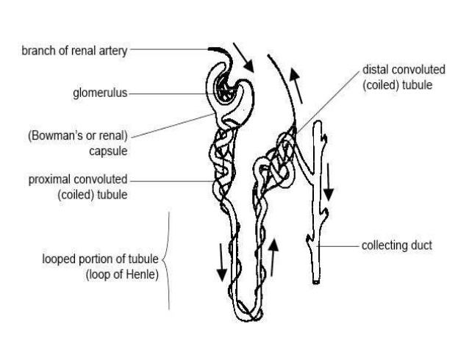

Figure 15. Excretory System of Fish
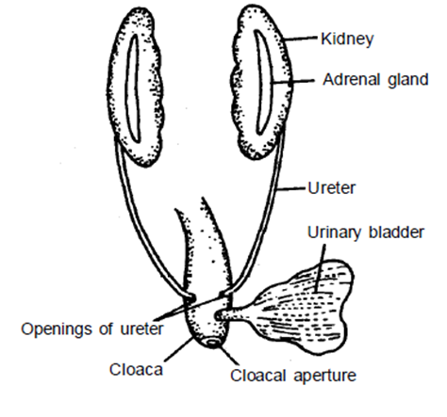

Figure 16. Excretory system of frog

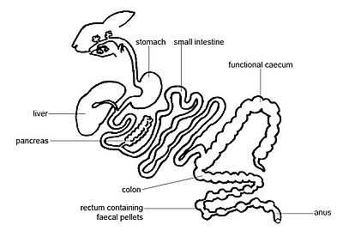

Figure 17. Excretory System of Rabbit

EXCRETORY SYSTEM OF FISH | EXCRETORY SYSTEM OF FROG | EXCRETORY SYSTEM OF RABBIT
1. Paired kidneys are very long and ribbon like. | 1. Paired kidneys are short and roughly oval in shape. | 1. The kidneys in rabbit are metanephric
2. Each kidney is differentiated into a small non-renal part (genital part) and a long posterior renal part. The two parts exhibit morphological difference. | 2. Each kidney possesses genital as well as renal region. But these are not morphologically differentiated. | 2. The kidneys are dark red, bean shaped situated in the middle of the abdominal cavity.
3. The kidneys are uriniferous 'Opisthonephros' but functional Mesonephros. | 3. The kidneys are mesonephros. | 3. The right kidney is slightly more anteriorly placed than the left.
4. Some uriniferous tubules retain peritoneal funnel. | 4. The peritoneal funnels are absent. | 4. The inner margin of each kidney consists of a notch called hilus.
5. The uriniferous tubules have a specialised urea - absorbing segment. | 5. The urea-absorbing segment is absent. | 5. Ureter emerges from the hilus
6. Uriniferous tubules lead into special tubes - the urinary ducts (ureters). These are distinct from wolffian ducts. | 6. Uriniferous tubules lead into the wolffian ducts. | 6. The ureter expands into a funnel-like pelvis in the kidney.
7. Ureters run back ward over the ventral surface of the kidneys. | 7. Wolffian ducts leave outer border of kidneys and run backward. | 7. The two ureters run posteriorly and open separately into the urinary bladder.
8. Ureters are independent ducts to carry urine from the kidneys to the Urinogenital sinuses. | 8. The ureters serve for the passage of genital elements as well as urine. So they are known as urino-genital ducts.Urino genital sinus is absent. | 8. The ureters carry only urine into the urinary bladder both in male and female.
9. The urinary bladder is absent. | 9. A large bilobed urinary bladder is present. It opens into the cloaca opposite the openings of the ureters. | 9. The neck of urinary bladder opens into the urethra that lies in penis. Urethra opens out by an opening at the tip of penis in males. In females it opens into vestibule that inturn opens out by vulva present behind the ciitoris.
10. The urine is hypotonic to blood. | 10. The urine is hypertonic to blood. | 10. The urinary bladder is thin walled, muscular and its neck is called urethra.
11. Scoliodon is a ureotelic animal. The endproduct of nitrogen metabolism is urea. A large Quantity of urea is retained in the body as an adaptation to marine life.Excess of urea is excreted chiefly through its gills. | 11. Frog is also ureotelic animal. It excretes urine from the cloaca in the form of urea. | 11. The kidney is without bidder's canal
 |  | 12. The kidneys are supplied with a renal artery and a renal vein. Renal portal vein is absent.
13. Uriniferous tubule is divided into
i. Proximal convoluted tubule
ii. Henle's loop and
iii. Distal convoluted tubule.

Practical 5

Study of Excretory System of Grasshopper
Introduction:
Insects are arthropods with jointed appendages, segmented bodies, and an exoskeleton composed of chitin. Insects are in the class Insecta, & are the largest and most diverse group of animals on earth. The genus Romalea is a large grasshopper common in the southeastern United States. Insects have three body regions (head, thorax, & abdomen), 3 pairs of legs attached to the thorax, a single pair of antenna attached to the head, mouthparts adapted for chewing or sucking, and two pairs of wings. Some insects may have a single pair of wings or be wingless. Insect legs are often adapted for digging, crawling, jumping, or swimming. The insects are mostly terrestrial; they breathe air which enters small lateral openings on the body called spiracles and circulates in a system of ducts to all organs and tissues. Their chewing or sucking mouth parts are adapted for feeding on plant or animal materials.
Classification:
Kingdom - Animalia Phylum - Arthropoda Class - Insecta Order - Orthoptera

Objective:
Identify & label the internal & external anatomy of a grasshopper.

Materials:
Model of Grasshopper

Different types and their functional mechanisms
The removal of waste products of metabolism, especially nitrogenous compounds from the body of insects is known as excretion. The excretion process helps the insect to maintain salt water balance and thereby physiological homeostasis. Following are the excretory organs.

- Malpighian tubules
Thin, blind-ending tubules, originating near the junction of mid and hindgut, predominantly involved in regulation of salt, water and nitrogenous waste excretion. This structure was discovered by Marcello Malpighi.

- Nephrocytes
Cells that sieve the haemolmph for products that they metabolize (pericardial cells).

- Fat bodies
A loose or compact aggregation of cells, mostly trophocytes, suspended in the
haemocoel, responsible for storage and excretion.

- Oenocytes
The cells of haemocoel, epidermis or fat body with many functions.

- Integument
The outer covering of the living tissues of an insect.

- Tracheal system
The insect gas exchange system, comprising tracheae and tracheoles.

- Rectum
Rectum is the posterior part of hind gut. Among the above organs, malpighian tubules are the major organ of excretion.
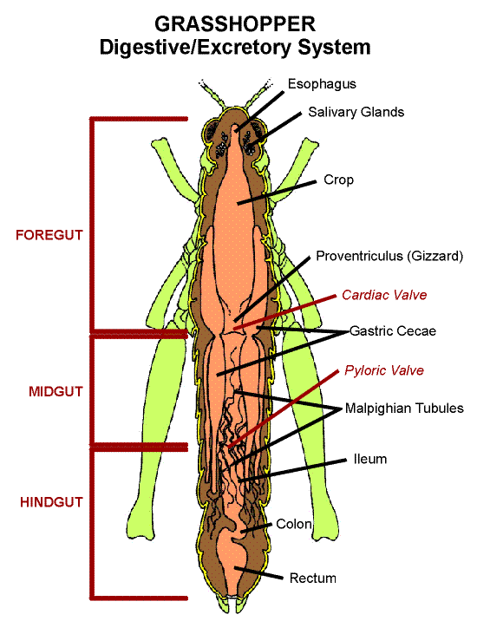
Figure 18. Excretory system of Grasshopper

Practical 5

Excretory system of Frog (Dissection)

Objectives:

• Describe the appearance of various organs found in the frog.

• Name the organs that make up excretory system of the frog.

Purpose:

In this lab, you will dissect a frog in order to observe the excretory system of frog anatomy.

Materials:

• Safety goggles, gloves, and a lab apron

• Forceps

• preserved frog

• dissecting pins (6–10)

• dissecting tray and paper towels

• Plastic storage bag and twist tie

• Scissors

• marking pen

• dissecting needle

Procedure:

- Put on safety goggles, gloves, and a lab apron.
- Place a frog on a dissection tray. To determine the frog’s sex, look at the hand digits, or fingers, on its forelegs. A male frog usually has thick pads on its “thumbs,” which is one external difference between the sexes, as shown in the diagram below. Male frogs are also usually smaller than female frogs. Observe several frogs to see the difference between males and females.
- Use the diagram below to locate and identify the external features of the head. Find the mouth, external nares, tympani, eyes, and nictitating membranes.
- Turn the frog on its back and pin down the legs. Cut the hinges of the mouth and open it wide. Use the diagram below to locate and identify the structures inside the mouth. Use a probe to help find each part: the vomerine teeth, the maxillary teeth, the internal nares, the tongue, and the openings to the Eustachian tubes, the esophagus, the pharynx, and the slit-like glottis.
- Look for the opening to the frog’s cloaca, located between the hind legs. Use forceps to lift the skin and use scissors to cut along the center of the body from the cloaca to the lip. Turn back the skin, cut toward the side at each leg, and pin the skin flat. The diagram above shows how to make these cuts
- Lift and cut through the muscles and breast bone to open up the body cavity. If your frog is a female, the abdominal cavity may be filled with dark-colored eggs. If so, remove the eggs on one side so you can see the organs underlying them.
- Use the diagram below to locate and identify the organs of the digestive system: esophagus, stomach, small intestine, large intestine, cloaca, liver, gallbladder, and pancreas.
- Again refer to the diagram below to identify the parts of the circulatory and respiratory systems that are in the chest cavity. Find the left atrium, right atrium, and ventricle of the heart. Find an artery attached to the heart and another artery near the backbone. Find a vein near one of the shoulders. Find the two lungs.
- Use a probe and scissors to lift and remove the intestines and liver. Use the diagram on the next page to identify the parts of the urinary and reproductive systems. Remove the peritoneal membrane, which is connective tissue that lies on top of the red kidneys. Observe the yellow fat bodies that are attached to the kidneys. Find the ureters; the urinary bladder; the testes and sperm ducts in the male; and the ovaries, oviducts, and uteri in the female.
- Remove the kidneys and look for threadlike spinal nerves that extend from the spinal cord. Dissect a thigh, and trace one nerve into a leg muscle. Note the size and texture of the leg muscles.
- Dispose of your materials according to the directions from your teacher.
- Clean up your work area and wash your hands before leaving the lab.

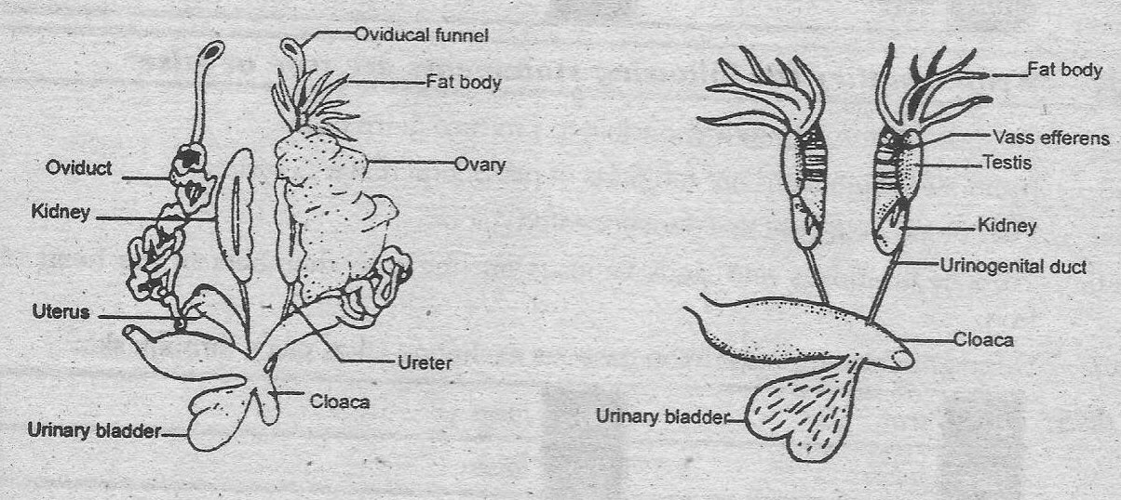

Figure 19. Excretory system of Frog

Practical 6

Study of digestive system in invertebrate and a vertebrate representative

Vertebrate Digestive Systems

Vertebrates have evolved more complex digestive systems to adapt to their dietary needs. Some animals have a single stomach, while others have multi-chambered stomachs. Birds have developed a digestive system adapted to eating un-masticated food.

Monogastric: Single-chambered Stomach

As the word monogastric suggests, this type of digestive system consists of one (“mono”) stomach chamber (“gastric”). Humans and many animals have a monogastric digestive system as illustrated in Figure 20a and 20b. The process of digestion begins with the mouth and the intake of food. The teeth play an important role in masticating (chewing) or physically breaking down food into smaller particles. The enzymes present in saliva also begin to chemically break down food. The esophagus is a long tube that connects the mouth to the stomach. Using peristalsis, or wave-like smooth muscle contractions, the muscles of the esophagus push the food towards the stomach. In order to speed up the actions of enzymes in the stomach, the stomach is an extremely acidic environment, with a pH between 1.5 and 2.5. The gastric juices, which include enzymes in the stomach, act on the food particles and continue the process of digestion. Further breakdown of food takes place in the small intestine where enzymes produced by the liver, the small intestine, and the pancreas continue the process of digestion. The nutrients are absorbed into the blood stream across the epithelial cells lining the walls of the small intestines. The waste material travels on to the large intestine where water is absorbed and the drier waste material is compacted into feces; it is stored until it is excreted through the rectum.

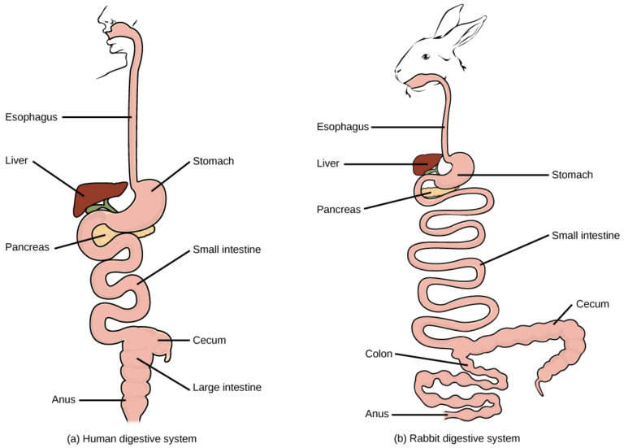

Figure 20. (a) Humans and herbivores, such as the (b) rabbit, have a monogastric digestive system. However, in the rabbit the small intestine and cecum are enlarged to allow more time to digest plant material. The enlarged organ provides more surface area for absorption of nutrients. Rabbits digest their food twice: the first time food passes through the digestive system, it collects in the cecum, and then it passes as soft feces called cecotrophes. The rabbit re-ingests these cecotrophes to further digest them.

Avian

Birds face special challenges when it comes to obtaining nutrition from food. They do not have teeth and so their digestive system, shown in Figure 21, must be able to process un-masticated food. Birds have evolved a variety of beak types that reflect the vast variety in their diet, ranging from seeds and insects to fruits and nuts. Because most birds fly, their metabolic rates are high in order to efficiently process food and keep their body weight low. The stomach of birds has two chambers: the proventriculus, where gastric juices are produced to digest the food before it enters the stomach, and the gizzard, where the food is stored, soaked, and mechanically ground. The undigested material forms food pellets that are sometimes regurgitated. Most of the chemical digestion and absorption happens in the intestine and the waste is excreted through the cloaca.

Illustration shows an avian digestive system. Food is swallowed through the esophagus into the crop, which is shaped like an upside-down heart. From the bottom of the crop food enters a tubular proventriculus, which empties into a spherical gizzard. From the gizzard, food enters the small intestine, then the large intestine. Waste exits the body through the cloaca. The liver and pancreas are located between the crop and gizzard. Rather than a single cecum, birds have two caeca at the junction of the small and large intestine.

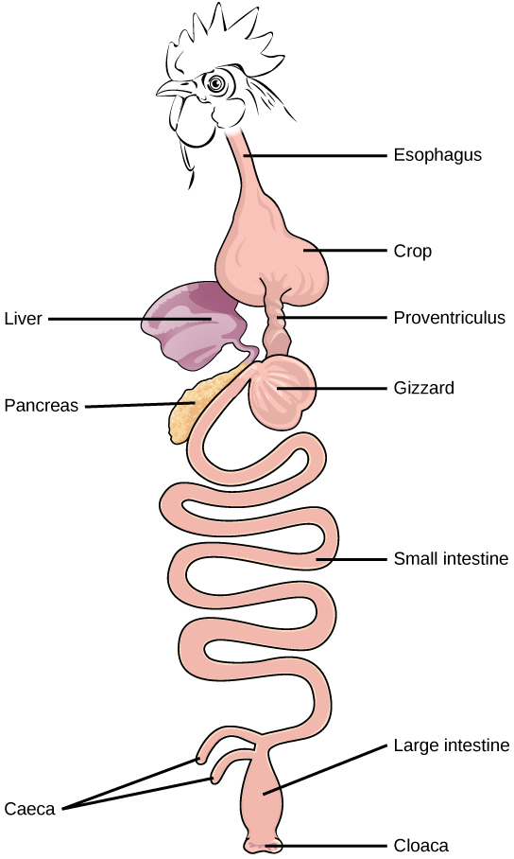

Figure 21 The avian esophagus has a pouch, called a crop, which stores food.

In the avian digestive system, food passes from the crop to the first of two stomachs, called the proventriculus, which contains digestive juices that break down food. From the proventriculus, the food enters the second stomach, called the gizzard, which grinds food. Some birds swallow stones or grit, which are stored in the gizzard, to aid the grinding process. Birds do not have separate openings to excrete urine and feces. Instead, uric acid from the kidneys is secreted into the large intestine and combined with waste from the digestive process. This waste is excreted through an opening called the cloaca.

Ruminants

Ruminants are mainly herbivores like cows, sheep, and goats, whose entire diet consists of eating large amounts of roughage or fiber. They have evolved digestive systems that help them digest vast amounts of cellulose. An interesting feature of the ruminants’ mouth is that they do not have upper incisor teeth. They use their lower teeth, tongue and lips to tear and chew their food. From the mouth, the food travels to the esophagus and on to the stomach.

To help digest the large amount of plant material, the stomach of the ruminants is a multi-chambered organ, as illustrated in Figure 22. The four compartments of the stomach are called the rumen, reticulum, omasum, and abomasum. These chambers contain many microbes that break down cellulose and ferment ingested food. The abomasum is the “true” stomach and is the equivalent of the monogastric stomach chamber where gastric juices are secreted. The four-compartment gastric chamber provides larger space and the microbial support necessary to digest plant material in ruminants. The fermentation process produces large amounts of gas in the stomach chamber, which must be eliminated. As in other animals, the small intestine plays an important role in nutrient absorption, and the large intestine helps in the elimination of waste. Illustration shows the digestive system of a goat. Food passes from the mouth, through the esophagus and into the rumen. It circulates clockwise through the rumen, then moves forward, and down into the small, pouch-shaped reticulum. From the reticulum the food, which is now cud, is regurgitated. The animal chews the cud, and then swallows it into the coiled omasum, which sits between the reticulum and the rumen. After circulating through the omasum the food enters the small intestine, then the large intestine. Waste is excreted through the anus.

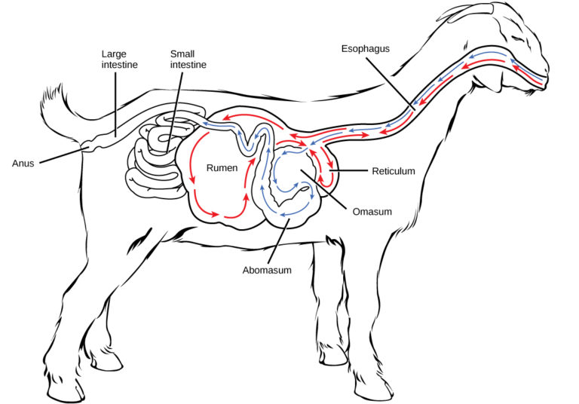

Figure 22. Ruminant animals, such as goats and cows, have four stomachs. The first two stomachs, the rumen and the reticulum, contain prokaryotes and protists that are able to digest cellulose fiber. The ruminant regurgitates cud from the reticulum, chews it, and swallows it into a third stomach, the omasum, which removes water. The cud then passes onto the fourth stomach, the abomasum, where it is digested by enzymes produced by the ruminant.

Pseudo-ruminants

Some animals, such as camels and alpacas, are pseudo-ruminants. They eat a lot of plant material and roughage. Digesting plant material is not easy because plant cell walls contain the polymeric sugar molecule cellulose. The digestive enzymes of these animals cannot break down cellulose, but microorganisms present in the digestive system can. Therefore, the digestive system must be able to handle large amounts of roughage and break down the cellulose. Pseudo-ruminants have a three-chamber stomach in the digestive system. However, their cecum—a pouched organ at the beginning of the large intestine containing many microorganisms that are necessary for the digestion of plant materials—is large and is the site where the roughage is fermented and digested. These animals do not have a rumen but have an omasum, abomasum, and reticulum.

Invertebrate Digestive Systems
Animals have evolved different types of digestive systems to aid in the digestion of the different foods they consume. The simplest example is that of a gastro-vascular cavity and is found in organisms with only one opening for digestion. Platyhelminthes (flatworms), Ctenophora (comb jellies), and Cnidaria (coral, jelly fish, and sea anemones) use this type of digestion. Gastro-vascular cavities, as shown in Figure 23a, are typically a blind tube or cavity with only one opening, the “mouth”, which also serves as an “anus”. Ingested material enters the mouth and passes through a hollow, tubular cavity. Cells within the cavity secrete digestive enzymes that break down the food. The food particles are engulfed by the cells lining the gastro-vascular cavity.
The alimentary canal, shown in Figure 23b, is a more advanced system: it consists of one tube with a mouth at one end and an anus at the other. Earthworms are an example of an animal with an alimentary canal. Once the food is ingested through the mouth, it passes through the esophagus and is stored in an organ called the crop; then it passes into the gizzard where it is churned and digested. From the gizzard, the food passes through the intestine, the nutrients are absorbed, and the waste is eliminated as feces, called castings, through the anus.
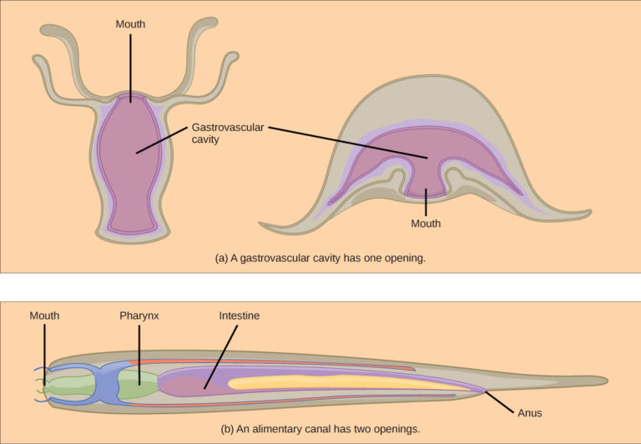

Figure 23 (a) A gastro-vascular cavity has a single opening through which food is ingested and waste is excreted, as shown in this hydra and in this jellyfish medusa. (b) An alimentary canal has two openings: a mouth for ingesting food, and an anus for eliminating waste, as shown in this nematode.
Practical 7

Study of digestive system in Reptiles (Model)

The digestive system of modern reptiles is similar in general plan to that of all higher vertebrates. The digestive system of Garden Lizard (Calotes) is formed of the alimentary canal and digestive glands.

Alimentary Canal:

The alimentary canal is a convoluted tube beginning from mouth and ends in a cloaca.

1. Mouth:

It is a wide transverse slit bounded by the upper and lower jaws, bearing teeth. Teeth are small, conical and similar (homodont), and directed backward. They are attached with the inner lateral sides of jaw bones. Such type of attachment of teeth is called pleurodont. They are adapted to catching and holding and not for chewing.

2. Buccal Cavity:

Mouth leads into a large and dorsoventrally compressed buccal cavity. In its roof open two small openings of internal nares and on its floor is present a narrow, elongated and fleshy protrusible tongue which is bifid in front.

3. Pharynx:

It is the posterior part of the buccal cavity. At the back of the tongue is present the glottis. In the pharynx are also present a pair of lateral openings of eustachian tubes and a posterior wide opening the gullet, leading to oesophagus.
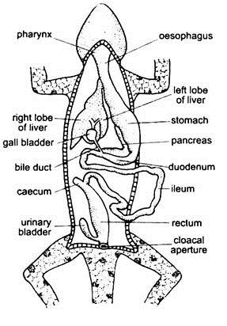

Figure 24. Digestive System of Reptiles

4. Oesophagus:

It is a straight, narrow tube passing through the neck dorsal to trachea and opens into stomach.

5. Stomach:

It is a muscular, cylindrical tube, which, though expansible, is little wider than the oesophagus. The stomach is not quite distinct into cardiac and pyloric portion. The posterior pyloric stomach leads into small intestine through pyloric sphincter.

6. Small Intestine:

The small intestine is a long, narrow and coiled tube. Its small anterior, U-shaped part is the duodenum and the posterior, much coiled part is the ileum. The duodenum receives the bile and pancreatic ducts. The ileum leads into the large intestine or rectum. At the point where the small intestine joins the rectum, the latter is produced into a short caecum.

7. Large Intestine:

It is small, sac-like, thick-walled tube, opening into cloaca by a sphinctered anus. The colon is absent.

8. Cloaca:

The cloaca is linearly subdivided into coprodaeum, urodaeum and proctodaeum. The last part opens externally through a sphinctered cloacal aperture.

Digestive Glands:
Digestive glands include mucous and salivary glands, gastric glands, liver, pancreas and intestinal glands. In the buccal cavity are present few unicellular mucous and salivary glands. The liver is a large, bilobed, brownish gland and placed on the dorsal side of stomach, behind the heart. The gall bladder is a small, rounded sac lying in a cleft at the lower margin of the right liver lobe. It acts as a reservoir for bile secreted by the liver cells.

The bile duct from the gall bladder opens into the upper part of duodenum. Pancreas is a whitish elongated structure situated in between the stomach and duodenum. It opens into the duodenum by a separate pancreatic duct. It secretes the pancreatic juice which is alkaline in nature and contains three enzymes, trypsin, amylopsin and lipase. The unicellular gastric glands are present in the inner wall of stomach which secretes gastric juice containing digestive enzyme pepsin. Besides this, unicellular parietal glands are also present in its wall that secretes hydrochloric acid.

Food, Feeding Mechanism and Digestion:

The Garden Lizard (Calotes) mainly feeds on small living insects. It catches its prey with the help of sticky tongue and taken in the buccal cavity.

Digestion occurs in the stomach where HCl and pepsin react on the food. HCl makes the medium acidic and kills the bacteria, while pepsin reacts with the food protein and breaks it into peptones and proteases. Later on partly digested food (chyme) enters the duodenum where bile from gall bladder neutralises the acidic chyme and emulsifies the fat portion of the food. In the duodenum also, the alkaline pancreatic juice reacts with the protein, carbohydrate and fat parts of the chyme.

Enzyme trypsin reacts with the protein, peptones and proteases and converts them into amino acids. Amylopsin reacts with the carbohydrates and transforms into glucose, and lipase reacts with emulsified fat, transforming into fatty acid and glycerol.

The digested food enters the ileum where the digested food is absorbed and the undigested food is stored in the rectum and egested periodically through cloaca.

Practical 8

Study of digestive system in Fish (Dissection)
The digestive system

The digestive system, in a functional sense, starts at the mouth, with the teeth used to capture prey or collect plant foods. Mouth shape and tooth structure vary greatly in fishes, depending on the kind of food normally eaten. Most fishes are predacious, feeding on small invertebrates or other fishes and have simple conical teeth on the jaws, on at least some of the bones of the roof of the mouth, and on special gill arch structures just in front of the esophagus. The latter are throat teeth. Most predacious fishes swallow their prey whole, and the teeth are used for grasping and holding prey, for orienting prey to be swallowed (head first) and for working the prey toward the esophagus. There are a variety of tooth types in fishes. Some fishes, such as sharks and piranhas, have cutting teeth for biting chunks out of their victims. A shark’s tooth, although superficially like that of a piranha, appears in many respects to be a modified scale, while that of the piranha is like that of other bony fishes, consisting of dentine and enamel. Parrot fishes have beaklike mouths with short incisor-like teeth for breaking off coral and have heavy pavementlike throat teeth for crushing the coral. Some catfishes have small brushlike teeth, arranged in rows on the jaws, for scraping plant and animal growth from rocks. Many fishes (such as the Cyprinidae or minnows) have no jaw teeth at all but have very strong throat teeth.

Some fishes gather planktonic food by straining it from their gill cavities with numerous elongate stiff rods (gill rakers) anchored by one end to the gill bars. The food collected on these rods is passed to the throat, where it is swallowed. Most fishes have only short gill rakers that help keep food particles from escaping out the mouth cavity into the gill chamber.

Once reaching the throat, food enters a short, often greatly distensible esophagus, a simple tube with a muscular wall leading into a stomach. The stomach varies greatly in fishes, depending upon the diet. In most predacious fishes it is a simple straight or curved tube or pouch with a muscular wall and a glandular lining. Food is largely digested there and leaves the stomach in liquid form.

Between the stomach and the intestine, ducts enter the digestive tube from the liver and pancreas. The liver is a large, clearly defined organ. The pancreas may be embedded in it, diffused through it, or broken into small parts spread along some of the intestine. The junction between the stomach and the intestine is marked by a muscular valve. Pyloric ceca (blind sacs) occur in some fishes at this junction and have a digestive or absorptive function or both.

The intestine itself is quite variable in length, depending upon the fish’s diet. It is short in predacious forms, sometimes no longer than the body cavity, but long in herbivorous forms, being coiled and several times longer than the entire length of the fish in some species of South American catfishes. The intestine is primarily an organ for absorbing nutrients into the bloodstream. The larger its internal surface, the greater it’s absorptive efficiency and a spiral valve is one method of increasing its absorption surface.

Sharks, rays, chimaeras, lungfishes, surviving chondrosteans, holosteans, and even a few of the more primitive teleosts have a spiral valve or at least traces of it in the intestine. Most modern teleosts have increased the area of the intestinal walls by having numerous folds and villi (fingerlike projections) somewhat like those in humans. Undigested substances are passed to the exterior through the anus in most teleost fishes. In lungfishes, sharks, and rays, it is first passed through the cloaca, a common cavity receiving the intestinal opening and the ducts from the urogenital system.

Dissection of Trout Fish:
Objective:
To give the students a chance to get a firsthand look at the inside of a trout and how their bodies work.

Background:
Trout exist in abundance in the streams throughout New York City's three watersheds. The Catskill, Delaware, and Croton, which supply New York City with it's drinking water, are healthy and clean sources of water. Because trout are indicator species, scientists measure their populations and health to determine the health of a stream.

Materials:
A whole fresh or frozen (thawed) trout
Dissecting tools (scissors, tweezers or forceps, probe, magnifying glass)
Newspapers and paper towels
Trout Anatomy diagram/ reference sheet to explain the function of each organ or characteristic.

Procedure:

- Choose a location where students can view the dissection. Cover the surface with newspaper.
- Study the external anatomy. Have students feel the fish’s skin and discuss what purpose the slime serves. (It protects against growth of fungus and it allows the fish to glide more easily through the water.) Have students use the magnifying glass to examine the scales and note how they are arranged. Have students describe the color patterns and discuss function of coloration (camouflage).
- Observed the lateral line. Discuss what it is used for and the way it works. Have students describe the fish’s overall shape and how this adaptation is beneficial to the fish. Look at the placement of the fins and ask students to imagine the fish swimming in the water. How does it move? How are the fins used? Note the range of movement of each fin.
- Allow students to feel the bony rays that support the fins. Have a volunteer count the number of rays on the anal fin. This is one of the most distinguishing characteristics of salmonids.
- Notice the relatively large size of the eyes along with the large pupil tells us how important vision is for this animal. Have students note that there is no eyelid. Have them observe the tough, clear membrane that covers the eye. Rotate the eye in the socket with a finger.
- Locate the nostrils. Describe the large olfactory lobes that are located in the brain. Ask students to speculate why a salmonoids smell receptors are so highly developed.
- Open the mouth, note the color of the gums, feel the teeth along the gum margins and on the roof of the mouth. What function these teeth perform? (The teeth are used for grasping and holding onto prey.) Note how wide the mouth opens and comment on why this is. Point out that the mouth is also used for breathing. In low oxygen conditions, fish actively pump water over gills by opening and closing the mouth. Demonstrate this action with the fish’s mouth.
- Point out the gills arches by having students look down the fish’s mouth. Use a probe to separate the arches and explore how they are arranged.
- Place the fish on its side and look at the operculum—the bony plates which protect the gills. Lift the operculum to see the gills. Cut the operculum away from its base, exposing the gills.
- Remove the gills by cutting the upper and lower attachments of the arch. Look at the gill rakers, the bony projections along the inside curve of the arches. Observe the large surface area provided by the gill filaments, and the thin tissue which allows blood vessels to come into contact with the oxygen in the water. Compare and contrast gills and lungs.
- Carefully cut the fish open using the scissors or scalpel. Let students observe how all the internal organs fit together. Look for the thin transparent membrane that encloses the organs. Cut away the flap of skin and look for fat deposits, which are found around the stomach.
- Look for the swim bladder. It is made of very thin tissue and is located in the upper body cavity, below the kidneys. It will be less developed in small fish and will not be inflated. It may be hard to find. If you can’t find it, point to its location and discuss its function.
- The male reproductive organs will be a flaccid white or orange tissue near the intestines. Eggs may or may not be noticeable in females and vary in size depending the fishes maturity.
- Put the fish on its back to find the kidney, located under the backbone. They are thin, dark in color and run the length of the body cavity. Ask a volunteer to discuss kidney functions.
- Investigate the digestive track by starting in the mouth and following the route that food would take. Put the probe through the mouth and esophagus to show the route. Follow the course of the stomach using a finger or probe. The first area of the stomach is called the cardiac stomach (where digestion begins.) Notice the different kinds of tissue that make up the stomach.
- The pyloric stomach (portion from which the pyloric ceca project) is made of different tissue and begins at bend below the cardiac stomach. Stomach area is increased by the pyloric ceca, how this improves the function of the stomach.
- The intestines extract nutrients from food. A network of blood vessels is used for nutrient exchange. Follow the intestines to the anal opening, where waste products are eliminated.
- Lift the stomach to show/discuss the spleen (reddish organ near end of the cardiac stomach.)
- The liver is in front of the stomach. Discuss it's role in the digestion of fats. Point out the gall bladder, a mass of darker tissue on the liver.
- Locate the heart, found near the fish’s mouth. Make out the different chambers. The gills, heart, and liver close together for a reason. Blood pressure is best near the heart (pump). Blood is filtered by the liver, and absorbs oxygen from the gills; both are vital functions.
- Cut through the fish to expose the backbone, muscles and muscle mass (this is the part we eat.)
- Carefully cut away the skin by lifting it while running the scalpel along the skin-muscle interface. The skin may be thin enough to place under a microscope or magnifying glass to observe the pattern of the scales and the growth rings. Remove scales to look at the rings.
- Compare trout anatomy to a mammal's.

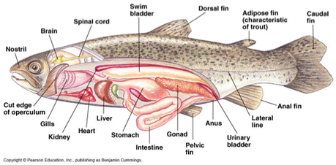

Figure 25. Digestive system in Fish

Practical 9

Study of digestive system in Honey Bee (Model)

The bee digestive system

The mouth is connected directly to the esophagus, and the esophagus extends through the head and thorax all the way back to the abdomen. In honey bees, after food goes through the esophagus it travels into the crop (or honey stomach) where it is stored for transport back to the hive.

At the end of the crop is a one-way valve known as the proventriculus. Anything that passes through this valve moves on to the ventriculus (also known as the true stomach or digesting stomach) where it is digested. But anything that goes through the one-way valve cannot go back the other way. So food that is digested cannot re-enter the crop, and this is why nectar is not bee vomit. Nectar that will be used to make honey never makes it into the digesting stomach, only the crop.

The ventriculus is lined with cells that secrete enzymes that digest any nectar and pollen that has passed through the one-way valve. At the far end, the ventriculus is attached to the ileum, which is like a small intestine.

Right where the ventriculus meets the ileum, about one hundred malpighian tubules connect to the digestive tract. Malpighian tubules act like our kidneys. Just like our kidneys filter waste products from our blood, the malpighian tubles filter waste products from the bee’s hemolymph. This liquid waste, which is analogous to urine, is dumped into the ileum where it joins the solid waste from the ventriculus.

The ileum removes nutrients from the digested food and moves the waste further along the digestive tract. From the ileum, the waste products from both the ventriculus and the malpighian tubules move into the rectum where it is stored until the bee can defecate through the anus.

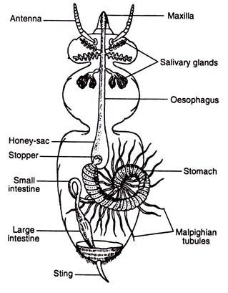

Figure 26. Digestive system in Honey Bee

The waste stream of a honey bee

All bees are built in a similar way, but the crop is more developed in those species that carry nectar back to the nest. The flow of food and waste through a honey bee looks like this:

mouth↔ esophagus↔ crop (honey stomach) → proventriculus (one-way valve)→ventriculus (digesting stomach)→ileum (intestine)→[waste from malpighian tubules joins food waste in the ileum]→rectum→ anus

So back to the photo, I would say the bee was defecating rather than urinating. But clearly she had a lot to drink that day. Who knows? Maybe she was getting ready for a mandatory drug test and was trying to flush away all the poppy nectar she drank.

Practical 10

Study of digestive system in Cockroach (Dissection)

EQUIPMENT

Forceps

Scissors

Pins

Petri dish with water

Microscope
Procedure

- Take a look at the external parts of the cockroach. Can you find the basic structures of an insect? Find the cephalothorax and thorax, which are clearly separated from each other. The cockroach has a hard exoskeleton consisting of different parts. In the cephalothorax, there are antennae, compound eyes and small ocelli close to the antennae. The compound eyes consist of small ommatidia, which can be seen through a microscope. In the end of the abdomen you can also find cerci (bristles). Turn the cockroach upside down to see the respiratory openings.

- Take a look at the mouthparts of the cockroach with a microscope. On the external side, you can see two different pairs of jaws. The upper jaws (mandibles) are strong structures which cut and chew food. The lower jaws (maxilla) are thread-like structures which move the food towards the other mouthparts. You can try to separate the mouthparts with forceps and try to separate them under a microscope. You can also find a hypopharynx which salivates the chewed food. In addition, you can find an upper lip (labrum), and lower lip (labium) with labial palps.
- After investigating the mouthparts, you can take a look at the thorax. There are three segments, each with a pair of appendages. The first segment of the thorax forms a bigger carapace (shell). The second segment contains elytra (covering wings) and the third segment contains flight wings. Insects have three pairs of appendages (legs). An appendage consists of hips (coxa), a trochanter, a thigh (femur), a shin (tibia), and an ankle (tarsus) with two claws.

- Finally, take a look at the internal parts. Cut the cuticula on the dorsal side with scissors, following the edge of the carapace. At the same time, lift the carapace with your forceps.
- First, you can find a bulge of fat which serves as storage of fat, and is an important part in the metabolism of toxins. On the surface of the fat bulge, you can see the trachea (silver lines). The silver color is formed because the trachea contains air. The trachea is the respiratory organs which transfer oxygen to the internal organs and muscles. You may also find a tubular heart, which pumps blood when the surrounding muscles constrict. The blood flows into coelom, where it is mixed with interstitial fluid (an open circulatory system).

- Remove the fat bulge by immersing it into water. Remove fat with forceps to reveal the digestive tract, consisting of an intestine, salivary glands and salivary storages (on the both sides of the digestive tract. You may also find the genitals (males: testicles; females: ovaries), but you can also identify the sex by the external parts: males have longer wings than females.

Digestive system in cockroach:

Cockroach is an omnivorous. It can eat all kinds of organic matter. The nutrition in cockroach is holozoic.

PARTS OF ALIMENTARY CANAL:

The alimentary canal is divided into three main parts:

Foregut:

It is the first section of the alimentary canal. It consists of the mouth. The mouth followed by the buccal cavity. Inside the buccal cavity there is a tongue and hypo pharynx.

Buccal cavity opens into pharynx. The pharynx continues as the oesophagus. The oesophagus is a small, narrow tabular structure which is followed by a large sac like structure known as crop. The crop is a storage bag of the food material.

Important point:

The buccal cavity receives the common duct of salivary glands. Cockroach has a pair of salivary glands. Saliva contains amylase which converts starch into sugar. The oesophagus is short in the length tabular structure while crop is large pear shaped structure. But both are thin walled structure. Gizzard is a small, rounded thick walled with muscular chitins lining structure. It has six teeth. These teeth are sharp to grind the food. Gizzard masticates the food.

Midgut:

It is also known as mesentrone. It narrow, short and tabular structure. At the junction of gizzard and mesentron there are 6-7 small finger like projection known as hepathic caeca. These are hanging in the haemocoel ending blindly but opening in the midgut.

Important point:

The white color blood which filled in the body cavity is known as heamocoel.

Function:

Hepatic caeca produces digestive enzymes. With the help of these digestive enzymes the digestion of food takes place in the mesentron. After the digestion the nutrient such as carbohydrates, fats and proteins are absorbed by the midgut, especially in the more anterior parts including the caeca. All the nutrients are absorbed. Remaining nutrients and water are absorbed in the hindgut especially in the rectum.

Hindgut:
It has three main parts:

Ileum:
It is a small, narrow, tabular part. It absorbs the remaining nutrients.

Colon:
It is highly coiled structure.

Rectum:
It is broad last part of the hindgut. It stores undigested food for some time.

Anus:
It is the last opening of digestive system. It opens to outside and undigested food is expel as feaces. At the junction of mesentron and the hindgut, there are so many (60-120) light pale, threads like structures are present which are known as malphighian tubules.

Function of malphighian tubles:
It helps in excretion.

Mechanism of the digestion:
In the buccal cavity:
Digestion starts in the buccal cavity with the help of salivary amylase. Salivary amylase converts starch into sugar.
In the mesentron:
It acts like a stomach of human. Here digestive enzymes are poured by hepatic caeca. These digestive enzymes contain: gastric amylase, maltase, invertage tryptase and lipase. The digestion of carbohydrates, proteins and fats is completed.
The digested food is reached in the haemocoel where some food is used to release energy for daily metabolic activities and extra digested food is stored in the form of glycogen, fats granules and protein granules in the heamocoel. From here it is transported to different body parts.

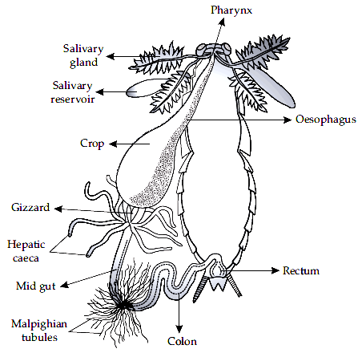

Figure 27. Digestive system of Cockroach

Practical 11

Study of digestive system in Earthworm (Dissection)
Digestive System of Earthworm

Digestive system of earthworm consists of alimentary canal and glands along with physiology of digestion.

Alimentary Canal
Alimentary canal is long and straight,extending from mouth to anus. It consists of following parts:

Mouth: 1st segment
Buccal Cavity: 2nd-3rd segment or middle of 3rd segment
Pharynx: 3rd-4th segment
Oesophagus : 5th -7th segment
Gizzard: 8th or 8th-9th segment
Stomach: 9th or 10th-14th segment
Intestine: 15th up to last segment except anus
Anus: last segment
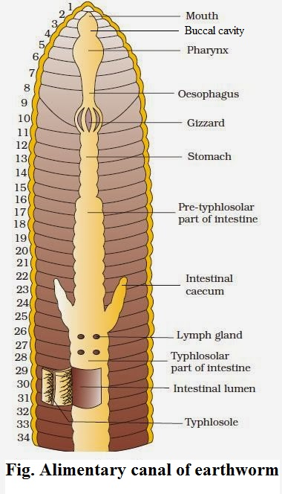
figure 28. Alimentary canal of earthworm

Mouth
It is crescentic aperture situated in the 1st segment below the prostomium.
Mouth leads into a buccal cavity.
Ingestion of food takes place through it.

Buccal Cavity
It is a short, wider, thin-walled tube extending from 2nd up to 3rd or middle of 3rd segment. It consists of two kinds of muscle. They are: protractile muscle and retractile muscle.
Buccal cavity protrude out through mouth with the help of special muscle for holding the food particles during feeding.
Buccal cavity leads into spacious organ called pharynx.

Pharynx
It is small, swollen, wider, thick-walled pear-shaped chamber, which extends up to 4th segment.
It is wider than buccal cavity.
It is distinguished from buccal cavity by means of constriction.
It has pharyngeal gland, located in the dorsal salivary chamber. Pharyngeal gland is composed of many chromaphil cells, which produce saliva containing proteolytic enzyme; protease and mucin. Mucin makes the food soft and protease converts protein into amino acid.

Oesophagus
It is narrow thin-walled tubular structure extending from 5th to 7th segment.
It has no gland.
It passes the food particles from pharynx to gizzard.
It leads into gizzard.

Gizzard
It is oval, thick-walled and highly muscular organ lying in the 8th or 8th-9th segment.
It is the hardest part of alimentary canal due to the presence of inner lining of cuticle. It also possess chitinuous teeth like projection. It helps in grinding or crushing food so act as grinder during feeding.

Stomach
Gizzard leads to short, narrow, thin-walled, highly vascular tubular structure called stomach, which extends from 9th or 10th to 14th segment. It is wider than oesophagus.
It has calciferous gland which helps in neutralization of food by calcification process.
Stomach leads to intestine.
The glandular cell of stomach produces proteolytic enzymes for the digestion of protein.

Intestine
It is long, wide and thin-walled tube which extends from 15th to last segment except anus. Its inner lining is ciliated, vascular, folded and glandular. Its intestinal lining is folded to form villi. One of the villi becomes larger and well developed than other called typhlosole which runs mid-dorsally from 27th to last 25th segment.
Typhlosole divides the intestine into 3 regions. They are:

i. Pre-typhlosolar region
It extends from 15th segment to 26th segment so it is the first part of the intestine.
It consists of villi but no typhlosole.
In 26th segment, there is a pair of short and conical lateral outgrowth called intestinal caeca which extends upward up to 23rd segment. Intestinal caeca produce amylase which helps in starch (carbohydrate) digestion.
ii. Typhlosolar region
It is the 2nd or middle part of the intestine which extends from 27th segment to last from 25th segment. It has both villi and typhlosole.
The typhlosole is highly vascular and glandular fold that increases the absorptive surface area of the intestine.

iii. Post-typhlosolar region
It is the last part of the intestine lying in the last 23rd-25th segment in front of anus. It is also called rectum.
It lacks villi and typhlosole.
It contains small pellets of mud which are thrown out through the anus to form casting.

Anus
It is a circular opening in the last segment called anal segment.
Undigested food materials release out through anus in the form of worm casting.

Digestive glands
There are different types of digestive glands associated with alimentary canal of earthworm.

- Pharyngeal gland
- Gastric gland
- Intestinal glands
- Intestinal caeca

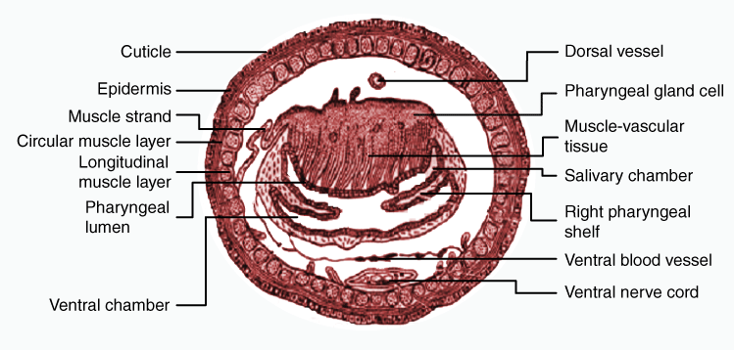
Figure 29. Transverse section of pharynx of Earthworm
Physiology of digestion
Digestion is the bio-chemical process in which complex organic food is broken down into simple, soluble and diffusible form in the presence of respective enzymes.

Earthworms feed upon all kinds of organic humus and debris such as decaying leaves and seeds, protozoan, etc. present in soil. They also feed directly on leaves, grasses and other vegetation.

During feeding the buccal cavity is protrude out with the help of protractile and retractile muscle. Then the food is drawn into the mouth. The ingested food enters into pharynx through buccal cavity. The dorsal chamber of pharynx consists of pharyngeal gland which is composed of chromaphil cell which produce saliva containing mucin and protease. Mucin lubricates the food and protease converts protein into amino acids. The foods then pass through oesophagus into gizzard, where grinding or crushing of food material takes place into fine state due to the contraction of circular muscles of gizzard. The grinded food material enters into the stomach where the neutralization of food takes place by calcification process. Also there occurs the complete digestion of protein by proteolytic enzymes. Now the food material enters into intestine. In intestine, intestinal caeca produce amylase which converts starch into glucose.
In intestine several enzymes are secreted and acts on the substrate as follows:

Protease: converts protein into amino acid.
Amylase: converts starch into two molecules of glucose i.e. maltose.
Cellulase: converts cellulose into glucose
Chitinase: digest chitin of exoskeleton of insects.
Lipase: converts fats into fatty acids and glycerol.
Digestion occurs mostly in the intestine and the digested food is absorbed by villi. Then pass into blood stream through capillaries. Undigested food and the soil are released out in the form of casting through anus.

T.S. of pharynx

Pharynx is small, wide, thick-walled, pear-shaped chamber. Two chambers are found in pharynx. They are: dorsal chamber and ventral chamber.
The dorsal chamber is also called salivary chamber which contains pharyngeal gland that is composed of many chromaphil cells. Dorsally pharyngeal gland is lined by villi. The chromaphil cells produce saliva containing proteolytic enzymes and mucin. Mucin makes the food soft and protease converts protein into amino acid. The ventral chamber is a conducting chamber which conducts digested or undigested food material from pharynx to oesophagus. Pharynx acts as sucking and pumping organ during feeding.

Dissection Process:
Killing:

Wash the live specimens with water to get rid of mucus. Drop them in a petri dish containing 30% alcohol. Take out the speci­mens immediately after ceasation of movements and put in tap water in a large beaker.

Dissection:

- Place the specimen on the fingers of your left hand. Insert the tip of one of the blades of a pair of fine scissors through the skin above the dorsal blood vessel at about 30th segment of the body. Hold the scissors almost in a horizontal position keeping the lower arm just below the body wall and cut the skin anteriorly for about 2 cm.

- Put the worm on the dissecting tray, keep­ing the dorsal surface upwards and fix it in a straight line on the wax with a few pins passing through the skin of the lateral sides and one at each of the anterior and the posterior end. Care should be taken not to damage the nerve ring at the anterior end and the anal region at the posterior end.

- Starting from the initial incision cut the skin along the mid-dorsal line, proceeding anteriorly or posteriorly or both as required for dissection. Hold the skin with a pair of fine forceps and free it from septa with a fine needle. Care must be taken not to damage the gut or other organs. Pin down the loose flaps of the skin and proceed for dissection of organ systems.

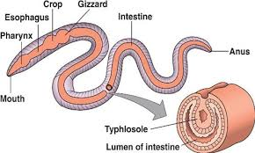

Figure 30. Reproductive system of earthworm

Practical 12

Study of male and female reproductive system in invertebrates

Invertebrate Reproductive Systems

Invertebrates that transfer sperm from male to female for internal fertilization require organs and plumbing to facilitate this function that may be as complex as those of any vertebrate. In contrast, reproductive systems of invertebrates that simply release their gametes into the water for external fertilization may be little more than centers for gametogenesis. Polychaete annelids, for example, have no permanent reproductive organs. Gametes arise by proliferation of cells lining the body cavity. When mature the gametes are released through coelomic or nephridial ducts or, in some species, may spill out through ruptures in the body wall.

Insects have separate sexes (dioecious), practice internal fertilization by copulation and insemination, and consequently have complex reproductive systems. Sperm from the testes pass through sperm ducts to seminal vesicles (where the sperm are stored) and then through a single ejaculatory duct to a penis. Seminal fluid from one or more accessory glands is added to the semen in the ejaculatory duct. Females have a pair of ovaries formed from a series of egg tubes (ovarioles). Mature ova pass through oviducts to a common genital chamber and then to a short copulatory bursa (vagina). In most insects, the male transfers sperm by inserting the penis directly into the female system where sperm are stored in a seminal receptacle. Often a single mating provides sufficient sperm to last the reproductive life of a female.

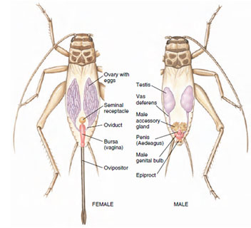
Figure 31. Reproductive system of crickets. Sperm from the paired testes of males pass through sperm tubes (vas deferens) to an ejaculatory duct housed in the penis. In females, eggs from the ovaries pass through oviducts to the genital bursa. At mating sperm enclosed in a membranous sac (spermatophore) formed by the secretions of the accessory gland are deposited in the genital bursa of the female, and then migrate to her seminal receptacle where they are stored. The female controls the release of a few sperm to fertilize her eggs at the moment they are laid, using the needlelike ovipositor to deposit the eggs in the soil.

Reproductive system of different Invertebrates

Invertebrates have an extremely diverse array of reproductive systems, the only commonality may be that they all lay eggs. Also, aside from cephalopods and arthropods, nearly all other invertebrates are hermaphroditic and exhibit external fertilization.

Cephalopods
All cephalopods are sexually dimorphic and reproduce by laying eggs. Most cephalopods have semi-internal fertilization, in which the male places his gametes inside the female's mantle cavity or pallial cavity to fertilize the ova found in the female's single ovary.[15] Likewise, male cephalopods have only a single testicle. In the female of most cephalopods the nidamental glands aid in development of the egg.
The "penis" in most unshelled male cephalopods (Coleoidea) is a long and muscular end of the gonoduct used to transfer spermatophores to a modified arm called a hectocotylus. That in turn is used to transfer the spermatophores to the female. In species where the hectocotylus is missing, the "penis" is long and able to extend beyond the mantle cavity and transfer the spermatophores directly to the female.

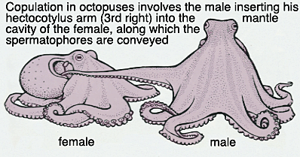

Figure 32. Digestive system of Cephalopods

Insects
Most insects reproduce oviparously, i.e. by laying eggs. The eggs are produced by the female in a pair of ovaries. Sperm, produced by the male in one testis or more commonly two, is transmitted to the female during mating by means of external genitalia. The sperm is stored within the female in one or more spermathecae. At the time of fertilization, the eggs travel along oviducts to be fertilized by the sperm and are then expelled from the body ("laid"), in most cases via an ovipositor.

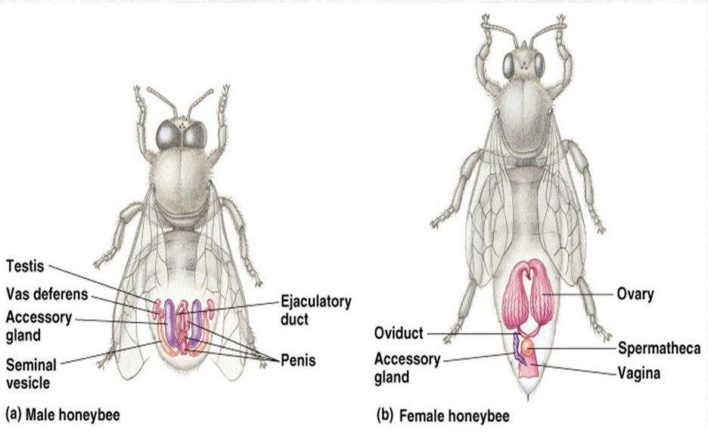
Figure 33. Reproductive system of insects
Arachnids
Arachnids may have one or two gonads, which are located in the abdomen. The genital opening is usually located on the underside of the second abdominal segment. In most species, the male transfers sperm to the female in a package, or spermatophore. Complex courtship rituals have evolved in many arachnids to ensure the safe delivery of the sperm to the female.
Arachnids usually lay yolky eggs, which hatch into immatures that resemble adults. Scorpions, however, are either ovoviviparous or viviparous, depending on species, and bear live young.

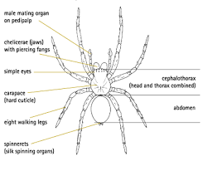
Figure 34. Arachnids
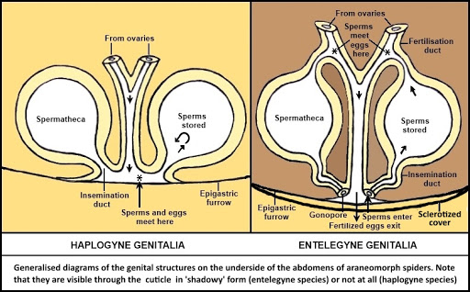
Figure 35. Reproductive system of Arachnids

Practical 13
Study of male and female reproductive system in vertebrates

Vertebrate Reproductive Systems

In vertebrates the reproductive and excretory systems are together called a urogenital system because of their close anatomical connection, especially in males. This association is very striking during embryonic development. In male fishes and amphibians the duct that drains the kidney (mesonephric duct or Wolffian duct) also serves as a sperm duct. In male reptiles, birds, and mammals in which the kidney develops its own independent duct (ureter) to carry away waste, the old mesonephric duct becomes exclusively a sperm duct or vas deferens. In all these forms, with the exception of most mammals, the ducts open into a cloaca (derived, appropriately, from the Latin meaning “sewer”), a common chamber into which intestinal, reproductive, and excretory canals empty. Almost all placental mammals have no cloaca; instead the urogenital system has its own opening separate from the anal opening. The uterine duct or oviduct of the female is an independent duct that does, however, open into the cloaca in forms having a cloaca.

Male Reproductive System

The male reproductive system of vertebrates, such as that of human males (Figure 36) includes testes, vasa efferentia, vas deferens, accessory glands, and (in some birds and reptiles, and all mammals) a penis.

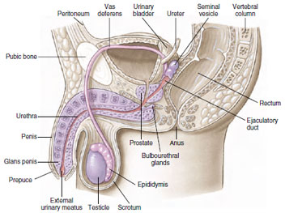

Figure 36 Human male reproductive systems showing the reproductive structures in sagittal view.

The paired testes are the sites of sperm production. Each testis is composed of numerous seminiferous tubules, in which the sperm develop. The sperm are surrounded by sustentacular cells (or Sertoli cells), which nourish the developing sperm. Between the tubules are interstitial cells, which produce the male sex hormone (testosterone). In most mammals the two testes are housed permanently in a sac-like scrotum suspended outside the abdominal cavity, or the testes descend into the scrotum during the breeding season. This odd and seemingly insecure arrangement provides an environment of slightly lower temperature, since in most mammals (including humans) sperm apparently do not form at temperatures maintained within the body. In marine mammals and all other vertebrates the testes are positioned permanently within the abdomen.

The sperm travel from the seminiferous tubules to the vasa efferentia, small tubes passing to a coiled epididymis (one for each testis), where final sperm maturation takes place, and then to a vas deferens, the ejaculatory duct. In mammals the vas deferens joins the urethra, a duct that serves to carry both sperm and urinary products through the penis, or external intromittent organ.

Most aquatic vertebrates have no need for a penis, since sperm and eggs are liberated into the water in close proximity to each other.
However, in terrestrial (and some aquatic) vertebrates that bear their young alive or enclose the egg within a shell, sperm must be transferred to the female. In most birds, this is a rather haphazard process of simply presenting cloaca to cloaca. Only reptiles and mammals have a true penis. In mammals the normally flaccid organ becomes erect when engorged with blood.
Many other mammals possess a bone in the penis (baculum), which presumably helps with rigidity.
In most mammals three sets of accessory glands open into the reproductive channels: a pair of seminal vesicles, a single prostate gland, and the pair of bulbourethral glands. Fluid secreted by these glands furnishes food to the sperm, lubricates the passageways for sperm, and counteracts the acidity of the urine so that the sperm are not harmed.

Female Reproductive System

The ovaries of female vertebrates produce both ova and female sex hormones (estrogens and progesterone). In all jawed vertebrates, mature ova from each ovary enter the funnel-like opening of a uterine tube or oviduct, which typically has a fringed margin that envelops the ovary at the time of ovulation. The terminal end of the uterine tube is unspecialized in most fishes and amphibians, but in cartilaginous fishes, reptiles, and birds that produce a large, shelled egg, special regions have developed for production of albumin and shell. In amniotes (reptiles, birds, and mammals; see Amniotes and the Amniotic Egg) the terminal portion of the uterine tube is expanded into a muscular uterus in which shelled eggs are held before laying or in which embryos complete their development. In placental mammals, the walls of the uterus establish a close vascular association with the embryonic membranes through a placenta.
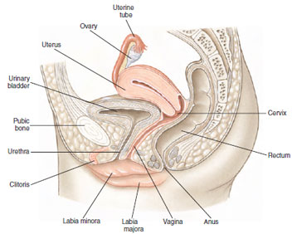

Figure 37 Human female reproductive systems showing the pelvis in sagittal section

The paired ovaries of the human female (Figure 37), slightly smaller than the male testes, contain many thousands of oocytes. Each oocyte develops within a follicle that enlarges and finally ruptures to release a secondary oocyte. During a woman’s fertile years, except following fertilization, approximately 13 oocytes mature each year, and usually the ovaries alternate in releasing oocytes. Because a woman is fertile for only about 30 years, of the approximately 400,000 primary oocytes in her ovaries at birth, only 300 to 400 have a chance to reach maturity; the others degenerate and are absorbed.
The uterine tubes, or oviducts, are lined with cilia for propelling the egg in its course. The two ducts open into the upper corners of the uterus, or womb, which is specialized for housing the embryo during the 9 months of its intrauterine existence. It is provided with thick muscular walls, many blood vessels, and a specialized lining: the endometrium. The uterus varies among different mammals, and in many it is designed to hold more than one developing embryo. Ancestrally it was paired but is fused in many eutherian mammals.

The vagina is a muscular tube adapted for receiving the male’s penis and for serving as birth canal during expulsion of a fetus from the uterus. Where vagina and uterus meet, the uterus projects down into the vagina to form a cervix.

The external genitalia of human females, or vulva, include folds of skin, the labia majora and labia minora, and a small erectile organ, the clitoris (the female homolog of the glans penis of males). The opening into the vagina is often reduced in size in the virgin state by a membrane, the hymen, although in sexually active females, this membrane may be much reduced in extent.

Practical 14
Study of male and female reproductive system of Chicken (Dissection)

Male reproductive system
The male reproductive organs in the domestic fowl consist of two testes, each with a deferent duct that leads from the testes to the cloaca. Fowls do not have a penis such as is found in other animals. The testes are bean shaped bodies located against the backbone at the front of the kidney. Their size is not constant and they become larger when the birds are actively mating. The left testes are often larger than the right. On the inside of each is a small, flattened area that is believed to correspond to the epididymis of mammals. The deferent duct starts at this flattened area.

Deferent duct
The deferent duct transports the sperm from the testes where they are formed to the cloaca from which they enter the oviduct of the female when mating. The deferent duct enters a small pimple-like structure in the cloaca. This structure equates to the mammalian penis and is much larger in ducks to form a penis like organ. The deferent duct is quite narrow at first but widens as it approaches the cloaca.

Testes and sperm
In the testes very twisted tubes called seminiferous tubules are found. It is in these tubules that a special process of cell division called meiosis and transformation produces the sperm. The sperm carry half of the total chromosomes required to produce an embryo. The mother provides the other half. One cubic millimeter of the fluid called semen produced by the male contains on average 3-5 million sperm. Under a microscope the sperm of the fowl will be seen to have a long pointed head with a long tail. The testes also produce hormones called androgens that influence the development of what are called secondary sex characteristics such as comb growth and condition, male behavior and mating.

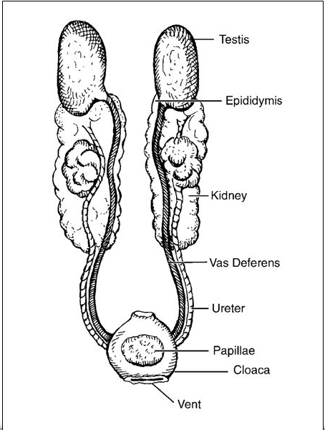

Figure 38. Reproductive system of Male Chicken

Practical 15
Study of female reproductive system of Chicken (Dissection)

Female Reproductive System

Ovary -Poultry have only one functioning ovary, usually the left ovary.

Oviduct

- Function:

Function to produce albumen (egg white), shell membrane, and the shell around the yolk.

- Five regions

- Infundibulum: receives the follicle and is the location of conception where the male and female gamete comes together.
- Magnum: produces the albumen.
- Isthmus: produces the inner and outer shell membranes.
- Uterus: plumps the egg, forms the shell and cuticle (seals pores of the egg shell) and determines the shell pigment.
- Vagina: produces some cuticle, and expels the egg and regulates timing of egg production.

- Cloaca

Cloaca is also known as the vestibule. The common chamber through which the egg passes is also responsible for the expulsion of feces and urine.

- Vent

Vent is the exterior opening through which passage occurs from the digestive system, the urinary tract and the reproductive tract.

- Ovulation

Ovulation is the releasing of the egg yolk from the ovary to begin its journey through the oviduct.

- Oviposition

The process of laying the fully formed egg which is regulated by hormones

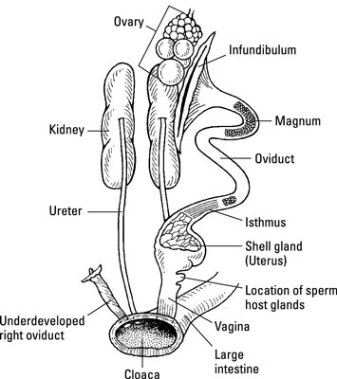

Figure 39. Female reproductive system of Chicken

Practical 16

Study of male and female reproductive system of Reptiles

Introduction
Although anatomy and physiology varies greatly among the diverse class Reptilia, the basic structure of the reproductive tract is fairly consistent. The paired ovaries and testes, which range in color from yellow to grayish-pink, are located dorsomedially within the coelom although their exact location is species-specific. The right gonad sits cranial to the left, particularly in snakes. Females possess a right and left oviduct, but no true uterus. The oviduct empties directly into the cloaca through genital papillae

Secondary sex characteristics
The very first step of any signalment, determining your patient’s gender, can come to a screeching halt with many reptiles. Observation of secondary sex characteristics (Box 1) can prove invaluable in determining gender.

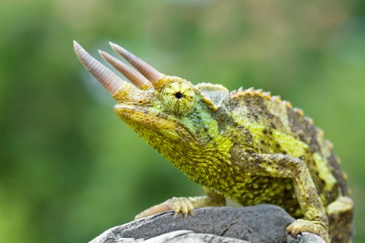

Figure 40. The Jackson’s or three-horned chameleon (Chamaeleo jacksoni xantholophus) is an example of sexual dimorphism. Only male possesses the three rostral horns.

Common secondary sex characteristics in reptiles

Lizards
- Males often have a bigger, more robust appearance overall and a larger head
- The male Jackson’s chameleon has three rostral horns.
- Femoral pores are larger, more prominent in iguanas and geckos.
- The presence of the hemipenes can create a dramatic bulge at the tail base of some male lizards.
- Many male iguanid lizards possess enlarged postanal scales
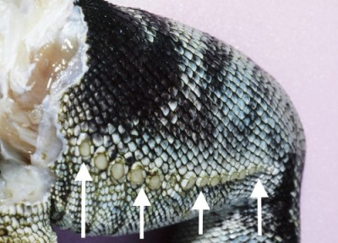

Figure 41 Femoral pores (arrows) are larger and more prominent in some male lizards such as this green iguana (Iguana iguana) shown here.

Snakes
- Spurs are generally larger in male boids*

Turtles and tortoises
- The plastron or bottom shell is often concave in males
- The tail is usually larger and longer in males
- The iris of the male Eastern box turtle is frequently red or bright orange. Females possess a brown or light colored iris.

Oviparity or egg lying
All chelonians (turtles and tortoises), pythons, most colubrids, monitors, and most iguanas lay eggs. Eggs can often be detected during visual examination in many species of snakes, although larger species like pythons require palpation. Viviparous or live bearing reptiles include many skinks, chameleons, boas, all rattlesnakes, and most vipers.

Egg production
The process of egg production in reptiles is very similar to that described in birds.
Rising estrogen levels promote vitellogenesis or yolk production within the liver. Yolk is then transported via the blood stream to the reproductive tract where it is deposited in oocytes. During this time, lab results in female reptiles frequently reveal high levels of triglycerides, hypercholesterolemia, and hypercalcemia.
Triggers for ovulation are poorly understood in the reptile, but when ovulation > does occur, oocytes enter the oviduct and become fertilized. (Females of some species can store sperm for an extended period and produce fertile eggs after being separated from males for a long time).
As oocytes move through the oviduct, albumen is added and the shell is layed down.
Depending on the species, the egg can normally remain within the oviduct anywhere from 9 days to 6 months, however most reptiles retain eggs for 1 to 2 months.

Many females can lay eggs in the absence of a male
Many lizard species, including iguanas, geckos, and some snakes such as the corn snake can begin folliculogenesis and even lay eggs without the presence of a mate. Although these eggs are frequently infertile, this is not always the case since some species can store sperm for extended periods of time. This fact is important to keep in mind, since it means egg-related problems cannot be ruled out in many “single”, pet reptiles.

Thinly shelled eggs
The thinly shelled eggs produced by many normal reptiles may surprise anyone familiar with the hard, strong avian eggshell. All snakes, most lizards, and some turtles produce thinly shelled eggs that are normally pliant. The eggs of tortoises, many geckos, and crocodilians are more rigid.

Phallus or hemipenes
The chelonian phallus sits in a groove on the cloacal floor. When engorged, the phallus extends cranioventrally (Fig 43).

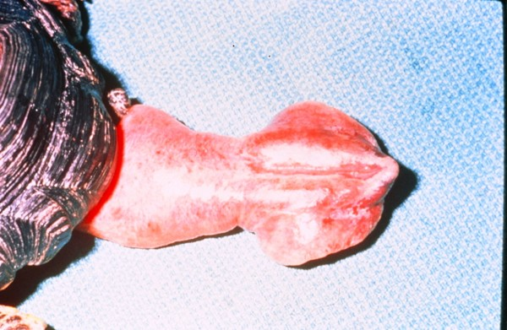

Figure 43 Normal extended phallus in a box turtle (Genus Terrapene).

Male snakes and lizards possess paired copulatory organs called hemipenes that normally range in color from pink to black. Hemipenes sit within pouches at the base of the tail just caudal to the cloaca (Fig 44, Fig 45). They are connected to the testes by the ductus deferens, and each hemipenis is functionally complete. During copulation, only one hemipenis averts into the female’s cloaca. Sperm travels along a groove on the outside of the averted organ.

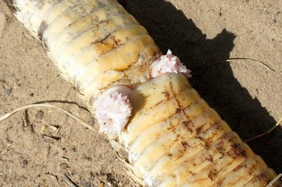

Figure 44. Hemipenes of a Western diamondback rattlesnake (Crotalus atrox).

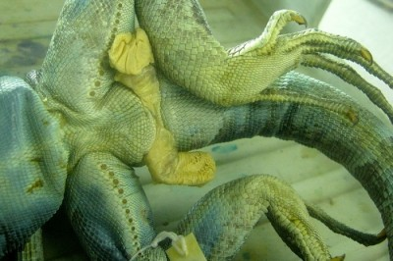

Figure 45. Hemipenes in a green iguana (Iguana iguana) cadaver. Hemipenes are generally pink in the live specimen

