
Laboratory Manual: Physiology (ZOO404)

Contents

S. No. | Practical | P. No.
1 | Determination of hemoglobin content. | 2
2 | Determination of hematocrit in blood sample | 5
3 | RBC counting by using Hemocytometer | 9
4 | Nerve muscle preparation, Muscle twitch, Comparison of muscle and nerve irritability, effect of stimulus strength, effect of stimulus frequency (tetany), effect of load or stretch, effect of prolonged activity (fatigue), neuromuscular fatigue, stimulation of motor points in frog | 13
5 | Recording of action potential by oscilloscope and demonstration of its various features. Experiments to demonstrate characteristic of reflex arc, experiment in human (students themselves) to demonstrate some aspect of sensory physiology | 17
6 | Normal cardiac activity in amphibian model, effect of temperature, effect of drug, heart block, tantalization of heart | 22
7 | Measurement of blood pressure | 25
8 | Blood pressure alteration in exercise. | 27
9 | Video Study of brains in different animals in relation to complexity of functions. | 29
10 | Video Study of human brain model and different areas eliciting behaviors. | 31
11 | Stages in estrous cycle (studies on the effects of hormones in breeding season) | 38
12 | Oxygen consumption in fish and effect of temperature (by dissolved oxygen meter)and terrestrial animal (mouse) | 40
13 | Oxygen consumption in fish and mouse by Respirometer | 43
14 | Study through clinics data on the insulin and glycemia in type1 and type 2 diabetic subjects. | 45

Practical No: 1 Determination of hemoglobin content.

General information
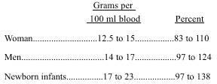
Hemoglobin is a conjugated protein composed of the basic protein globin linked to 4 heme molecules. Ninety-eight percent of all the iron found in the blood is contained in hemoglobin. Hemoglobin transports oxygen and carbon dioxide. This important substance reacts with oxygen to form oxyhemoglobin. In the tissues, oxygen is released and reduced hemoglobin is formed. Hemoglobin can react with acids, bases, and oxidizing and reducing agents. It also can exist in a variety of forms. The normal values for hemoglobin determinations are as follows:
Fig 1.1: The volume of hemoglobin in male and female

Compounds of hemoglobin
- Oxyhemoglobin. Oxygen combines loosely with iron (ferrous state) in hemoglobin. The loosely attached oxygen diffuses into the tissues for oxidative processes. The hemoglobin then binds carbon dioxide and exists as reduced hemoglobin.
- Carboxyhemoglobin. Hemoglobin combines with carbon monoxide to form carboxyhemoglobin. Carbon monoxide has an affinity 200 times greater for hemoglobin than oxygen does. Hemoglobin in this combination is incapable of oxygen transport.
- Methamoglobin. This compound is formed when the ferrous state of the heme is oxidized to the ferric state. This compound is incapable of oxygen transport.
- Sulfhemoglobin. This compound results from the combination of inorganic sulfides and hemoglobin. This compound is incapable of oxygen transport. This is an irreversible reaction.
- Cyanmethemoglobin. This compound results when methemoglobin combines with the cyanide radical. This compound is used in hemoglobinometry.

Hemobloginometry
The hemoglobin concentration is directly proportional to the oxygen-combining capacity of blood. Therefore, the measurement of the hemoglobin concentration in the blood is important as a screening test for diseases associated with anemia and for following the response of these diseases to treatment. There are four basic ways to measure the hemoglobin concentration:
- Measurement of the oxygen-combining capacity of blood (gasometric)
- Measurement of the iron content (chemical method)
- Colorimetric measurement of specific gravity (gravimetric method)
- The cyanmethemoglobin method is the method of choice and is most widely used

Cyanmethemoglobin (hemoglobin-cyanide) method for estimation of hemoglobin
This is the method of choice for estimation of hemoglobin and is recommended by International Committee for Standardization in hematology. This is because
- All forms of hemoglobin are converted to cyanmethemoglobin (except sulfhemoglobin)
- A stable and reliable standard is available.

Principle
Blood is mixed with a solution of potassium ferricyanide, potassium cyanide and a non-ionic detergent (Drabkin’s solution). Erythrocytes are lysed producing an evenly distributed hemoglobin solution. Potassium ferricyanide converts hemoglobin to methemoglobin, and methemoglobin combines with potassium cyanide to form cyanmethemoglobin (hemiglobincyanide). All forms of hemoglobin present in blood are completely converted to a single compound, cyanmethemoglobin. When the reaction is completed, absorbance of the solution is measured in a spectrophotometer at 540 nm. At this wavelength, cyanmethemoglobin has a broad absorbance peak. To obtain the amount of hemoglobin in the unknown sample, its absorbance is compared with that of the standard cyanmethemoglo-bin solution (the hemoglobin concentration of which is known) by using a formula or a previously prepared graph/table.

Equipment
- Photoelectric colorimeter or spectrophotometer
- Sahli’s pipette marked at 20 μl (20 cmm)
- Pipette 5 ml

Reagents
- Drabkin’s solution (ph 7.0-7.4): Potassium ferricyanide 200 mg Potassium cyanide 50 mg
Potassium dihydrogen phosphate 140 mg Non-ionic detergent 1 ml
Distilled water to 1000 ml
- Cyanmethemoglobin standard solution with known hemoglobin value.
Specimen: EDTA-anticoagulated venous blood or blood obtained from skin puncture.

Method
- In a test tube, take 5 ml of Drabkin’s solution and to it add 20 μl of blood (1:251 dilution). Stopper the tube, mix by inverting several times, and allow standing for at least 5 minutes. This time is adequate for conversion of hemoglobin to cyanmethemoglobin.
- Transfer the test sample to a cuvette. Read the absorbance in a spectrophotometer at 540 nm or in a photoelectric colorimeter using a yellow-green filter. Also take the absorbance of the standard solution. Absorbance should be read against reagent blank (Drabkin’s solution).
- Hemoglobin value is derived from the formula given below or from the previously prepared graph or table.
Preparation of graph and table: If a graph or a table is prepared which correlates absorbance with hemoglobin concentration, result can be obtained quickly. This is particularly suitable when a large number of samples are regularly processed on the same instrument. Diluted cyanmethemoglobin standards are available commercially for preparation of a calibration graph. Alternatively, standard cyanmethemoglobin solution is diluted serially with Drabkin’s solution. On a linear graph paper, hemoglobin concentration (horizontal axis) in each dilution is plotted against the absorbance (vertical axis). A straight line joining the points and passing through the origin is obtained. From this graph, a table can be prepared relating absorbance to hemoglobin concentration.

Practical No: 2 Determination of hematocrit in blood sample

Determination of hematocrit in blood sample

Introduction
The hematocrit or packed cell volume (PCV) determines the percentage of red blood cells (RBCs) in whole blood.
The normal hematocrit value for men is 42% to 52%; for women, 37% to 47%; and for newborns, 53% to 65%. When hematocrit determinations are below normal, medical conditions such as anemia and leukemia may be present. Above-normal hematocrit determinations indicate medical conditions like dehydration, such as occur in severe burn cases.
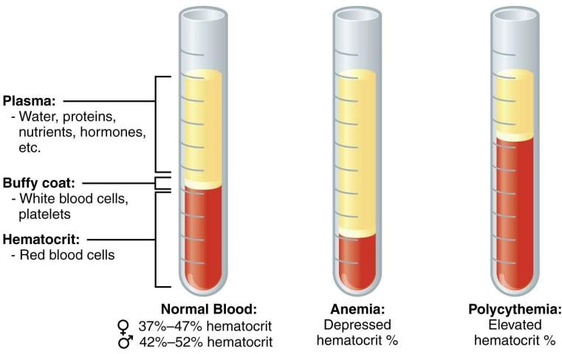
Fig 1.2: Detail of blood parts
Currently, automated hematology analyzers supply most hematocrits. However, when hematology analyzers are not available, hematocrit determinations can be manually performed by two methods,
- Macrohaematocrit
- Microhaematocrit
Both methods call for the blood to be centrifuged, and the percentage of packed red cells is found by calculation. The microhematocrit method is the most accurate manual method of determining blood volume and should be used whenever feasible.
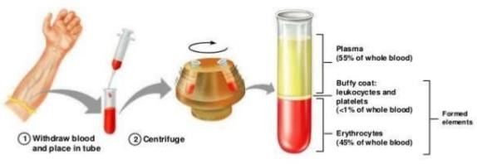
Fig 1.3: Parts of blood

1. Macrohaematocrit
A large volume of blood is required in this method. Approximately 2 to 4 ml is required.

Principle:
Anticoagulated blood is taken in a Wintrobe tube. Fill upto the uppermost mark and then rotate for desired length of time. The packed cell volume (PCV) of red cells is directly read from the graduated tube as %.

Requirement:
- Blood specimen: EDTA or double oxalated anti-coagulated blood is used in this method. Determine P.C.V. within six hr. of blood collection.
- Wintrobe Tube: It is 110 mm in length and 2.5 mm in diameter. The lower 100 mm are graduated or marked, from 100 at top and 0 (zero) at bottom for PCV.
- Long necked pasture pipette or a special type of syringes is used for filling Wintrobe tube.
- Centrifuge machine with known speed.

Procedure:
- Mix 0.4 ml of EDTA with 2 ml blood.
- Fill the Wintrobe tube up to upper most mark with the help of pasture pipette or syringe.
- Fill the Wintrobe tube to balance first one. If the blood sample is not available, fill the tube with water.
- Place the Wintrobe tube in opposite side in centrifuge. Turn the centrifuge to slow speed, then slowly increase the speed to 3,000 rpm. Centrifuge for 30 min. at 3,000 rpm. After 30 min. switch off the centrifuge and allow it to stop by itself.
- Take out the Wintrobe tube and read PCV directly with the help of graduation mark given on the tube.

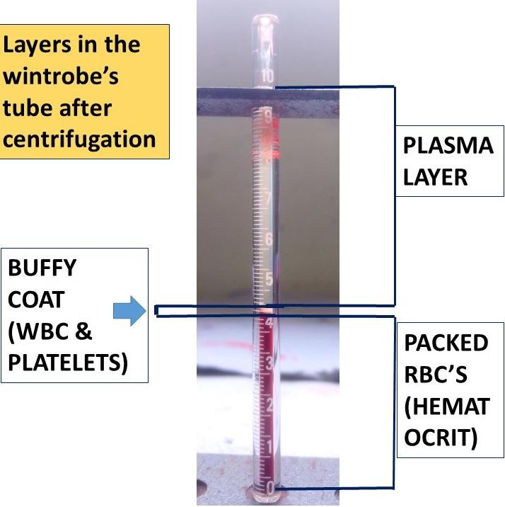
Fig 1.4: View of macrohaematocrit

2. Microhaematocrit
This method requires small amount of blood, 2 to 3 drops only. The blood can be obtained by finger puncture.

Principle:
Anti-coagulated blood is centrifuged in a sealed capillary tube, and then PCV is determined by a special haematocrit reader.

Requirement
- Blood Specimen: Blood from finger puncture may be used or EDTA or double oxalate venous blood can also be used.
- Capillary Tube: Use plain capillary tube for anti-coagulated venous blood and use heparinised capillary tube (Coated with heparin internally) for blood obtained from finger puncture. The capillary tube is approximately 75 mm in length.
- Microhaematocrit Centrifuge: This is a special type of centrifuge. It has speed about 15,000 r.p.m. The top of centrifuge is flat with grooves. The centrifuge also has timer, which is usually set for 5 min.
- Haematocrit Reader: There are several types of readers used for reading hct. The simplest method is use of card reader, which can be made by hand.
- Clay: This is used to seal the end of capillary tube.

Procedure:
- Draw the blood sample into appropriate capillary tube with capillary action. Use plain tube for anti-coagulated blood and heparinized tube for plain blood. In case of finger puncture, the blood should flow freely with little pressure. Now wipe off the first drop and then collect the blood specimen.
- Fill the tube about 3/4th length with blood. Seal the end of the tube with clay or wax or ultimately by heating. The sealing should be about 2 mm deep. Place two hct tubes in the groove of centrifuge exactly opposite to each other.
- It is not necessary that the capillary tube have exact amount of blood level. In case, if there is no filled capillary tube to balance we can use an empty capillary tube. Centrifuge at 13,000 ± 2000 rpm for 15 minutes. If the hematocrit exceeds 50 percent, centrifuge for an additional 3 minutes.
- Remove capillary tube from centrifuge. It will show three layers. Top layer is of plasma or serum; the middle layer is thin creamy white in color and is known as Buffy coat. It is a layer of WBC; the last layer is the column of RBC. Use the hct reader for finding the value of hct.

Card Reader:
The reader is used as, hold the tube against Scale so that the bottom of red cell is matched with 0 (zero) line of the card. Move the tube across the card until the uppermost line of plasma is matched to 100% line of card.
Check to make sure that bottom of red cell column is still in the line of zero and the tube should be straight and vertical. The line that passes through the top of the column of RBC gives the hct value.
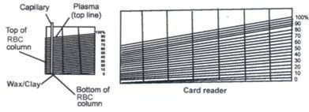
Fig 1.5: View of microhaematocrit

Practical No: 3 RBC counting by using Hemocytometer

RBC Counting by using Hemocytometer

Introduction
Although a variety of automated cell counting instruments have been developed, Hemocytometer remains the most common method used for cell counting around the world. The most frequently used hemocytometer is the Neubauer (or ‘Improved Neubauer’) chamber. Other hemocytometers include the Burker, Thoma and Fuchs-Rosenthal. Using these, the particles (e.g., leucocytes, erythrocytes, thrombocytes, bacteria, fungus spores, pollen) are visually counted under a microscope. Neubauer’s chamber is a thick glass plate with the size of a glass slide (30x70x4mm). The counting region consists of two square shaped ruled areas. There are depressions or the moats on either side or in between the areas on which the squares are marked thus giving an “H” shape.
The ruled area is 3mm2 divided into 9 large squares each with a 1 mm2 area. The large central square (which can be seen in its entirely with the 10X objective), is divided into 25 medium squares with double or triple lines. Each of these 25 squares are is again divided into 16 small squares with single lines, so that each of the smallest squares has an area of 1/400 mm2.
The glass cover is a squared glass of width 22 mm. The glass cover is placed on the top of the Neubauer chamber, covering the central area. The ruled area is 0.1 mm lower than the rest of the chamber. So that when a cover slip is kept on the counting region, there is a gap of 0.1 mm (1/10mm) between the cover slip and the ruled area.
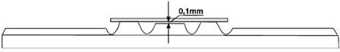
Fig 1.6: View of hemocytometer
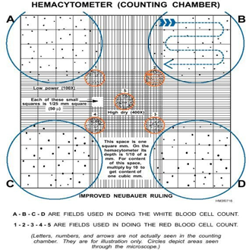
Fig 1.7: Detail of hemocytometer

The counting can be done either in the central large square or in the corner squares, depending on the size of the cells under study.

WBC Counting Area
The four large sqaures placed at the corners are used for white blood cell count. Since their concentration is lower than red blood cells a larger area is required to perform the cell count.

RBC Counting Area
The large center square is used for RBC counts. As already stated, this area is subdivided into 25 medium sqaures, which in turn are each divided into 16 squares. Of the 25 medium sqaures, only the four corner squares and the center square within the large center square are used to perform RBC counts.

Materials:
Biologicals: 1. Droplet of blood from capillary

Glass/plastic ware:
- RBC diluting pipette with hose and bulb
- Trash bin for lancets
- Plastic droppers

Chemicals
- RBC diluent 3.2 or 4% w/v Sodium Citrate (Na3C6H5O7) /d.H2O/ Normal Saline (Saline maintains the normal disk shape of RBC and prevents auto agglutination)
- 95% Alcohol for rinsing

Instruments
- Sterile lancet
- Hemocytometer for RBC and WBC counting
- Microscope

Others
- Tissue paper
- Gloves for use while staining

Method
1. Sample Preparation
- As before make a pin-prick using a fresh unused lancet on the index- or ring finger. If you have been pricked before on that finger, use another finger.
- Bring a cleaned RBC dilution pipette tip close to the droplet of oozing blood. Using the bulb allow (by capillarity and pressure) blood to enter up to the 0.5 mark.
- Using a small tube of Sodium-Citrate solution, additionally aspirate this solution to reach the mark 101 (1:200 dilution)
- Gently turn the dilution tube in your hand.

Preparing Neubauer Chamber
Clean the Neubauer chamber and the cover slip with 70% EtOH. Put the glass cover on the Neubauer chamber central area. Use a flat surface to place the chamber, like a table or a workbench.

Introducing the sample into the Neubauer chamber
With a pipette, carefully draw up around 20 ml of the cell mixture (dilution). Place the pipette tip against the edge of the coverglass and slowly expel the liquid until the counting chamber is full. Capillary action will help to ensure that the counting chamber is full, but care should be taken not to overfill the chamber. A volume of 10 ml is sufficient to fill one counting chamber.
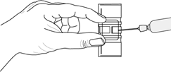
Fig 1.8: Set sample on hemocytometer

Microscope focusing and Cell Counting
- Place the Neubauer chamber on the microscope stage. Using the 10X objective, focus both onto the grid pattern and the cell particles.
- To count the RBCs and Platelets, the microscope must be switched to 40X objective. Count the cells in the respective areas as stated early.
- Write down the amount of cells counted
- If cells are touching the 4 perimeter sides of a corner square, only count cells on 2 sides, either the 2 outer sides or 2 inner sides.

Calculations:
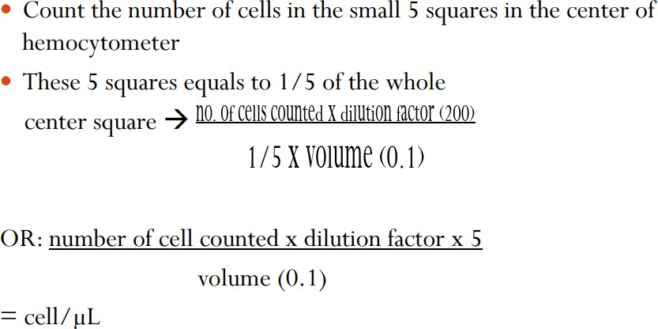

Practical No: 4 Nerve muscle preparation, Muscle twitch, Comparison of muscle and nerve irritability, effect of stimulus strength, effect of stimulus frequency (tetany), effect of load or stretch, effect of prolonged activity (fatigue), neuromuscular fatigue, stimulation of motor points in frog

Introduction
The functional unit of skeletal muscle activity is the motor unit. Interposed between the axon branches and the muscle fibers is a structure called the neuromuscular junction (motor end-plate). The most convenient way of examining the properties of the motor unit is by use the nerve-muscle preparation.
Purpose
- To make a sciatic nerve & gastrocnemius (SNG) preparation
- To measure the effects of different stimulus intensities on the muscle response
- To measure a single twitch, incomplete tetanus and complete tetanus
Chemicals
Ringer’s solution is a solution of recently boiled distilled water containing NaCl 6.5g, KCl 0.14g, CaCl2 0.12g, NaHCO3 0.20g, NaH2PO4 0.01g per liter
Equipment
- RM6240 biological signal collecting system
- Force transducer
Procedure
For intact Nerve-Muscle preparation, pith the toad, resulting in the toad not feeling pain. As soon as the brain and spinal cord destroyed, the toad should become flaccid. Then peel the skin of one leg. Fix the toad on the frog board with the dorsal surface uppermost. Identify the gastrocnemius muscle. Tie a knot around the Achilles tendon using suture thread. Cut the Achilles tendon as close to the bottom of the foot as possible. Locate the sciatic nerve in the thigh region. Use the glass hooks to separate the sciatic nerve. Pass a piece of thread beneath the sciatic nerve.
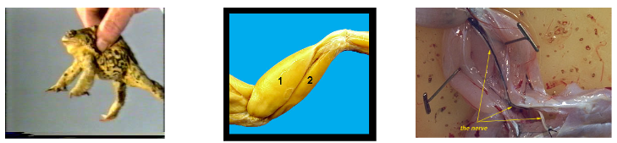
Fig 3.1: Nerve-Muscle
Hold knee in place by pushing down two T-pins. Tie the free end of the thread to the hole on the end of the tongue of the force transducer. Place the stimulating electrode on the sciatic nerve.
Warning:
- Do not touches the nerve with any object that is made of metal; this will render the nerve useless.
- Avoid stretching or otherwise damaging the nerve. Keep the tissue moist with frog ringer’s solution.
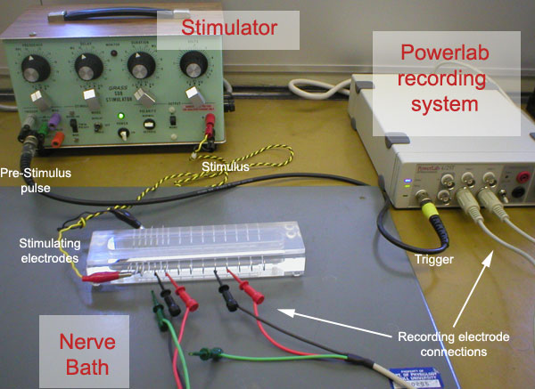
Fig 3.2: View of electrocardiogram

Effect of stimulus intensity on twitch amplitude
Set record parameters. The recording trace should be set to zero.
Apply a light load to the muscle by raising the force transducer with the tension adjuster until the trace moves approximately 2 g above the baseline. Warning: Make sure to lift the muscle vertically to an angle that is perpendicular to the rest of the frog leg.
Display the stimulation mark. Change the stimulus amplitude to 0.2V. Determine the threshold voltage by increasing the stimulus voltage in 0.01V increments. Stop and save the recording trace.
Fig 3.3: Threshold stimulus maximal stimulus

Table 3.1: Measure the following values
 | Intensity stimulus (V) | Tension of contraction (g)
Threshold
intensity
Maximal
intensity

Table 3.2: Record the following values in a single twitch induced by maximal stimulus
Duration (ms)
Latent period
Contraction
Relaxation

Effect of stimulus frequency on twitch amplitude
Set record parameters. Click on the record button. Select the frequency ascending mode. Display the stimulation mark. Begin the recording. Set the stimulus intensity to the lowest value that will give strong contraction as during the twitch amplitude calculation. Stop and save the recording trace.

Twitch incomplete tetanus complete tetanus
Table 3.3: Determine the following values
 | Frequency of stimulus (Hz) | Tension of contraction (g)
Single twitch
Incomplete tetanus
Complete tetanus

Practical No: 5 Recording of action potential by oscilloscope and demonstration of its various features. Experiments to demonstrate characteristic of reflex arc, experiment in human (students themselves) to demonstrate some aspect of sensory physiology

Background
Neurons are cells in the nervous system that are used to conduct signals at high speed from one part of the body to another. This enables rapid, precise responses to occur in order to compensate for changes in the environment.
Neurons are able to send signals at high speed due to their ability to generate and conduct an electrical signal called an action potential down the length of their axons. An action potential is a brief reversal of the membrane potential, so that for a brief interval at a segment of the axon the intracellular fluid just inside of the plasma membrane is more positive than is the extracellular fluid just outside the plasma membrane. This signal is typically generated at the axon hillock of the neuron, and requires the opening of voltage-gated ion channels — specialized pore-like transmembrane proteins that open to allow ion passage in response to changes in the relative charge difference across the plasma membrane.
There are two different types of voltage-gated ion channels important for the generation action potentials: those specific for sodium ion (Na+), and those specific for potassium ion (K+). In the intervals between action potentials (i.e., when the neuron is “resting”) the two types of ions are kept at different concentrations across the plasma membrane. Na+ is maintained at higher concentrations outside the cell than inside the cell. Conversely, K+ tends to be accumulated at higher concentrations inside the cell than outside the cell. The potential for movement of these ions across the cell membrane is thus influenced by the concentration gradients for each ion. Moreover, charge differences across the cell membrane affect the potential for diffusion of these ions. The interior of cells is typically more negatively charged than is the outside of the cell, due to negative charges on certain side-chains of the amino acids of proteins inside the cell, phosphorylated compounds (e.g., ATP), etc. As a result, under resting conditions, there is a strong electrochemical gradient favoring the flow of Na+ into the cell, and a weak electrochemical gradient favoring the flow of K+ out of the cell. Ion concentrations are maintained at relatively constant levels, however, due to the normally low permeability of the plasma membrane to Na+ and low-level activity of the Na+/K+ pump, which pumps Na+ back out into the extracellular fluid and K+ back into the intracellular fluid. The distribution of charged particles across the cell membrane at rest generates the resting potential of the cell membrane, which is variable among different neurons, but typically around -70 mV. The membrane potential (the difference in overall charge across the plasma membrane) of the neuron can change if the relative difference in charges across the membrane is changed. The action potential is generated by just such a redistribution of charged particles across the membrane. By opening large numbers of voltage-gated channels, the permeability of the membrane to Na+ and K+ is increased markedly, allowing the ions to flow along their respective electrochemical gradients from one side of the membrane to the other.
Experimental Procedures
We will be running a simulation of experiments conducted on whole nerve segments using PhysioEx™ (Benjamin Cummings). The software should be loaded for you and the screen illustrated in Figure.

Fig 4.1: PhysioEx™ software
There are three different pieces of equipment displayed on the screen which you should note. First, there is a nerve chamber. A segment of a nerve has been dissected and suspended over a series of metal bars that act as electrodes. The two electrodes at the bottom are stimulating electrodes and are connected to an electrical stimulator. The stimulator can be used to apply electrical current to the nerve at different voltages and frequencies to try to elicit an action potential. The other set of electrodes are called recording electrodes, and they are connected to an oscilloscope. Differences in charge between the two recording electrodes (such as those caused by an action potential passing by) cause the line traced on the oscilloscope screen to deflect. Thus, we can observe any action potentials forming in the nerve.
Stimulation of an Action Potential
- Electrical Stimulation – Observation of Threshold
Initially, the voltage on the electrical stimulator is set to 0.0 V. Increase the voltage to 1.0 V by clicking on the + button next to “Voltage”. Then click on “Single Stimulus”. Notice that a flat-line tracing is recorded on the oscilloscope, meaning no action potential was generated. Increase the voltage by 0.3 V using the + button next to “Voltage” and click on “Single Stimulus” again. A second tracing should appear in a different color. Repeat this procedure, increasing the voltage by 0.1 to 0.2 V increments until an action potential is recorded. Determine and record the minimum amount of voltage needed to evoke the action potential. This value is the threshold stimulus. Record this voltage on your data sheet.
B. Electrical Stimulation – Observation of Compound Action Potential and Determination of Maximal Stimulus
Continue increasing the voltage above threshold by 0.1-0.2 V increments. Notice that as you increase the stimulus strength, the amplitude of the action potential increases slightly (Fig 6.12). This is because as you increase stimulus strength you are reaching the threshold of more individual neurons in the nerve, more neurons undergo action potentials, and thus the compound action potentials strength increases. Eventually, though, you will reach a point where no further increase in the amplitude of the compound action potential will occur. This is because the stimulus strength is now strong enough for all the neurons in the nerve to undergo action potential. The lowest stimulus strength required to cause all the neurons in the nerve to undergo action potentials is called the maximal stimulus. Determine and record this voltage.

Fig 4.2: A pair of compound action potentials recorded on the PhysioEx oscilloscope.
Notice that the green tracing (produced when the nerve was stimulated at a higher voltage) has higher amplitude than does the pink tracing. This illustrates that through the submaximal range of stimuli strengths, action potential amplitude will increase with increased stimulus intensity.
C. Chemical Stimulation
Click on the “Clear” button on the oscilloscope to remove previous tracings. Move your pointer over to the dropper bottle on the left labeled “Sodium Chloride”, left click on the dropper and hold, then drag the dropper over the nerve chamber and release the left mouse button to apply the NaCl solution onto the nerve. Notice what happens on the oscilloscope. If we assume that the NaCl concentration in this solution is greater than that normally found in extracellular fluid, explain why the application of NaCl to the nerve caused this response. Click the “Clean” button on the nerve chamber to wash the NaCl solution from the nerve. Then apply a dropper from the bottle labeled “Hydrochloric Acid” to the nerve. Again, note the response of the nerve, and provide an explanation for this response. Click on the “Clean” button of the nerve chamber when you are finished.
D. Heat Stimulation
Place your pointer over the glass rod on the lower left portion of the screen, left click, and drag it down to the heater just below it. Left click on the heated rod, drag it over the nerve chamber, and release the left click to apply the stimulus. Note the response of the nerve on the oscilloscope, and provide an explanation for this response.

Practical No: 6 Normal cardiac activity in amphibian model, effect of temperature, effect of drug, heart block, tantalization of heart

Introduction
Kymograph is an instrument for recording variations in pressure, as of the blood, or in tension, as of a muscle, by means of a pen or stylus that marks a rotating drum. A kymograph (which means 'wave writer') is a device that gives a graphical representation of spatial position over time in which a spatial axis represents time. It basically consists of a revolving drum wrapped with a sheet of paper on which a stylus moves back and forth recording perceived changes of phenomena such as motion or pressure.
It was invented by German physiologist Carl Ludwig in the 1840s and found its first use as a means to intrusively monitor blood pressure, and has found several applications in the field of medicine. Its primary use was to measure phenomena such as changes in muscular contractions or other physiological processes, including speech sounds. Kymographs were also used to measure atmospheric pressure, tuning fork vibrations, and the functioning of steam engines.

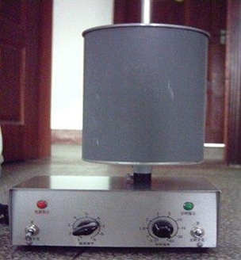
Fig 5.1: View of kymograph

Cardiac activity
The heart primary function is simply to act as a pump that provides pressure move blood to its ultimate destination – the tissues, the control of cardiac contractility is complex and represent a balance of intrinsic ( within the heart) and extrinsic ( from outside the heart ) factor. An isolated heart beats regularly without any extrinsic stimulation from nerves or hormones. This mechanical automaticity reflects the fact that the action potentials which are conducted throughout the heart (the signals which lead to contraction) are generated spontaneously within the cardiac muscle itself. The cells responsible for spontaneous action potential production are often referred to as pacemaker cells because they determine the rate at which the heart beats. Several cell types in the heart are capable of pacemaker activity, but in the intact organ it is the fastest pacemaker which drives the rest of the heart.
Normally the pace making frequency is highest in a group of specialized cells called the sinoatrial node (SN\SAN), which also have a different shape of action potential. These cells dictate the rate of electrical events in the rest of the heart.
The Sino-atrial node in human is located in the wall of the right atrium close to the superior vena cava. In the frog or turtle heart the pacemaker region is the sinus venous, an enlarged region between the vena cava and the right atrium.

Purpose
To study frog heart beat records and examine some of these intrinsic and extrinsic factors that make the heart such a unique and versatile pump (To record the relative force and frequency of contraction in a resting heart).

Materials/Chemicals
- Gloves,
- In Frog, Formaldehyde (or any Anesthetic) ,
- Kymograph,
- Dissection tools,
- Dissection dish,
- Ringer's Solution (10.4 g NaCl , 0.32 g KCL , 0.48 g CaCl2 , 0.32 g NaHCO4; Make up in 11 distilled wate

Procedure
clean aseptic work area:
- Double pith a frog and fasten it to a frog board, ventral side up.
- Use scissors to make a Iongitudinal incision through the skin and body wall of the thoracic region to expose the heart.
- Hold the pericardium with forceps and carefully cut away the sac from the heart, using scissors. From this point on make sure that the heart is periodically moistened with frog ringer's solution.
- Using forceps, gently lift the apex of the heart upward.
- Insert a bent insect pin or small fish hook through the tip of the ventricle, being careful not to puncture the ventricle.
- Tie a thin thread to the hook and connect the ventricle to the transducer as you connected the gastrocnemius muscle to the transducer in:
- If physiograph type of transducer is used, attach the thread to the transducer hook and adjust the tension on the ventricle until the recording pen is raised slightly above the baseline.

Results

Normal heartbeat
Obtain a recording of the normal cardiac rhythm, using a medium to fast paper speed so as to distinguish the atrial and ventricular. Run a 1-second time line while recording so that the duration of systole and diastole of the ventricle can be determined.

Temperature
Record the heart contractions at room temperature. Then drop warm (40°C) frog ringer's solution on the heart until significant changes are seen in rate and contractility.
Record contraction at this time finally, drop cold (5°C) ringer's on the heart and record when changes are observed.
Then rinse the heart with room temperature ringer’s to return the beat to normal before continuing the experiments

Practical No: 7 Measurement of blood pressure

Introduction
A sphygmomanometer is a device that measures blood pressure. It is composes of an inflatable rubber cuff, which is wrapped around the arm. A measuring device indicates the cuff's pressure. A bulb inflates the cuff and a valve releases pressure. A stethoscope is used to listen to arterial blood flow sounds.
As the heart beats, blood forced through the arteries cause a rise in pressure, called systolic pressure, followed by a decrease in pressure as the heart's ventricles prepare for another beat. This low pressure is called the diastolic pressure.
The sphygmomanometer cuff is inflated to well above expected systolic pressure. As the valve is opened, cuff pressure (slowly) decreases. When the cuff's pressure equals the arterial systolic pressure, blood begins to flow past the cuff, creating blood flow turbulence and audible sounds. Using a stethoscope, these sounds are heard and the cuff's pressure is recorded. The blood flow sounds will continue until the cuff's pressure falls below the arterial diastolic pressure. The pressure when the blood flow sounds stop indicates the diastolic pressure.
Systolic and diastolic pressures are commonly stated as systolic 'over' diastolic e.g. 120 over 80. Blood flow sounds are called Korotkoff sounds.
Instrument required
  - Sphygmomanometer
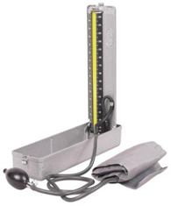
Fig 6.1: View of Sphygmomanometer

Procedures
- To begin blood pressure measurement, use a properly sized blood pressure cuff. The length of the cuff's bladder should be at least equal to 80% of the circumference of the upper arm.
- Wrap the cuff around the upper arm with the cuff's lower edge one inch above the antecubital fossa.
- Lightly press the stethoscope's bell over the brachial artery just below the cuff's edge. Some health care workers have difficulty using the bell in the antecubital fossa, so we suggest using the bell or the diaphragm to measure the blood pressure.
- Rapidly inflate the cuff to 180mmHg. Release air from the cuff at a moderate rate (3mm/sec).
- Listen with the stethoscope and simultaneously observe the sphygmomanometer. The first knocking sound (Korotkoff) is the subject's systolic pressure. When the knocking sound disappears, that is the diastolic pressure (such as 120/80).
- Record the pressure in both arms and note the difference; also record the subject's position (supine), which arm was used, and the cuff size (small, standard or large adult cuff).
- If the subject's pressure is elevated, measure blood pressure two additional times, waiting a few minutes between measurements.
- Then ask the subject to exercise (running, jumping, etc.) for about 30 minutes and record the blood pressure.
- Now check and record the differences in blood pressure during normal conditions and after exercise. What is the difference you recorded and why is that so?

Precautions
- Use a larger cuff on obese or heavily muscled subjects.
- Use a smaller cuff for pediatric patients.
- For pediatric patients a lower blood pressure may indicate the presence of hypertension.
- Don't place the cuff over clothing.
- Flex and support the subject's arm.
- In some patients the Korotkoff sounds disappear as the systolic pressure is bled down. After an interval, the Korotkoff sounds reappear. This interval is referred to as the "auscultatory gap." This pathophysiologic occurrence can lead to a marked under-estimation of systolic pressure if the cuff pressure is not elevated enough. It is for this reason that the rapid inflation of the blood pressure cuff to 180mmHg was recommended above. The "auscultatory gap" is felt to be associated with carotid atherosclerosis and a decrease in arterial compliance in patients with increased blood pressure.

Practical No: 8 Blood pressure alteration in exercise.

Blood pressure after exercise
Exercise can increase blood pressure, but the effects are typically temporary. Your blood pressure should gradually return to normal after you finish exercising. The quicker your blood pressure returns to its resting level, the healthier you probably are.
According to guidelines provided by the Centers for Disease Control and Prevention Trusted Source, “normal” blood pressure is less than 120/80 mm Hg. This includes a systolic pressure reading under 120 mm Hg (the top number) and a diastolic pressure reading (the bottom number) under 80 mm Hg. Exercise increases systolic blood pressure. Systolic blood pressure is a measure of blood vessel pressure when your heart beats.
Diastolic blood pressure is a measure of the pressure in the blood vessels between heartbeats. It shouldn’t change significantly during exercise. If it does, consult your doctor.
It’s difficult to say conclusively what blood pressure readings are considered healthy after exercise, as blood pressure varies from person to person. Normal levels for one person might be a sign of a problem for another person.
In general, though, high blood pressure after a resting period of up to two hours following exercise includes any reading greater than 140/90 mm Hg. Low blood pressure after exercise includes any reading lower than 90/60 mm Hg.

Effects of exercise on blood pressure
Aerobic activities such as swimming, cycling, and running put additional demands on your cardiovascular system. Your muscles need more oxygen than they do when you’re at rest, so you have to breathe more quickly.
Your heart starts to pump harder and faster to circulate blood to deliver oxygen to your muscles. As a result, systolic blood pressure rises.
It’s normal for systolic blood pressure to rise to between 160 and 220 mm Hg during exercise. Unless you’ve cleared it with your doctor, stop exercising if your systolic blood pressure surpasses 200 mm Hg. Beyond 220 mm Hg, your risk of a heart problem increases.
Different factors can influence how your cardiovascular system responds to exercise. Some of these factors include diet, medical conditions, and medications.
For instance, exercise hypertension is a condition that causes an extreme spike in blood pressure during physical activity. People with exercise hypertension can experience spikes in systolic blood pressure up to 250 mm Hg during exercise.
In general, your blood pressure should return to normal within several hours of a workout. Even then, you might notice that your blood pressure doesn’t return to exactly what it was before exercise. That’s because it’s normal for blood pressure to drop slightly within a few hours of exercise.

Practical No: 9 Video Study of brains in different animals in relation to complexity of functions.
Nervous systems throughout the animal kingdom vary in structure and complexity, as illustrated by the variety of animals shown in Figure 1. Some organisms, like sea sponges, lack a true nervous system. Others, like jellyfish, lack a true brain and instead have a system of separate but connected nerve cells (neurons) called a “nerve net.” Echinoderms such as sea stars have nerve cells that are bundled into fibers called nerves.
Flatworms of the phylum Platyhelminthes have both a central nervous system (CNS), made up of a small “brain” and two nerve cords, and a peripheral nervous system (PNS) containing a system of nerves that extend throughout the body. The insect nervous system is more complex but also fairly decentralized. It contains a brain, ventral nerve cord, and ganglia (clusters of connected neurons). These ganglia can control movements and behaviors without input from the brain. Octopi may have the most complicated of invertebrate nervous systems—they have neurons that are organized in specialized lobes and eyes that are structurally similar to vertebrate species.
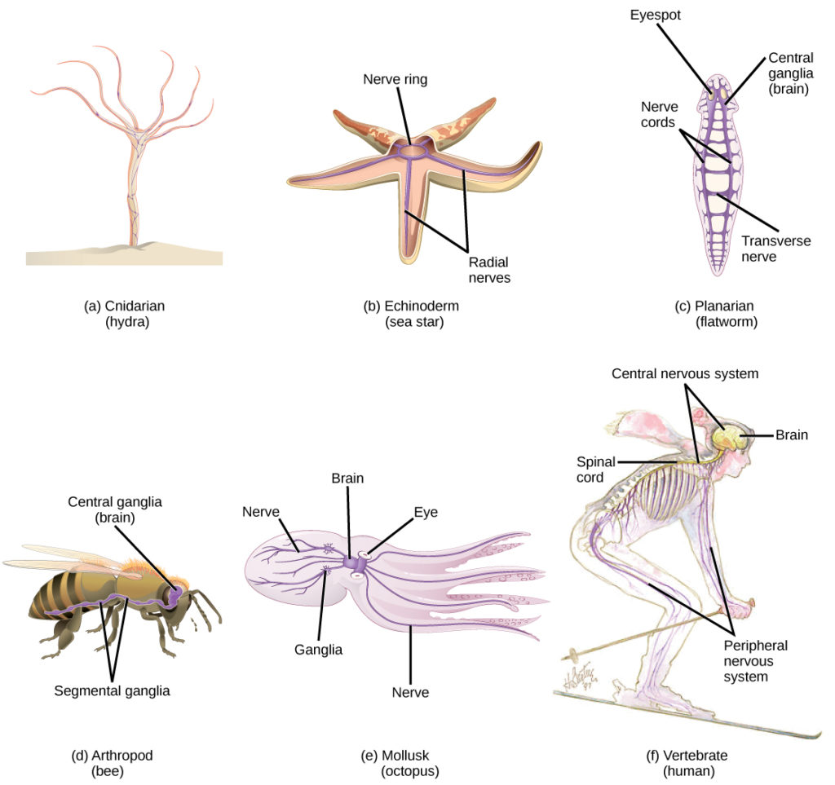
Figure 1. Nervous systems vary in structure and complexity. In (a) cnidarians, nerve cells form a decentralized nerve net. In (b) echinoderms, nerve cells are bundled into fibers called nerves. In animals exhibiting bilateral symmetry such as (c) planarians, neurons cluster into an anterior brain that processes information. In addition to a brain, (d) arthropods have clusters of nerve cell bodies, called peripheral ganglia, located along the ventral nerve cord. Mollusks such as squid and (e) octopi, which must hunt to survive, have complex brains containing millions of neurons. In (f) vertebrates, the brain and spinal cord comprise the central nervous system, while neurons extending into the rest of the body comprise the peripheral nervous system. (credit e: modification of work by Michael Vecchione, Clyde F.E. Roper, and Michael J. Sweeney, NOAA; credit f: modification of work by NIH)
Compared to invertebrates, vertebrate nervous systems are more complex, centralized, and specialized. While there is great diversity among different vertebrate nervous systems, they all share a basic structure: a CNS that contains a brain and spinal cord and a PNS made up of peripheral sensory and motor nerves. One interesting difference between the nervous systems of invertebrates and vertebrates is that the nerve cords of many invertebrates are located ventrally whereas the vertebrate spinal cords are located dorsally. There is debate among evolutionary biologists as to whether these different nervous system plans evolved separately or whether the invertebrate body plan arrangement somehow “flipped” during the evolution of vertebrates.

Practical No: 10 Video Study of human brain model and different areas eliciting behaviors.

Mammals, including humans, have developed brain layers that provide more advanced functions for instance, better memory, more sophisticated social interactions, and the ability to experience emotions.
Humans have a very large and highly developed outer layer known as the cerebral cortex which makes us particularly adept at these processes.

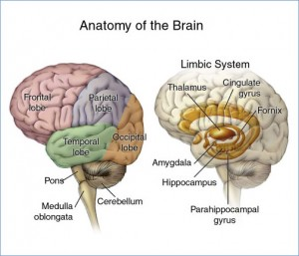
Figure: The Major Structures in the Human Brain.

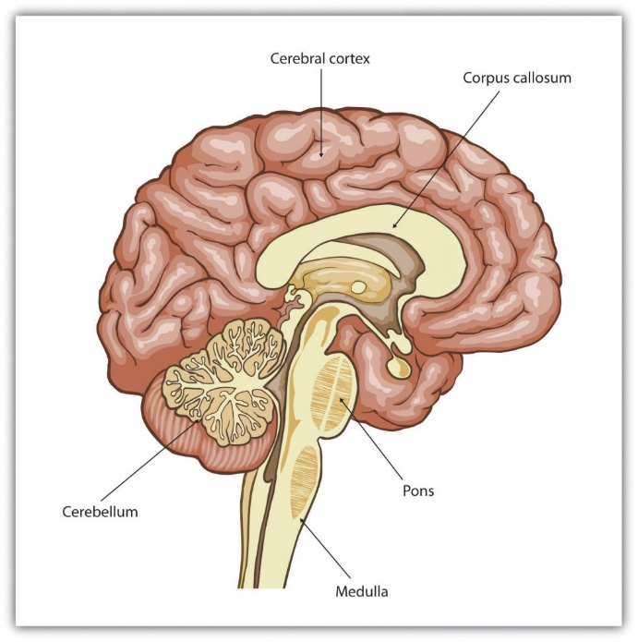
Figure: Cerebral Cortex.
Humans have a very large and highly developed outer brain layer known as the cerebral cortex. The cortex provides humans with excellent memory, outstanding cognitive skills, and the ability to experience complex emotions.

The Old Brain: Wired for Survival
The brain stem is the oldest and innermost region of the brain. It’s designed to control the most basic functions of life, including breathing, attention, and motor responses. The brain stem begins where the spinal cord enters the skull and forms the medulla, the area of the brain stems that controls heart rate and breathing. In many cases the medulla alone is sufficient to maintain life animals that have the remainder of their brains above the medulla severed are still able to eat, breathe, and even move. The spherical shape above the medulla is the pons, a structure in the brain stem that helps control the movements of the body, playing a particularly important role in balance and walking.
Running through the medulla and the pons is a long, narrow network of neurons known as the reticular formation. The job of the reticular formation is to filter out some of the stimuli that are coming into the brain from the spinal cord and to relay the remainder of the signals to other areas of the brain. The reticular formation also plays important roles in walking, eating, sexual activity, and sleeping. When electrical stimulation is applied to the reticular formation of an animal, it immediately becomes fully awake, and when the reticular formation is severed from the higher brain regions, the animal falls into a deep coma.
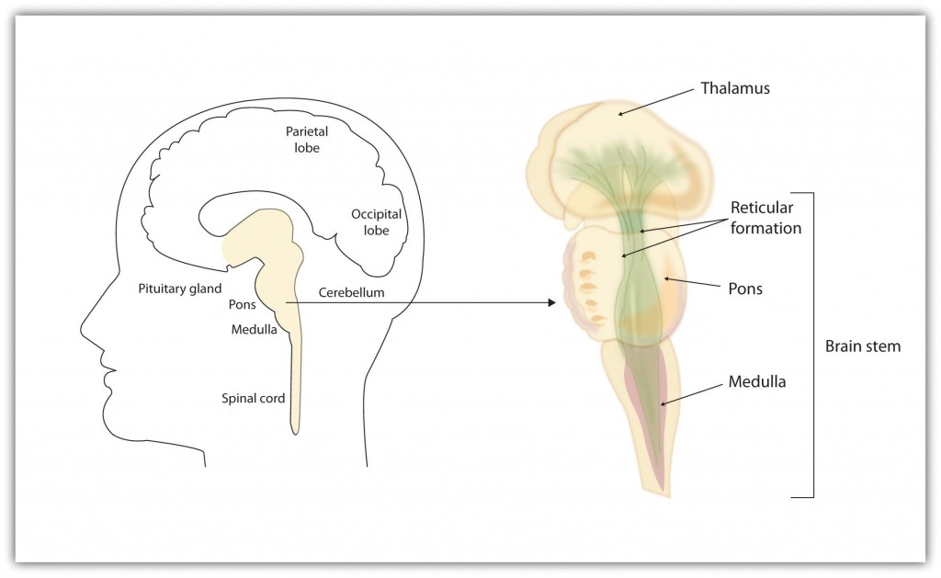
Figure: The Brain Stem and the Thalamus.

The brain stem is an extension of the spinal cord, including the medulla, the pons, the thalamus, and the reticular formation.

Above the brain stem are other parts of the old brain that also are involved in the processing of behavior and emotions. The thalamus is the egg-shaped structure above the brain stem that applies still more filtering to the sensory information that is coming up from the spinal cord and through the reticular formation, and it relays some of these remaining signals to the higher brain levels. The thalamus also receives some of the higher brain’s replies, forwarding them to the medulla and the cerebellum. The thalamus is also important in sleep because it shuts off incoming signals from the senses, allowing us to rest.
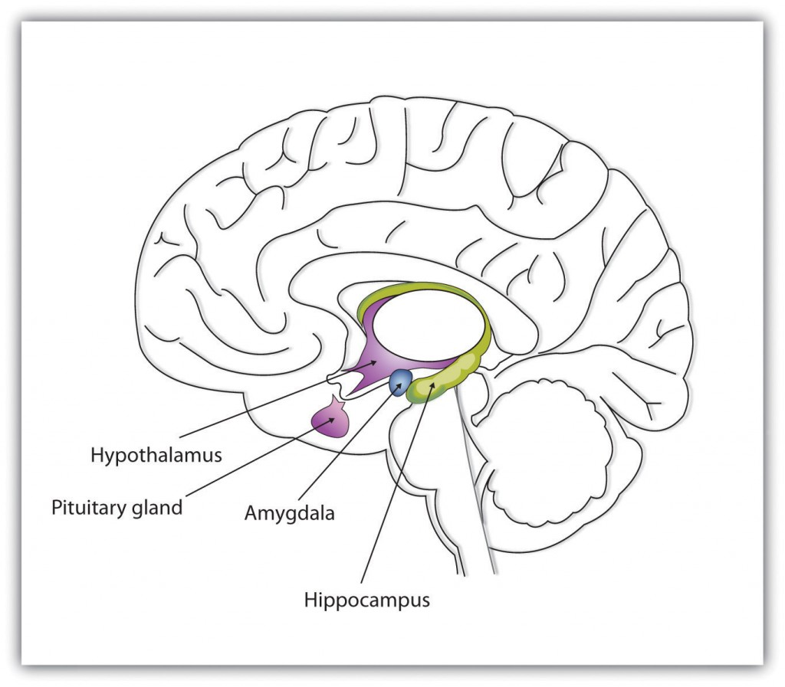
Figure: The Limbic System.

This diagram shows the major parts of the limbic system, as well as the pituitary gland, which is controlled by it.

The cerebellum (literally, “little brain”) consists of two wrinkled ovals behind the brain stem. It functions to coordinate voluntary movement. People who have damage to the cerebellum have difficulty walking, keeping their balance, and holding their hands steady. Consuming alcohol influences the cerebellum, which is why people who are drunk have more difficulty walking in a straight line. Also, the cerebellum contributes to emotional responses, helps us discriminate between different sounds and textures, and is important in learning (Bower & Parsons, 2003).
Whereas the primary function of the brain stem is to regulate the most basic aspects of life, including motor functions, the limbic system is largely responsible for memory and emotions, including our responses to reward and punishment. The limbic system is a brain area, located between the brain stem and the two cerebral hemispheres, that governs emotion and memory. It includes the amygdala, the hypothalamus, and the hippocampus.
The amygdala consists of two “almond-shaped” clusters (amygdala comes from the Latin word for “almond”) and is primarily responsible for regulating our perceptions of, and reactions to, aggression and fear. The amygdala has connections to other bodily systems related to fear, including the sympathetic nervous system (which we will see later is important in fear responses), facial responses (which perceive and express emotions), the processing of smells, and the release of neurotransmitters related to stress and aggression (Best, 2009). In one early study, Klüver and Bucy (1939) damaged the amygdala of an aggressive rhesus monkey. They found that the once angry animal immediately became passive and no longer responded to fearful situations with aggressive behavior. Electrical stimulation of the amygdala in other animals also influences aggression. In addition to helping us experience fear, the amygdala also helps us learn from situations that create fear. When we experience events that are dangerous, the amygdala stimulates the brain to remember the details of the situation so that we learn to avoid it in the future (Sigurdsson, Doyère, Cain, & LeDoux, 2007).
Located just under the thalamus (hence its name), the hypothalamus is a brain structure that contains a number of small areas that perform a variety of functions, including the regulation of hunger and sexual behavior, as well as linking the nervous system to the endocrine system via the pituitary gland. Through its many interactions with other parts of the brain, the hypothalamus helps regulate body temperature, hunger, thirst, and sex, and responds to the satisfaction of these needs by creating feelings of pleasure.
The hippocampus consists of two “horns” that curve back from the amygdala. The hippocampus is important in storing information in long-term memory. If the hippocampus is damaged, a person cannot build new memories, living instead in a strange world where everything he or she experiences just fades away, even while older memories from the time before the damage are untouched.

The Cerebral Cortex Creates Consciousness and Thinking
The key to the advanced intelligence of humans is not found in the size of our brains. What sets humans apart from other animals is our larger cerebral cortex — the outer bark-like layer of our brain that allows us to so successfully use language, acquire complex skills, create tools, and live in social groups (Gibson, 2002). In humans, the cerebral cortex is wrinkled and folded, rather than smooth as it is in most other animals. This creates a much greater surface area and size, and allows increased capacities for learning, remembering, and thinking. The folding of the cerebral cortex is referred to as corticalization.
Although the cortex is only about one-tenth of an inch thick, it makes up more than 80% of the brain’s weight. The cortex contains about 20 billion nerve cells and 300 trillion synaptic connections (de Courten-Myers, 1999). Supporting all these neurons are billions more glial cells (glia), cells that surround and link to the neurons, protecting them, providing them with nutrients, and absorbing unused neurotransmitters. The glia come in different forms and have different functions. For instance, the myelin sheath surrounding the axon of many neurons is a type of glial cell. The glia are essential partners of neurons, without which the neurons could not survive or function (Miller, 2005).
The cerebral cortex is divided into two hemispheres, and each hemisphere is divided into four lobes, each separated by folds known as fissures. If we look at the cortex starting at the front of the brain and moving over the top we see first the frontal lobe (behind the forehead), which is responsible primarily for thinking, planning, memory, and judgment. Following the frontal lobe is the parietal lobe, which extends from the middle to the back of the skull and which is responsible primarily for processing information about touch. Then comes the occipital lobe at the very back of the skull, which processes visual information. Finally, in front of the occipital lobe (pretty much between the ears) is the temporal lobe, responsible primarily for hearing and language.
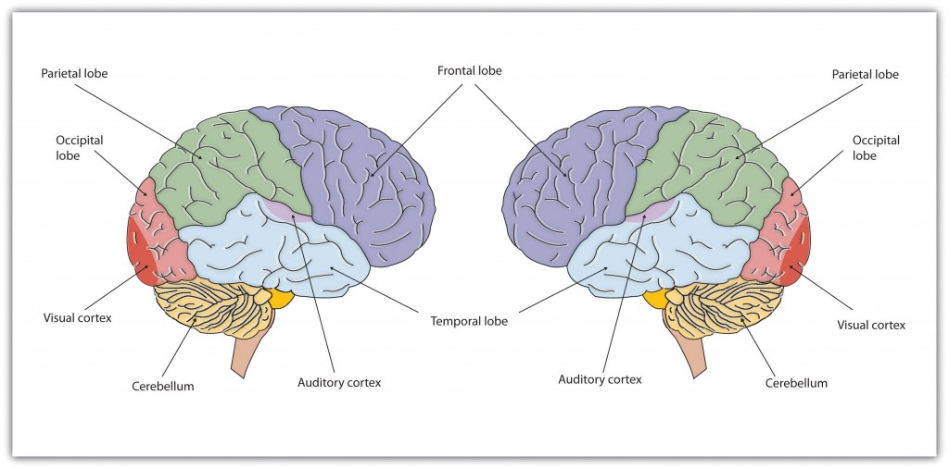
Figure: The Two Hemispheres.

The brain is divided into two hemispheres (left and right), each of which has four lobes (temporal, frontal, occipital, and parietal). Furthermore, there are specific cortical areas that control different processes.

Functions of the Cortex
When the German physicists Gustav Fritsch and Eduard Hitzig (1870/2009) applied mild electric stimulation to different parts of a dog’s cortex, they discovered that they could make different parts of the dog’s body move. Furthermore, they discovered an important and unexpected principle of brain activity. They found that stimulating the right side of the brain produced movement in the left side of the dog’s body, and vice versa. This finding follows from a general principle about how the brain is structured, called contralateral control, meaning the brain is wired such that in most cases the left hemisphere receives sensations from and controls the right side of the body, and vice versa.
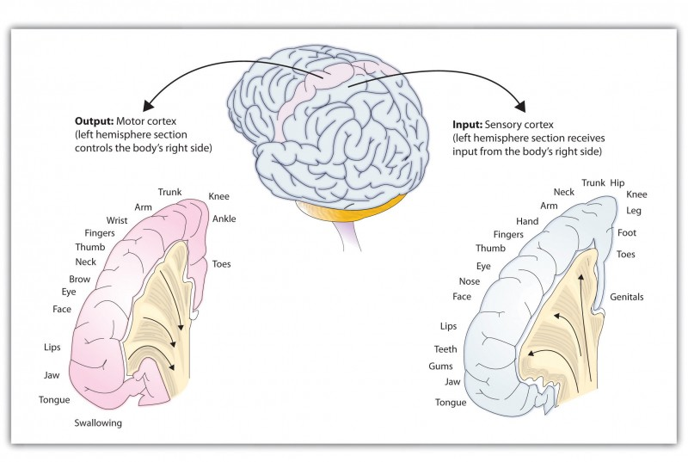Figure: The Sensory Cortex and the Motor Cortex.

The portion of the sensory and motor cortex devoted to receiving messages that control specific regions of the body is determined by the amount of fine movement that area is capable of performing. Thus the hand and fingers have as much area in the cerebral cortex as does the entire trunk of the body.
Fritsch and Hitzig also found that the movement that followed the brain stimulation only occurred when they stimulated a specific arch-shaped region that runs across the top of the brain from ear to ear, just at the front of the parietal lobe. Fritsch and Hitzig had discovered the motor cortex, the part of the cortex that controls and executes movements of the body by sending signals to the cerebellum and the spinal cord. More recent research has mapped the motor cortex even more fully, by providing mild electronic stimulation to different areas of the motor cortex in fully conscious patients while observing their bodily responses (because the brain has no sensory receptors, these patients feel no pain). This research has revealed that the motor cortex is specialized for providing control over the body, in the sense that the parts of the body that require more precise and finer movements, such as the face and the hands, also are allotted the greatest amount of cortical space.
Just as the motor cortex sends out messages to the specific parts of the body, the somatosensory cortex, an area just behind and parallel to the motor cortex at the back of the frontal lobe, receives information from the skin’s sensory receptors and the movements of different body parts. Again, the more sensitive the body region, the more area is dedicated to it in the sensory cortex. Other areas of the cortex process other types of sensory information. The association areas are involved in higher mental functions, such as learning, thinking, planning, judging, moral reflecting, figuring, and spatial reasoning.

Practical No: 11 Stages in estrous cycle (studies on the effects of hormones in breeding season)

Introduction
The estrous cycle or oestrus cycle is the set of recurring physiological changes that are induced by reproductive hormones in most mammalian therian females. Estrous cycles start after sexual maturity in females and are interrupted by anestrous phases or by pregnancies. Typically, estrous cycles continue until death.
Stages of estrus cycle
A four-phase terminology is used in reference to animals with estrous cycles.
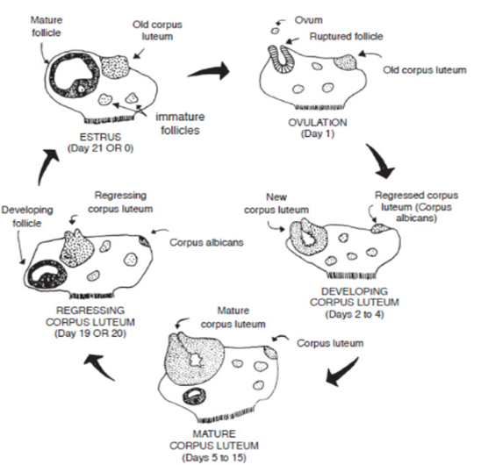
Fig 8.2: Stages of estrus cycle

- In proestrus stage one or several follicles of the ovary start to grow. Their number is species specific. Typically this phase can last as little as one day or as long as three weeks, depending on the species. Under the influence of estrogen, the lining in the uterus (endometrium) starts to develop.
- Estrus or oestrus refers to the phase when the female is sexually receptive. Under regulation by gonadotropic hormones, ovarian follicles mature and estrogen secretions exert their biggest influence. The female then exhibits sexually receptive behavior. Estrus is commonly seen in the mammalian species, including primates.
- Metestrus or diestrus phase is characterized by the activity of the corpus luteum, which produces progesterone. The signs of estrogen stimulation subside and the corpus luteum starts to form. The uterine lining begins to appear. In the absence of pregnancy the diestrus phase (also termed pseudo-pregnancy) terminates with the regression of the corpus luteum. The lining in the uterus is not shed, but is reorganized for the next cycle.
- Anestrus refers to the phase when the sexual cycle rests. This is typically a seasonal event and controlled by light exposure through the pineal gland that releases melatonin. Melatonin may repress stimulation of reproduction in long-day breeders and stimulate reproduction in short-day breeders. Melatonin is thought to act by regulating the hypothalamic pulse activity of the gonadotropin-releasing hormone.
After completion (or abortion) of a pregnancy, some species have postpartum estrus, which is ovulation and corpus luteum production that occurs immediately following the birth of the young. For example, the mouse has a fertile postpartum estrus that occurs 14 to 24 hours following parturition. Estrous cycle variability differs among species, but cycles are typically more frequent in smaller animals. Even within species significant variability can be observed, thus cats may undergo an estrous cycle of 3 to 7 weeks. Domestication can affect estrous cycles due to changes in the environment.

Practical No: 12 Oxygen consumption in fish and effect of temperature (by dissolved oxygen meter)and terrestrial animal (mouse)

Background
Dissolved oxygen concentration (DO) is considered the most important water quality variable in fish culture. In the broadest sense, however, dissolved oxygen concentration is no more important than other environmental variables because any factor that is outside the range tolerated by fish can cause stress or death. What makes dissolved oxygen concentration so important in intensive fish culture is the speed with which it can change. Over a matter of hours, sometimes even minutes, DO can change from optimum to lethal levels. No other critical environmental variable in fish culture is so dynamic. The dynamic nature of dissolved oxygen results from the interaction of three factors. First, oxygen is not very soluble in water so water has only a limited capacity to “hold” oxygen. Second, the rate of oxygen use by fish, plankton and organisms living in the pond mud can be high. Third, oxygen diffuses very slowly from the atmosphere into undisturbed water. The combination of these three factors—limited solubility, rapid use and slow replenishment—can cause rapid changes in dissolved oxygen concentrations. Dissolved oxygen levels can be managed with aeration, but the response time for taking corrective measures is short. This makes it critical to have a rapid and reliable method of measuring dissolved oxygen concentrations so that aeration devices can be activated when needed.
There are a number of ways to measure dissolved oxygen concentration. Select a method based on 1) the number of ponds or tanks to be measured, 2) the level of accuracy required, and 3) the cost of the measurement technique. The titration-based “drop count” method fairly rapidly assesses whether or not there is sufficient dissolved oxygen in water. The drop count method is inexpensive and appropriate if DO concentration is to be measured infrequently in a few ponds or tanks. However, on commercial fish farms or in any other situation where DO measurement of many ponds or culture units is routine, a dissolved oxygen meter is an indispensable piece of equipment.
What is an oxygen meter?
An oxygen meter has two components—the sensor (sometimes called the probe) and the meter. The sensor reacts with oxygen and an electrical signal is produced in proportion to the oxygen concentration. The signal is then amplified, translated into concentration units, and displayed by the meter. The meter circuitry also compensates the reading for changes in temperature, altitude or salinity.
DO meters do not measure oxygen concentration directly, but measure a voltage that is produced by the chemical reactions of oxygen with the various components of the sensor.
Materials
- Dissolved oxygen meter
- Beakers
- Thermometer
- Fishes and mouse
Procedure
Making dissolved oxygen measurements
The process of measuring dissolved oxygen concentration with an oxygen meter is simple, although it involves a bit more than simply putting the sensor in the water and reading a number on the display. Accurate measurement of DO concentration with polarographic sensors requires moving the sensor in the water. Oxygen is consumed across the membrane, so failure to move the sensor will create an oxygen-depleted microzone around the sensor tip and show a measurement that is too low. Move the sensor up and down or side to side about 1 foot per second to prevent this problem. The response of dissolved oxygen sensors is not instantaneous. Measured values will change rapidly at first and then begin to stabilize within 15 to 20 seconds, although it is rare that measured values in ponds will fully stabilize.
Dissolved oxygen measurements made near the pond bank are very different (usually lower) than those made in open areas of the pond because of the effects of sediment respiration and pond bank vegetation. The dissolved oxygen meter should not be turned off between measurements to avoid depolarizing the probe. Recalibrate the meter when it is used again. If a large meter adjustment is necessary during recalibration it may be an indication of problems with the membrane or sensor.
Dissolved oxygen monitoring in ponds
Dissolved oxygen concentrations in fish ponds vary with depth, from one side of a pond to the other and particularly from one time of day to another. In general, dissolved oxygen concentrations are lowest at dawn and highest at dusk; lowest near the bottom and highest near the surface; and lowest near the upwind side and highest near the downwind side.
Effect of temperature on oxygen consumption
Take pond water in beakers at different temperature ranges from 10-30 degrees. Place gold fishes in these beakers (one each). Let the fishes settle. Take a stop watch and record the oxygen consumption of fishes in water at different time intervals.
In the same way use an enclosed glass chamber and record the oxygen consumption of mouse.

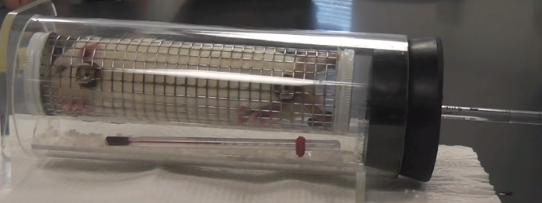
Fig 7.1: Oxygen consumption by rat

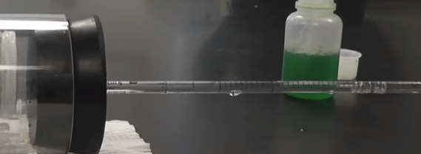
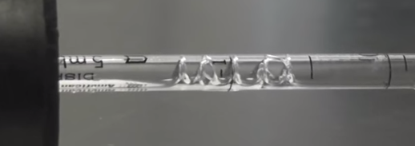
Fig 7.2: Comparison of bubble movement in tube at different time intervals

Practical No:13 Oxygen consumption in fish and mouse by Respirometer

Introduction
A respirometer is a device used to measure the rate of respiration of a living organism by measuring its rate of oxygen consumption. They allow investigation into how factors such as age, chemicals or the effect of light affect the rate of respiration. There are various different types of respirometer. One type is shown in the diagram.
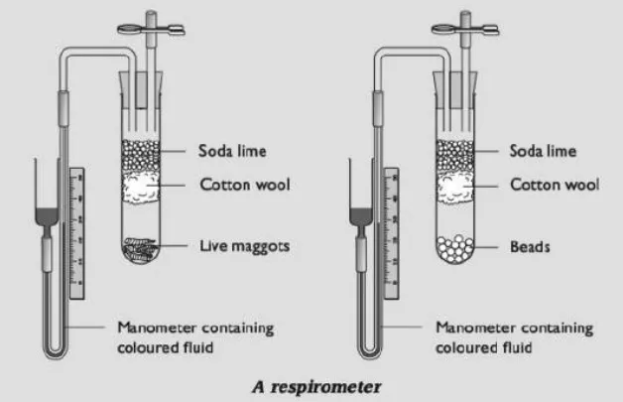
Fig 8.1: A view of Respirometer
Using a respirometer to measure the rate of uptake of oxygen
The organisms to be investigated are placed in one tube, and non-living material of the same mass in the other tube. Soda lime is placed in each tube, to absorb all carbon dioxide. Cotton wool prevents contact of the soda lime with the organism.
Coloured fluid is poured into the reservoir of each manometer and allowed to flow into the capillary tube. It is essential that there are no air bubbles. You must end up with exactly the same quantity of fluid in the two manometers. Two rubber bungs are now taken, fitted with tubes as shown in the diagram. Close the spring clips. Attach the manometers to the bent glass tubing, ensuring an airtight connection. Next, place the bungs into the tops of the tubes. Open the spring clips. (This allows the pressure throughout the apparatus to equilibrate with atmospheric pressure.) Note the level of the manometer fluid in each tube. Close the clips. Each minute, record the level of the fluid in each tube.
As the organisms respire, they take oxygen from the air around them and give out carbon dioxide. The removal of oxygen from the air inside the tube reduces the volume and pressure, causing the manometer fluid to move towards the organisms. The carbon dioxide given out is absorbed by the soda lime. The distance moved by the fluid is therefore affected only by the oxygen taken up and not by the carbon dioxide given out. You would not expect the manometer fluid in the tube with no organisms to move, but it may do so because of temperature changes. This allows you to control for this variable, by subtracting the distance moved by the fluid in the control manometer from the distance moved in the experimental manometer (connected to the Living organisms), to give you an adjusted distance moved.
Calculate the mean (adjusted) distance moved by the manometer fluid per minute. If you know the diameter of the capillary tube, you can convert the distance moved to a volume:
Volume of liquid in a tube - length x πr²
This gives you a value for the volume of oxygen absorbed by the organisms per minute.
Using a respirometer to investigate the effect of temperature on the rate of respiration
The respirometer can be placed in water baths at different temperatures. You can use the same respirometer for the whole experiment. Or you could have different ones for each temperature. (In each case, there are difficulties with controlling some variables — you might like to think about what these are.) At each temperature, you need a control respirometer with no organisms in it.
If you are simply comparing the rates of respiration at different temperatures, then you do not need to convert the distance moved by the manometer fluid to a volume. You could just plot distance moved on the y-axis of your graph and time on the x-axis. The rate of respiration is represented by the gradient of the graph.
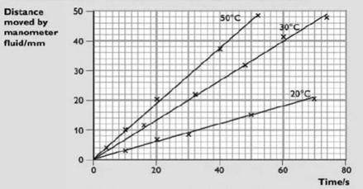
Fig 8.2: Comparing rates of respiration at different temperature

Practical No:14 Study through clinics data on the insulin and glycemia in type1 and type 2 diabetic subjects.

Type 1 diabetes:

The body’s immune system is responsible for fighting off foreign invaders, such as harmful viruses and bacteria.
In people with type 1 diabetes, the immune system mistakes the body’s own healthy cells for foreign invaders. The immune system attacks and destroys the insulin-producing beta cells in the pancreas. After these beta cells are destroyed, the body is unable to produce insulin.
Researchers don’t know why the immune system sometimes attacks the body’s own cells. It may have something to do with genetic and environmental factors, such as exposure to viruses. Research into autoimmune diseases is ongoing.

Type 2 diabetes:

People with type 2 diabetes have insulin resistance. The body still produces insulin, but it’s unable to use it effectively.
Other genetic and environmental factors may also play a role. When you develop type 2 diabetes, your pancreas will try to compensate by producing more insulin. Because your body is unable to effectively use insulin, glucose will accumulate in your bloodstream.
Top of Form

Hyperglycemia and hypoglycemia in type 1 diabetes

- Hyperglycemia occurs when blood sugar levels are too high. People develop hyperglycemia if their diabetes is not treated properly.
- Hypoglycemia sets in when blood sugar levels are too low. This is usually a side effect of treatment with blood-sugar-lowering medication.
- Diabetes is a metabolic disease with far-reaching health effects.
- In type 1 diabetes, the body only produces very little insulin, or none at all.
- In type 2 diabetes, not enough insulin is released into the bloodstream, or the insulin cannot be used properly.
- We need insulin to live. Without it, sugar (glucose) builds up in the blood because it cannot be taken out and used by the body.
- Very high blood sugar, known as hyperglycemia, leads to a number of symptoms. If blood sugar levels are too low, it is called hypoglycemia.

When is blood sugar considered to be too high or too low?

Slight fluctuations in blood sugar levels are completely normal and also happen on a daily basis in people who do not have diabetes. Between around 60 and 140 milligrams of sugar per deciliter of blood (mg/dL) is considered to be healthy. This is equivalent to blood sugar concentrations between 3.3 and 7.8 mmol/L. “Millimole per liter” (mmol/L) is the international unit for measuring blood sugar. It indicates the concentration of a certain substance per liter.

If type 1 diabetes is left untreated, people’s blood sugar levels can get very high, sometimes exceeding 27.8 mmol/L (500 mg/dL). Blood sugar concentrations below 3.3 mmol/L (60 mg/dL) are considered to be too low.

Signs of hyperglycemia

Signs of very high blood sugar levels in type 1 diabetes may include the following:

- Extreme thirst, drinking a lot and then urinating frequently as a result
- Unintentionally losing a lot of weight within a few weeks
- Noticeable loss of energy with muscle weakness, tiredness and generally feeling quite unwell
- Nausea and stomach ache
- Trouble seeing
- Poor concentration
- Frequent infections (cystitis, thrush)
- Confusion and drowsiness, or even coma
- If you or your child have these symptoms, you should see a doctor as soon as you can.

Signs of hypoglycemia
Low blood sugar is most common in people who use insulin or take certain tablets to reduce high blood sugar. This is because things like unplanned physical activity, eating meals later than usual, or drinking too much alcohol can mean that you need less insulin than you thought, causing your blood sugar to drop very low.

Signs that your blood sugar is too low may include:

- Racing pulse
- Cold sweats
- Pale face
- Headache
- Feeling incredibly hungry
- Shivering, feeling weak in the knees
- Feeling restless, nervous or anxious
- Difficulty concentrating, confusion

These symptoms do not occur all at once. The signs of hypoglycemia not only depend on the blood sugar level, but also vary from person to person. If you are not sure whether your blood sugar is too low, you can measure it to make sure. Mild hypoglycemia doesn't usually have any harmful effects. But it is important to react quickly enough and eat or drink something, such as dextrose sugar or sugary lemonade.

People who have severe hypoglycemia may feel very drowsy and confused, and might even become unconscious. If this happens, someone else can inject the hormone glucagon.

Method of Collecting Data:

This practical requires a questionnaire survey of diabetes patients (Clinics data on the insulin and glycaemia in type1 and type 2 diabetic patients).

Results:
Compute your results in tabulated form.

