
Laboratory Manual
Essentials of Genetics (BIO301)

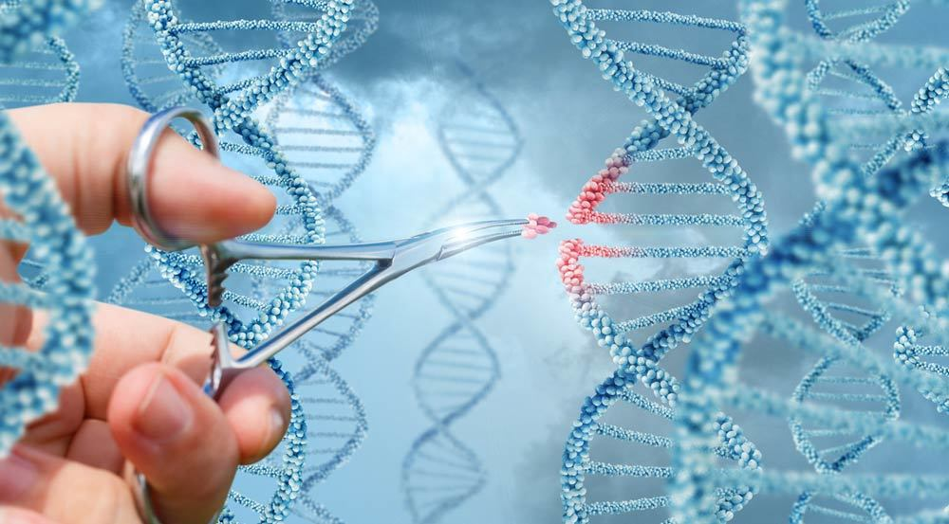



Virtual University of Pakistan

Contents
S. No. | Practical | P. No.
1 | Preparation of stock and working solutions | 2
2 | Sources and Recovery of DNA | 5
3 | DNA Extraction part 1 | 6
4 | DNA Extraction part 2 | 8
5 | RNA purification from blood | 9
6 | Quantification of Nucleic acids by Gel electrophoresis | 10
7 | Quantification of Nucleic acids by spectrophotometer | 12
8 | cDNA synthesis | 13
9 | Primer Designing | 18
10 | PCR and its types | 19
11 | Blotting techniques | 26
12 | Karyotyping | 30
13 | Chromosome staining, banding of chromosomes (C, Q, R, T) | 34
14 | Genetics problems | 38

Practical No: 1 Preparation of stock and working solutions

The following general instructions are applicable in the preparation of all reagents. Use graduated cylinders or pipettes closest to the volume being measured for preparing liquid reagents. Store all reagents in sterile containers unless otherwise noted. Label all reagents with name of reagent, date prepared, initials of scientist that prepared reagent, lot number, and expiration date. Record each preparation in the lab’s reagent logbook.

1M Tris-HCl (Tris Hydroxymethyl amino methane) pH 8
Tris base 121.1g
H₂O to 800ml
Adjust to desired pH with concentrated HCl. Mix and add H₂O to 1 Liter.
Store at room temperature

0.5 M EDTA (Ethylenediamine Tetra acetic Acid) pH 8.0
Na₂EDTA.2H2O 186.1g
H₂O to 700ml
Adjust pH to 8.0 with 10M NaOH (almost 50ml) Mix and add H₂O to 1 Liter.
Store at room temperature

10M NaOH
NaOH 400 g
H₂O to 1 Liter Store at room temperature

10 mg/ml Ethidium Bromide
Ethidium Bromide 0.2 g H₂O to 20ml
Mix well and store at 4ºC in dark.

TE (Tris 10 mM-EDTA 2mM) pH 8.0 (Lysis Buffer)

1M Tris-HCl ph 8.0 10 ml
0.5 M EDTA pH 8.0 4 ml
H₂O to 1 Liter
Store at room temperature

Low TE (Tris 10 mM-EDTA 0.2 mM) pH 8.0 for DNA storage
1M Tris-HCl pH 8.0 10 ml
0.5 M EDTA pH 8.0 0.4 ml
H₂O to 1 Lite
Store at room temperature

Proteinase K (10mg/ml)
Proteinase K 100 mg lyophilized powder in Ultra-pure H2O to 10 ml. Make the aliquot and store at approximately -20 C.

TEN buffer (10mM Tris, 2mM EDTA, 400 mM NaCl)
1 M Tris-HCl pH 8.0 10 ml
5M NaCl 80 ml
0.5M EDTA 4 ml
H₂O to 1 Liter
Store at room temperature

SDS 10% w/v
Sodium dodecyl sulfate 100g H2O to 700ml Heat to approximately 65oC to dissolve.
Bring to a final volume of 1.0 L with ultra-pure water.
Store at room temperature
CAUTION: SDS can be irritating to mucous membranes. Wear safety glasses, mask and gloves when handling

50x TAE (Tris-Acetate-EDTA) Electrophoresis Stock buffer
Tris base 242g
Glacial acetic acid 57.1 ml
0.5 M EDTA pH 8.0 100ml H₂O to 1 Liter
Store at room temperature

1x TAE (Tris 40mM, Acetate 20mM, EDTA 2mM) Electrophoresis working buffer
50x TAE 10 ml H₂O to 500 ml the pH of diluted buffer is 8.3.
Store at room temperature

10x TBE (Tris 90mM-Borate 90mM-EDTA 2mM) Electrophoresis buffer
Tris base 108g
Boric Acid 55g
0.5M EDTA pH 8.0 40 ml H₂O to 1 Liter
Store at room temperature

2x Gel Loading Dye
2% Bromophenol blue 0.25 ml
2% Xylene cyanol 0.25 ml
Glycerol 7ml
H₂O 10ml
Store at room temperature

5M Sodium Chloride
Sodium Chloride 292.2 g
H₂O to 1 Liter
Store at room temperature

6M Sodium Chloride
Sodium Chloride 351g H₂O to 1 Liter and Store at room temperature

Practical no: 2 Sources and Recovery of DNA
Sources of DNA
Purified DNA is required for a variety of molecular biology applications. DNA can be purified from any living organism and its living parts
Origin of Samples:
- Human tissues i.e. histological samples, prenatal samples, postmortem harvesting.
- Blood, (EDTA).
- Hair, (follicle part of the hair to be specific.
- Rodent tissues, as rats are the most common lab mammals used in labs.
- Leaf.
- Bacteria, Bacterial cultures.
- Yeast, yeast cultures.
- Fungi.
- Insect, i.e. Drosophila melanogaster
- Stool.
- Body fluids, i.e. semen.
- Spores.
- Soil.
- Clinical samples (e.g. biopsy samples, fine needle aspirates).
- Forensic samples (e.g. dried blood spots, buccal swabs finger prints).

DNA extraction is used to isolate
Types of DNA
Mitochondrial DNA
Genomic DNA
Plasmid DNA

Practical no: 3 Isolation of DNA by organic method part A

DNA Extraction from Whole Blood
Materials
- Lysis buffer (TE)
- Proteinase K
- Phenol-chloroform isoamyl alcohol (PCI)
- SDS 10%
- TNE buffer
- Isopropanol
- Ice cold 95-100% ethanol
- Ultrapure (DNA- & DNase-free) water
Lab equipment needed
- Pippetes,
- 1.5mL sterile microcentrifuge tubes or 15, 50 mL Falcons,
- Racks,
- Tips
- Vortex
- Freezer
- Centrifuge
Blood Sample
Blood collection in anticoagulant i.e. Ethylenediamide tetra-acetic acid (0.5 M EDTA) containing tube 1.5 mL eppendorf or 15 mL Falcon tube
Storage of Blood Samples
Field blood samples should be place on ice immediately after their collection store in freezer at -20°C before
DNA extraction
Steps in Organic DNA Extraction
1- Lysis of Red Blood Cells, RBC
2- Digestion step (Lysis of White blood cells, WBC)
3- Phase Separation step (Extraction of Protein)
4- DNA Precipitation
5- Washing with ice cold Ethanol
6- Dilute the pellet
1. Lysis of Red Blood Cells, RBC
- Lysis of red blood cells
- Added 800 uL of Tris EDTA buffer (Tris HCl 10mM, EDTA 2mM) in 200 uL ml of the blood. Mixed by inverting several times.
- Centrifuged at 5000 rpm for 10 min.
- Discarded the supernatant.
- Break the pellet formed at the bottom of the eppendorf tube by tapping it gently. Add 1 mL TE buffer and mixed it gently.
- Centrifuged at 5000 rpm for 10 min. this step may be repeated until pallet becomes light pink.
2. Digestion step (Lysis of White blood cells, WBC)
- Pellet obtained after lysis of RBCs re-suspended in
- 400 uL Buffer TNE (Tris HCL 10mM, EDTA 2mM, NaCl 400mM),
- 200uL 10% SDS
- 50 uL Proteinase K (50 l of 10µg/uL conc.).
- Homogenize the tube with gentle rotation
- Samples incubate at overnight in 58 °C in shaker water bath.
- Next Day

Practical no: 4 Isolation of DNA by organic method part B

3. Phase Separation step (Extraction of Protein)
- In this step, we can remove the digested protein through
- Phenol-chloroform isoamyl alcohol (PCI, in ratio 25:24:1 respectively) (Organic Method).
- DNA released into solution is extracted with PCI to remove proteinaceous materials.
- Add equal volume of phenol-chloroform-isoamyl (PCI) alcohol Mix gently for 2 min and centrifuge for 10 minutes at 10,000 rpm at 4C.
- Carefully remove the top (aqueous) phase containing the DNA using a 1000-ul pipette transfer to a new tube.
4. DNA Precipitation
- Precipitate the DNA with absolute isopropanol and inverted the tubes gently till DNA threads became visible and then left the tubes at room temperature for 10 minutes.
- Centrifuged at 8000 rpm for 10 minutes and discarded the supernatant carefully and white pellet of DNA may visible at the bottom of the tube.
5. Washing with ice cold Ethanol
- Washed DNA pellet with 1 mL of 70-100% ethanol, break and mix the pellet
- Then centrifuged at 8000 rpm for 10 minutes and discarded the supernatant carefully
- Air dried the DNA pellet at room temperature for at least 2 hours
6. Dilute the pellet
- Add 50-100 uL of low T.E. (Tris HCl 10 mL, EDTA 0.2mM) or DEPC water
- Place the tubes in a shaking water bath at 70°C for one hour so that nucleases were inactivated. Finally DNA will store at –20ºC.

Practical no: 5 RNA purification from blood

RNA extraction by Trizol reagents
- Collect 250 uL samples to a 1.5 mL eppendorff and add 750uL Trizol and samples is overtaxed for 15 sec. incubate at room temperature for 7 minutes.
- Pulse spin to remove liquid from the tube lid.
- Add 200uL 100% chloroform to the sample, vortex for 15 sec and incubate at room temperature for 7 minutes.
- Centrifuge at 12,000g for minutes at room temperature.
- Transfer 450uL of the upper aqueous layer to a separate microcentrifuge tube.
- Add 500uL 100% isopropanol, invert tube several time to mix and hold at room temperature for 10 minutes.
- Discard supernatant. Care should be taken to assure that the RNA pellet is not disturbed.
- Add 1 mL of 80% ethanol. Mix gently.
- Centrifuge at 10,000g for 5 minute at 4C.
- Discard ethanol. Invert tube on a clean tissue wipe and allow to air dry for 10 minutes. It is important not to let the RNA pellet over dry as this will decrease its solubility.
- Hydrate pellet in 50 uL of RNase free water and store at -40 to -80 ºC.

Practical no: 6 Quantification of Nucleic acids by Gel electrophoresis

DNA Quantification
DNA yield can be assessed using various methods including absorbance (optical density), agarose gel electrophoresis.
Agarose gel electrophoresis
Agarose gel electrophoresis is another way to quickly estimate DNA concentration. To use this method, a horizontal gel electrophoresis tank with an external power supply, analytical-grade agarose, an appropriate running buffer (e.g., 1X TAE) and an intercalating DNA dye along with appropriately sized DNA standards are required. A sample of the isolated DNA is loaded into a well of the agarose gel and then exposed to an electric field.
For the quantification and quality of DNA,
0.8 % Agarose gel was prepared by boiling 0.8 g of Agarose in 100 mL of 1X TAE buffer.
As the temperature of gel solution reduced to approximately 55°C, Ethidium bromide (Conc.10mg/mL) add at the rate of of 5 μL/100 ml of gel solution.
Melted agarose was poured into gel casting tray with comb (10-20 wells) position appropriately.
When the gel get solidify, transfer into electrophoresis tank filled with 1X TAE buffer.
The level of buffer keep at least 1 cm above the gel
The wells carefully load with 5 μL DNA mixed with 3 μL 3X Bromophenol blue (gel loading dye).
Standard DNA ladder load along with the DNA samples in a separate well
Electrophoresis carries out at 100V for 30-60 min.
On completion of electrophoresis, the gel visualizes under UV light in Gel documentation system and estimate the quality and quantity.

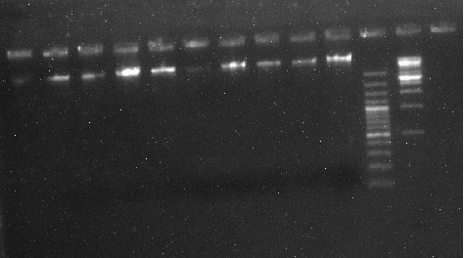
Fig 6.1: DNA bands in gel electrophoresis

Practical no: 7 Quantification of Nucleic acid by Spectrophotometer
Nanodrop (Spectrophotometer)
The most common technique to determine DNARNA yield and purity is measurement of absorbance using Nanodrop. A spectrophotometer is able to determine the average concentrations of the nucleic acids DNA or RNA present in a mixture, as well as their purity. The absorbance method is a spectrophotometer equipped with a UV lamp, and a solution of purified DNA/RNA sample. DNA concentration is estimated by measuring the absorbance at 260nm. To evaluate DNA purity, measure absorbance from 230 nm to detect other possible contaminants. The most common purity calculation is the ratio of the absorbance at 260nm divided by the reading at 280nm (Protein detection). Good-quality DNA will have an A_{260/280} is widely considered ~1.8 and for RNA is ~2.0. A reading of 1.7, 1.6 etc does not render the DNA unsuitable for any application, but lower ratios indicate more contaminants are present.
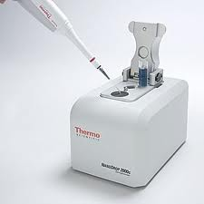
Fig 7.1: Nanodrop
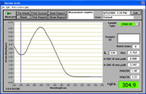
Fig 7.2: Concentration of samples view on Nanodrop

Practical no: 8 cDNA synthesis

The synthesis of DNA from an RNA template, via reverse transcription, results in complementary DNA (cDNA). cDNA can then serve as template in a variety of downstream applications for RNA studies such as gene expression; therefore, cDNA synthesis is the first step for many protocols in molecular biology.
Step 1. Prepare sample
RNA serves as the template in cDNA synthesis. Total RNA is routinely used in cDNA synthesis for downstream applications such as RT-(q)PCR, whereas specific types of RNAs (e.g., messenger RNA (mRNA) and small RNAs such as miRNA) may be enriched for certain applications like cDNA library construction and miRNA profiling.
Maintaining RNA integrity is critical and requires special precautions during extraction, processing, storage, and experimental use. Best practices to prevent degradation of RNA include wearing gloves, pipetting with aerosol-barrier tips, using nuclease-free labware and reagents, and decontamination of work areas.
To isolate and purify RNA, a variety of strategies are available depending on the type of source materials (e.g., blood, tissues, cells, plants) and goals of the experiments. The main goals of isolation workflows are to stabilize RNA molecules, to inhibit RNases, and to maximize yield with proper storage and extraction methods. Optimal purification methods remove endogenous compounds, like complex polysaccharides and humic acid from plant tissues that interfere with enzyme activity; and common inhibitors of reverse transcriptases, such as salts, metal ions, ethanol, and phenol. Once purified, RNA should be stored at –80°C with minimal freeze-thaw cycles.
Step 2. Remove genomic DNA
Trace amounts of genomic DNA (gDNA) may be co-purified with RNA. Contaminating gDNA can interfere with reverse transcription and may lead to false positives, higher background, or lower detection in sensitive applications such as RT-qPCR.
The traditional method of gDNA removal is the addition of DNase I to preparations of isolated RNA. DNase I must be removed prior to cDNA synthesis since any residual enzyme would degrade single-stranded DNA. Unfortunately, RNA loss or damage can occur during DNase I inactivation treatment.
Step 3. Select reverse transcriptase
Most reverse transcriptases used in molecular biology are derived from the pol gene of avian myeloblastosis virus (AMV) or Moloney murine leukemia virus (MMLV). The AMV reverse transcriptase was one of the first enzymes isolated for cDNA synthesis in the lab. The enzyme possesses strong RNase H activity that degrades RNA in RNA:cDNA hybrids, resulting in shorter cDNA fragments (<5 kb).
The MMLV reverse transcriptase became a popular alternative due to its monomeric structure, which allowed for simpler cloning and modifications to the recombinant enzyme. Although MMLV is less thermostable than AMV reverse transcriptase, MMLV reverse transcriptase is capable of synthesizing longer cDNA (<7 kb) at a higher efficiency, due to its lower RNase H activity.
To further improve cDNA synthesis, MMLV reverse transcriptase has been engineered for even lower RNase H activity (i.e., mutated RNase H domain, or RNaseH–), higher thermostability (up to 55°C), and enhanced processivity (65 times higher). These attributes result in increased cDNA length and yield, higher sensitivity, improved resistance to inhibitors, and faster reaction times
Step 4. Prepare reaction mix
In addition to enzyme and primers, the main reaction components for reverse transcription include RNA template (pre-treated to remove genomic DNA), buffer, dNTPs, DTT, RNase inhibitor, and RNase-free water.
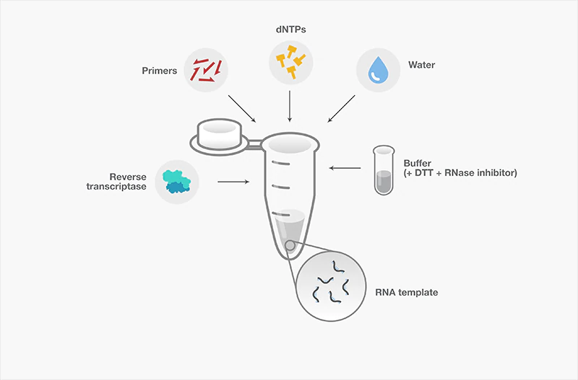
Fig 8.1: The diagram shows reverse transcription reaction with its main components
Table 8.1: Reverse transcription reaction with its main components
Component | Key features
RNA template | Maintaining RNA integrity is critical and requires special precautions during extraction, processing, storage, and experimental use (see step 1):  - Total RNA - routinely used in cDNA synthesis for downstream applications such as RT-(q)PCR  - Messenger RNA (mRNA) and small RNAs such as miRNA) may be enriched for certain applications like cDNA library construction and miRNA profiling
Reaction buffer | - Maintains a favorable pH and ionic strength for the reaction.  - The supplied buffer may also contain additives to enhance the efficiency of reverse transcription.
dNTPs | - Generally, should be at 0.5–1 mM each, preferably at equimolar concentrations  - High-quality dNTPs, freshly diluted, are recommended to ensure proficient reverse transcription
DTT | - Reducing agent, often included for optimal enzyme activity.  - Reaction efficiencies may be compromised if DTT or other additives precipitate; hence, reaction components should be dissolved and well mixed.
RNase inhibitor | Often included in the reaction buffer or added to the reverse transcription reaction to prevent RNA degradation. They may be:  - Co-purified during isolation  - Introduced during reaction setup  A number of known RNases exist, and appropriate RNase inhibitors should be chosen based on their mode of actions and reaction requirements.
Water | Eliminate any RNases by using:  - Nuclease-free from a commercial source  - DEPC (diethylpyrocarbonate)-treated water  Contaminating RNases cannot be removed by simple filtration, and autoclaved water is not adequate because RNases are heat stable.

Step 5. Perform cDNA synthesis
Reverse transcription reactions involve three main steps: primer annealing, DNA polymerization, and enzyme deactivation. The temperature and duration of these steps vary by primer choice, target RNA, and reverse transcriptase used. The critical step is during DNA polymerization. In this step, reaction temperature and duration may vary according to the primer choice and reverse transcriptase used. If using random hexamers, then we recommend incubating the reverse transcription reaction at room temperature (~25 °C) for 10 min after enzyme addition to extend the primers. Among reverse transcriptases there are differences in thermostability, which in turn determines the highest optimal polymerization temperature for each. Using a thermostable reverse transcriptase allows, a higher reaction temperature (e.g., 50°C), to help denature RNA with high GC content or secondary structures without impacting enzyme activity. With such enzymes, high-temperature incubation can result in an increase in cDNA yield, length, and representation.
Reagents
- RNA template
- 5X First Strand Buffer
- 10mM dNTP Set
- 0.1M DTT
- Random Primers
- RNaseOUT Ribonuclease Inhibitor
- SuperScript II RNase H- Reverse Transcriptase
- Water
Procedure
1. Combine 10 μl total RNA
2. Add 1μl Random Primers
3. Molecular grade water 1 μl
4. Vortex and then spin down tube.
5. Incubate at 65°C for 5 min.
6. Place tube on ice.
7. Add 4 μl 5X Buffer
8. Add 2μl dNTP mix
9. Add 1μl SuperScript II RNase H- Reverse Transcriptase
10. RNase inhibitor
PCR protocol (RT-PCR)
11. Incubate at 25°C for 5 min
12. Incubate at 42°C for 60 min.
13. Incubate at 70°C for 5 min.
14. Add x μl molecular grade water.

Practical no: 9 Primer Designing

Primer Designing and properties
Primer properties
1. Primer Length: It is generally accepted that the optimal length of PCR primers is 18-22 bp. This length is long enough for adequate specificity and short enough for primers to bind easily to the template at the annealing temperature.
2. GC Content: The GC content (the number of G's and C's in the primer as a percentage of the total bases) of primer should be 40-60%.
3. GC Clamp: The presence of G or C bases within the last five bases from the 3' end of primers (GC clamp) helps promote specific binding at the 3' end due to the stronger bonding of G and C bases. More than 3 G's or C's should be avoided in the last 5 bases at the 3' end of the primer.
4. Repeats: A repeat is a di-nucleotide occurring many times consecutively and should be avoided because they can misprime. For example: ATATATAT. A maximum number of di-nucleotide repeats acceptable in an oligo is 4 di-nucleotides.
5. Runs: Primers with long runs of a single base should generally be avoided as they can misprime. For example, AGCGGGGGATGGGG has runs of base 'G' of value 5 and 4. A maximum number of runs accepted is 4bp.
Primer Designing tools
Here is a list of free primer design programs to use when designing primers:
- Primer-BLAST. Primer-BLAST was developed by NCBI and utilises the Primer3 platform in combination with the BLAST algorithm. ...
- Primer3.
- Primer3Plus.
- Primer Quest.
- Oligo Perfect.
- Perl Primer.
- OLIGO.
- GenScript Real-time PCR (TaqMan) Primer Design.

Practical no: 10 PCR and its types

The polymerase chain reaction (PCR) is the cardinal laboratory technology of molecular biology. Arguably one of the most powerful laboratory techniques ever discovered, PCR combines the unique attributes of being very sensitive and specific with a great degree of flexibility. With the PCR it is possible to specifically address a particular DNA sequence and to amplify this sequence to extremely high copy numbers. Since its initial development in the early 1980’s, dozens of variations in the basic theme of PCR have successfully been carried out. In fact, the very flexibility and application-specific
variation of PCR make it seem like there are as many ways to do a PCR reaction as there are researchers doing them. Here, a basic, straight-forward PCR protocol is presented. Where appropriate, some of the choices for modifying this standard reaction that are routinely available to researchers are discussed.
Materials and Reagents
- Tris-HCl
- MgCl2
- Taq DNA polymerase
- dNTPs
- Template DNA (genomic, plasmid, cosmid, bacterial/yeast colony, etc.)
- Primers
- Water
Equipment
Thermal cycler (MJ Research)
Primers
Designing appropriate primers is essential to the successful outcome of a PCR experiment. When designing a set of primers to a specific region of DNA desired for amplification, one primer should anneal to the plus strand, which by convention is oriented in the 5' → 3' direction (also known as the sense or non-template strand) and the other primer should complement the minus strand, which is oriented in the 3' → 5' direction (antisense or template strand).
There are a few common problems that arise when designing primers:
1) Self-annealing of primers resulting in formation of secondary structures such as hairpin loops
2) Primer annealing to each other, rather than the DNA template, creating primer dimers
3) Drastically different melting temperatures (Tm) for each primer, making it difficult to select an annealing temperature that will allow both primers to efficiently bind to their target sequence during thermal cycling
Setting up a Reaction Mixture
- Start by making a table of reagents that will be added to the reaction mixture.
- Label PCR tube(s) with the ethanol-resistant marker.
- Reaction volumes will vary depending on the concentrations of the stock reagents.
The final concentrations (CF) for a typical 50 μl reaction are as follows.
  - X buffer (usually supplied by the manufacturer of the DNA polymerase; may contain 15 mM MgCl₂). Add 5 μl of 10X buffer per reaction.
  - 200 μM dNTPs (50 μM of each of the four nucleotides). Add 1 μl of 10 mM dNTPs per reaction (dATP, dCTP, dTTP and dGTP are at 2.5 mM each).
  - 1.5 mM Mg²⁺. Add only if it is not present in the 10X buffer or as needed for PCR optimization. For example, to obtain the 4.0 mM Mg²⁺ required for optimal amplicon production of a conserved 566 bp DNA segment found in an uncharacterized Mycobacteriophage add 8 μl of 25 mM MgCl₂ to the reaction.
  - 20 to 50 pmol of each primer. Add 1 μl of each 20 μM primer.
  - Add 10⁴ to 10⁷ molecules (or about 1 to 1000 ng) DNA template. Add 0.5 μl of 2ng/μl genomic Mycobacteriophage DNA.
  - Add 0.5 to 2.5 units of DNA polymerase per 50 μl reaction, For example, add 0.5 μl of Sigma 0.5 Units/μl Taq DNA polymerase.
  - Add Q.S. sterile distilled water to obtain a 50 μl final volume per reaction as pre-determined in the table of reagents. Thus, 33 μl per reaction is required to bring the volume up to 50 μl. However, it should be noted that water is added first but requires initially making a table of reagents and determining the volumes of all other reagents added to the reaction.

Table 10.1: PCR reactions components
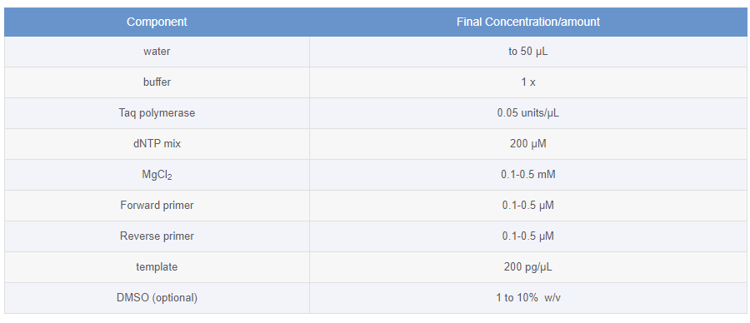

Setting Up Thermal Cycling Conditions
- Denaturation (strand separation): The separation of the two hydrogen-bonded complementary chains of DNA into a pair of single-stranded polynucleotide molecules by a process of heating (94°C to 96°C)
- Annealing (primer binding): The temperature is lowered (45-60 °C) so the primers can attach themselves to the single-stranded DNA strands.
- Extension (synthesis of new DNA): It starts at the annealed primer and works its way along the DNA strand (72°C).
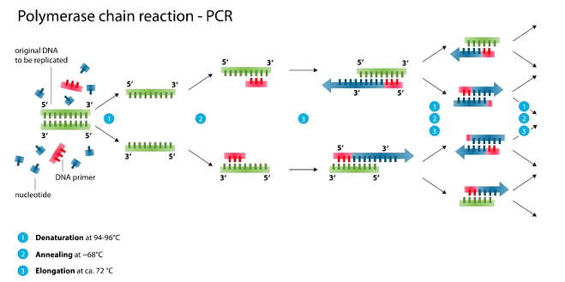
Fig 10.1: The PCR process
Advantages & disadvantages
Selective DNA isolation, Amplification and quantification of DNA, Disease diagnosis, DNA polymerase is prone to error, which in turn causes mutations in the PCR fragments that are made. Additionally, the specificity of the PCR fragments can mutate to the template DNA, due to nonspecific binding of primers. Furthermore, prior information on the sequence is necessary in order to generate the primers
PCR Variations
Nested PCR:
It Increases the specificity of DNA amplification, by reducing background due to non-specific amplification of DNA. Two sets of primers are used in two successive PCRs. In the first reaction, one pair of primers is used to generate DNA products, which besides the intended target, may still consist of non-specifically amplified DNA fragments. The product(s) are then used in a second PCR with a set of primers whose binding sites are completely or partially different from and located 3' of each of the primers used in the first reaction. Nested PCR is often more successful in specifically amplifying long DNA fragments than conventional PCR, but it requires more detailed knowledge of the target sequences.
Multiplex-PCR:
It consists of multiple primer sets within a single PCR mixture to produce amplicons of varying sizes that are specific to different DNA sequences. By targeting multiple genes at once, additional information may be gained from a single test-run that otherwise would require several times the reagents and more time to perform. Annealing temperatures for each of the primer sets must be optimized to work correctly within a single reaction, and amplicon sizes. That is, their base pair length should be different enough to form distinct bands when visualized by gel electrophoresis.
Reverse Transcription PCR (RT-PCR):
It is useful for amplifying DNA from RNA. Reverse transcriptase reverse transcribes RNA into cDNA, which is then amplified by PCR. RT-PCR is widely used in expression profiling, to determine the expression of a gene or to identify the sequence of an RNA transcript, including transcription start and termination sites. If the genomic DNA sequence of a gene is known, RT-PCR can be used to map the location of exons and introns in the gene. The 5' end of a gene (corresponding to the transcription start site) is typically identified by RACE-PCR (Rapid Amplification of cDNA Ends).
Quantitative PCR (qPCR):
It is used to measure the quantity of a target sequence (commonly in real-time). It quantitatively measures starting amounts of DNA, cDNA, or RNA. Quantitative PCR is commonly used to determine whether a DNA sequence is present in a sample and the number of its copies in the sample. Quantitative PCR has a very high degree of precision. Quantitative PCR methods use fluorescent dyes, such as Sybr Green, EvaGreen or fluorophore-containing DNA probes, such as TaqMan, to measure the amount of amplified product in real time. It is also sometimes abbreviated to RT-PCR (real-time PCR) but this abbreviation should be used only for reverse transcription PCR. qPCR is the appropriate contractions for quantitative PCR (real-time PCR).
Hot start PCR:
A technique that reduces non-specific amplification during the initial set up stages of the PCR. It may be performed manually by heating the reaction components to the denaturation temperature (e.g., 95 °C) before adding the polymerase. Specialized enzyme systems have been developed that inhibit the polymerase's activity at ambient temperature, either by the binding of an antibody or by the presence of covalently bound inhibitors that dissociate only after a high-temperature activation step. Hot-start/cold-finish PCR is achieved with new hybrid polymerases that are inactive at ambient temperature and are instantly activated at elongation temperature.
Asymmetric PCR:
Preferentially amplifies one DNA strand in a double-stranded DNA template. It is used in sequencing and hybridization probing where amplification of only one of the two complementary strands is required. PCR is carried out as usual, but with a great excess of the primer for the strand targeted for amplification. Because of the slow (arithmetic) amplification later in the reaction after the limiting primer has been used up, extra cycles of PCR are required. A recent modification on this process, known as Linear-After-The-Exponential-PCR (LATE-PCR), uses a limiting primer with a higher melting temperature (Tm) than the excess primer to maintain reaction efficiency as the limiting primer concentration decreases midreaction.
Nanoparticle-Assisted PCR (nanoPCR):
In recent years, it has been reported that some nanoparticles (NPs) can enhance the efficiency of PCR (thus being called nanoPCR), and some even perform better than the original PCR enhancers. It was also found that quantum dots (QDs) can improve PCR specificity and efficiency. Single-walled carbon nanotubes (SWCNTs) and multi-walled carbon nanotubes (MWCNTs) are efficient in enhancing the amplification of long PCR. Carbon nanopowder
(CNP) was reported be able to improve the efficiency of repeated PCR and long PCR. ZnO, TiO2, and Ag NPs were also found to increase PCR yield. Importantly, already known data has indicated that non-metallic NPs retained acceptable amplification fidelity. Given that many NPs are capable of enhancing PCR efficiency, it is clear that there is likely to be great potential for nanoPCR technology improvements and product development.
Allele-specific PCR:
A diagnostic or cloning technique based on single-nucleotide variations (SNVs not to be confused with SNPs) (single-base differences in a patient). It requires prior knowledge of a DNA sequence, including differences between alleles, and uses primers whose 3' ends encompass the SNV (base pair buffer around SNV usually incorporated). PCR amplification under stringent conditions is much less efficient in the presence of a mismatch between template and primer, so successful amplification with an SNP-specific primer signals presence of the specific SNP in a sequence.
Inverse PCR:
It is commonly used to identify the flanking sequences around genomic inserts. It involves a series of DNA digestions and self-ligation, resulting in known sequences at either end of the unknown sequence.
Colony PCR:
Colony PCR is a method used to screen for plasmids containing a desired insert directly from bacterial colonies without the need for culturing or plasmid purification steps.
In situ PCR:
In situ PCR is a method in which the polymerase chain reaction actually takes place in the cell on a slide, and the product can be visualized in the same way as in traditional in situ hybridization.
AFLP-PCR:
AFLP-PCR uses restriction enzymes to digest genomic DNA, followed by ligation of adaptors to the sticky ends of the restriction fragments. A subset of the restriction fragments is then selected to be amplified. This selection is achieved by using primers complementary to the adaptor sequence, the restriction site sequence and a few nucleotides inside the restriction site fragments. The amplified fragments are separated and visualized on denaturing polyacrylamide gels, either through autoradiography or fluorescence methodologies, or via automated capillary sequencing instruments.

Practical no: 11 Blotting Techniques

Southern blotting
Introduction
Southern blot is a method used in molecular biology for detection of a specific DNA sequence in DNA samples.
Principle
Southern blotting combines transfer of electrophoresis-separated DNA fragments to a filter membrane and subsequent fragment detection by probe hybridization.
Materials & methods
- DNA (genomic or other source) is digested with a restriction enzyme and separated by gel electrophoresis, usually an agarose gel. Because there are so many different restriction fragments on the gel, it usually appears as a smear rather than discrete bands. The DNA is denatured into single strands by incubation with NaOH.
- The DNA is transferred to a membrane which is a sheet of special blotting paper. The DNA fragments retain the same pattern of separation they had on the gel.
- The blot is incubated with many copies of a probe which is single-stranded DNA. This probe will form base pairs with its complementary DNA sequence and bind to form a double-stranded DNA molecule. The probe cannot be seen but it is either radioactive or has an enzyme bound to it (e.g. alkaline phosphatase or horseradish peroxidase).
- The location of the probe is revealed by incubating it with a colorless substrate that the attached enzyme converts to a colored product that can be seen or gives off light which will expose X-ray film. If the probe was labeled with radioactivity, it can expose X-ray film directly.
Advantages & Disadvantages
Southern blots allow investigators to determine the molecular weight of a restriction fragment and to measure relative amounts in different samples.

Northern blotting
Introduction
The northern blot is a technique used in molecular biology research to study gene expression by detection of RNA (or isolated mRNA) in a sample
Principle
Northern blotting involves the use of electrophoresis to separate RNA samples by size and detection with a hybridization probe complementary to part of or the entire target sequence. The term 'northern blot' actually refers specifically to the capillary transfer of RNA from the electrophoresis gel to the blotting membrane. However, the entire process is commonly referred to as northern blotting.
Materials & Methods
Northern blots allow investigators to determine the molecular weight of an mRNA and to measure relative amounts of the mRNA present in different samples.
- RNA (either total RNA or just mRNA) is separated by gel electrophoresis, usually an agarose gel. Because there are so many different RNA molecules on the gel, it usually appears as a smear rather than discrete bands.
- The RNA is transferred to a sheet of special blotting paper called nitrocellulose, though other types of paper, or membranes, can be used. The RNA molecules retain the same pattern of separation they had on the gel.
- The blot is incubated with a probe which is single-stranded DNA. This probe will form base pairs with its complementary RNA sequence and bind to form a double-stranded RNA-DNA molecule. The probe cannot be seen but it is either radioactive or has an enzyme bound to it (e.g. alkaline phosphatase or horseradish peroxidase).
- The location of the probe is revealed by incubating it with a colorless substrate that the attached enzyme converts to a colored product that can be seen or gives off light which will expose X-ray film. If the probe was labeled with radioactivity, it can expose X-ray film directly.
Advantages & Disadvantages
Analysis of gene expression northern blotting is able to detect small changes in gene expression that microarrays cannot. The microarrays have over northern blots is that thousands of genes can be visualized at a time, while northern blotting is usually looking at one or a small number of genes.
A problem in northern blotting is often sample degradation by RNAses. The chemicals used in most northern blots can be a risk to the researcher, since formaldehyde, radioactive material; ethidium bromide, DEPC, and UV light are all harmful under certain exposures. Compared to RT-PCR, northern blotting has a low sensitivity, but it also has a high specificity, which is important to reduce false positive results.
The advantages of using northern blotting include the detection of RNA size, the observation of alternate splice products, the use of probes with partial homology, the quality and quantity of RNA can be measured on the gel prior to blotting, and the membranes can be stored and reproved for years after blotting.
Western blotting
Introduction
The western blot (sometimes called the protein immunoblotting) is a widely used analytical technique used to detect specific proteins in a sample of tissue homogenate or extract.
Principle
It uses gel electrophoresis to separate native proteins by 3-D structure or denatured proteins by the length of the polypeptide. The proteins are then transferred to a membrane (typically nitrocellulose or PVDF), where they are stained with antibodies specific to the target protein. The gel electrophoresis step is included in western blot analysis to resolve the issue of the cross-reactivity of antibodies.
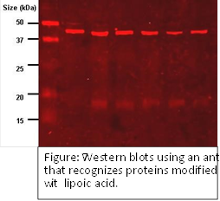
Fig 11.1: DNA bands on agarose gel
Materials & Methods
Western blots allow investigators to determine the molecular weight of a protein and to measure relative amounts of the protein present in different samples.
- Proteins are separated by gel electrophoresis, usually SDS-PAGE.
- The proteins are transferred to a sheet of special blotting paper called nitrocellulose, though other types of paper, or membranes, can be used. The proteins retain the same pattern of separation they had on the gel.
- The blot is incubated with a generic protein (such as milk proteins) to bind to any remaining sticky places on the nitrocellulose. An antibody is then added to the solution which is able to bind to its specific protein. The antibody has an enzyme (e.g. alkaline phosphatase or horseradish peroxidase) or dye attached to it which cannot be seen at this time.
- The location of the antibody is revealed by incubating it with a colorless substrate that the attached enzyme converts to a colored product that can be seen and photographed.
Advantages & Disadvantages
The confirmatory HIV test employs a western blot to detect anti-HIV antibody in a human serum sample. Proteins from known HIV-infected cells are separated and blotted on a membrane as above. Then, the serum to be tested is applied in the primary antibody incubation step; free antibody is washed away, and a secondary anti-human antibody linked to an enzyme signal is added. The stained bands then indicate the proteins to which the patient's serum contains antibody. A western blot is also used as the definitive test for bovine spongiform encephalopathy (BSE, commonly referred to as 'mad cow disease').

Practical no: 12 Karyotyping

Karyotyping
A chromosome is the structure that organizes DNA and protein in cells. It is a single piece of coiled DNA containing coding and non-coding sequences. Human cells have 23 pairs of chromosomes including 22 pairs of autosomes and one pair of sex chromosome, giving a total of 46 per cell. In tumor cells, chromosomal instability has been considered to be one of the hallmarks of tumor formation. Here we use the karyotype analysis to separate the chromosomes and observe the chromosomes in tumor cells with a microscope.
Materials and Reagents
15ml falcon tubes, heparin tubes, culture flask, micropipette, pasture pipette, 1 to 10ml pipette, beaker, mouth cap, head cap, gloves and tips.
Chemicals:
Alcohol, methanol, Glacial acetic acid, RPMI-1640, Streptomycin, penicillin, L-glutamine, EtBr, colchicine or colcemid, KCl, Giemsa, trypsin and water.
Instruments:
Laminar airflow or class III safely cabinet, centrifuge, microscope, incubator and refrigerator.
Karyotyping protocol for Peripheral Blood Lymphocyte Culture:
The Peripheral blood lymphocyte culture method is divided into the following steps:
Sample collection:
2 ml of the whole blood sample is collected in the heparin tube, strict aseptic conditions are maintained during the sample collection.
The sample must proceed under 24 hours. However, before doing the culturing, place sample for some time at room temperature.
Cell culture:
One of the most important procedures in the cytogenetic analysis is to maintain aseptic conditions, therefore, before doing the cell culture check all the instruments and reagents used for the culturing whether it is contamination free or not.
Wipe the laminar airflow with the alcohol. Wear gloves, mask and head cap. Further, wear a clean lab coat.
Do not open any of the reagents until now.
Now clean all the plasticware and glassware with alcohol. Clean your hands with alcohol too.
Now add 7ml of RPMI-1640 compete-media to the 15 ml falcon tube, Carefully close the bottle and cover it with parafilm.
Add 100mg/ml 10μl penicillin and 20μl streptomycin antibiotics to the culture tube.
Add 200mM of 100µL L-glutamine followed by the addition of 100µL of phytohemagglutinin M.
Now carefully add 0.7ml of a blood sample in the culture tube.
The culture is mixed well by inverting gently several times and incubated at 37℃ in the incubator for 70 to 72 hours.
Remember, the tubes are placed at the angle of 45 degrees, therefore, the culture can grow efficiently.
Pre-Harvesting:
In the pre-harvesting stage, at the 70th hour of culture 100µL of 0.2% colcemid is added to the culture tube.
Again incubate it for 2 hours more at the same condition.
The complete process of Karyotyping
Harvesting:
The culture tube is taken and centrifuged at 3500rpm for 8 to 10 minutes at room temperature.
The supernatant is discarded and to the pellet, add 0.56% of KCl (called hypotonic solution, prewarmed at 37℃ ).
The hypotonic solution is added up to the 8ml mark of the falcon tube., and mix it gently using the pasture pipette.
Then incubate the tube in the prewarmed water bath at 37℃ for 15 to 17 minutes.
Note: The hypotonic treatment is a very crucial step in the entire process, set your own time of incubation at which you will observe the good separation of chromosomes.
The hypo-treatment step varies from lab to lab.
Immediately after the hypo-treatment, add 2ml of chilled fixative (3 part methanol: 1 part glacial acetic acid).
Mix it with the same pasture pipette until brown homogenizes mixture appears.
The tubes are centrifuged at 2500rpm to 3500rpm for 8 to 10 minutes.
Discard the supernatant and to the pellet add 8ml of chilled fixative again.
Mix it properly and centrifuge at the same rpm and the same time as the last step.
Repeat the fixative-centrifugation step until clear-white pellet appears.
Once clear pellet appears, dissolve the pellet in the 2ml fixative. Now store the tube at 4℃ until the next step.
Slide preparation and Giemsa staining:
Take a Greece free chilled slide and drop down 2 to 3 drops of the culture solution from ~2 feet hight.
Chilled slide!!
Using a prechilled slide fix the chromosome faster.
Heat fix the slide by heating it gently several times and stain it with Giemsa stain for 5 to 10 minutes.
Again!!
Heating will fix the chromosome faster, however, care must be taken while heating the slide, the chromosome components must not be burned.
After staining, wash the slide with the running tap water and dry it. Observe the slide first in the 10X and then in the 100X under the microscope.
Target 10 good metaphases from each slide for interpreting results.
Read our amazing article on DNA: DNA story: The structure and function of DNA
Giemsa banding:
- Three or four drops of the cell suspension dropped from the height of 2 feet.
- Age slide for 3 hours at 80℃.
- Stain slide in 2% Giemsa solution for 5 minutes.
- Deep the slide in the trypsin solution for 10 to 15 seconds and immediately washes it with the PBS.
- Again stain the slide in the Giemsa solution for some time (continuous stirred) and wash it with D/W.
- Air-dry the slide, the slide is ready for microscopic examination.

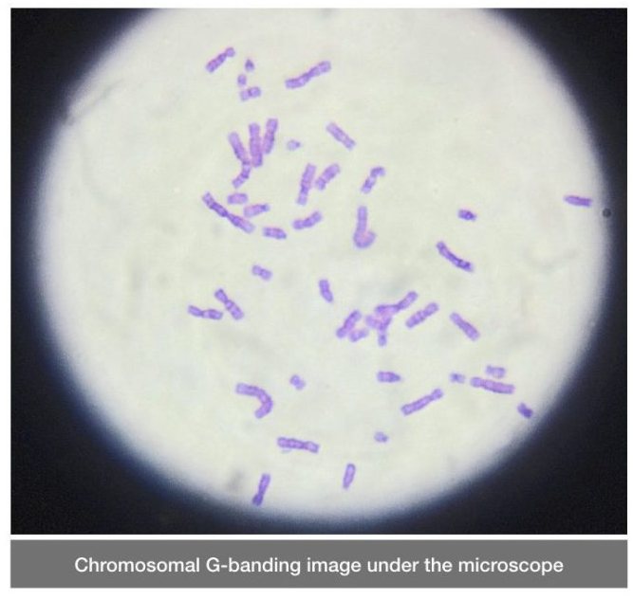
Fig 12.1: The chromosome view through karyotyping

Practical no: 13 Chromosome staining, banding of chromosomes (C, Q, R, T)

Introduction
Chromosomes display a banded pattern when treated with some stains. Bands are alternating light and dark stripes that appear along the lengths of chromosomes.
Unique banding patterns are used to identify chromosomes and to diagnose chromosomal aberrations, including chromosome breakage, loss, duplication, translocation or inverted segments.
A range of different chromosome treatments produce a range of banding patterns: Q-bands, Rbands, C-bands and T-bands.
In recent years a number of chromosome banding techniques have been developed that employ molecular cytogenetic techniques, for example fluorescence in situ hybridization (FISH).
Chromosome structure and bands
The chromosomes of eukaryotes are composed of a combination of nuclear DNA and proteins. During mitosis chromosomes replicate and condensed through coiling forming chromosomes consisting of two chromatids joined at the centromere. Each chromatid condenses approximately ten-thousand fold reaching maximal condensation at metaphase – DNA of roughly 5 cm in length is condensed to 5 micrometers in a metaphase chromosome. These condensed chromosomes are visible under the light microscope.
During the condensation process DNA is looped around protein complexes called nucleosomes. This primary structure then undergoes more cycles of coiling producing the well-known metaphase chromosome structure. Some of the looped segments of DNA are close together and condense more than others, forming regions known as domains. These closely condensed domains tend to stain more darkly than the areas where the loops are more loosely arranged.
In the order Diptera, which includes Drosophila, salivary gland chromosomes undergo repeated rounds of replication without cell division forming highly replicated chromosomes – polytene chromosomes. A polytene chromosome in a Drosophila salivary gland cell can contain as many as five thousand alternating dark and light bands. In these chromosomes the dark bands correspond to highly condensed domains and the lighter bands to less condensed DNA. It is in the less condensed areas where active genes can be identified. A gene becomes active by unravelling to permit transcription into messenger RNA. These unravelled regions are observed as “puffs” under the microscope. The gene becomes inactive by resolving the “puff” through condensation.
C-Banding
C-banding stains areas of heterochromatin, which is tightly packed and repetitive DNA. Cbanding is specifically useful in humans to stain the centromeric chromosome regions and other regions containing constitutive heterochromatin - secondary constrictions of human chromosomes 1, 9, 16, and the distal segment of the Y chromosome long arm.
Q-Banding
Quinacrine mustard, an alkylating agent, was the first chemical to band chromosomes viewed under a fluorescence microscope. Quinacrine dihydrochloride has subsequently been substituted by quinacrine mustard. The alternating bands of bright and dull fluorescence are called Q bands. The bright bands are primary composed of DNA rich in adenine and thymine, while the dull bands are rich in guanine and cytosine.
Q bands are especially useful for distinguishing the human Y chromosome and various chromosome polymorphisms involving satellites and centromeres of specific chromosomes.
R-banding
Reverse banding (R-banding) involves the incubation of slides containing metaphase chromosomes in hot phosphate buffer and stained with Giemsa. The banding pattern that results is essentially the reverse of G bands. R bands are GC-rich. The AT-rich regions are selectively denatured by heat leaving the GC-rich regions intact. Fluorochromes that are GC specific also produce a reverse chromosome banding pattern. R-banding is helpful for analyzing the structure of chromosome ends, since these areas usually stain light with G-banding.
T-Banding
T-banding involves the staining of telomeric regions of chromosomes using either Giemsa or acridine orange after controlled thermal denaturation. T bands apparently represent a subset of the R bands because they are smaller than the corresponding R bands and are more strictly telomeric.
MATERIALS & METHODS
Harvesting of culture
- Spindle inhibitors – Colchicine/colcemed (0.1g/ml)
- Hypotonic treatment – 0.075M KCl
- Fixation (3:1 methanol : acetic acid)
- Preparation of slides
- Slides stained with 4% Giemsa for 20-25min
- Screening of slides to study the morphology of chromosome
- Construction of karyotype
C-banding
- Treat the slides in 0.2 N HCI for one hr at room temperature.
- Rinse in de-ionized water.
- Immerse in 1% barium hydroxide at 50°C for 5-15 min.
- Rinse in deionized water.
- Incubate at 60°C in 2XSSC buffer for one hr.
- Rinse in de-ionized water and stain in 4% Giemsa stain for 90 min.
- Rinse in de-ionized water, dry and examine under oil immersion.
Q-banding
- Dehydrate the slides by dipping in alcohol with decreasing concentration 90%, 70% and 50% one min each.
- Rinse in distilled water. .
- Wash the slide in phosphate buffer at pH 6.8.
- Stain the slide in quinacrine mustard (5 mg in 100 mI) or in quinacrine dihydrochloride 5% for 20 min.
- Rinse in phosphate buffer and mount in the same buffer. • Examine under fluorescent microscope.
R-banding
- Age the slides for 7 -10 days .
- Place the slides in a Coplinjar containing phosphate buffer ofpH 6.5 at 85°C and incubate for 20-25 min.
- Stain the slides in 0.01% acridine orange in the phosphate buffer pH 6.5 for 4-6 min.
Rinse in phosphate buffer and mount in the same buffer. • Examine under fluorescent microscope.
T -banding
- Age the slide for 7 days.
- Place the slides in PBS pH 5.0 for 20-60 min at 87°C.
- Rinse in PBS.
- Stain in 3% Giemsa in phosphate buffer pH 6.8 at 87°C, leave for 5-30 min and rinse.
- Slides are stained in Hoechst 33258 stain for 10 min (Hoechst stain 0.5 pg/m1 of phosphate buffer).Rinse in phosphate buffer and examine in fluorescent microscope.
- Alternatively, the stained slides are covered with a cover slip and placed in a wet chamber under UV lamp for 2 to 3 hrs or under direct sunlight for 2 hrs.
- Remove the cover slip and stain in Giemsa stain for 10 min.
- Rinse in buffer, dry and mount in DPX.

Practical no: 14 Genetics problems

Simple Genetics Practice Problems
- For each genotype, indicate whether it is heterozygous (HE) or homozygous (HO)
AA ____  Bb ____  Cc ____  Dd ____ | Ee ____ ff ____ GG ____  HH ____ | Ii ____ Jj ____ kk ____ Ll ____ | Mm ____ nn ____ OO ____  Pp ____

- For each of the genotypes below, determine the phenotype.
Purple flowers are dominant to white flowers  PP ___________________________ Pp ___________________________ pp ___________________________ | Brown eyes are dominant to blue eyes  BB ___________________________ Bb ___________________________ bb ___________________________
Round seeds are dominant to wrinkled  RR ___________________________ Rr ___________________________ rr ___________________________ | Bobtails are recessive (long tails dominant)  TT ___________________________ Tt ___________________________ tt ___________________________

For each phenotype, list the genotypes. (Remember to use the letter of the dominant trait)
Straight hair is dominant to curly.  ____________ straight  ____________ straight  ____________ curly | Pointed heads are dominant to round heads.  ____________ pointed  ____________ pointed  ____________ round

4. Set up the square for each of the crosses listed below. The trait being studied is round seeds
(dominant) and wrinkled seeds (recessive)
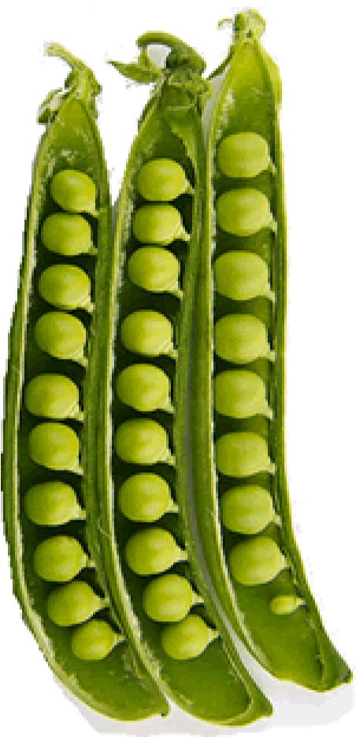
Rr x rr
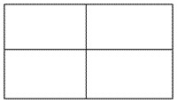
What percentage of the offspring will be round? _______
Rr x R r
What percentage of the offspring will be round? _______
RR x Rr
What percentage of the offspring will be round? ___________
Practice with Crosses. Show all work!
- A TT (tall) plant is crossed with a tt (short plant).
What percentage of the offspring will be tall? ___________
- A Tt plant is crossed with a Tt plant.
What percentage of the offspring will be short? ______
- A heterozygous round seeded plant (Rr) is crossed with a homozygous round seeded plant (RR). What percentage of the offspring will be homozygous (RR)? ____________
- A homozygous round seeded plant is crossed with a homozygous wrinkled seeded plant. What are the genotypes of the parents? __________ X __________
What percentage of the offspring will also be homozygous? ______________
- In pea plants purple flowers are dominant to white flowers. If two white flowered plants are cross, what percentage of their offspring will be white flowered? ______________
- A white flowered plant is crossed with a plant that is heterozygous for the trait. What percentage of the offspring will have purple flowers? _____________
- Two plants, both heterozygous for the gene that controls flower color are crossed. What percentage of their offspring will have purple flowers? ______________.
What percentage will have white flowers? ___________
- In guinea pigs, the allele for short hair is dominant.
What genotype would a heterozygous short haired guinea pig have? _______
What genotype would a purebreeding short haired guinea pig have? _______
What genotype would a long haired guinea pig have? ________
- Show the cross for a pure breeding short haired guinea pig and a long haired guinea pig. What percentage of the offspring will have short hair? __________
- Show the cross for two heterozygous guinea pigs.
What percentage of the offspring will have short hair? ________.
What percentage of the offspring will have long hair? _______
- Two short haired guinea pigs are mated several times. Out of 100 offspring, 25 of them have long hair. What are the probable genotypes of the parents?
________ X ___________ Show the cross to prove it!

