BIF401 Mid term
What is mutation 2
Uses of clustalw 2
Pseudonots 3
Uniprot 3
Scoringatrix formula 5
Pam matric steps5
Bif 401 (16 June)
Shotgun and fingerprint proteomics 2 and 3 marks
EMBI and EBI stands for 2 marks
Hydrophobic amino acids 3 marks
Rooted and unrooted tree 5 marks
PAM steps 5 marks
BIF401 #Midterm_Current_Paper_Spring_2019 15 June 8 AM
How DP create function to deal with matches.mismatches and gapes(5)
What are the four scoring possibilities for computing a position of matrix
#Paper_2
Today Bif 401
How protein sequence can identified?
Difference local and global alignment?
Challenges of bif?
Gene mutation?
Newick notation? Give example?

Bif401
Define system bilogy and its application(2)
What is the need of bioinformatics. 3
Write the methods of clustring 3
Local & global alignments 5
Why RNA has short life span?illustrate ur answer with diagram. 5

Bif401
Pusdoknots?
System biology
Msa
PSA
RNA types
Koi code tha protein name likhna tha
bif 401
STEP OF BLOSUM 5
HOW BULGE ARE FORMED 5
Name three hydrophobic amino acid.
bioinformatic in society role
BIF 401

1.Descride the 3D-ID boewei algrithim ...2
2.What is the role of 5' cap and poly A tail? ...2
3. What are the methods for clustring the phylogenetic trees.....3
4.write the four objectives of the comparing sequensing?....3
5. What is the phenomineon of reduency of amino acid and what us the name of the amino acid which has three codos....5
6. Hydroxyl group of RNA is less stable then DNA justify the statment with diagram....5
Purines and pyrimidins structures (2)
Cluster method for construct phylogenetics trees (3)
Global and local alignment differences (3)
One of the method for construction a phylogenetics tree(5)

BIF401 : TIME: 10:30

Q1: What are Substitutions & Indel? (2)

Q2: Why unpaired nucleotides should make the structure of RNA destabilized? (2)

Q3: Write formula for finding distance between two sequences and elaborate it. (3)

Q4: Top down proteomics. (3)

Q5: Write down Four Steps of FASTA. (5)

Q6: Differentiate Acidic and Basic Amino Acids. (5)

MCQ's were easy; exact from PPTs covering all topics.

1.Descride the 3D-ID boewei algrithim ...2

.What is the role of 5' cap and poly A tail? ...2

3. What are the methods for clustring the phylogenetic trees.....3

4.write the four objectives of the comparing sequensing?....3

5. What is the phenomineon of reduency of amino acid and what us the name of the amino acid which has three codos....5

6. Hydroxyl group of RNA is less stable then DNA justify the statment with diagram....5

Today bif 401 paper at 4:30

Nussinov Jacobson algorithm possibilities (5)

Identity and similarity and also write their formulas?(5)

Online tool to predict RNA structure?

Purines and pyrimidine aminoacids ?

Write URL of ncbi?

BIF401
4 short Q and 2 long Q
Short Q:
1. What is the bioinformatics promise to the society? (2 marks)
2. What dose role of 5’ cap and 3’ role A poly tail? (2)
3. What is dot plots?
4. What does a Uniprot sequences give any information about protein quer
Write down stpes of BLOSUM?
2. Hydroxyl group is less stable in RNA as compared to DNA? Explain it with a figure?

Bif401 question paper
1 ..what is bioinformatics promises to the society ??
2 what does uniport sequences give any information about protein query ??
3.diffrentiate between acid and basic amino acids ??
4..how bulge loop formed ??
5.diffrentiate between mass spectrometry and figerprntingspectometer .?
6..tertiary structure of RNA formed ??

My today paper of BIF401
Total Q 26 (40 marks)
20 MCQS
4 short Q and 2 long Q
Short Q:
1. What is the bioinformatics promise to the society? (2 marks)
2. What dose role of 5’ cap and 3’ role A poly tail? (2)
3. What is dot plots?
4. What does a Uniprot sequences give any information about protein query?
Long Q:
1. Write down stpes of BLOSUM?
2. Hydroxyl group is less stable in RNA as compared to DNA? Explain it with a figure?

BIF401 paper:
Q1:What are pseudoknots?
Q2:What is the purpose of 3D-1D bowie algorithm
Q3:What is needs of bioinformatics?
Q4:uses of blastx, tblastx and tblastn?
Q5:Steps involved in FASTA algorithm?
Q6:Difference between acidic and basic amino acids?

Bif401 today 12 bjy ka paper :p
Formula of domain and descibeit's method?
Difference in basic and acidic amino acid?
How to show phylogenetic tree describe the types to visuilaizae it (5)
Difference between .... peptide and unshot protein? (Question yadni a rhacomplete )
Why we use FASTA algorithem?

BIF401:
What is the acronym meaning/definition of BLAST?
Local and global alignment
Threonine is an hydrophobic amino acid?
How does protein is sequenced??
BIF401:
What is the uses and functions of blast?
How does protein sequenced is identify?

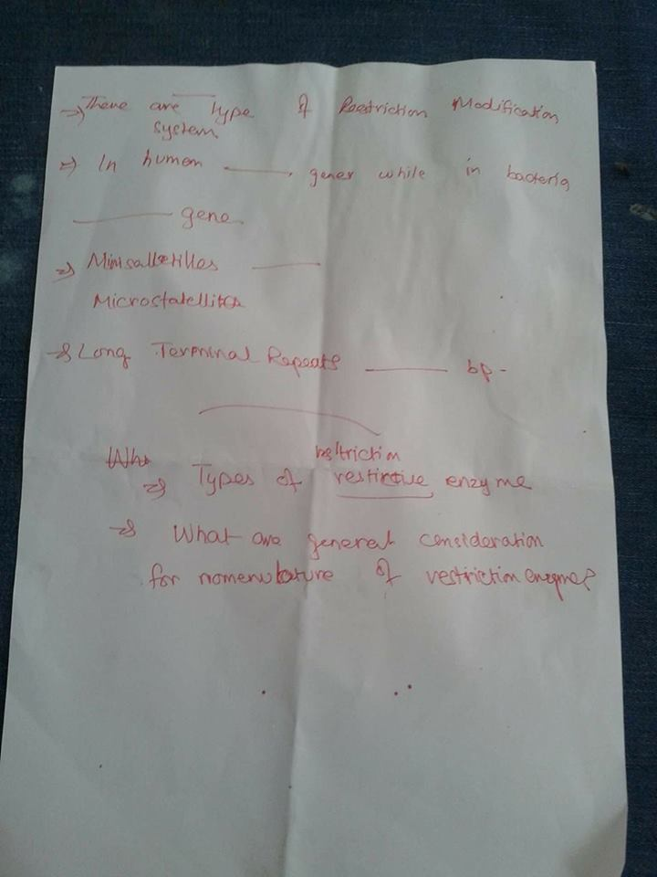
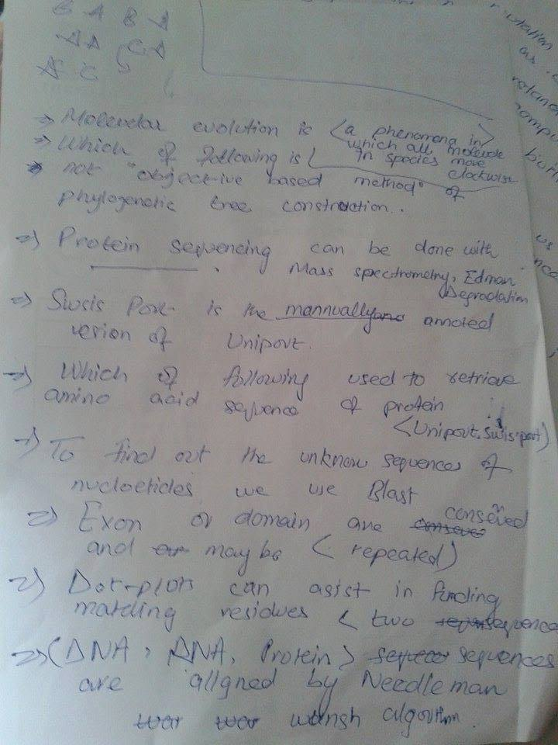
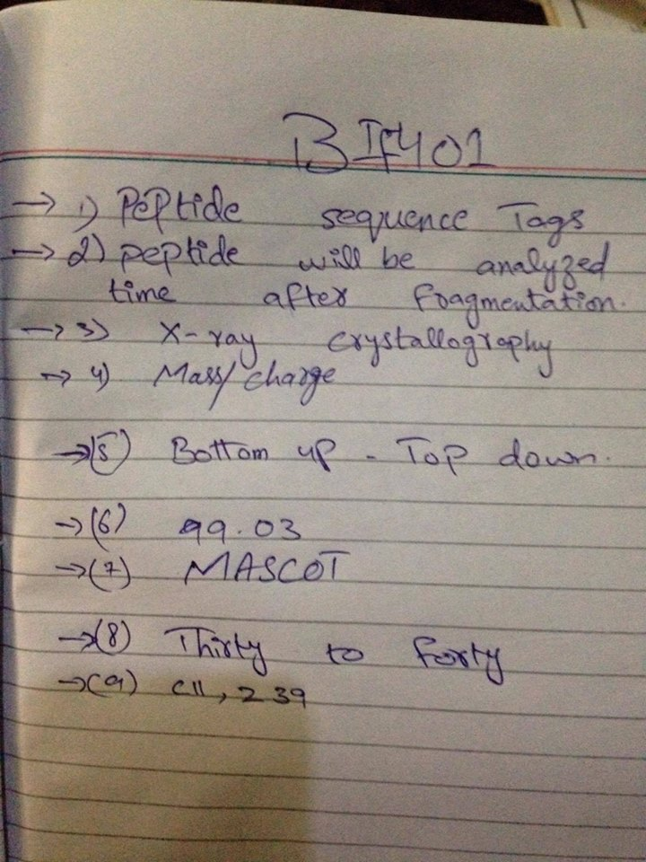
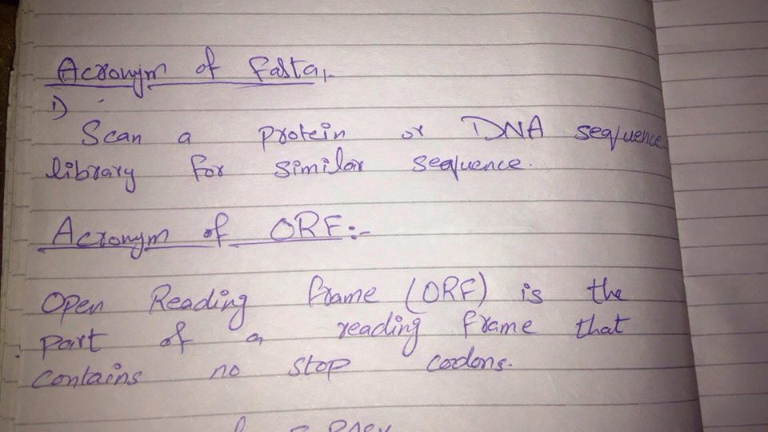
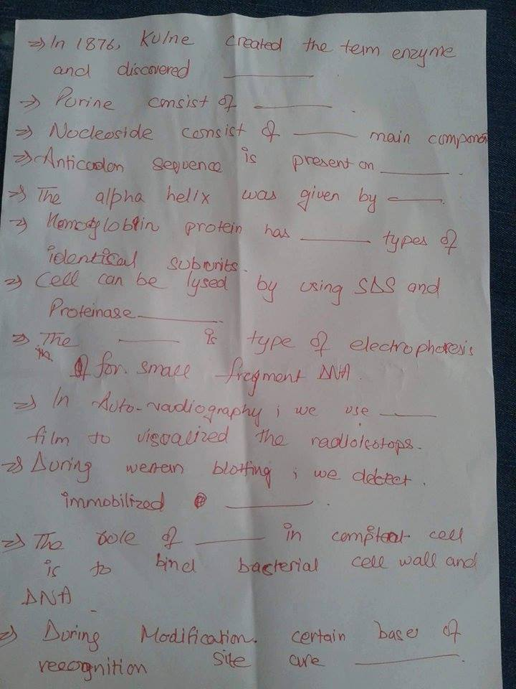
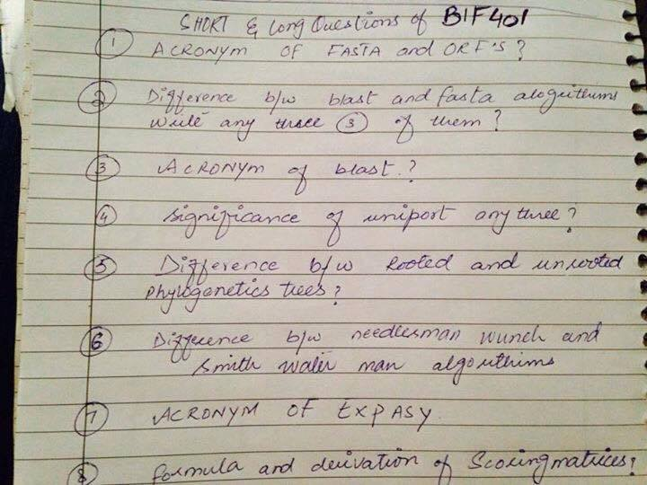
Today is paper of BIF401 at 2:30
Purpose of tblastn and tblastx 2marks
Orf and fasta stand for 3 marks
tblastn and tblastx 3 marks
Amino acids codon 5 marks
Destabilizing of RNA 5 marks
Mcqs were conceptual

