Bif 501 mid term

Mcqs

ORF stands for

IUB stands for

PAM stands for

3 nucleotides code for.... Aminoacids

Endosymbiots hypothesis purposed in...

SINES are ... Bp long

RNA is ... Single strand

In order to predict exone we need to get...

Bypass is the type of algorithm

Median string problem is one of the way tp find..

Gel electrophoresis used to fined

Baqi bhool gay

Questions:

Partial digestion and complete digestion. 2 marks

Tendem repeats and interspersed repeats. 2 marks

In frame hexamer 3 marks

Waardengrb syndrome 5 marks

Cluster analysis. 5marks
BIF501

Timing (2:30 pm)

1) Dynamic programing? 2

2) Synteny? 2

3) Synteny of mouse and human X chromosome? 3

4) Six applications of Bioinformatics? 3

5) Local alignment problems? 5

6) Note on endosymbiont hypothesis? 5
Write a note on uniprot? 2 mrks
2. write a note on proteome and its advantages? 5 mrks
3. Annotations of transponsable element? 3 mrks
4. Wardenburg ,s syndrome? 5 mrks
5. Edit graph? 3 mrks

note on DDJB embi

six model organism

dna comparison

edit distance with example
#BIF501 #Midterm_Current_Paper_Spring_2019 15 June 8 AM
1.LINES and SINES
2.Euchromatin and heterochromatin differences
3.Collinear arrangement of nucleotides
4. Bypass algorithm its advantages
5.Local alignment problem
6. Enzyme commission numbers with example
Mcqs saray past se thy almost
[15/06 10:01 am] Alvi: BIF 501:
8:00 AM
15-06-2019
Q.No 1: Genome and genome informatics? Mrks 2
Q.No 2: Why we can not use brute force approch motif? 2 mrks
Q No 3: Six model of organisms?mrks 3
Q No 4: diff btwn genebank, EMBL, DDJB? Mrks3
Q No 5: diff btwn indels, insertion and deletion in an alignment? 5 mrks
Q No 6: note on splice signls? Mrks 5
HN
[15/06 10:03 am] Alvi: BIF 501:
8:00 AM
15-06-2019
Q.No 1: Genome and genome informatics? Mrks 2
Q.No 2: Why we can not use brute force approch motif? 2 mrks
Q No 3: Six model of organisms?mrks 3
Q No 4: diff btwn genebank, EMBL, DDJB? Mrks3
Q No 5: diff btwn indels, insertion and deletion in an alignment? 5 mrks
Q No 6: note on splice signls? Mrks 5
Bif 8am:by pass algorithm,lines and sines, chromatin and heterochromatin,
Bif 501
Mcqs
ORF stands for
IUB stands for
PAM stands for
3 nucleotides code for.... Aminoacids
Endosymbiots hypothesis purposed in...
SINES are ... Bp long
RNA is ... Single strand
In order to predict exone we need to get...
Bypass is the type of algorithm
Median string problem is one of the way tp find..
Gel electrophoresis used to fined
Baqi bhool gay
Questions:
Partial digestion and complete digestion. 2 marks
Tendem repeats and interspersed repeats. 2 marks
In frame hexamer 3 marks
Waardengrb syndrome 5 marks
Cluster analysis. 5marks

image: https://storage.ning.com/topology/rest/1.0/file/get/2742202890?profile=RESIZE_180x180&width=48&height=48&crop=1%3A1

image: https://api.ning.com/files/bR8nA-I0SJG6CIZy-G9bFxGXvn7hyT4N02K91fZsBDwSAIVAhU74oiWF5BLjEKrNuuwmyDKushBjV7-opkYm*m2jWzSgMBAS/ddd.png?size=64&crop=1%3A1
Permalink Reply by + M.Tariq Malik on December 13, 2017 at 6:53pm
BIF501
Timing (2:30 pm)
1) Dynamic programing? 2
2) Synteny? 2
3) Synteny of mouse and human X chromosome? 3
4) Six applications of Bioinformatics? 3
5) Local alignment problems? 5
6) Note on endosymbiont hypothesis? 5

image: https://storage.ning.com/topology/rest/1.0/file/get/2742202890?profile=RESIZE_180x180&width=48&height=48&crop=1%3A1
image: https://api.ning.com/files/bR8nA-I0SJG6CIZy-G9bFxGXvn7hyT4N02K91fZsBDwSAIVAhU74oiWF5BLjEKrNuuwmyDKushBjV7-opkYm*m2jWzSgMBAS/ddd.png?size=64&crop=1%3A1
Permalink Reply by + M.Tariq Malik on December 13, 2017 at 6:53pm
solved paper
Attachments:

image: http://static.ning.com/socialnetworkmain/widgets/forum/gfx/fileicons/file.gif?xn_version=4063921297
bif501 solve pst paper.docx, 26 KB

image: https://storage.ning.com/topology/rest/1.0/file/get/2742202890?profile=RESIZE_180x180&width=48&height=48&crop=1%3A1
image: https://api.ning.com/files/bR8nA-I0SJG6CIZy-G9bFxGXvn7hyT4N02K91fZsBDwSAIVAhU74oiWF5BLjEKrNuuwmyDKushBjV7-opkYm*m2jWzSgMBAS/ddd.png?size=64&crop=1%3A1
Permalink Reply by + M.Tariq Malik on December 13, 2017 at 6:54pm
BIF501 VU Solved Mid Term Papers, BIF501 Solved MCQs
Link BIF501

image: https://storage.ning.com/topology/rest/1.0/file/get/2742202890?profile=RESIZE_180x180&width=48&height=48&crop=1%3A1
image: https://api.ning.com/files/bR8nA-I0SJG6CIZy-G9bFxGXvn7hyT4N02K91fZsBDwSAIVAhU74oiWF5BLjEKrNuuwmyDKushBjV7-opkYm*m2jWzSgMBAS/ddd.png?size=64&crop=1%3A1
Permalink Reply by + M.Tariq Malik on December 13, 2017 at 6:56pm

BIF501 Some Midterm papers
bif501
1_short note on centromere and telomere
2_list 4 amino acids that are mutable
3_describe role of EcoR1 restriction enzyme and restriction fragments
4_differentiate brute force and greedy approaches
5_short note on Genebank, EMBI, DDJB
6_Note on wardenberg syndrome

image: https://storage.ning.com/topology/rest/1.0/file/get/2742202890?profile=RESIZE_180x180&width=48&height=48&crop=1%3A1
image: https://api.ning.com/files/bR8nA-I0SJG6CIZy-G9bFxGXvn7hyT4N02K91fZsBDwSAIVAhU74oiWF5BLjEKrNuuwmyDKushBjV7-opkYm*m2jWzSgMBAS/ddd.png?size=64&crop=1%3A1
Permalink Reply by + M.Tariq Malik on December 13, 2017 at 6:56pm
Bif501 22. Decemeber
Two way of sequence submissions in ncbi
Describe synteny of human X chromosome
Short note on transposable elements
Describes the diagonal edges of edit graph in lcs
Note on gold bug theory
Note on splicing sites in ecor1 with algorithm examplfy

image: https://storage.ning.com/topology/rest/1.0/file/get/2742202890?profile=RESIZE_180x180&width=48&height=48&crop=1%3A1
image: https://api.ning.com/files/bR8nA-I0SJG6CIZy-G9bFxGXvn7hyT4N02K91fZsBDwSAIVAhU74oiWF5BLjEKrNuuwmyDKushBjV7-opkYm*m2jWzSgMBAS/ddd.png?size=64&crop=1%3A1
Permalink Reply by + M.Tariq Malik on December 13, 2017 at 6:57pm
bif501
1-brute force algorithm
2-cystic fibrosis
3-difference in eu,aryotic and prokaryotic genome
4-bypass algorithm and its adavantages
5-gene synteny. Advantages and how it can be changed
6- start and stop codins and their puspose

image: https://storage.ning.com/topology/rest/1.0/file/get/2742202890?profile=RESIZE_180x180&width=48&height=48&crop=1%3A1
image: https://api.ning.com/files/bR8nA-I0SJG6CIZy-G9bFxGXvn7hyT4N02K91fZsBDwSAIVAhU74oiWF5BLjEKrNuuwmyDKushBjV7-opkYm*m2jWzSgMBAS/ddd.png?size=64&crop=1%3A1
Permalink Reply by + M.Tariq Malik on December 13, 2017 at 6:58pm

bif501 quiz 2017

image: http://storage.ning.com/topology/rest/1.0/file/get/1938193145?profile=original
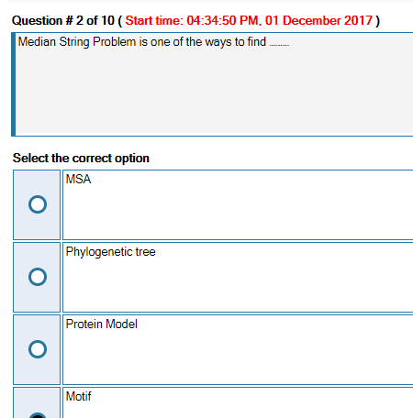
image: http://storage.ning.com/topology/rest/1.0/file/get/1938193225?profile=original
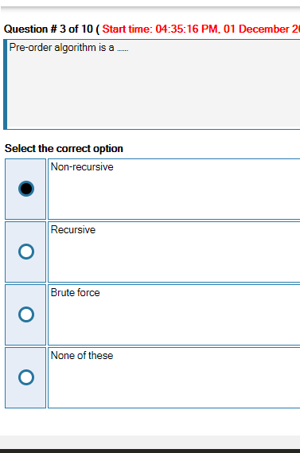
image: http://storage.ning.com/topology/rest/1.0/file/get/1938193312?profile=original
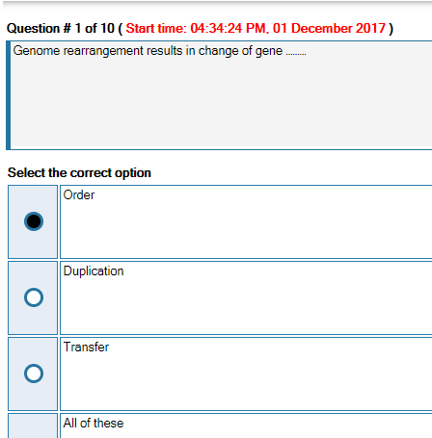
image: http://storage.ning.com/topology/rest/1.0/file/get/1938197245?profile=original
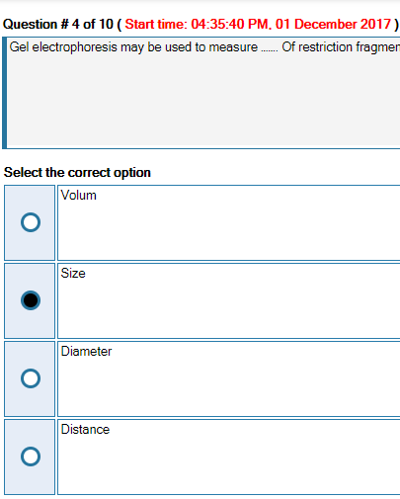
image: http://storage.ning.com/topology/rest/1.0/file/get/1938197395?profile=original
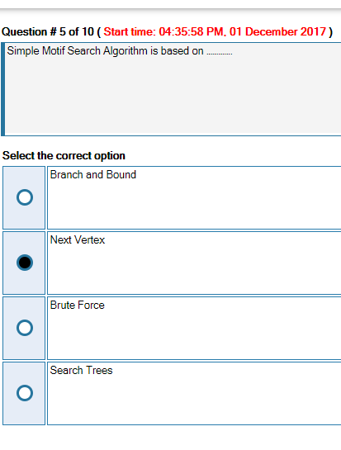
image: http://storage.ning.com/topology/rest/1.0/file/get/1938197692?profile=original
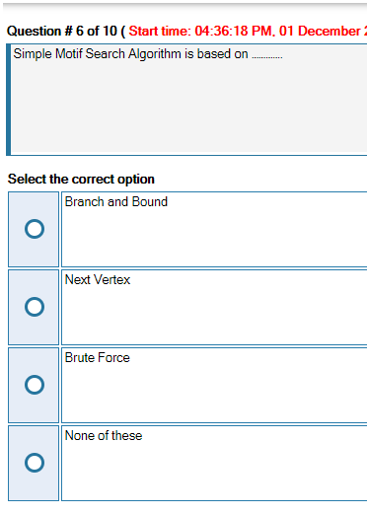
image: http://storage.ning.com/topology/rest/1.0/file/get/1938199294?profile=original
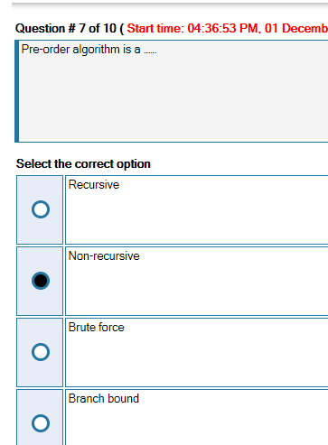
image: http://storage.ning.com/topology/rest/1.0/file/get/1938199461?profile=original
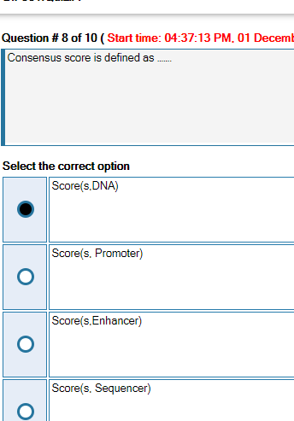
image: http://storage.ning.com/topology/rest/1.0/file/get/1938199479?profile=original
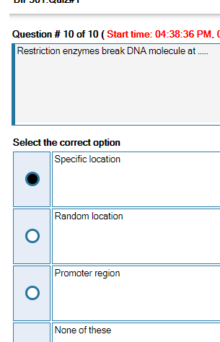

image: https://storage.ning.com/topology/rest/1.0/file/get/2742202890?profile=RESIZE_180x180&width=48&height=48&crop=1%3A1
image: https://api.ning.com/files/bR8nA-I0SJG6CIZy-G9bFxGXvn7hyT4N02K91fZsBDwSAIVAhU74oiWF5BLjEKrNuuwmyDKushBjV7-opkYm*m2jWzSgMBAS/ddd.png?size=64&crop=1%3A1
Permalink Reply by + M.Tariq Malik on December 13, 2017 at 6:58pm

image: http://storage.ning.com/topology/rest/1.0/file/get/1802074572?profile=original
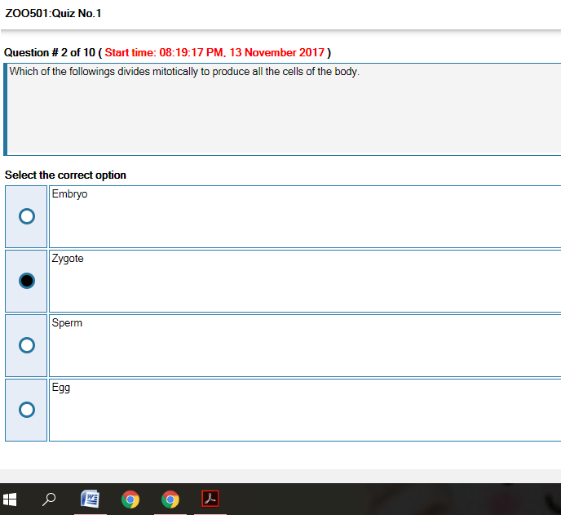
image: http://storage.ning.com/topology/rest/1.0/file/get/1802074658?profile=original
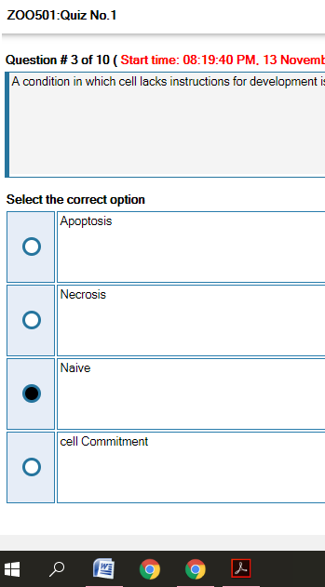
image: http://storage.ning.com/topology/rest/1.0/file/get/1802074776?profile=original
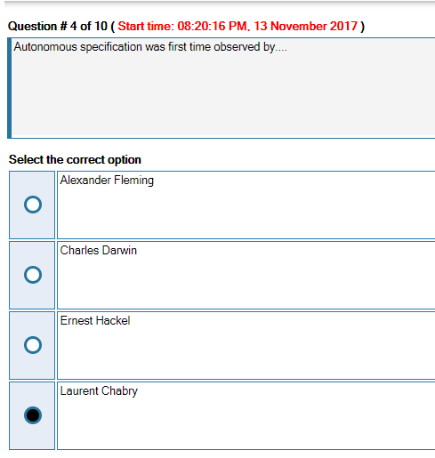
image: http://storage.ning.com/topology/rest/1.0/file/get/1802074941?profile=original
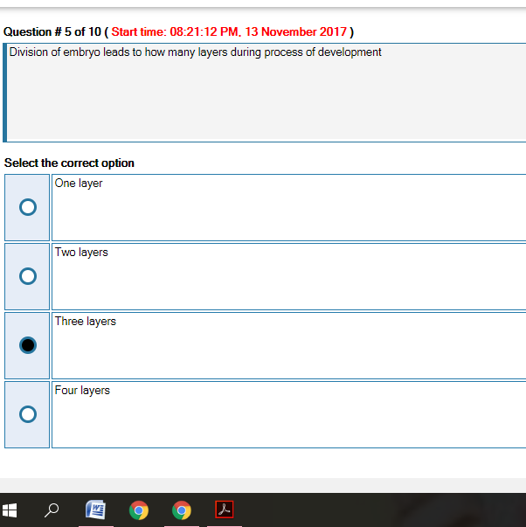
image: http://storage.ning.com/topology/rest/1.0/file/get/1802074985?profile=original
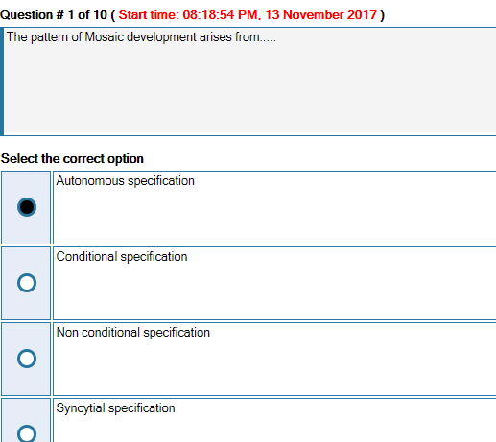
image: http://storage.ning.com/topology/rest/1.0/file/get/1802075252?profile=original
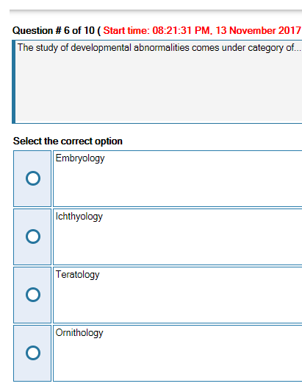
image: http://storage.ning.com/topology/rest/1.0/file/get/1802078064?profile=original

image: http://storage.ning.com/topology/rest/1.0/file/get/1802080917?profile=original
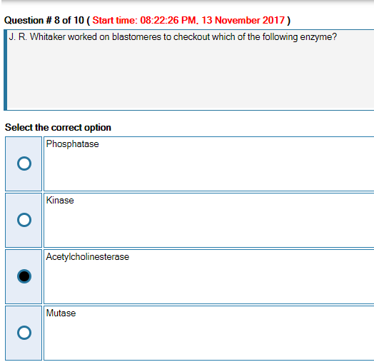
image: http://storage.ning.com/topology/rest/1.0/file/get/1802080990?profile=original
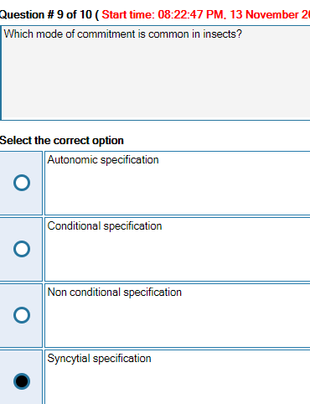
image: http://storage.ning.com/topology/rest/1.0/file/get/1802081136?profile=original
